Sinclair Tour and Travel 5494 5083
Sydney Vivid Lights Tour – 4 days
Departing Tuesday 26th May 2026
$2,750 per person twin share. Single $330
Be quick to book!
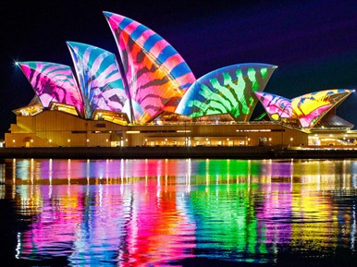
Tour Inclusions
Door to door transfers
Return airfares Sunshine Coast to Sydney
Airport transfers Sydney & return transfer with Sydney Tour
Showboat Dinner Cruise
Opera House Tour – with dinner
Hop On Hop Off Ferry Pass
Opal Card Ferry Pass included
Tours done by ferry/walking.
(not suitable for those with mobility issues)

Day One Tuesday 26th May.
After pick up from your door as usual, you’ll be taken to Sunshine Coast airport for your flight to Sydney. On arrival into Sydney, we’ll be met at the airport and transferred to our Hotel – our home for 3 nights, and right in the centre of the Vivid Magic.
Vivid Sydney is an annual lights festival that illuminates the city with a dazzling spectacle of colour, music and creativity. It’s quite a marvel to witness the spectacular transformation of Sydney Harbour into a glittering haven of extravagant lights. As you can imagine, everything VIVID happens at night, so we’ve tailored our tour to include as many nighttime activities as it’s possible to walk! Free time to settle into your Hotel before an EARLY dinner at our Hotel. Then we can walk down to catch a ferry to Circular Quay for some more amazing lights. (D)

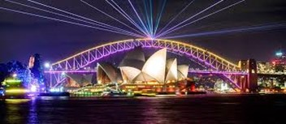
Ibis Darling Harbour (02) 9288 7113
Day Two Wednesday 27th May.
After a delicious brekky at our Hotel, there’s a new day ahead. Sydney Vivid Lights Tour is ABOUT THE LIGHTS, so we don’t usually plan too many daytime activities.
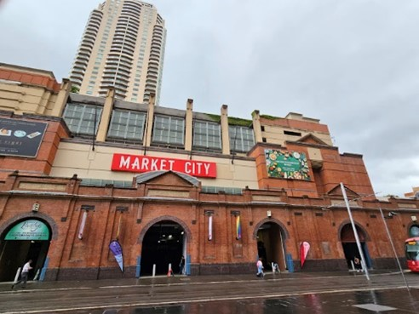

BUT there’s loads to do yourself. Paddy’s Markets is very close. Or the Chinese Garden of Friendship. It’s all up to you today. OR come and See The Lion King – Wednesday Matinee Show. (optional extra cost) Giraffes strut. Birds swoop. Gazelles leap. The entire Serengeti comes to life as never before. And as the music soars, Pride Rock slowly emerges from the mist. More than 120 million people around the world have experienced the awe-inspiring visual artistry, the unforgettable music, and the uniquely theatrical storytelling of this Broadway spectacular – one of the most breathtaking and beloved productions ever to grace the stage.
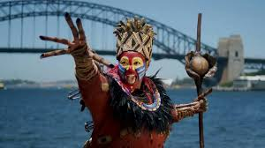

You may wish to walk to the city (quite close), explore the galleries OR choose to explore Sydney Harbour. You can hop on and hop off a boat at a particular scenic spot and get back on when the next boat comes along.
The Hop On Hop Off Sydney Harbour Explorer service offers a flexible, hop-on hop-off 24-hour ferry pass for nine key destination points on Sydney Harbour, which include the city's major tourist attractions. The nine stops are: Darling Harbour, Circular Quay, Taronga Zoo, Watsons Bay, Luna Park, Manly, Fort Denison, Shark Island and Garden Island. That means you can visit each of these destinations at your leisure and then hop on the next cruise boat when it suits. Boats run at 35-40-minute intervals.
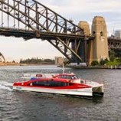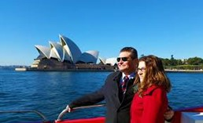

We’ll meet in the foyer about 6pm before we walk across the footbridge to join our 7pm Dinner Cruise on Sydney’s newest SHOWBOAT. You’ll be welcomed by glamorous showgirls and escorted to your seat. Then prepare for the magic to unfold as the “Voyage of Love” cabaret show takes centre stage – a breathtaking performance that will leave you mesmerized.
What a magnificent way to see the beautiful Vivid Lights. The light projections on the sails of the Sydney Opera House are some of Vivid’s most iconic events. This magnificent piece of architecture comes alive with the most amazing three-dimensional light displays and is guaranteed to take your breath away. (B)(D)
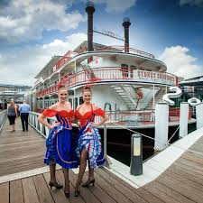

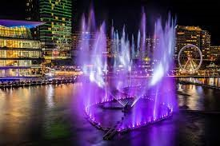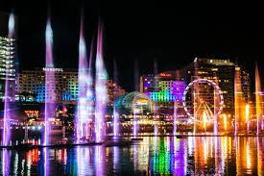
Ibis Darling Harbour (02) 9288 7113
Day Three Thursday 28th May.
After another delicious brekky at our Hotel, the day is once again yours to enjoy and explore. Later this afternoon, we’ll meet in the foyer (if you want a ride) to enjoy a Behind the Scenes tour of the magnificent Opera House 3.45pm tour. Discover the stories, history, and magic of Sydney Opera House with a guided tour. Step beneath the world-famous sails and explore the building that brings to life over 1800 performances each year. An early light dinner is included here tonight. (B)(D)
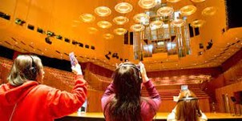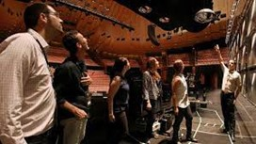

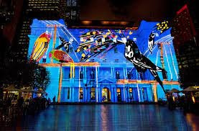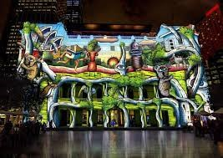
Ibis Darling Harbour (02) 9288 7113
Day Four Friday 29th May.
Sadly, this will be our last breakfast together. How hard will it be to go back to tea and toast! After breakfast, we will be collected for our 2-hour tour on the way to the airport for our flight home. Here we’ll be met by a representative of Sinclair Tour and Travel who’ll drive you back to your home. We do hope you’ve enjoyed your tour with Sinclair Tour and Travel - Sydney Vivid Lights Tour. Please tell your friends. That’s how our business grows. We look forward to traveling with you again really soon. (B)

TERMS AND CONDITIONS
These terms and conditions apply to bookings you make with us. These terms and conditions govern our relationship with you. Please read the following terms and conditions carefully. You must not make any booking unless you are 18 years of age or older and understand and agree with the following terms and conditions. We will rely on the authority of the person making the booking to act on behalf of any other person on the booking and the person making the booking will bind all other persons on the booking to these and conditions.
BOOKINGS, DEPOSITS AND PAYMENTS
In order to secure your booking, we require a deposit, per person, within 7 days of making your booking. Deposit amounts are outlined in each itinerary. $1000 deposit required for this Sydney Vivid Tour. When making a booking for yourself you warrant that you are 18 years of age or older. If you are making a booking on behalf of another person/s or thirds parties, you warrant that you have their authority to do so and have conveyed these terms and conditions to them and they are properly informed. You agree to indemnify us and the Supplier against any claims from any person/s or third parties who you made the booking for if they have not in been properly informed in regard to these terms and conditions.
If you are making a booking on behalf of a minor/s you warrant that you are their parent or legal guardian and take full responsibility for said minor/s and will not hold us or a Supplier responsible for any breach of these term and condition by any minor under your control.
When making a booking for yourself or on behalf of another person or on behalf of a minor, you warrant that all information provided by you is true and correct. We take no responsibility for any errors or incorrect information provided by you and will not be held responsible for costs, fees, penalties or payments incurred for errors or incorrect information provided by you.
All deposits are non-refundable for changes of mind or cancellations by you (subject to your rights under the Australian Consumer Law).
You are required to pay the balance payment at least 60 days prior to the tour date. For tour bookings made within 60 of the tour date full payment is required on booking.
Failure to make payment by the due date may result in your booking being cancelled and deposits forfeited.
Payments made by direct deposit may take up to three business days to process. If you are paying by this method, you will need to make the payment at least three business days prior to the actual due date. You must notify us once your payment has been made.
Payments made by personal cheque (excluding bank cheques) require five business days to process. If you are paying by this method, you will need to make the payment at least five business days prior to the actual due date. You agree not to stop payment of the cheque even when you cancel a booking. You agree that we may apply the proceeds of the cheque to satisfy any liability you have to us or to a Supplier, including any liability in respect of cancellation fees, before refunding the balance to you
CHANGE AND CANCELLATION FEES
Please be aware that some confirmed bookings are not refundable if cancelled and may not be transferable to another date or otherwise changed. Alternatively, a change may only be permissible subject to payment of an additional fee or charge. Changes and cancellations of confirmed bookings may incur fees from Suppliers. It is your responsibility to check if a booking is non-refundable or will incur charges for changing it before placing the booking.
If you cancel your booking, we reserve our right to charge you cancelation fees on the following basis: -
- Bookings cancelled more than 60 days from the tour date will not incur a fee subject to any additional non-refundable fees or charges from Suppliers.
- Bookings cancelled not more than 59 days but not less than 15 days from the tour date will incur a fee which is 50% of the Tour Price subject to any additional non-refundable fees or charges from Suppliers.
- Bookings cancelled not more than 14 days but not less than 8 days from the tour date will incur a fee which is 75% of the Tour Price subject to any additional non-refundable fees or charges from Suppliers.
- Bookings cancelled within 8 days from the tour date will be required to pay for 100% of the Tour Price.
- Bookings cancelled after the tour date will be required to pay for 100% of the Tour Price.
Please be advised that a $100 administration fee (per person) will be charged on ALL cancellations regardless of the number of days’ notice given.
To cover cancellations as a result of illness or loss of baggage, we strongly encourage passengers to arrange travel insurance. We now sell Covermore travel insurance and just need your date of birth to be able to provide you with a quote.

REFUNDS
Your entitlement to a refund for cancelled bookings is subject to the relevant Supplier’s terms and conditions, and our cancellation fees as outlined described above.
If you are entitled to a refund then, subject to the Supplier’s terms and conditions, we will arrange for it to be supplied to us on your behalf, unless we expressly agree with you otherwise.
If we are managing or arranging a refund for a cancelled booking on your behalf it will not be paid to you until the Supplier provides the refund to us, and we will not be liable for any delay on the part of the Supplier. Be aware that typically airlines will take between 60-90 days to process a refund.
SUMMARY
Please read all of the terms and conditions, the following is a summary of our terms and conditions: -
- Prices, including, in some cases, of confirmed bookings, may be subject to change.

- Some confirmed bookings are non-refundable if cancelled by you and it is your responsibility to check if this applies.

- We will be entitled to retain our service fees even if a booking is cancelled or does not proceed for any reason which is not our fault.

- It is your responsibility to make yourself aware of all information relevant to your travel plans, including but not limited to visa requirements and health precautions.

- We are not liable for the accuracy of any published Supplier content including websites and brochures

SUMMARY OF OBLIGATIONS
Before making a booking, it is important that you meet the following requirements:
- You are over the age of eighteen (18) and have sufficient funds to pay for the travel services.
- You have read our terms and conditions and if booking for third parties warrant that you have their authority to do so and have conveyed these terms and conditions to them. You agree to indemnify us and the Supplier against any claims from third parties who have not in fact been properly informed.
- You have read the terms and conditions of any applicable Suppliers and agree to be bound by those.
- You are responsible for checking the accuracy of all documents provided to you.
- You are responsible for confirming departure times of any booked services at least 24 hours prior to travel.
- You warrant and acknowledge that you have accessed the Smartraveller website http://smartraveller.gov.au for any specific information in relation to your intended destination.
- You accept that passports, visas and other required identification documents are your responsibility.
PRICES, TAXES, FEES AND SURCHARGES
All prices that we quote are in Australian Dollars. Quoted prices are subject to change at the discretion of the Supplier prior to booking. Price changes may occur after booking because of matters outside our control which may increase the cost of the Product. Such factors include but are not limited to currency fluctuations, fuel surcharges, taxes and airfare increases. Please contact us for up-to-date prices. Even when paid in full, prices may change because of matters outside our control.
In the event there is an increase in cost incurred by us we reserve our right to alter our prices and charge a surcharge. If we require a surcharge to be paid due to increases in costs, this will be requested in writing. If you do not pay this surcharge, your action will be regarded as a cancellation by you and cancellation charges will apply.
Prices include all applicable taxes requiring payment prior to departure and may be subject to adjustment in the event of an increase in those taxes. On other occasions, you may be liable for taxes in addition to the quoted price of the Product. For example, there may be a local tax charged at some airports or resorts.

You agree to pay fees and surcharges incurred by us on your behalf, which include but are not limited to booking or reservation fees, cancellation and amendment fees, credit card merchant fees, insurance claim processing fees or fees for ad-hoc services performed as required.
You authorise us to charge all monies payable by you in relation to any booking we make on your behalf or other services we have procured or provided to the credit card or debit card designated by you. If payment is not received from the card issuer or its agents for any reason, you agree to pay us all amounts due immediately on demand. Please not surcharges in relation to credit and debit card payments are non-refundable and we accept no responsibility for an inappropriate surcharge being applied if the correct card type has not been advised
PRODUCTS
All tours and Products that we quote on are subject to availability and may be withdrawn or varied by us or the Supplier without notice.
MISCELLANEOUS
It is your responsibility to make yourself aware of all information that it is necessary or desirable to know in order to make optimum use of the tour, Products and to undertake travel generally.
It is your responsibility to ensure you have the necessary passports, visas, documents and vaccinations for international travel.
It is your responsibility to obtain medical advice prior to your booking to ensure it is safe for you to undertake the tour, participate in activities and are aware of the associated risks.
It is your responsibility to further investigate and confirm any matters that are applicable to you
SPECIAL REQUIREMENTS
You must inform us regarding any special requirements you may have for your travel arrangements such as special meal and seating requests, room type or disabled access prior to making a booking. If you do not specifically inform us, we will assume that you do not have any such requirements, and the booking will be made on that basis.
We require that you are able to walk unaided and able to have full control of your own luggage.

FREQUENT FLYER AND LOYALTY PROGRAMS
When booking with us, it is your responsibility to let us know your frequent flyer membership details (or other applicable loyalty program details) for inclusion in your booking. Notwithstanding that your details may be included in the booking; we cannot guarantee that the Supplier will credit you with points for your booking.
AGENCY
In order for us to facilitate tours we may need to act as an agent for and sell various travel related products as an agent on behalf of numerous transports, accommodation and other service providers, such as airlines, coach, rail and cruise line operators, as well as travel wholesalers (“Suppliers”). Any brochures provided by us to you are supplied by Suppliers or are prepared by us based on content supplied by Suppliers, and we accept no liability for errors in that material. Your oral or written instructions to us are authority for us to make travel bookings on your behalf and to arrange relevant contracts between you and the applicable Supplier. Notwithstanding this authority, we are not your agent and do not have any fiduciary duty to you. We exercise care in the selection of reputable Suppliers; however, we have no control over, or liability for, the Products provided by the Suppliers, who are third parties. All bookings are made on your behalf subject to the terms and conditions, including conditions of carriage and limitations of liability, imposed by the Supplier. We recommend that you read them before finalising the transaction and we can provide you with copies of the relevant terms and conditions on request.
Your legal rights and remedies in connection with the provision of Products are against the Supplier and, except to the extent a problem is directly and primarily caused by fault on our part, are not against us. Specifically, if for any reason (excluding fault on our part) any Supplier is unable to provide the Product for which you have contracted either at all, or to the requisite standard, your remedies are against that Supplier and not against us
LIABILITY
To the extent permitted by law, we do not accept any liability in contract, tort or otherwise for any injury, damage, loss (including consequential loss), delay, additional expense or inconvenience caused directly or indirectly by the acts, omissions or default, whether negligent or otherwise, of third party providers over whom we have no direct control, an event of Force Majeure affecting you, us or a Supplier or any other event which is beyond our control or which is not preventable by reasonable diligence on our part. Under circumstances where our liability cannot be excluded and where liability may be lawfully limited, such liability is limited to the remedies required of us under applicable law (including the Australian Consumer Law). In particular, we disclaim any liability for any consequential loss, including loss of enjoyment or amenity. This liability clause is subject to your rights under the Australian Consumer Law and nothing in these terms and conditions is intended to limit any rights you may have under the Competition and Consumer Act 2010 (Cth).
Without limitation of the disclaimer of liability in the previous paragraph, any obligation we have to you will be suspended during the time and to the extent that we are prevented from, or delayed in, complying with that obligation by an event of Force Majeure.
Your rights with respect to a confirmed booking affected by an event of Force Majeure will be subject to the terms and conditions of the relevant Supplier
GOVERNING LAW
If any dispute arises between you and us, the laws applicable in Queensland will apply. You irrevocably and unconditionally submit to the exclusive jurisdiction of the courts of Queensland and waive any right that you may have to object to an action being brought in those courts.
DEFINITIONS
- "we" and "us" means Sinclair Tour & Travel.
- “you” means the person and the people who make a booking for a tour or Product with us and use our services.
- "Supplier” means a third-party company or person who provides Products, including a wholesaler of such Products.
- "Product" means travel and holiday related products and services including accommodation, leisure activities and various forms of transport, including packaged combinations thereof.ravel documents” means any document (whether in electronic form or otherwise) used to confirm an arrangement with a Supplier, including (without limitation) airline tickets, hotel vouchers and tour vouchers.
- “Force Majeure" means an act of God, peril of the sea, accident of navigation, war (including civil war), sabotage, riot, insurrection, civil commotion, coup d’état, national emergency, martial law, fire (including wildfire), explosion, lightning, flood, tsunami, cyclone, hurricane, tornado or other major weather event, earthquake, landslide, volcanic eruption or other natural catastrophe, epidemic, pandemic, quarantine, outbreaks of infectious disease or any other public health crisis, radiation or radioactive contamination, national strike or other major lack of availability of labour, raw materials or energy beyond the control of the affected party. For the avoidance of doubt, the inability of a party to make a profit or avoid a financial loss, changes in market prices or conditions, or a party’s inability to perform its obligations due to insufficiency of finance does not in itself constitute Force Majeure.

