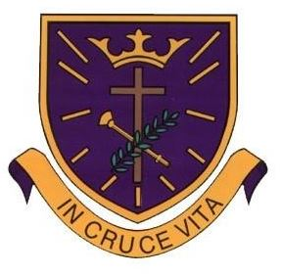
St Oswald’s Catholic Primary School

RSHE
Intent, implementation and overview of learning

Intent
‘I am a child of God.’ 1 John 3:1
At St Oswald’s Catholic Primary School, we believe that Relationships, Sex and Health Education (RSHE) enables our children to become healthy, safe, independent and responsible members of society. It aims to help them to understand how they are developing personally and socially and tackles many of the moral, social and cultural issues that are part of growing up. We are dedicated to ensuring that St Oswald’s Catholic Primary School is a happy, stimulating and caring place and RSHE is placed at the heart of our school ethos.
From September 2020, Relationship and Sex and Health Education (RSHE) is mandatory for all schools. The Governors at St Oswald’s Catholic Primary School have adopted the ‘Journey In Love’ programme to support RSHE across the school from EYFS to Year 6. The programme of study is authentic to the teaching of the Catholic Church, which embraces and fulfils the statutory curriculum. This, alongside ‘Scarf’, ‘No Outsiders’ and the PSHE, Computing and Science Curriculum, forms the basis of our teaching of RSHE here at St Oswald’s.
It includes teaching about personal health, physical and emotional wellbeing, strong emotions, personal relationships, family structures, trusted adults, growing bodies, puberty, periods, life cycles, the dangers of social media, where babies come from, an understanding of the Common Good and living in the wider world. The entire teaching is underpinned with a religious understanding that our deepest identity is as a child of God- created, chosen and loved by God.
We are increasingly aware that our children are exposed to many negative sexual influences in the media. These have a profound effect on loss of innocence from a very early age and undermine the moral teachings of Christ and His Church.
We are also mindful that young people are bombarded with false body images and stereotypes that would leave them vulnerable to accepting an image of themselves and others that is far less than God’s desire for them.
It is essential, therefore that our children are given the opportunity to discover the full miracle of God’s creation that is unique to them. That they know that they, and the people around them, are created out of unconditional love and that when we live out the Gospel message of Christ, we can together become all that God created us to be.
Our RSHE Curriculum intends to:
- Provide a framework in which sensitive discussions can take place.
- Help pupils develop feelings of dignity, self-worth, self-respect, confidence and empathy.
- Prepare pupils for puberty and give them an understanding of sexual development and the importance of health and hygiene.
- Create a positive culture around issues of sexuality and relationships.
- Teach pupils the correct vocabulary to describe themselves and their bodies.

Overview of Learning
Year A- 2024/25
 | Autumn 1 | Autumn 2 | Spring 1 | Spring 2 | Summer 1 | Summer 2
 | SCARF:  Me and my Relationships | SCARF:  Valuing Difference | SCARF:  Keeping Safe | SCARF:  Rights and Respect | SCARF:  Being my Best | SCARF:  Growing and Changing
Park Class  (Reception) | -What makes me special  -People close to me  -Getting help | -Similarities and difference  -Celebrating difference  -Showing kindness | -Keeping my body safe  -Safe secrets and touches  -People who help to keep us safe | -Looking after things: friends, environment, money | -Keeping by body healthy – food, exercise, sleep  Growth Mindset | -Cycles  -Life stages  -Girls and boys – similarities and difference
Chisnall Class  (Y1/2) | -Feelings  -Getting help  -Classroom rules  -Special people  -Being a good friend | -Recognising, valuing and celebrating difference  -Developing respect and accepting others  -Bullying and getting help | -How our feelings can keep us safe – including online safety  -Safe and unsafe touches  -Medicine Safety  Sleep | -Taking care of things:  Myself  My money  My environment | -Growth Mindset  -Healthy eating  -Hygiene and health  -Cooperation | -Getting help  -Becoming independent  -My body parts  -Taking care of self and others
Blainscough Class  (Y3/4) | -Rules and their purpose  -Cooperation  -Friendship (including respectful relationships)  -Coping with loss | -Recognising and respecting diversity  -Being respectful and tolerant  -My community | -Managing risk  -Decision-making skills  -Drugs and their risks  -Staying safe online | -Skills we need to develop as we grow up  -Helping and being helped  -Looking after the environment  -Managing money | -Keeping myself healthy and well  -Celebrating and developing my skills  -Developing empathy | -Relationships  -Changing bodies and puberty  -Keeping safe  -Safe and unsafe secrets
Ellerbeck Class  (Y5/6) | -Feelings  -Friendship skills, including compromise  -Assertive skills  -Cooperation  -Recognising emotional needs | -Recognising and celebrating difference, including religions and cultural influence and pressure of social media | -Managing risk, including online safety  -Norms around use of legal drugs (tobacco, alcohol)  -Decision-making skills | -Rights, respect and duties relating to my health  -Making a difference  -Decisions about lending, borrowing and spending | -Growing independence and taking ownership  -Keeping myself healthy  -Media awareness and safety  -My community | -Managing difficult feelings  -Managing change  -How my feelings help keeping safe  -Getting help
 | No Outsiders | No Outsiders | No Outsiders | No Outsiders | No Outsiders | No Outsiders
 | Journey In Love:  Social & Emotional |  | Journey In Love:  Physical |  | Journey In Love:  Spiritual

Year B- 2025/26
 | Autumn 1 | Autumn 2 | Spring 1 | Spring 2 | Summer 1 | Summer 2
 | SCARF:  Me and my Relationships | SCARF:  Valuing Difference | SCARF:  Keeping Safe | SCARF:  Rights and Respect | SCARF:  Being my Best | SCARF:  Growing and Changing
Park Class  (Reception) | -What makes me special  -People close to me  -Getting help | -Similarities and difference  -Celebrating difference  -Showing kindness | -Keeping my body safe  -Safe secrets and touches  -People who help to keep us safe | -Looking after things: friends, environment, money | -Keeping by body healthy food, exercise, sleep  -Growth Mindset | -Cycles  -Life stages  Girls and boys – similarities and difference
Chisnall Class  (Y1/2) | -Bullying and teasing  -Our school rules about bullying  -Being a good friend  -Feelings/self-regulation | -Being kind and helping others  -Celebrating difference  -People who help us  -Listening Skills | -Safe and unsafe secrets  -Appropriate touch  -Medicine safety | -Cooperation  -Self-regulation  -Online safety  -Looking after money – saving and spending | -Growth Mindset  -Looking after my body  -Hygiene and health  -Exercise and sleep | -Life cycles  -Dealing with loss  -Being supportive  -Growing and changing  -Privacy
Blainscough Class  (Y3/4) | -Healthy relationships  -Listening to feelings  -Bullying  -Assertive skills | -Recognising and celebrating difference (including religions and cultural difference)  -Understanding and challenging stereotypes | -Managing risk  -Understanding the norms of drug use (cigarette and alcohol use)  -Influences  -Online safety | -Making a difference (different ways of helping others or the environment)  -Media influence  -Decisions about spending money | -Having choices and making decisions about my health  -Taking care of my environment  -My skills and interests | -Body changes during puberty  -Managing difficult feelings  -Relationships including marriage
Ellerbeck Class  (Y5/6) | -Assertiveness  -Cooperation  -Safe/unsafe touches  -Positive relationships | -Recognising and celebrating difference  -Recognising and reflecting on prejudice-based bullying  -Understanding Bystander behaviour  -Gender stereotyping | -Understanding emotional needs  -Staying safe online  -Drugs: norms and risks (including the law) | -Understanding media bias, including social media  -Caring: communities and the environment  -Earning and saving money  -Understanding democracy | -Aspirations and goal setting  -Managing risk  -Looking after my mental health | -Coping with changes  -Keeping safe  -Body Image  -Sex education  -Self-esteem
 | No Outsiders | No Outsiders | No Outsiders | No Outsiders | No Outsiders | No Outsiders
 | Journey In Love:  Social & Emotional |  | Journey In Love:  Physical |  | Journey In Love:  Spiritual

Park Class-Year A & B- 2024/25
Park Class  (Reception) | Autumn 1 | Autumn 2 | Spring 1 | Spring 2 | Summer 1 | Summer 2
Park Class  (Reception) | SCARF:  Me and my Relationships | SCARF:  Valuing Difference | SCARF:  Keeping Safe | SCARF:  Rights and Respect | SCARF:  Being my Best | SCARF:  Growing and Changing
Park Class  (Reception) | -What makes me special  -People close to me  -Getting help | -Similarities and difference  -Celebrating difference  -Showing kindness | -Keeping my body safe  -Safe secrets and touches  -People who help to keep us safe | -Looking after things: friends, environment, money | -Keeping by body healthy – food, exercise, sleep  Growth Mindset | -Cycles  -Life stages  -Girls and boys – similarities and difference
Park Class  (Reception) | 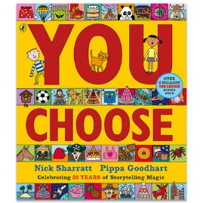  No Outsiders: | 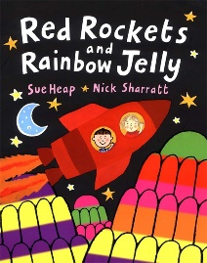  No Outsiders: | 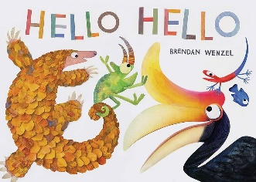  No Outsiders: | 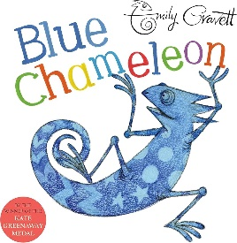  No Outsiders: | 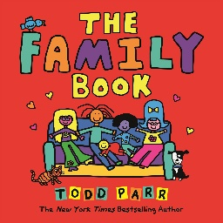  No Outsiders: | 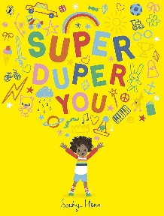  No Outsiders:
Park Class  (Reception) | Journey In Love:  Social & Emotional  EYFS- A focus on recognising the joy of being a special person in a family. |  | Journey In Love:  Physical  EYFS- A focus on recognising that we are all different and unique. |  | Journey In Love:  Spiritual  EYFS- A focus on celebrating the joy of being a special person in God’s family.

Year A- 2024/25
Chisnall Class  (Y1/2) | Autumn 1 | Autumn 2 | Spring 1 | Spring 2 | Summer 1 | Summer 2
Chisnall Class  (Y1/2) | SCARF:  Me and my Relationships | SCARF:  Valuing Difference | SCARF:  Keeping Safe | SCARF:  Rights and Respect | SCARF:  Being my Best | SCARF:  Growing and Changing
Chisnall Class  (Y1/2) | -Feelings  -Getting help  -Classroom rules  -Special people  -Being a good friend | -Recognising, valuing and celebrating difference  -Developing respect and accepting others  -Bullying and getting help | -How our feelings can keep us safe – including online safety  -Safe and unsafe touches  -Medicine Safety  Sleep | -Taking care of things:  Myself  My money  My environment | -Growth Mindset  -Healthy eating  -Hygiene and health  -Cooperation | -Getting help  -Becoming independent  -My body parts  -Taking care of self and others
Chisnall Class  (Y1/2) | 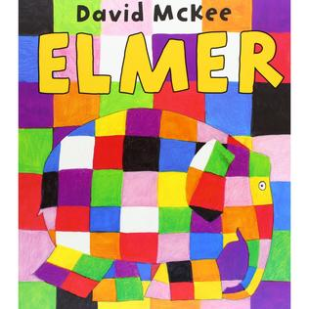  No Outsiders: | 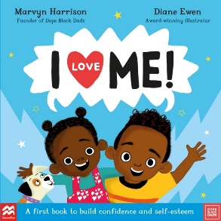  No Outsiders: | 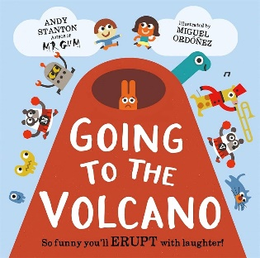  No Outsiders: | 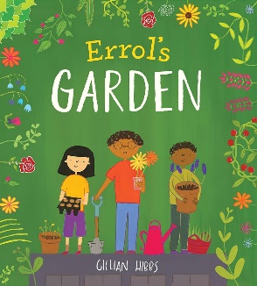  No Outsiders: | 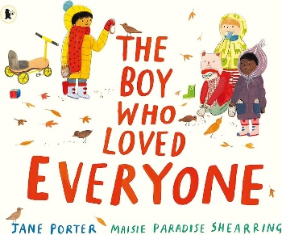  No Outsiders: | 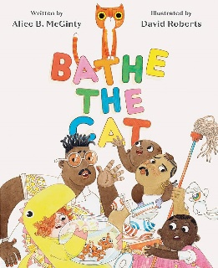  No Outsiders:
Chisnall Class  (Y1/2) | Journey In Love:  Social & Emotional  Year 1- A focus on recognising signs that we are loved in our family.  Year 2- A focus on recognising the joy and friendship of belonging to a diverse community. |  | Journey In Love:  Physical  Year 1- A focus on recognising how we are cared for and kept safe in our families.  Year 2- A focus on describing ways of being safe in communities. |  | Journey In Love:  Spiritual  Year 1- A focus on celebrating the ways that God loves and cares for us.  Year 2- A focus on celebrating ways of meeting God in our communities.

Year B- 2025/26
Chisnall Class  (Y1/2) | Autumn 1 | Autumn 2 | Spring 1 | Spring 2 | Summer 1 | Summer 2
Chisnall Class  (Y1/2) | SCARF:  Me and my Relationships | SCARF:  Valuing Difference | SCARF:  Keeping Safe | SCARF:  Rights and Respect | SCARF:  Being my Best | SCARF:  Growing and Changing
Chisnall Class  (Y1/2) | -Bullying and teasing  -Our school rules about bullying  -Being a good friend  -Feelings/self-regulation | -Being kind and helping others  -Celebrating difference  -People who help us  -Listening Skills | -Safe and unsafe secrets  -Appropriate touch  -Medicine safety | -Cooperation  -Self-regulation  -Online safety  -Looking after money – saving and spending | -Growth Mindset  -Looking after my body  -Hygiene and health  -Exercise and sleep | -Life cycles  -Dealing with loss  -Being supportive  -Growing and changing  -Privacy
Chisnall Class  (Y1/2) | 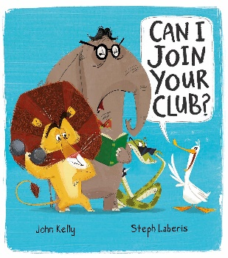  No Outsiders: | 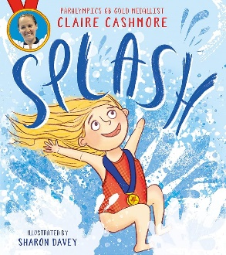  No Outsiders: | 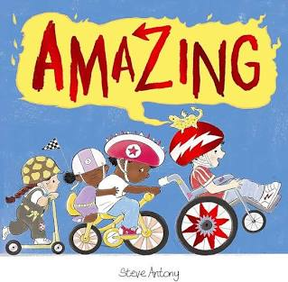  No Outsiders: | 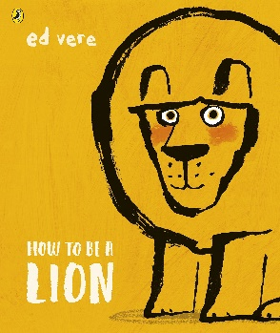  No Outsiders: | 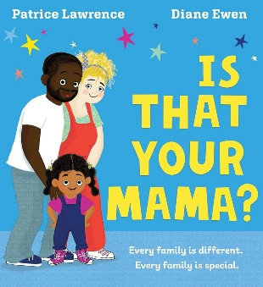  No Outsiders: | 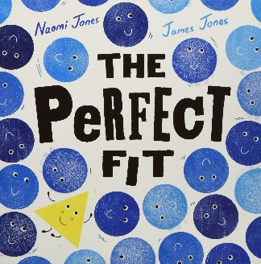  No Outsiders:
Chisnall Class  (Y1/2) | Journey In Love:  Social & Emotional  Year 1- A focus on recognising signs that we are loved in our family.  Year 2- A focus on recognising the joy and friendship of belonging to a diverse community. |  | Journey In Love:  Physical  Year 1- A focus on recognising how we are cared for and kept safe in our families.  Year 2- A focus on describing ways of being safe in communities. |  | Journey In Love:  Spiritual  Year 1- A focus on celebrating the ways that God loves and cares for us.  Year 2- A focus on celebrating ways of meeting God in our communities.

Blainscough- Year A- 2024/25
Blainscough Class  (Y3/4) | Autumn 1 | Autumn 2 | Spring 1 | Spring 2 | Summer 1 | Summer 2
Blainscough Class  (Y3/4) | SCARF:  Me and my Relationships | SCARF:  Valuing Difference | SCARF:  Keeping Safe | SCARF:  Rights and Respect | SCARF:  Being my Best | SCARF:  Growing and Changing
Blainscough Class  (Y3/4) | -Rules and their purpose  -Cooperation  -Friendship (including respectful relationships)  -Coping with loss | -Recognising and respecting diversity  -Being respectful and tolerant  -My community | -Managing risk  -Decision-making skills  -Drugs and their risks  -Staying safe online | -Skills we need to develop as we grow up  -Helping and being helped  -Looking after the environment  -Managing money | -Keeping myself healthy and well  -Celebrating and developing my skills  -Developing empathy | -Relationships  -Changing bodies and puberty  -Keeping safe  -Safe and unsafe secrets
Blainscough Class  (Y3/4) | 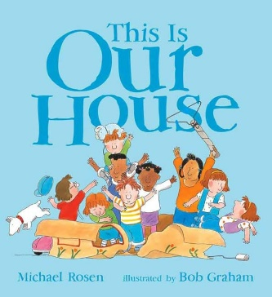  No Outsiders: | 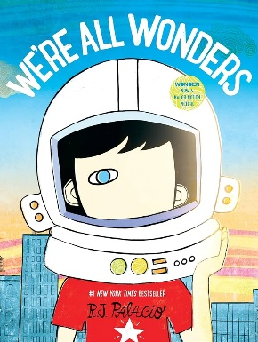  No Outsiders: | 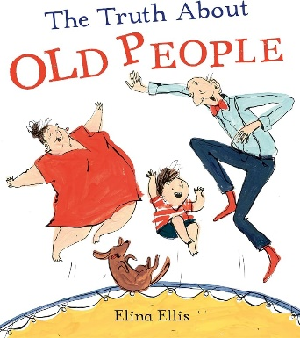  No Outsiders: | 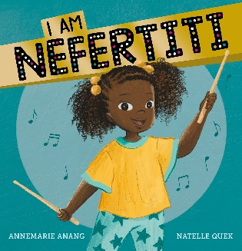  No Outsiders: | 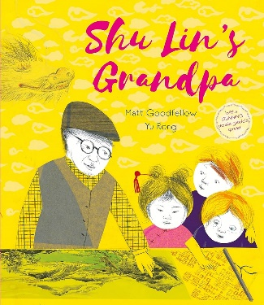  No Outsiders: | 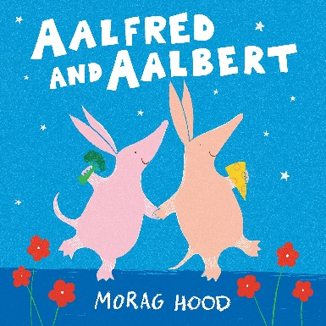  No Outsiders:
Blainscough Class  (Y3/4) | Journey In Love:  Social & Emotional  Year 3- A focus on describing and giving reasons how friendships make us feel happy and safe.  Year 4- A focus on describing how we should all be accepted and respected. |  | Journey In Love:  Physical  Year 3- A focus on describing and giving reasons why friendships can break down and how they can be repaired and strengthened.  Year 4- A focus on describing how we should treat others, making links with the diverse modern society we live in. |  | Journey In Love:  Spiritual  Year 3- A focus on celebrating the joy and happiness of living in friendship with God and others.  Year 4- A focus on celebrating the uniqueness and innate beauty of each of us.

Blainscough- Year B- 2025/26
Blainscough Class  (Y3/4) | Autumn 1 | Autumn 2 | Spring 1 | Spring 2 | Summer 1 | Summer 2
Blainscough Class  (Y3/4) | SCARF:  Me and my Relationships | SCARF:  Valuing Difference | SCARF:  Keeping Safe | SCARF:  Rights and Respect | SCARF:  Being my Best | SCARF:  Growing and Changing
Blainscough Class  (Y3/4) | -Healthy relationships  -Listening to feelings  -Bullying  -Assertive skills | -Recognising and celebrating difference (including religions and cultural difference)  -Understanding and challenging stereotypes | -Managing risk  -Understanding the norms of drug use (cigarette and alcohol use)  -Influences  -Online safety | -Making a difference (different ways of helping others or the environment)  -Media influence  -Decisions about spending money | -Having choices and making decisions about my health  -Taking care of my environment  -My skills and interests | -Body changes during puberty  -Managing difficult feelings  -Relationships including marriage
Blainscough Class  (Y3/4) | 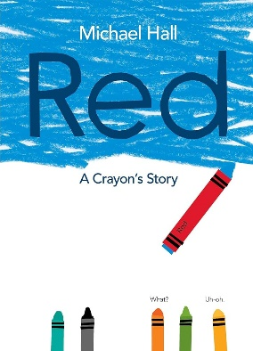  No Outsiders: | 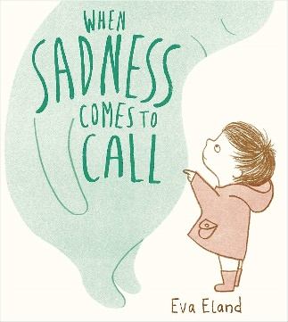  No Outsiders: | No Outsiders:  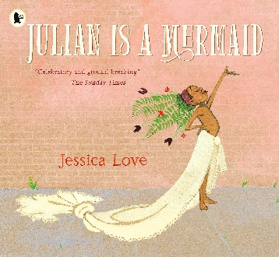 | 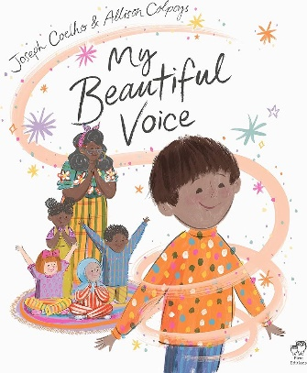  No Outsiders: | 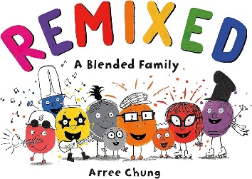  No Outsiders: | No Outsiders:  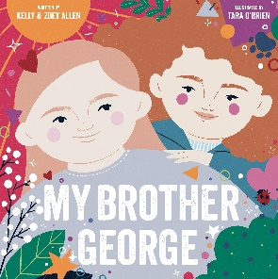
Blainscough Class  (Y3/4) | Journey In Love:  Social & Emotional  Year 3- A focus on describing and giving reasons how friendships make us feel happy and safe.  Year 4- A focus on describing how we should all be accepted and respected. |  | Journey In Love:  Physical  Year 3- A focus on describing and giving reasons why friendships can break down and how they can be repaired and strengthened.  Year 4- A focus on describing how we should treat others, making links with the diverse modern society we live in. |  | Journey In Love:  Spiritual  Year 3- A focus on celebrating the joy and happiness of living in friendship with God and others.  Year 4- A focus on celebrating the uniqueness and innate beauty of each of us.

Ellerbeck- Year A- 2024/25
Ellerbeck Class  (Y5/6) | Autumn 1 | Autumn 2 | Spring 1 | Spring 2 | Summer 1 | Summer 2
Ellerbeck Class  (Y5/6) | SCARF:  Me and my Relationships | SCARF:  Valuing Difference | SCARF:  Keeping Safe | SCARF:  Rights and Respect | SCARF:  Being my Best | SCARF:  Growing and Changing
Ellerbeck Class  (Y5/6) | -Feelings  -Friendship skills, including compromise  -Assertive skills  -Cooperation  -Recognising emotional needs | -Recognising and celebrating difference, including religions and cultural influence and pressure of social media | -Managing risk, including online safety  -Norms around use of legal drugs (tobacco, alcohol)  -Decision-making skills | -Rights, respect and duties  relating to my health  -Making a difference  -Decisions about lending, borrowing and spending | -Growing independence and taking ownership  -Keeping myself healthy  -Media awareness and safety  -My community | -Managing difficult feelings  -Managing change  -How my feelings help keeping safe  -Getting help
Ellerbeck Class  (Y5/6) | 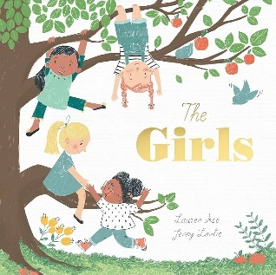  No Outsiders: | 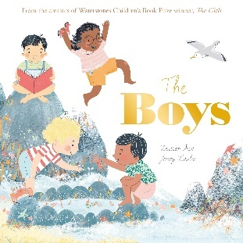  No Outsiders: | 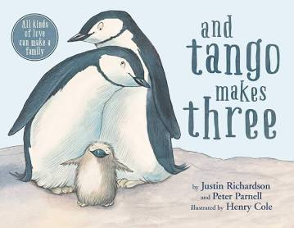  No Outsiders: | 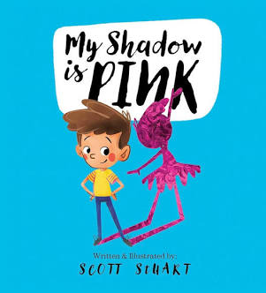  No Outsiders: | 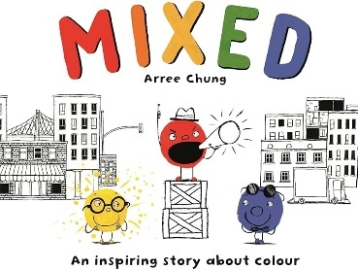  No Outsiders: | 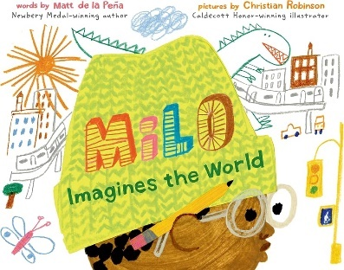  No Outsiders:
Ellerbeck Class  (Y5/6) | Journey In Love:  Social & Emotional  Year 5- A focus on showing knowledge and understanding of emotional relationship changes as we grow and develop.  Year 6- A focus on developing a secure understanding that stable and caring relationships, which may be of different types, are at the heart of happy families. |  | Journey In Love:  Physical  Year 5- A focus on showing knowledge and understanding of the physical changes in puberty.  Year 6- A focus on explaining how human life is conceived. |  | Journey In Love:  Spiritual  Year 5- A focus on celebrating the joy of growing physically and spiritually.  Year 6- A focus on showing an understanding of how being made in the image and likeness of God informs decisions and actions when building relationships with others, including life-long relationships.

Ellerbeck- Year B- 2025/26
Ellerbeck Class  (Y5/6) | Autumn 1 | Autumn 2 | Spring 1 | Spring 2 | Summer 1 | Summer 2
Ellerbeck Class  (Y5/6) | SCARF:  Me and my Relationships | SCARF:  Valuing Difference | SCARF:  Keeping Safe | SCARF:  Rights and Respect | SCARF:  Being my Best | SCARF:  Growing and Changing
Ellerbeck Class  (Y5/6) | -Assertiveness  -Cooperation  -Safe/unsafe touches  -Positive relationships | -Recognising and celebrating difference  -Recognising and reflecting on prejudice-based bullying  -Understanding Bystander behaviour  -Gender stereotyping | -Understanding emotional needs  -Staying safe online  -Drugs: norms and risks (including the law) | -Understanding media bias, including social media  -Caring: communities and the environment  -Earning and saving money  -Understanding democracy | -Aspirations and goal setting  -Managing risk  -Looking after my mental health | -Coping with changes  -Keeping safe  -Body Image  -Sex education  -Self-esteem
Ellerbeck Class  (Y5/6) | 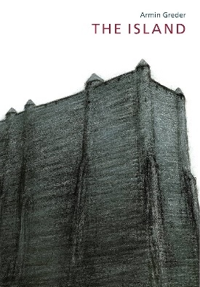  No Outsiders: | No Outsiders:  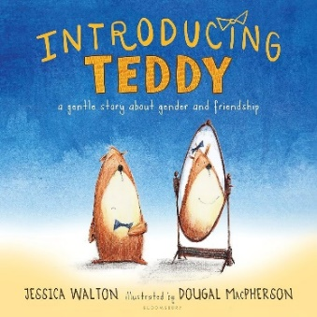 | No Outsiders:  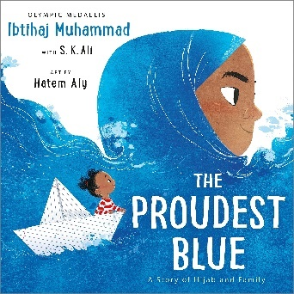 | No Outsiders:  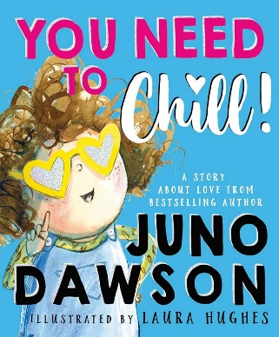 | No Outsiders:  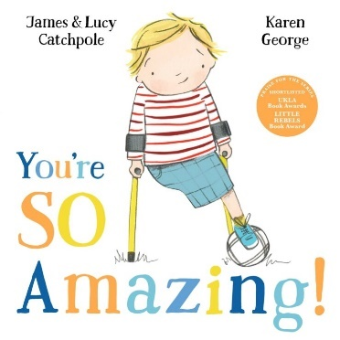 | 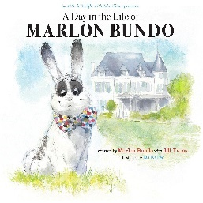  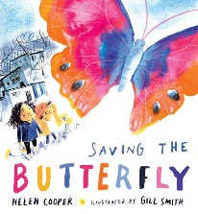  No Outsiders:
Ellerbeck Class  (Y5/6) | Journey In Love:  Social & Emotional  Year 5- A focus on showing knowledge and understanding of emotional relationship changes as we grow and develop.  Year 6- A focus on developing a secure understanding that stable and caring relationships, which may be of different types, are at the heart of happy families. |  | Journey In Love:  Physical  Year 5- A focus on showing knowledge and understanding of the physical changes in puberty.  Year 6- A focus on explaining how human life is conceived. |  | Journey In Love:  Spiritual  Year 5- A focus on celebrating the joy of growing physically and spiritually.  Year 6- A focus on showing an understanding of how being made in the image and likeness of God informs decisions and actions when building relationships with others, including life-long relationships.

