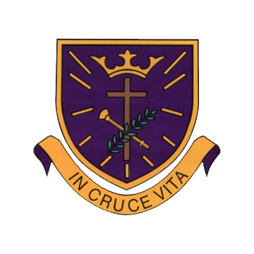

St Oswald’s Catholic Primary School

Religious Education Policy

Leader/Co-ordinator | Mrs P Atherton
Groups involved in discussion | Headteacher  RE Co-ordinator  All Staff  Governing Body
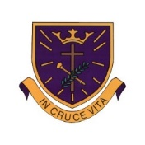

Introduction and Aims

This policy provides a framework for all staff which includes guidance on planning, assessment, recording and reporting in Religious Education. It offers guidance on teaching styles and opportunities for meeting the needs of all pupils, as well as giving advice on equality.

Mission Statement

Live, love and learn like Jesus

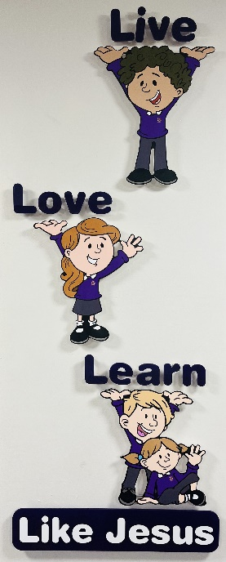
St. Oswald’s is a Roman Catholic Primary School established to work in partnership with the parish and parents in order to provide the best possible education for our children.

We accept as a prime and serious responsibility the title of ‘Catholic School’ and hold the example of Jesus Christ as a model for each individual in every aspect of life.

Central to our Catholic faith is the belief that Christianity is not just for learning but for living and therefore living the faith permeates the whole curriculum and all that is done in school.

We recognise the need to serve all members of the school community and endeavour to fulfil their academic, spiritual, moral, social and physical needs.

In order to achieve this we strive to create and maintain a caring and supportive environment for all who learn and work in our school community.

Religious Education Intent

At St Oswald’s Catholic Primary School, Religious Education plays a central and vital part of school life. It is a way of understanding our faith and knowing what it is to be a part of a community. It is a rigorous academic discipline and as such is taught, developed and resourced with the same commitment as any other subject. It is very much the core subject. The beliefs and values studied in Catholic Religious Education inspire and draw together every aspect of the life of our Catholic School.

We are committed to Catholic RE because all pupils have the right to receive an overall Religious Education. RE is for all and is a collaborative activity, which respects and promotes the child’s innate capacity for wonder, awe, reverence and imagination.

Religious Education Implementation
At St Oswald’s we intend to educate the whole person. At the heart of the school is a sense of purpose, which is to create a community that shares the values of love, respect, truth and reconciliation as shown through the example of Christ.

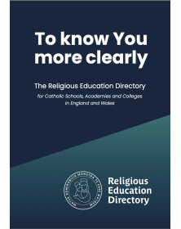
A new Religious Education Directory (RED) was published in 2023 and we are currently working on adapting our RE curriculum in light of this new guidance. This is expected to be fully in place by September 2026. The ‘To Know You More Clearly’ framework has started to be progressively rolled out across the school in line with guidance from the archdiocese. Currently, the RED is being implemented throughout Reception, KS1 and LKS2.


To fulfil our intentions and objectives, we currently follow the ‘Come and See’ Programme of Religious Education recommended by the Archdiocese of Liverpool. Come and See is of primary importance within school since its purpose is to unify and inspire every aspect of school life. It provides a Catholic framework for the teacher to explore the themes with all children. The programme is currently being implemented in UKS2 classes (Y5/6).

As part of the ‘Come and See’ Programme, there is a focus on other faiths as well as the Christian themes which are explored in each year group. Judaism is studied every year along with one other faith. The following table shows which other faiths will be studied over the next 3 years.

2024/25 | 2025/26 | 2026/27
Judaism | Judaism | Judaism
Sikhism | Hinduism | Islam

Religious Education Aims

- To support the Mission Statement of the school in communicating an understanding of the redeeming love of Jesus Christ, underpinning the ethos of the school and its nurturing role.
- To help develop children’s own beliefs, values and attitudes through an exploration of Christ’s and the Apostles’ teachings as found in Scripture, the examination of religious language and symbolism, along with their shared human experience.
- With emphasis on Roman Catholic beliefs and practices, to know the place significance of Christianity and other world religions in the contemporary world, in the surrounding wider and local communities, and within the Parish.
- To deliver the RE syllabus; Come and See/RED.

These are explored in a manner which encourages investigation and reflection by the pupils, develops the appropriate skills and attitudes and promotes free, informed and full response to God’s call in everyday life.

In the words of the Curriculum Directory 2012, the outcome of Catholic Religious Education is…
‘religiously literate young people who have the knowledge, understanding and skills – appropriate to their age, ability and capacity to think spiritually, ethically and theologically, and who are aware of the demands of religious commitment in everyday life.’

The staff at St. Oswald’s Catholic Primary School will work to give each child the entitlement of a broad, balanced, differentiated curriculum (irrespective of ability) encouraging in every individual a sense of self-worth and self-esteem. All teaching and learning is underpinned by the school mission statement.

Curriculum and School Organisation

To fulfil our aims and objectives we use the ‘To Know You More Clearly’ framework and ‘Come and See’ programme- both recommended by the Archdiocese of Liverpool.

The Process
The processes of delivering each of the topics in ‘To Know You More Clearly’ and ‘Come and See’ has the following main stages which enable pupils to develop knowledge, skills and attitudes. These are outlined below.
‘To Know You More Clearly’ | ‘Come and See’
Hear  Believe  Celebrate  Live | Explore  Reveal  Respond

The Approach Chosen
As we are in a transition period, Reception, KS1 and LKS2 follow ‘To Know You More Clearly’ and UKS2 pupils follow ‘Come and See’. All children in mixed year classes follow the same year group of study, however, the work is adapted and differentiated to suit the needs of every child. The topics are therefore taught on a two-year rolling programme to ensure that all children have full access to the content from every year group and to ensure that material is not duplicated.
 | Year A | Year B
Park (Reception) | ‘To Know You More Clearly’- Reception Programme of Study | ‘To Know You More Clearly’- Reception Programme of Study
Chisnall (Y1/Y2) | ‘To Know You More Clearly’- Y2 Programme of Study | ‘To Know You More Clearly’- Y1 Programme of Study
Blainscough (Y3/Y4) | ‘Come and See’- Y4 Programme of Study | ‘Come and See’- Y3 Programme of Study

 | Year A | Year B
Ellerbeck (Y5/Y6) | ‘Come and See’- Y6 Programme of Study | ‘Come and See’- Y5 Programme of Study

*By September 2026, all classes throughout school will follow ‘To Know You More Clearly’, in line with the graduated roll out of the Religious Education Directory (RED) as recommended by the Archdiocese of Liverpool.

Planning

Long Term Planning
Long term Planning is the responsibility of the Leadership Team. Each class has its own long-term plan according to the programme of study for that particular year group.

Medium Term Planning
Medium Term Planning is the responsibility of the RE Co-ordinator. The medium term plan details:-
• the content and focus of each theme
• links to the Catechism of the Catholic Church and Religious Education Curriculum Directory
• Key concepts, skills and attitudes
• Attainment targets
• Christian doctrine for the term
• Themes and topics
• The start dates for each topic (each topic should be given equal time – each topic will take four weeks to complete)

The planner shows the allocated length of time required to ensure that the three learning outcomes for each topic will be achieved. Delivery of a topic requires approximately ten hours. It is recommended that the following structure is followed:
Explore-A quarter of the time allocation
Reveal- Half of the time allocation
Respond- A quarter of the time allocation

Short-Term Planning
Short Term Planning is the responsibility of the class teacher. In KS1, planning is documented on the recommended planning proforma from the Archdiocese. PowerPoint Slides are also used to supplement the planning. These should include the following:-

• Mind map and key words for the topic
• Objectives and Success Criteria for every lesson
• Standards-Skills (previously known as ‘driver’ words)
• Key stages of process
• Differentiation and activities
• Resources
• Dates
• Reflection
• Evaluation
Time Allocation for Religious Education

The Bishop’s requirement of 10 percent of curriculum teaching time is clearly indicated on the class timetables. This time does not include time for collective worship and hymn practice. In Key Stage One and the Foundation Stage the time spent on RE each week is at least 2 hours and 15 minutes. In Key Stage Two, the time spent on RE each week is at least 2 hours and 30 minutes.

However, RE is not solely confined to one lesson; rather it permeates throughout the school with opportunities arising in other areas of the curriculum.

The Impact of Religious Education- Assessment, Recording and Reporting
Assessment is focused by the overall aims and objectives of Religious Education. It is related to the concepts, skills and attitudes to be developed through the exploration of the themes and the learning outcomes for each branch/topic. Assessment establishes what pupils know, understand and can do. It does not assess faith or the practice of faith.

In our school it involves:
Informal Assessment
• General observation of children engaged in general tasks and activities
• Observation of contributions made to classroom displays
• Review: end of task, activity, lesson, topic
• Marking of more formal written work
• Children write standards/skills (previously known as driver words) in purple pen in their learning intentions

Formal Assessment
One topic per term is identified by the Christian Education Team for formal assessment.

 | 2024/25 | 2025/26 | 2026/27
‘To Know You More Clearly’’
Autumn | Creation and Covenant | Prophecy and Promise | Creation and Covenant
Spring | Galilee to Jerusalem | Desert to Graden | Galilee to Jerusalem
Summer | To the ends of the Earth | Dialogue and Encounter | To the ends of the Earth
‘Come and See’
Autumn | Christian Living Theme  Advent/Christmas  ̴ Loving | Church Theme  Domestic Church  ̴ Family | Sacramental Theme  Baptism/Confirmation  ̴ Belonging
Spring | Church Theme  Local Church  ̴ Community | Sacramental Theme  Eucharist  ̴ Relating | Christian Living Theme  Lent/Easter  ̴ Giving
Summer | Sacramental Theme  Inter-relating  ̴ Reconciliation | Christian Living Theme  Pentecost  ̴ Serving | Church Theme  Universal Church  ̴ World

Every term, each class teacher will formally assess every child’s progress of RE on the Religious Education Tracker (on TEAMS). This will then be analysed by the RE coordinator who will then discuss with class teachers any actions to be taken for specific children moving forwards.

Recording
Recording provides evidence of achievement. It involves pupils in self-assessment and progress in dialogue with the teacher. It takes many forms:
• Notes from observations
• Written comments on pupil’s books
• Visual evidence – for example photographs
• Year Group Assessment and Evidence Files

Reporting
There are four dimensions to reporting in Religious Education.
Reporting:
• Provides feedback to pupils on their achievement and progress
• Informs teachers and colleagues of the achievement of individual pupils and the areas studied by a class and year group
• Informs parents of the progress and achievement of their child
• Informs parents, governors, parish and external agencies of the content and quality of Religious Education being provided and the achievements of the pupils.

At St. Oswald’s parents are given the opportunity on two occasions during the school year to meet with their child’s class teacher to receive verbal reports on the progress of their child. Parents also receive an end of year report, which provides a detailed and personalised account of their child’s progress of RE throughout the year.
Monitoring, Evaluating and Reviewing

Aims and Purposes of Monitoring, Evaluation and Review
• To identify strengths and weaknesses in order to help us improve the quality of teaching and learning in our school for the benefit of our pupils.
• To make informed decisions from the basis of secure evidence and use this to develop corporate priorities.
• To raise expectations and standards across all areas.
• To assist in target setting.
•To celebrate achievement and successes and provide evidence to support judgements.
• To support staff development.
• To ensure that all staff have a clear picture of standards and areas for development within their own classes, teams, whole school and curriculum areas.

Key Principles
• Monitoring standards is central to maintaining and improving, it is at the heart of school planning as it leads to evaluation and review, which identifies the starting point for development.
• Monitoring leads to action.
• Monitoring provides a means of obtaining an accurate picture of various aspects of school life and practices that involve the staff and children.
• Confidentiality must be respected at all times.
• It must involve head teacher, staff and governors as appropriate.
• The system must be manageable in terms of time and information and have an agreed focus.

Contribution to Sacramental Preparation

We believe that it is essential that Home, School and Parish work very closely together in preparing each pupil for the Sacraments.
St Oswald’s Catholic Primary School fully supports the parish in their preparation of the children for the Sacraments of Eucharist and Reconciliation. Parents are invited to attend an initial meeting during which the process of preparation and the commitment is outlined. Input from the parish priest and school is given.

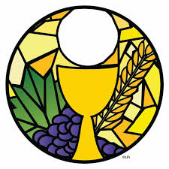
The Parish Priest, Father Graeme, delivers the Sacramental Programme which is based on ‘Family Catechesis’ - assisting parents in bringing their children up in the ways of the Catholic Faith. Through the different sessions the children explore and learn about different aspects of the Catholic Faith and the 3 sacraments of initiation after Baptism: Reconciliation (1st Confession) and Holy Eucharist (1st Communion).

Parents are the first and best teachers of their children in the ways of faith, as is made clear when the child is baptised.

Inclusion

As a school we ensure that all children and staff are treated fairly and equally. All children have equal rights to access all areas of the curriculum, regardless of race, gender and disability. Within this subject area, the SLT and all staff endeavour to provide the appropriate provision for this to occur.

Monitoring and Review

We are aware of the need to monitor the school’s Religious Education policy, and to review it regularly, so that we can take account of new initiatives and research, changes in the curriculum, developments in technology or changes to the physical environment of the school. We will therefore review this policy every year, or earlier if necessary. This policy was last updated in January 2025.

This policy was last updated on | January 2025
Discussed and agreed by Governing Body | February 2025
Formal Review of Policy | September 2025 ✓  September 2026 ✓  September 2027

