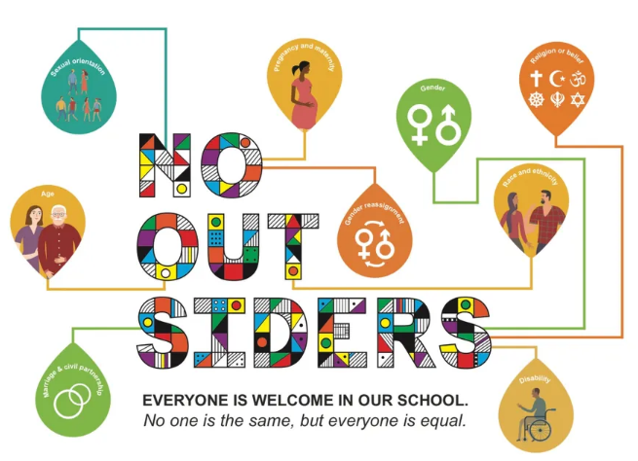

At St Oswald’s Catholic Primary School, we believe in the importance of equality and everybody having the same opportunities. This is modelled by our staff and taught through lessons and other experiences both discretely and explicitly. This is taught through the subjects of PSHE and RSE and links to other aspects of our curriculum. We enhance our PSHE and RSE curriculum, by including No Outsiders, which address many themes through picture books.

This scheme was created by Andrew Moffat MBE, who was nominated for the Global Teacher Prize in 2018-19.

**[Teaching children diversity and tolerance | Andrew Moffat, Birmingham | Global Teacher Prize - YouTube](https://www.youtube.com/watch?app=desktop&v=mDYkzWyfwJA&feature=youtu.be&cbrd=1)**

No Outsiders has three core values:

• Respect for diversity through education in schools;

• Commitment to community cohesion through understanding and acceptance of difference;

• Promotion of dialogue to counter fear and hate in society.

No Outsiders is a scheme that was introduced to our school in 2025-26 and it involves the use of age appropriate story books (see below for a list of the books we use) to teach about seven of the protected characteristics of the Equality Act 2010.

These include:

• age;

• disability;

• gender reassignment;

• race;

• religion or belief;

• gender;

• sexual orientation.

It is important we create a school culture in which children, staff and the whole school community work together to foster an environment of inclusivity through effective spiritual, moral, social and cultural (SMSC) and character education.

We believe that it is vital that our pupils can discuss inappropriate and discriminative language and understand how to address boundaries in order to prepare them for a future in modern Britain.

We strive to ensure that our pupils are surrounded by a consistent message:

• There are no outsiders here;

• Everyone is different;

• We like being different;

• We are all equal in our difference;

• I can get along with you even if we are different;

• We live in the U.K.; our British values support this and the law says this too.

We will work alongside our families, parents and carers to deliver this message of inclusivity. You are very welcome to call in to see your child’s class teacher to discuss this approach and to view the picture books we use for this.

At St Oswald’s Catholic Primary School, there are no outsiders. Everyone is welcome!

|  |  |  |  |  |  |
| --- | --- | --- | --- | --- | --- |
| No Outsiders- Cycle A | | | | | |
| EYFS | | | | | |
|  |  |  |  |  |  |
| I can choose what I like | It’s ok to like different things. | To say hello | All families are different | To celebrate my family | To make a new friend. |
| Year 1/2 | | | | | |
|  | A First Book to Build Confidence and ... |  |  | The Boy Who Loved Everyone | Bathe the Cat : McGinty, Alice B., Roberts, David: Amazon.co.uk: Books |
| I like the way I am. | To like myself. | To join in. | To ask for help. | To make you feel welcome. | To work together. |
| Year 3/4 | | | | | |
|  |  | The Truth About Old People: Amazon.co ... | I Am Nefertiti: Amazon.co.uk: Anang, Annemarie, Quek, Natelle:  9781912923311: Books | Matt Goodfellow, Yu Rong, Yu Rong ... | Aalfred and Aalbert: An Adorable and ... |
| To understand what discrimination means. | To find my wonder. | To recognise a stereotype. | To show respect. | To show welcoming behaviour. | To find common ground. |
| Year 5/6 | | | | | |
| The Girls by Lauren Ace, Jenny Løvlie ... | The Boys: Amazon.co.uk: Ace, Lauren ... | And Tango Makes Three : Richardson ... | My Shadow is Pink : Scott Stuart, Scott ... | Mixed: A Colorful Story : Chung, Arree ... | Milo Imagines The World: Amazon.co.uk ... |
| To explore friendship. | To check in with people. | To exchange dialogue and express and opinion. | To find self-acceptance. | To consider responses to racist behaviour. | To try not to judge by appearances. |

|  |  |  |  |  |  |  |  |  |  |  |  |  |
| --- | --- | --- | --- | --- | --- | --- | --- | --- | --- | --- | --- | --- |
| No Outsiders- Cycle B | | | | | | | | | | | | |
| EYFS | | | | | | | | | | | | |
|  |  | | |  | |  | | |  | |  | |
| I can choose what I like | It’s ok to like different things. | | | To say hello | | All families are different | | | To celebrate my family | | To make a new friend. | |
| Year 1/2 | | | | | | | | | | | | |
| Can I Join Your Club? : Kelly, John ... | | Splash by Claire Cashmore, Sharon Davey ... | | | Amazing: Amazon.co.uk: Antony, Steve ... | | How to be a Lion: Amazon.co.uk: Vere ... | | Is That Your Mama?: An empowering ... | | Naomi, Jones, James: Amazon.co.uk: Books | |
| To welcome different people. | | I know I can be what I want to be. | | | To consider what makes a good friend. | | To have self-confidence. | | To know all families look different. | | To know I fit in. | |
| Year 3/4 | | | | | | | | | | | | |
| Michael, Hall ... | | When Sadness Comes to Call: Eva Eland ... | | | Julian Is a Mermaid: The ground ... | | My Beautiful Voice: Amazon.co.uk ... | | Remixed: A Blended Family : Arree Chung ... | | My Brother George : Kelly Allen, Zoey ... | |
| To help someone be who they are. | | To look after my mental health. | | | To show acceptance. | | To speak up. | | To understand how families change. | | To consider how my language affects others. | |
| Year 5/6 | | | | | | | | | | | | |
| The Island : Armin Greder, Armin Greder ... | Introducing Teddy: A Gentle Story about ... | | The Proudest Blue: A Story of Hijab and ... | | | You Need to Chill: A sparklingly funny ... | | You're So Amazing! : Catchpole, James ... | | the Butterfly: A story about refugees ... | | Day In The Life Of Marlon Bundo | NSPCC ... |
| To consider the causes of racism. | To show acceptance and non-judgement. | | To consider how new experiences affect us. | | | To consider responses to change. | | To consider attitudes towards disability. | | To consider how experiences shape us. | | To consider how democracy works. |