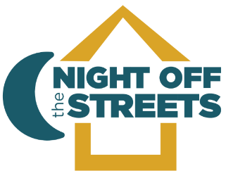
NOW HIRING
Center Manager for Night Off The Streets (NOTS)
The Center Manager oversees the daily operations of the organization, which includes: managing the operation of the warming center, building and maintaining strong community partnerships, overseeing data tracking and reporting, representing NOTS at community events and meetings and working with the Board of Directors to fulfill the NOTS mission of providing shelter, outreach and resources for individuals experiencing homelessness in Carson City.
Minimally qualified candidates will have experience working with a non-profit, and must possess a bachelor’s degree, a vehicle for transportation, and a valid driver’s license. Once hired, CPR and first aid certification must be acquired within the first 60 days of employment.
The ideal candidate will have strong presentation, writing, speaking, and interpersonal skills, including team building, problem solving and conflict resolution. Previous experience in grant management and working with unhoused and vulnerable populations is desirable but not required.
Salary range is $50,000 to $60,000 annually commensurate with qualifications and experience.
Submit resumes to nots.donor.relations@gmail.com by June 12, 2026.

