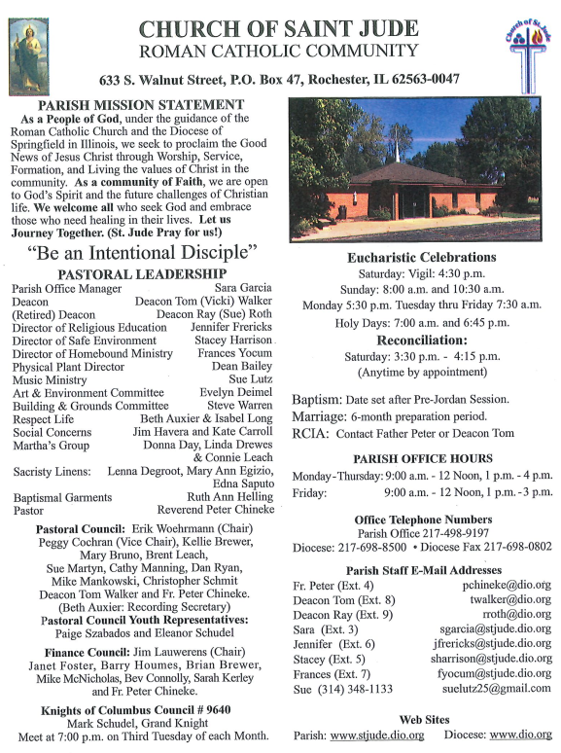

August 3rd, 2025
^{th} Sunday in Ordinary Time
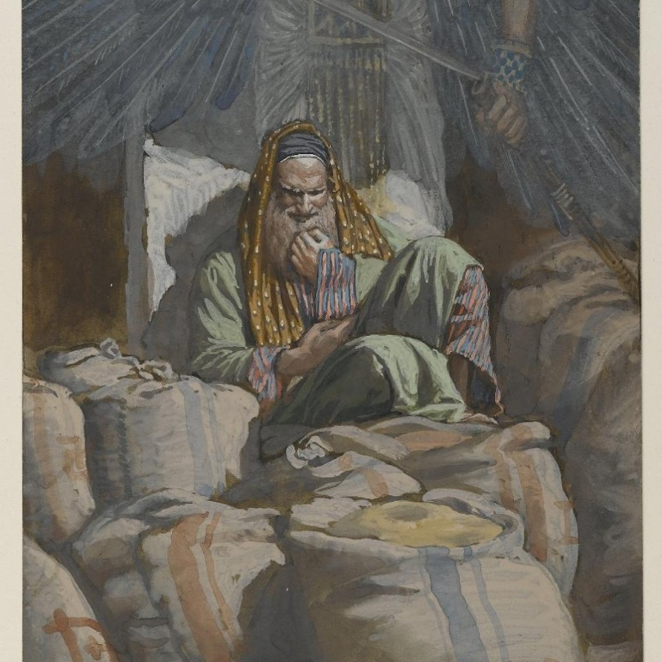

August 3, 2025
18th Sunday in Ordinary Time
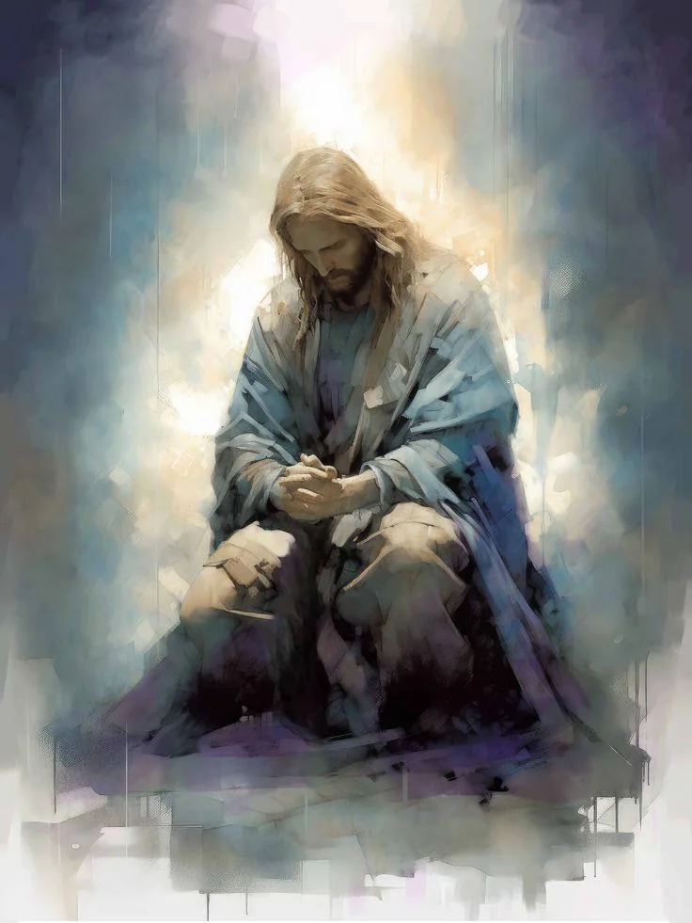
September 1st, 2025
22nd Sunday in Ordinary Time
Take My Yoke…...And Learn from Me.
Every Sunday or solemnity, the Church provides us with five different passages in the Bible to aid our liturgical worship in the Holy Eucharistic celebration. Some of them, we proclaim; others we chant. Sometimes, we either proclaim or chant all of them. These include: the First Reading(often from the Old Testament); the Responsorial Psalm (always from the book of Psalms); The Second Reading (usually from New Testament letters); the Gospel Acclamation (usually from the Gospels); and the Gospel (always from any of the four Gospels).This week, our Gospel Acclamation, is from the Gospel of Matthew 11:29 “Take my yoke upon you, says the Lord, and learn from me, for I am meek and humble of heart. “Christ’s invitation in Matthew 11:29 reaches into the heart of our struggles: “Take my yoke upon you… and you will find rest.” A yoke is not a promise of escape from burden, but of companionship in carrying it. In the light of the Cross, our suffering is transformed from meaningless weight into redemptive participation in Christ’s love. When we gaze upon the Cross, we see not defeat but victory through surrender. Jesus bore the crushing yoke of sin and suffering, yet in His gentleness and humility He reveals the mystery of God’s power: strength is perfected in weakness, and suffering becomes a path to salvation. Our wounds, when united with His, are no longer sources of despair but channels of grace. In our everyday life and experience, we see how this truth when lived out courageously, comforts the weary and afflicted. To the grieving, the sick, or those burdened with trials, Christ does not remove the cross but carries it with them. He sanctifies their suffering, teaching that in every pain endured with faith there lies hidden a seed of resurrection. The Cross whispers that we are never abandoned; in our darkest hours, Christ is yoked beside us, guiding with His meekness and humility.
May our sufferings be a participation in the Cross of Christ. Amen.

Fr. Peter

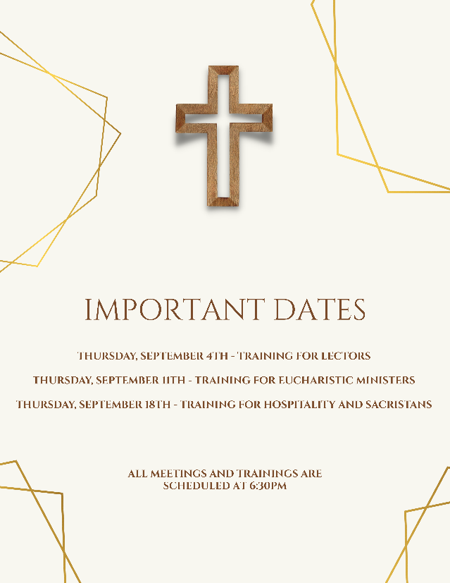
Please note that there will be no 8:00AM Mass celebrated on Sunday, September 22nd, 2025. If you have any questions regarding this information, please contact the Parish Office.
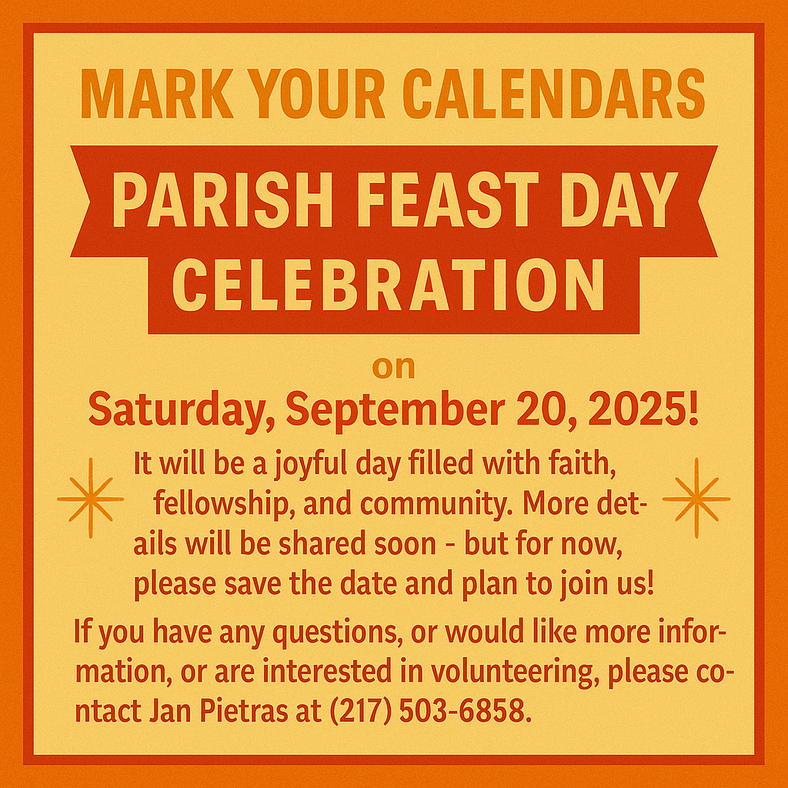

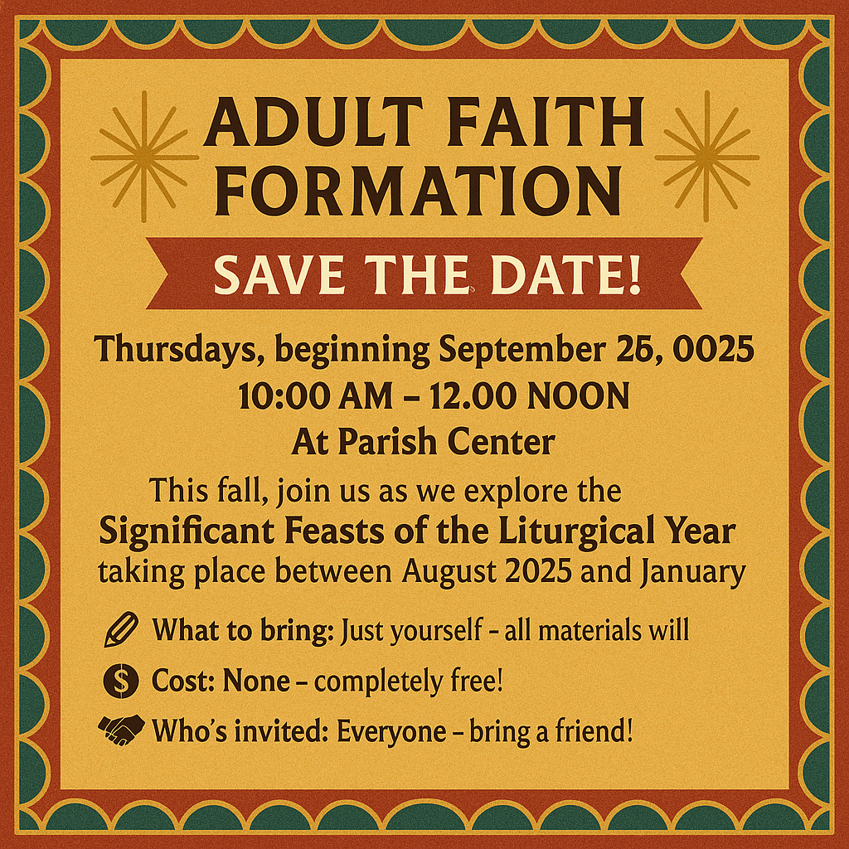
Women’s Catholic Convention
The SDCCW’s Catholic Women’s Convention will be held October 1st at St Paul’s in Highland, IL. All women are invited to attend! Deadline to register is September 14th. Last year, over 240 women from across the diocese attended Call SDCCW President Janet Zimmerman at 217-494-4743.

Men’s Leadership Summit
Our diocese has an exciting, educational, and inspirational experience for men. The Men’s Leadership Summit is Oct. 18 in Edwardsville and features John Edwards, a popular Catholic speaker and host of Just a Guy in a Pew. Email gortiz@dio.org for registration!

Join us after the 8:00 AM Mass for Coffee & Donut Fellowship on:
• Sunday, September 7
• Sunday, September 21
Come enjoy a sweet treat, hot coffee, and time together as a parish family. All are welcome!
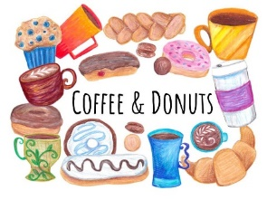

Catholic Faith and Science Series
Join us for this video series, where Fr. Robert J. Spitzer, S.J., Ph.D. walks us through the scientific evidence for God, philosophical proofs for God's existence, the historicity of Jesus' miracles and Resurrection, why an all-loving God would allow suffering, medical evidence for our transphysical soul, and more. This course will be facilitated by Fr. Brian Alford and is open to teens and adults.
Meeting twice monthly on Sundays, 6:15-7:30pm in the Cathedral atrium beginning September 28. The course is free, but a participant workbook will be sold for $10. Register by email to vcompton@cathedral.dio.org or by calling the

ATTENTION!

If you still have a baby bottle from the Baby Bottle Boomerang, please return them as soon as possible either to the Parish Office during business hours or at the back of church in the basket labelled “Baby Bottles”. These are the property of the Loving Arms Pregnancy Center in Taylorville, and they need these back to reuse for next year. Thank you

FAITH FORMATION UPDATES
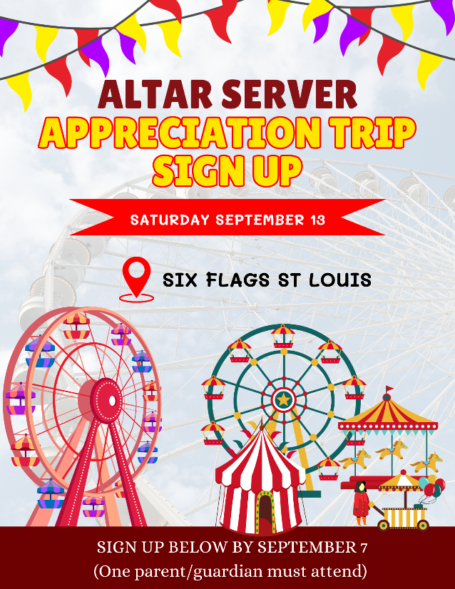
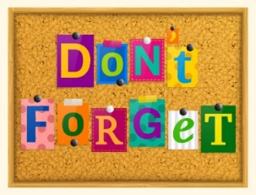
Don’t forget to register for PSR!
If you need the link for registration please contact Alicia Harney or look for the link on our parish Facebook account. Those who have not registered have been sent an email with the link as well!

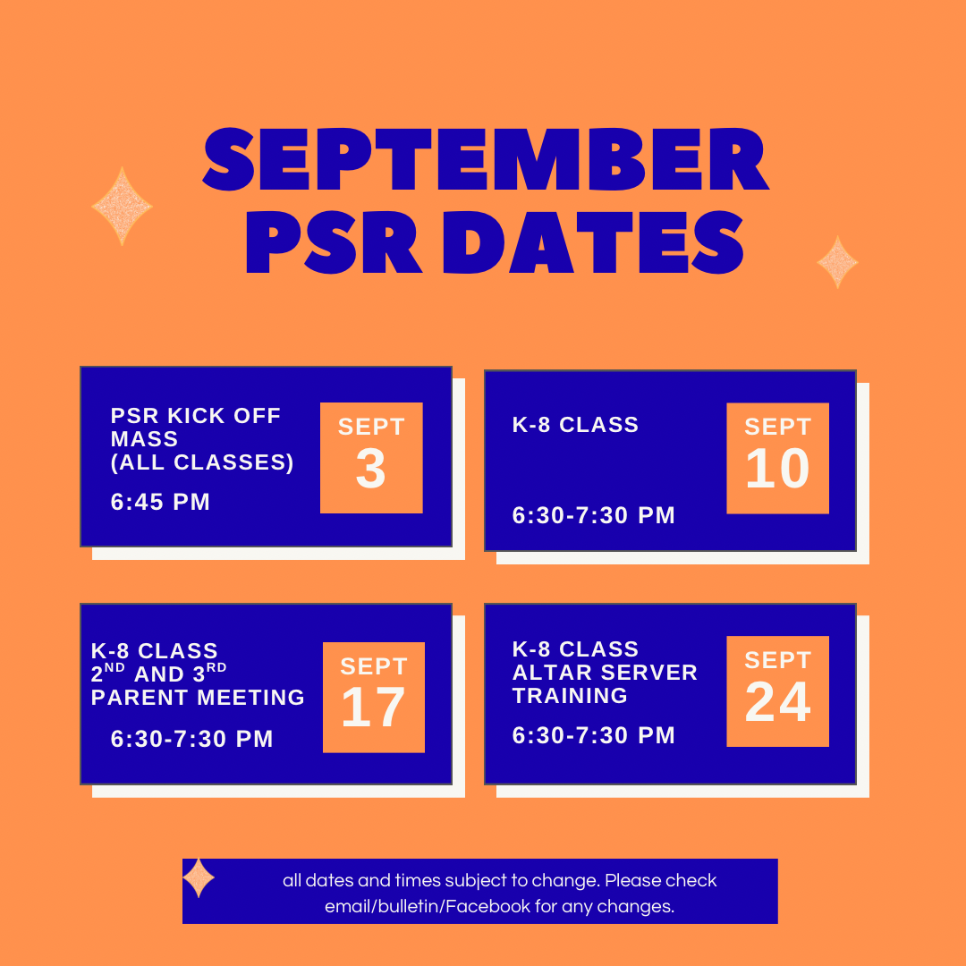

FAITH FORMATION UPDATES
Rochester Homecoming Parade
It’s a Great Day to Be A ROCKET!
This year's parade will be on Wednesday, October 8, 2025, at 5:30 pm. The theme this year is: "Blasting off with Rocket Pride: from Launchpad to Legacy" (Think outer space, astronauts, rocket fuel, aliens, stars/planets etc...)

St Jude’s will be putting a float in the parade this year!!!!

Planning for our float has just started. If you have any ideas for the float, please let Father Peter or Deacon Ray know. We will need people to ride on the float (and throw candy!!) We would love to have folks of every age – families with little ones, teens, grandparents, –There is a place for EVERYONE.
Go Rockets!!!!!!!!!!!!!!

Faith Formation Schedule
Aug. 27 HS Youth Group, 7-9pm

Sept. 3: PSR Begins, 6:30-7:30pm
HS Youth Group, 7-9pm
Sept. 10 PSR, 6:30-7:30pm
Sacrament Meeting for 2nd and 3rd grade Families during class.
HS Youth Group, 7-9pm
Sept. 17 PSR, 6:30-7:30pm
HS Youth Group, 7-9pm
Sept. 24 PSR, 6:30-7:30pm
HS Youth Group, 7-9pm

Mass Intentions & Times († indicates deceased)
Saturday, August 30th:
4:30 pm Mass (Int: The Britz Family)
Sunday, August 31st:
8:00 am Mass (Int: Bob Parnell†)
10:30 am Mass (Int: Isaac Weitekamp†)
Monday, September 1st:
5:30 pm Mass (Int: Dan Connolly†)
Tuesday, September 2nd:
7:15 am Mass (Int: Sharon Saner†)
Wednesday, September 3rd:
7:15 am Mass (Int: Douglas Cearley†)
Thursday, September 4th:
7:15am Mass (Int: Dan Connolly†)
Friday, September 5th:
7:15am Mass (Int: Delores Edwards†)
Saturday, September 6th:
4:30 pm Mass (Int: Harry Nickles†)
Sunday, September 7th:
8:00 am Mass (Int: Lynn Leach†)
10:30 am Mass (Int: Eldon & Marian Auxier†)

Sacrificial Giving, July 1, 2025 – June 30, 2026
September Volunteers: Week #1
Tuesday, September 2nd, Counting Day:
Team #1
Church Dusters:
Barb Scheufele & Mary Jo Duesterhaus
September Aluminum Cans Recycle:
Del Reeves
September St. Martin de Porres Food:
Jerry Calvert
Advertiser of the Week:
State Farm Insurance
Mike McNicholas
4341 Conestoga Drive,
Springfield, IL
(217) 726-6453, mikemcnicholas.com

Liturgy Schedule
Saturday, September 6th - 4:30 pm
Eucharistic Ministers: Fr. Peter, Dcn. Walker,
V. Walker, & B. Scheufele,
Lectors: B. Auxier and T. Bertrand
Servers: D. Sommer
Hospitality: K. Foster and D. & J. Kratz
Sacristans: NEEDED

Sunday, September 7th– 8:00 am
Eucharistic Ministers: Fr. Peter, Dcn. Roth, S. Roth, and D. Anderson
Lectors: K. Blumhorst and B. Connolly
Servers: B. Howard, R. & E. Strawkas
Hospitality: L. McWard, C. Vogt, and B. Yong
Sacristan: Z. Dahlkamp

Sunday, September 7th- 10:30 am
Eucharistic Ministers: Fr. Peter, S. Warren,
D. Kuntzman, and NEEDED
Lectors: A. Harney and L. Warren
Servers: S. Harney
Hospitality: D. Roark and NEEDED
Sacristan: H. Crusen
CLOW: Carolyn Pemberton

Documents of Vatican II, Continued
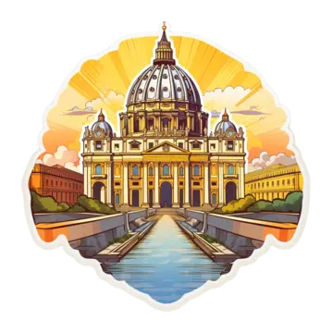
Mark your calendars for August 21,
September 18 and October 23 as Fathers Brian Alford and Daniel McGrath discuss the Pastoral Constitution on the Church in the Modern World!
Then on November 20 and December 11, they will cover the remaining documents of the Second Vatican Council.
All events are in the Cathedral Atrium @ 7:00pm

Spiritual Support for the Sick

Request the Sacrament of Anointing of the Sick for yourself or a loved one facing illness or surgery. The Sacrament may be administered privately or after any Mass. If you or a loved one is in the hospital, Father would like to know so it is possible for him to visit. Please call the Parish Office at (217) 498-9197 for the anointing and/or a hospital visit.

Eucharistic Ministers taking communion to Carriage Crossing & Rochester Estates at 9:15am Sundays

Frances Yocum is having a Communion Service at 2:30 pm on the 2nd Tuesdays at Rochester Estates.

It is a privilege to pray for those who are ill. In hopes of keeping our list current, parishioners and parishioners’ family and friends will be on the prayer list for 1 month unless the office is contacted to notify us that additional time is necessary. We are happy to keep people on the list as long as needed.

Please remember the elderly and homebound
of our parish in your daily prayer.
God bless them all, and ….

Pray for Parishioners – Leroy Bozarth, JoAnn Camille, Ann Carell, Carrie Downey, Herta Duban, Gary Dumonceaux, *Henry Gartner, Paul Harris, Jerry Jasinski, Betty Limper, Marilyn Merkley, Andrea Miller, Scott Moss, Suzanne Moss, Ginger Rentschler, Ray Roland, Rene Runions, Brittany and Steve Smith and family, Owen Smith and his family (Kristin, Paisley, and Adam), Frances Tomashavich, Bill & Laurie White, Patrick Witcik, Ehren Woehrmann, and Ron Wojcicki.

Pray for Family and Friends of Parishioners
Mary Aplington – sister of Beth Yong
John Aplington – brother of Beth Yong
Mary Barrow – sister of Leigh Ann Szabados
Carolyn Binion – friend of Paulette Dumonceaux
Gene Blade – friend of Pat Carlisle
Tamie Bottoms-Smith – cousin of Char Weitekamp
John Brunsman – father of Laura Horstman
Steven Butts - brother of Michelle Bullock
Suzanne Camp – friend of Beth Yong
Atticus Cassidy – cousin of Steve Decker
Leo Conway – father of Gary Conway
Judy Conway - friend of Maggie Patterson
Eddie Cook – friend of Lenna DeGroot family
Chris Crusen – brother of Tom Crusen
Linda Curtis – sister of Connie Leach
Bill Davis – friend of Donald & Lou Ellen Markovitch
Kelly Diaz – niece of Stan & Mary Jo Duesterhaus
Alison Donoho – friend of Jane and Harry Hendrickson
Leo J. Dougherty – brother-in-law of Frances Yocum
Sarah Egizio – daughter-in-law of Mary Ann Egizio
Frank Emerson- brother-in-law of Jean McDonald
Lynne (Auxier) Feece – sister-in-law of Beth Auxier
Cindy Frericks- mother-in-law of Jennifer Frericks
Ken Frericks- father-in-law of Jennifer Frericks
Jody Frese – sister-in-law of Barb Scheufele
Lauren Friedmeyer & her baby, Nellie – granddaughter & great granddaughter of Bill & Laurie White
Gary Garrison – brother-in-law of Kathleen Klee
Steven Godar - father of Dennis Godar
Jennifer Harbeck - cousin of Brad Zack
Brandon Harris – grandson of Les & LuAnn White
Chad Kunkle – friend of Pat & Steve Jones and Family
Jim Kirbach – friend of the Hendricksons
Carol Kirby – friend of Ginger Rentschler
Dale Laningham – friend of the Hendricksons
Glen Limper - son of Al & Betty Limper
Kristine Lundburg – sister of Mary Gartner
Rochelle Lynam – daughter of Tom & Helen Crusen
Robin Mahnken – friend of Jerry & Mary Jo Jasinski
Ann Martin – sister of Betty Downey
Mark Maxwell – brother-in-law of Beth Auxier
Paula McDonald- sister-in-law to Jean McDonald
Liz McKinney – friend of Roy & Cindy Collings
Donna Meyers - mother of Kellie Brewer
Wayne Michels – friend of Beth Auxier
Cindy Murdock – aunt of Leanne Collings
Fred J. Naffziger – brother of Michele Naffziger
Theresa Oldani – friend of Diane Bortmess, friend of
Kelly Conlon & Family
Margie Palmatier – friend of the Hendricksons
Ann Pardieck – family friend of Hartzel & Mary Bruno
Emily Parnell – daughter-in-law of Peggy Parnell
Father Zach Patibandla – friend of Emma & Phil
Van Dyke
Mike Patterson – father of Lori Farris
Mary Poeling – cousin of Maggie Patterson
Sabrina Rice – niece of Beth Auxier
Tom Ridley – nephew of Frances Yocum
Mark & Chris Riedle – family of Tess & David Riedle
Teresa Rouse – friend of Jane Molohon
Bud Saputo- brother of Vito and Edna Saputo
Joe Saputo – brother of Vito & Edna Saputo
Rose Serrano – sister of Emma Van Dyke
Special Intentions of Andy Mihelich
Special Intentions of Barb Scoggins
Special Intentions of Carol Mataya
Special Intentions of Steve & Pat Jones and Brian & Sherri Jones
Marlene Spurgeon – friend of Pat Carlisle
Russ Steil- father of Teresa O’Sullivan
Mary Stewart – friend of Suzanne Moss
Georgann Turner – sister of Kathleen Klee
Kathy Whitaker – friend of Peggy Parnell
Ron Wiggins – friend of Larry & Frances Yocum
Vicki Will – sister-in-law of Brian Sommer
Connie & Marc Wilson – niece and nephew of Ginger Rentschler

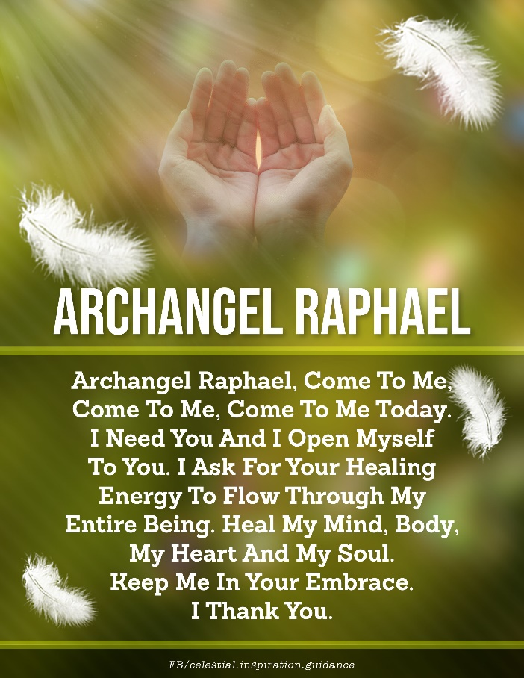

St. Augustine, Bishop of Hippo and Doctor of the Church
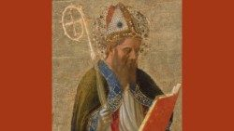
St. Augustine of Hippo, Bishop and Doctor of the Church, was an indefatigable truth-seeker. The author of hundreds of books, tracts, treatises and letters. He was born in Thagaste on November 13, AD 354, and died in the city of Hippo (present-day Annaba in Algeria), on August 28, AD 430.

