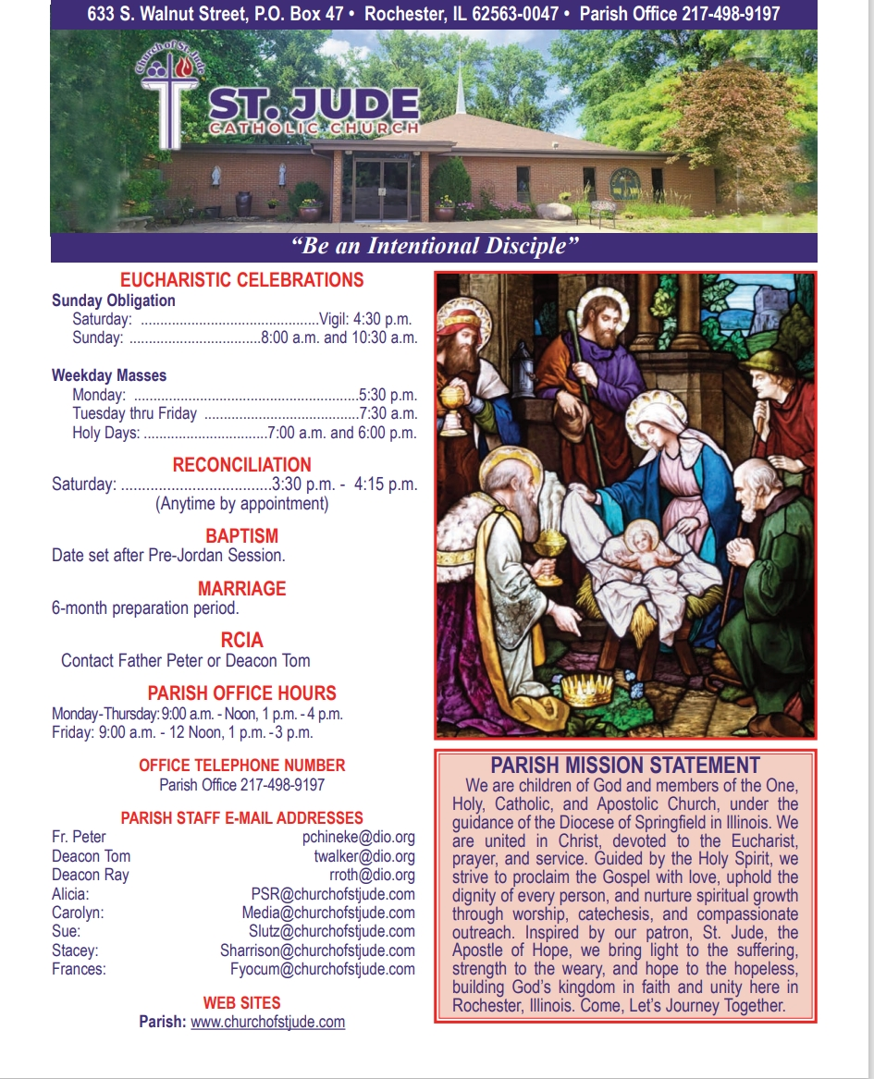

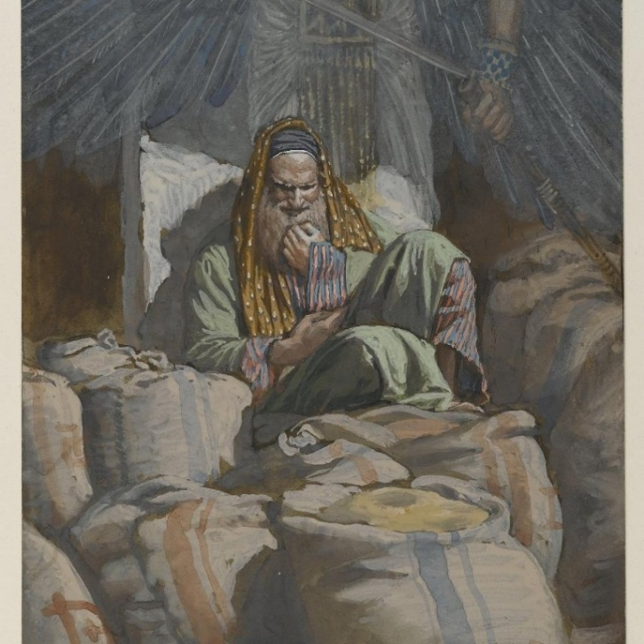
August 3rd, 2025
^{th} Sunday in Ordinary Time

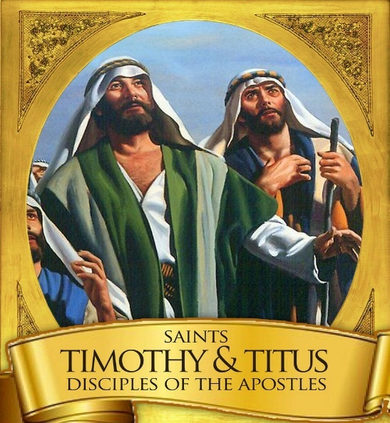
January 26th – Feast of Saints Timothy and Titus
Tomorrow, January 26th, is the feast of Saints Timothy and Titus – companions and faithful servants of Jesus Christ. They were not mere assistants, but true co-ministers – sons in the faith who shared the burdens of their master – St. Paul. They defended the truth and strengthened the early Christian communities. Their lives reveal the beauty of shared ministry rooted in humility, obedience, and love for Christ.
Timothy, though young and often hesitant, was entrusted with great responsibility. Paul urged him to persevere, to teach with courage, and to guard the sacred deposit of faith (Tim 6:20). Titus, practical and firm, was sent to troubled churches to restore unity and order. Both men accepted difficult missions not for personal honor, but out of fidelity to God and loyalty to the one who sent them.
Their relationship with Paul reflects the heart of ecclesial collaboration. They did not act independently or seek recognition; rather, they served in communion with their bishop-mentor. Their obedience was not blind submission, but a spiritual bond grounded in shared faith, prayer, and mission. Together, they formed one body serving Christ’s Church.
For today’s Catholics, especially priests, Timothy and Titus offer a powerful example. Just as they worked side by side with Paul, so priests are called to serve as co-ministers with their bishops. In a world that often values autonomy and self-promotion, their witness reminds us that authentic --ministry flows from communion, trust, and humble service.
They teach us that the Church grows when her servants labor together in unity, respecting roles while sharing one mission. Through their example, we learn that loyalty, perseverance, and faithfulness are not signs of weakness, but of deep spiritual strength.
May Timothy and Titus inspire all who serve the Church to walk faithfully with their shepherds, to labor with joy, and to proclaim Christ with courage, so that God’s people may be strengthened and His Kingdom made visible in our time.
Fr. Peter Chineke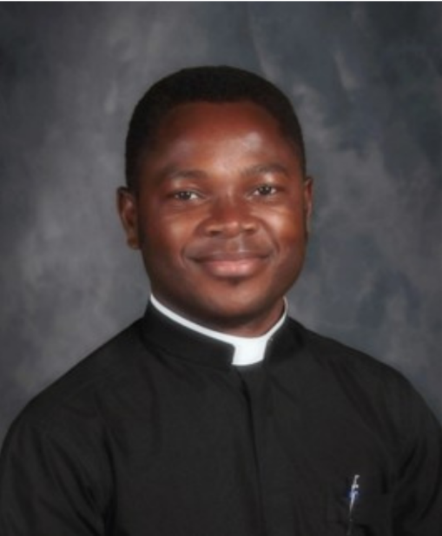
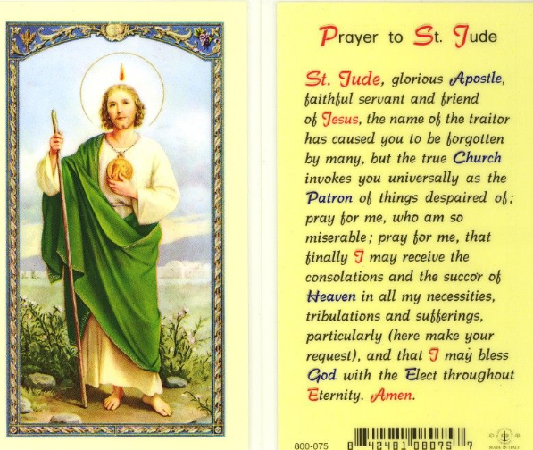


Our website will be undergoing general maintenance for the next few weeks. Just a heads-up as we prepare to start fresh for the New Year!
Lasagna Fundraiser – Take & Bake
Lasagnas ordered using the church order form may be picked up after any Mass on January 31 or February 1. Orders placed through individual participants will be delivered by that participant. Pricing:
• Large sausage, veggie, or cheese – $22
• Large sausage (gluten-free) – $25
• Small sausage, veggie, or cheese – $10
Thank you for supporting our teens!
Diocesan Victim Assistance Coordinator This is the liaison between the diocese and anyone with an allegation of sexual abuse of a minor. (217)-321-1155
Donut Sunday
Please join us for fellowship, donuts, fruit, juice, milk, and coffee on the following dates:
February 1st and February 15th
We look forward to seeing you!

Job Opening: Live Stream Mass Coordinator
St. Jude’s Catholic Church is seeking a reliable and detail-oriented individual to assist with live streaming weekend Masses. Responsibilities include setting up equipment, managing the live broadcast, and ensuring quality audio and video for our online parish community. Technical experience is helpful, but training will be provided.
If you are interested or would like more information, please contact the parish office.

ADULT FAITH FORMATION
During the six weeks of Lent, journey with us as we explore one of the greatest mysteries of the Christian Faith: the mystery of Jesus’ presence in the breaking of the bread. Our guide will be Dr. Grant Pitre, author of Jesus and the Jewish Roots of the Eucharist.
In our discussions, we will focus on three questions Dr. Pitre answers in his book.
What was the Passover like at the time of Jesus?
What was Jesus’ purpose in instituting the Eucharist at Passover?
What did Jesus mean when he said, “This is my body … This is my Blood”?
To assist us with planning, please sign up on the sheet, ADULT FAITH FORMATION, found in the foyer of the church OR contact Evelyn Deimel: 217.725.7339 or edeimel44@comcast.net.
We need your information by the 3rd of February so we can purchase the books and get them to you by 12 February. Our first session is the first Thursday after Ash Wednesday, 19th of February.
Thank you!

Mass Intentions & Times (†indicates deceased)
Saturday, January 24th
4:30pm Mass (Int: Evelyn Conboy †)
Sunday, January 25th
8:00am Mass (Int: Dan Connolly †)
10:30am Mass (Int: For the people)
Monday, January 26th
5:30pm Mass (Int: Brent Manning†)
Tuesday, January 27th
7:15am Mass (Int: Daniel Richmiller†)
Wednesday, January 28st
7:15am Mass (Int: Wilma Lewis†)
Thursday, January 29th
7:15am Mass (Int: David Crusen†)
Friday, January 30th
7:15am Mass (Int: Greg Park†)
Saturday, January 31st
4:30pm Mass (Int: Carrie Haney†)
Sunday, February 1st
8:00am Mass (Int: Trish Leach†)
Mass (Int: Virginia Chineke†)
______________________________________
January Volunteers: Week #4
Monday, January 26th Counting Day:
Team #4
Church Dusters:
Michelle Bertrand
January Aluminum Cans Recycle
Gleason Family
January St. Martin de Porres Food
Carlo Catalano
Rochester Estates – 4th Sunday of the Month
Eucharistic Minister: Barb Scheufele
Carriage Crossing – 2nd Sunday of the Month
Eucharistic Minister: Isabel Long

Next Week Schedule
LITURGY SCHEDULE
Saturday, January 31st at 4:30pm
Eucharistic Ministers: Fr. Peter, Dcn. Roth,
B. Scheufele, F. Yocum
Lectors: I. Long, E. Prather
Servers: A. and N. Horstman
Hospitality: J. Sponsler, L. Yocum, B. Auxier
Sacristan: Kay Foster
Sunday, February 1st at 8:00am
Eucharistic Ministers: Fr. Peter, Dcn. Walker,
L. DeGroot, D. Wuellner
Lectors: D. Kuntzman, B. Connollly
Servers: R. and E. Strawkas
Hospitality: Y. Brandis, C. Vogt, B. Yong
Sacristan: Zana Dahlkamp
Sunday, February 1st at 10:30am
Eucharistic Ministers: Fr. Peter, A. Harney,
D. Roark, S. Swaney
Lectors: M. Maynerich, C. Schmit
Servers: A., J. and M. Zucco, S. Harney
Hospitality: Brewer Family
Sacristan: Helen Crusen
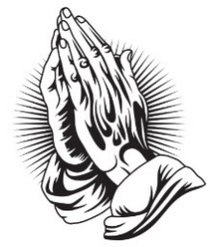
To keep our prayer list current, names will be removed after 30 days. Please contact the office if you would like a name to remain on the list or be removed sooner.
SDCCW

“Heaven Meets Earth: A Journey through the Holy Mass” held February 24-25 at Villa Maria Conference Center on Lake Springfield. Led by retreat director Sr. Margaret Schreiber, OP, PhD. This retreat offers spiritual presentations, prayer, Holy mass, confession, fellowship, and time for quiet reflection.

Registation forms with cost and further information are available at the parish office or at dio.org/events.
Deadline to register is February 14th. For more information contact
Mary Ann Sullivan at (217)-822-1928
Janet Zimmerman at (217)-494-4743
Spiritual Support for the Sick
Request the Sacrament of Anointing of the Sick for yourself or a loved one facing illness or surgery. The Sacrament may be administered privately or after any Mass. If you or a loved one is in the hospital, Father would like to know so it is possible for him to visit. Please call the Parish Office at (217) 498-9197 for the anointing and/or a hospital visit.

Eucharistic Ministers taking communion to Carriage Crossing & Rochester Estates at 9:15am Sundays Frances Yocum is having a Communion Service at 2:30 pm on the 2nd Tuesdays at Rochester Estate
It is a privilege to pray for those who are ill. In hopes of keeping our list current, parishioners and parishioners’ family and friends will be on the prayer list for 1 month unless the office is contacted to notify us that additional time is necessary. We are happy to keep people on the list as long as needed.

Please remember the elderly and homebound
of our parish in your daily prayer.
God bless them all, and ….

Pray for Parishioners – Leroy Bozarth, JoAnn Camille, Ann Carell, Morgan Culbertson, Carrie Downey, Herta Duban, Gary Dumonceaux, Kaitlyn Galman, Henry Gartner, Noah Harney, Paul Harris, Jerry Jasinski, Marilyn Merkley, Andrea Miller, Scott Moss, Suzanne Moss, Ginger Rentschler, Ray Roland, Rene Runions, Brittany and Steve Smith and family, Owen Smith and his family (Kristin, Paisley, and Adam), Frances Tomashavich, Bill & Laurie White, Jill Whitney, Ehren Woehrmann

Pray for Family and Friends of Parishioners
Mary Aplington – sister of Beth Yong
John Aplington – brother of Beth Yong
Mary Barrow – sister of Leigh Ann Szabados
Carolyn Binion – friend of Paulette Dumonceaux
Tamie Bottoms-Smith – cousin of Char Weitekamp
John Brunsman – father of Laura Horstman
Steven Butts - brother of Michelle Bullock
Atticus Cassidy – cousin of Steve Decker
Leo Conway – father of Gary Conway
Eddie Cook – friend of Lenna DeGroot family
Chris Crusen – brother of Tom Crusen
Linda Curtis – sister of Connie Leach
Bill Davis – friend of Donald & Lou Ellen Markovitch
Kelly Diaz – niece of Stan & Mary Jo Duesterhaus
Leo J. Dougherty – brother-in-law of Frances Yocum
Sarah Egizio – daughter-in-law of Mary Ann Egizio
Frank Emerson- brother-in-law of Jean McDonald
Jason & Molly Everitt & Family – nephew & niece of Lenna DeGroot
Lynne (Auxier) Feece – sister-in-law of Beth Auxier
Carole Fulcher - friend of Pat Carlisle
Cindy Frericks- mother-in-law of Jennifer Frericks
Ken Frericks- father-in-law of Jennifer Frericks
Lauren Friedmeyer & her baby, Nellie – granddaughter & great granddaughter of Bill & Laurie White
Jennifer Harbeck - cousin of Brad Zack
Brandon Harris – grandson of Les & LuAnn White
Oaklynn Harrison – granddaughter of Stacey Harrison
Chad Kunkle – friend of Pat & Steve Jones and Family
Jim Kirbach – friend of the Hendricksons
Carol Kirby – friend of Ginger Rentschler
Kristine Lundburg – sister of Mary Gartner
Rochelle Lynam – daughter of Tom & Helen Crusen
Robin Mahnken – friend of Jerry & Mary Jo Jasinski
Ann Martin – sister of Betty Downey
Paula McDonald- sister-in-law to Jean McDonald
Merdith Messett – friend of Marie Ginter
Donna Meyers - mother of Kellie Brewer
Wayne Michels – friend of Beth Auxier
Cindy Murdock – aunt of Leanne Collings
Fred J. Naffziger – brother of Michele Naffziger
Theresa Oldani – friend of Diane Bortmess, friend of
Kelly Conlon & Family
Claudia Oller – Mary Bruno
Margie Palmatier – friend of the Hendricksons
Emily Parnell – daughter-in-law of Peggy Parnell
Father Zach Patibandla – our 2025 summer priest
Mike Patterson – father of Lori Farris
Mary Poeling – cousin of Maggie Patterson
Sabrina Rice – niece of Beth Auxier
Tom Ridley – nephew of Frances Yocum
Mark & Chris Riedle – family of Tess & David Riedle
Teresa Rouse – friend of Jane Molohon
*Joe Rupnick – friend of Hartzel & Mary Bruno
Bud Saputo- brother of Vito and Edna Saputo
Joe Saputo – brother of Vito & Edna Saputo
Special Intentions of Andy Mihelich
Special Intentions of Barb Scoggins
Special Intentions of Carol Mataya
Special Intentions of Steve & Pat Jones and Brian & Sherri Jones
Marlene Spurgeon – friend of Pat Carlisle
Russ Steil- father of Teresa O’Sullivan
Mary Stewart – friend of Suzanne Moss
Ron & Kim Thompson – friends of Emma Van Dyke
Cindy Usher – friend of Mary Bruno
Judy Waidman – aunt of Jim and Christina Lauwerens
Kathy Whitaker – friend of Peggy Parnell
Vicki Will – sister-in-law of Brian Sommer
Connie & Marc Wilson – niece and nephew of Ginger Rentschler
Sharon White- Laurie White Sister
Lorine Wallin-Friend of Helling Family
Tommy Regan- Friend of Frances Yocum
The Schieferdecker family and Grant - cousins of Jim and Barb Scheufele
Jody Frese - sister - in - law of Barb and Jim Scheufele
Richard Yong-Beth Yong

Burning of Palms for Ash Wednesday
As we prepare for the holy season of Lent, we invite parishioners to bring in the blessed palms from last year’s Palm Sunday Masses. These blessed palms will be burnt for the ashes used on Ash Wednesday. Please place your palms in the designated basket at the entrance of the Church.
We will be burning the palms on Tuesday Feb 17th. Please watch the bulletin for further information about The Burning of Palms Rite.



Diocese of Springfield, IL – Care Manager
Do you have a healthcare background? Do you love your Catholic faith and have a desire to help priests set and meet healthy living goals? Our diocese is seeking applications for a unique, mission-driven position dedicated to providing essential healthcare navigation and support for our clergy. This role does not require hands-on clinical care. Please submit your resume to REC@metacareusa.com

For more information, scan QR code

PSR January At a Glance
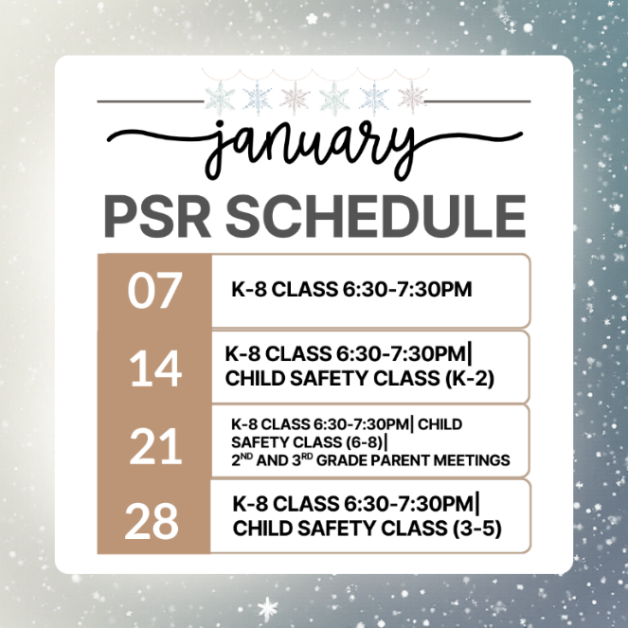

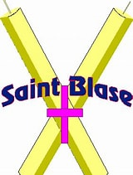
FEAST OF ST BLAISE FEBRUARY 3, 2026
BLESSING OF THE THROATS AT 7:15 am DAILY MASS
St Blaise, was a physician and bishop in the early Church, believed to have lived in the 3rd century. He dedicated his life to serving both the physical and spiritual needs of his community.
Saint Blaise is widely venerated as the patron saint of throat ailments, thanks to a legendary event where he miraculously cured a boy choking on a fishbone.

