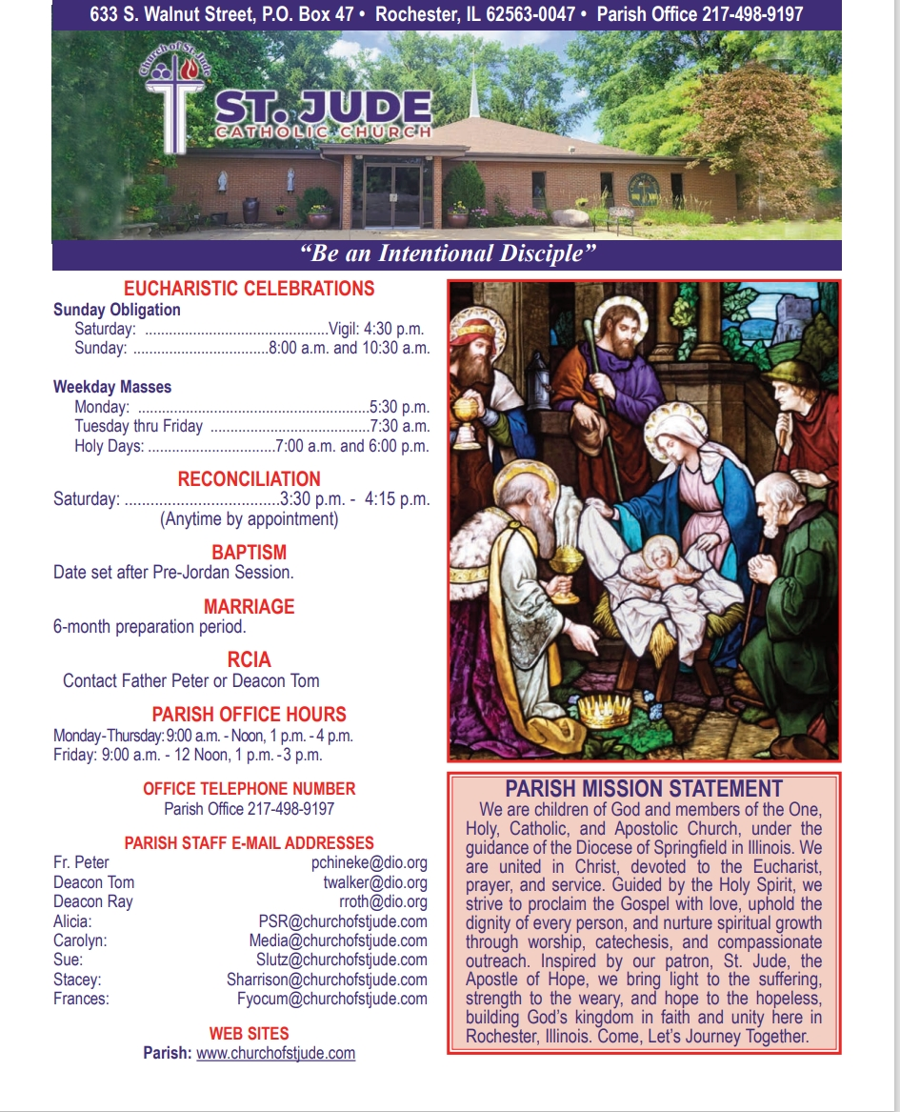

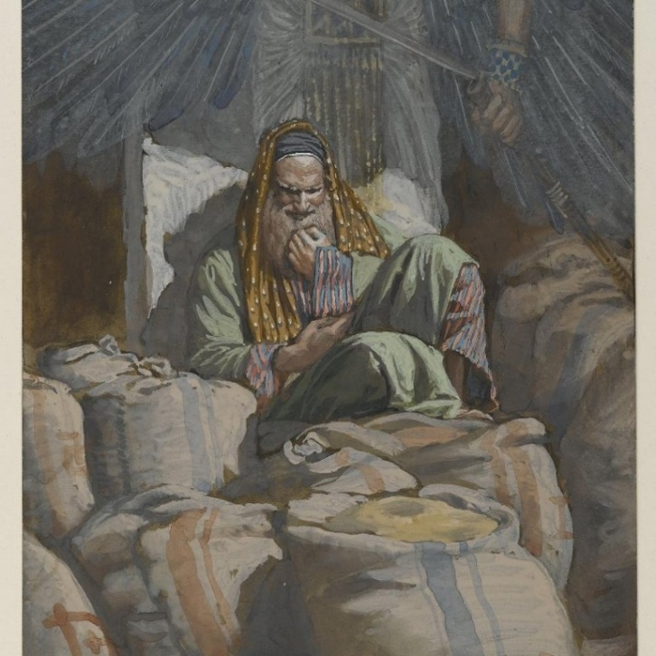
August 3rd, 2025
^{th} Sunday in Ordinary Time

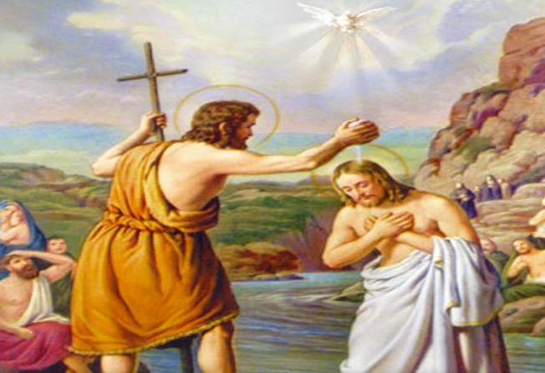
Sunday January 18th, 2026
"You are my servant, Israel, in whom I will be glorified" (Is 49:3)
God's tender affirmation to His chosen Servant resonates through salvation history, first addressed to Israel, then fulfilled in Christ, and extended to the Church as the new Israel. In the Servant Songs, this divine proclamation forms a people for divine glory amid the shadows of exile, which prefigures the obedient passion of Jesus through which the glory of God shines even brighter.
As Christians, we are baptized into the death and resurrection of our Lord Jesus Christ. We also inherit the identity of being called "the Israel of God" (Gal 6:16) as a Church. St. Paul went further to declare that as the “Israel of God” (the Church), we are grafted onto the olive tree of ancient promise (Rom 11:17-24). We are no ethnic substitute but spiritual heirs, called to embody servanthood that glorifies the Father. As Pope John Paul II taught, the Servant's mission – light to nations – becomes ours through fidelity to the Gospel.
In today's world, this demands a life of humble service that reflects the glory of God. In the midst of the radical individualism and injustice in today’s world, Christians must reject self-glorification, embracing the cross as servants by forgiving our enemies and those who hate us, serving the poor, and bearing witness to the truth in workplaces and at home. When trials in the human condition obscure the very purpose of our existence as children of God and lights of the world, we must endeavor to remember the word of God in Isaiah 49:8 – “I will help you.” As individuals, families, and communities, it is our obligation to be the epiphanies of glory, evangelizing the peoples in the margins and peripheries of the world.
“You are my servant, Israel, in whom I will be glorified” is God’s prophetic declaration concerning the life of every baptized Christian as a member of the Church. He wants to be glorified in our lives – a glorification that happens when we live holy, healthy, and happy lives that draw others to Christ. As we continue with our New Year's resolutions, may our lives be a shining light, illuminating the paths of the people around us. Amen.
Fr. Peter Chineke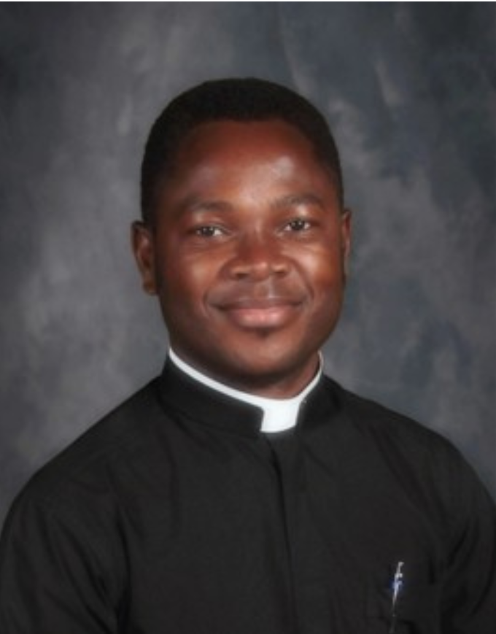

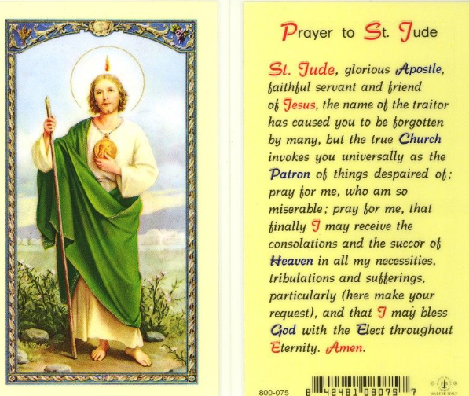


Our website will be undergoing general maintenance for the next few weeks. Just a heads-up as we prepare to start fresh for the New Year!
Lasagna Fundraiser – Take & Bake
The teens going on the Catholic Heart Work Camp mission trip are teaming up with the teens going on the Rome Pilgrimage for the annual Take & Bake Lasagna Fundraiser. Orders may be placed in one of three ways:
• Directly from a participating teen
• Using the order form at the back of church
• By contacting Kay Foster at 217-494-2984Orders will be accepted through Friday, January 23. Lasagnas ordered using the church order form may be picked up after any Mass on January 31 or February 1. Orders placed through individual participants will be delivered by that participant. Pricing:
• Large sausage, veggie, or cheese – $22
• Large sausage (gluten-free) – $25
• Small sausage, veggie, or cheese – $10
Thank you for supporting our teens!

Donut Sunday
Please join us for fellowship, donuts, fruit, juice, milk, and coffee on the following dates:
January 18th, February 1st, and February 15th.
We look forward to seeing you!

Job Opening: Live Stream Mass Coordinator
St. Jude’s Catholic Church is seeking a reliable and detail-oriented individual to assist with live streaming weekend Masses. Responsibilities include setting up equipment, managing the live broadcast, and ensuring quality audio and video for our online parish community. Technical experience is helpful, but training will be provided.
If you are interested or would like more information, please contact the parish office.
Intentional Discipleship
On the weekend of January 24th and 25th we will be recognizing those in our community who have answered the call to Intentional Discipleship by serving as Extraordinary Ministers of Holy Communion. We have received the Bishop’s mandate that allows these individuals to assist in the distribution of Holy Communion at Mass and to take Holy Communion to the sick and shut ins of our parish. These individuals will be commissioned at each of the Masses that weekend.
Those individuals who answered the call to Intentional Discipleship by serving in the ministries of Hospitality, Lectors and Sacristans will be recognized and blessed at each of the Masses that same weekend.
Each of these individuals is a great blessing to our parish family. It is with great joy that our parish family celebrates their Commissioning or Blessing with them.

Mass Intentions & Times (†indicates deceased)
Saturday, January 17th
4:30pm Mass (Int: Delbert Collings† & Carolyn Carmichael †)
Sunday, January 18th
8:00am Mass (Int: Deceased members of Helling Family†)
10:30am Mass (Int: For the People)
Monday, January 19th
5:30pm Mass (Int: Dan Connolly†)
Tuesday, January 20^{h}
7:15am Mass (Int: Greg Park†)
Wednesday, January 21st
7:15am Mass (Int: Dan Connolly†)
Thursday, January 22nd
7:15am Mass (Int: JoAnn Camille) – 90th birthday
Friday, January 23rd
7:15am Mass (Int: Wilma Lewis)
Saturday, January 24th
4:30pm Mass (Int: Evelyn Conboy†)
Sunday, January 25th
8:00am Mass (Int: Dan Connolly†)
10:30am Mass (Int: For the People)
Monday, January 26th
5:30pm Mass (Int: Brent Manning†)
Thursday, January 29th
7:15am Mass (Int: David Crusen†)
______________________________________
January Volunteers: Week #3
Monday, January 19th Counting Day:
Team #3
Church Dusters:
Donna Day
January Aluminum Cans Recycle
Gleason Family
January St. Martin de Porres Food
Carlo Catalano
Rochester Estates – 3rd Sunday of the Month
Eucharistic Minister: Zana Dahlmkamp
Carriage Crossing – 3rdSunday of the Month
Eucharistic Minister: Christopher Schmit
Diocesan Victim Assistance Coordinator This is the liaison between the diocese and anyone with an allegation of sexual abuse of a minor. (217)-321-1155

Next Week Schedule
LITURGY SCHEDULE
Saturday, January 24th at 4:30pm
Eucharistic Ministers: Fr. Peter, Dcn. Walker,
V. Walker, M. Mankowski
Lectors: B. Auxier, D. Day
Servers: Douglas Sommer
Hospitality: J. Sponslor, L. & F. Yocum
Sacristan: Isabel Long
Sunday, January 25th at 8:00am
Eucharistic Ministers: Fr. Peter, Dcn. Roth, B. Connolly, Z. Dahlkamp
Lectors: J. & H. Hendrickson
Servers: B. Howard, R. Roth
Hospitality: D. & L. Wuellner, C. Vogt
Sacristan: Dcn. Roth
Sunday, January 25th at 10:30am
Eucharistic Ministers: Fr. Peter, S. Warren, S. Kerley, C. Manning
Lectors: L. Warren, M. Schudel
Servers: N. & R. Houmes, L. Batten, L. Schudel
Hospitality: D. Roark, S. & D. Decker
Sacristan: Helen Crusan
St. Jude’s welcomes visiting priests to celebrate Mass. We appreciate their generosity and support of our parish family and invite you to warmly welcome them and introduce yourself.
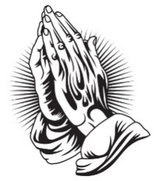
To keep our prayer list current, names will be removed after 30 days. Please contact the office if you would like a name to remain on the list or be removed sooner.

Spiritual Support for the Sick
Request the Sacrament of Anointing of the Sick for yourself or a loved one facing illness or surgery. The Sacrament may be administered privately or after any Mass. If you or a loved one is in the hospital, Father would like to know so it is possible for him to visit. Please call the Parish Office at (217) 498-9197 for the anointing and/or a hospital visit.
Eucharistic Ministers taking communion to Carriage Crossing & Rochester Estates at 9:15am Sundays Frances Yocum is having a Communion Service at 2:30 pm on the 2nd Tuesdays at Rochester Estate

It is a privilege to pray for those who are ill. In hopes of keeping our list current, parishioners and parishioners’ family and friends will be on the prayer list for 1 month unless the office is contacted to notify us that additional time is necessary. We are happy to keep people on the list as long as needed.

Please remember the elderly and homebound
of our parish in your daily prayer.
God bless them all, and ….

Pray for Parishioners – Leroy Bozarth, JoAnn Camille, Ann Carell, Morgan Culbertson, Carrie Downey, Herta Duban, Gary Dumonceaux, Kaitlyn Galman, Henry Gartner, Noah Harney, Paul Harris, Jerry Jasinski, Marilyn Merkley, Andrea Miller, Scott Moss, Suzanne Moss, Ginger Rentschler, Ray Roland, Rene Runions, Brittany and Steve Smith and family, Owen Smith and his family (Kristin, Paisley, and Adam), Frances Tomashavich, Bill & Laurie White, *Jill Whitney, Patrick Witcik, and Ehren Woehrmann

Pray for Family and Friends of Parishioners
Mary Aplington – sister of Beth Yong
John Aplington – brother of Beth Yong
Mary Barrow – sister of Leigh Ann Szabados
Carolyn Binion – friend of Paulette Dumonceaux
Tamie Bottoms-Smith – cousin of Char Weitekamp
John Brunsman – father of Laura Horstman
Steven Butts - brother of Michelle Bullock
Atticus Cassidy – cousin of Steve Decker
Leo Conway – father of Gary Conway
Eddie Cook – friend of Lenna DeGroot family
Chris Crusen – brother of Tom Crusen
Linda Curtis – sister of Connie Leach
Bill Davis – friend of Donald & Lou Ellen Markovitch
Kelly Diaz – niece of Stan & Mary Jo Duesterhaus
Leo J. Dougherty – brother-in-law of Frances Yocum
Sarah Egizio – daughter-in-law of Mary Ann Egizio
Frank Emerson- brother-in-law of Jean McDonald
Jason & Molly Everitt & Family – nephew & niece of Lenna DeGroot
Lynne (Auxier) Feece – sister-in-law of Beth Auxier
Carole Fulcher - friend of Pat Carlisle
Cindy Frericks- mother-in-law of Jennifer Frericks
Ken Frericks- father-in-law of Jennifer Frericks
Lauren Friedmeyer & her baby, Nellie – granddaughter & great granddaughter of Bill & Laurie White
Jennifer Harbeck - cousin of Brad Zack
Brandon Harris – grandson of Les & LuAnn White
Oaklynn Harrison – granddaughter of Stacey Harrison
Chad Kunkle – friend of Pat & Steve Jones and Family
Jim Kirbach – friend of the Hendricksons
Carol Kirby – friend of Ginger Rentschler
Kristine Lundburg – sister of Mary Gartner
Rochelle Lynam – daughter of Tom & Helen Crusen
Robin Mahnken – friend of Jerry & Mary Jo Jasinski
Ann Martin – sister of Betty Downey
Paula McDonald- sister-in-law to Jean McDonald
Liz McKinney – friend of Roy & Cindy Collings
Merdith Messett – friend of Marie Ginter
Donna Meyers - mother of Kellie Brewer
Wayne Michels – friend of Beth Auxier
Cindy Murdock – aunt of Leanne Collings
Fred J. Naffziger – brother of Michele Naffziger
Theresa Oldani – friend of Diane Bortmess, friend of
Kelly Conlon & Family
Claudia Oller – Mary Bruno
Margie Palmatier – friend of the Hendricksons
Emily Parnell – daughter-in-law of Peggy Parnell
Father Zach Patibandla – our 2025 summer priest
Mike Patterson – father of Lori Farris
Mary Poeling – cousin of Maggie Patterson
Sabrina Rice – niece of Beth Auxier
Tom Ridley – nephew of Frances Yocum
Mark & Chris Riedle – family of Tess & David Riedle
Teresa Rouse – friend of Jane Molohon
*Joe Rupnick – friend of Hartzel & Mary Bruno
Bud Saputo- brother of Vito and Edna Saputo
Joe Saputo – brother of Vito & Edna Saputo
Special Intentions of Andy Mihelich
Special Intentions of Barb Scoggins
Special Intentions of Carol Mataya
Special Intentions of Steve & Pat Jones and Brian & Sherri Jones
Marlene Spurgeon – friend of Pat Carlisle
Russ Steil- father of Teresa O’Sullivan
Mary Stewart – friend of Suzanne Moss
Ron & Kim Thompson – friends of Emma Van Dyke
Cindy Usher – friend of Mary Bruno
Judy Waidman – aunt of Jim and Christina Lauwerens
Kathy Whitaker – friend of Peggy Parnell
Vicki Will – sister-in-law of Brian Sommer
Connie & Marc Wilson – niece and nephew of Ginger Rentschler
Sharon White- Laurie White Sister
Lorine Wallin-Friend of Helling Family
Tommy Regan- Friend of Frances Yocum
The Schieferdecker family and Grant - cousins of Jim and Barb Scheufele
Jody Frese - sister - in - law of Barb and Jim Scheufele
Richard Yong-Beth Yong

Burning of Palms for Ash Wednesday
As we prepare for the holy season of Lent, we invite parishioners to bring in the blessed palms from last year’s Palm Sunday Masses. These blessed palms will be burnt for the ashes used on Ash Wednesday. Please place your palms in the designated basket at the entrance of the Church.
We will be burning the palms on Tuesday Feb 17th. Please watch the bulletin for further information about The Burning of Palms Rite.



Diocese of Springfield, IL – Care Manager
Do you have a healthcare background? Do you love your Catholic faith and have a desire to help priests set and meet healthy living goals? Our diocese is seeking applications for a unique, mission-driven position dedicated to providing essential healthcare navigation and support for our clergy. This role does not require hands-on clinical care. Please submit your resume to REC@metacareusa.com
For more information, scan QR code:


PSR January At a Glance
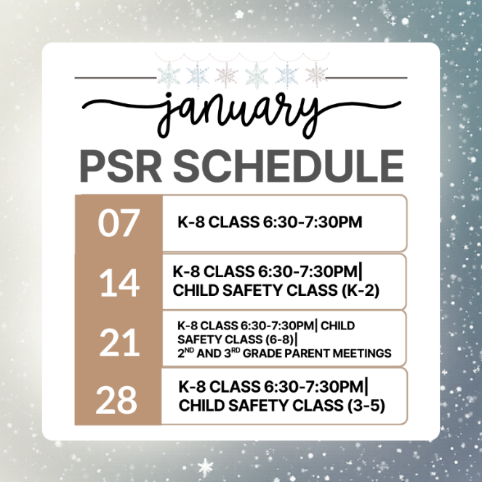

Ordinary Time
Have you ever wondered what Ordinary Time is? Even though it does not have big celebrations like Christmas or Easter, it is such an important part of the Church year. Ordinary Time is about learning from Jesus’ life, His teachings, and the ways He showed love and care for others.
The word “ordinary” might sound boring, but it actually means “counted in order”. Each week is numbered, like the 1st Sunday, 2nd Sunday, and so on. These weeks give us time to reflect on how Jesus lived and how we can follow His example in our everyday lives.
During Ordinary Time, the Church’s color is green, a color that reminds us of growth. Just like plants grow little by little, our faith grows when we pray, show kindness, and help others. Even simple things such as helping a sibling, sharing a smile, or saying a prayer for someone are ways we can grow closer to Jesus during this season.
In the Gospel, John the Baptist points to Jesus and says, “Look! This is God’s Lamb who takes away the sins of the world.” Jesus is God’s Son, sent to show us love, forgiveness, that Jesus is with us every day and that following Him helps us grow in faith.
Families can make Ordinary Time fun too. You can talk about one way each of you can “grow in faith” this week or read a story about Jesus’ life together.
So while it might seem “ordinary,” this season is really extraordinary because it gives us time to practice living like Jesus every day. – Alicia Harney

