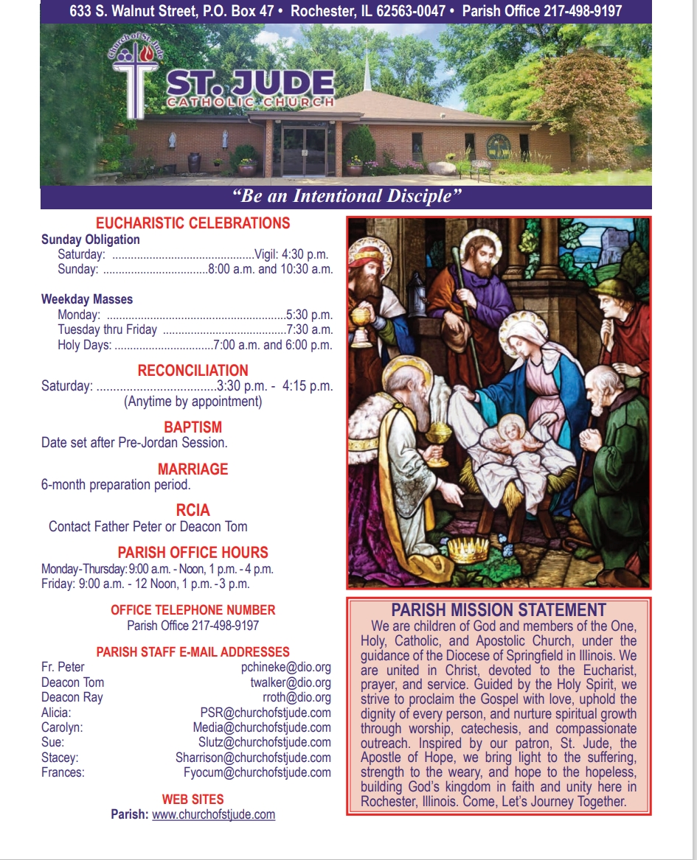

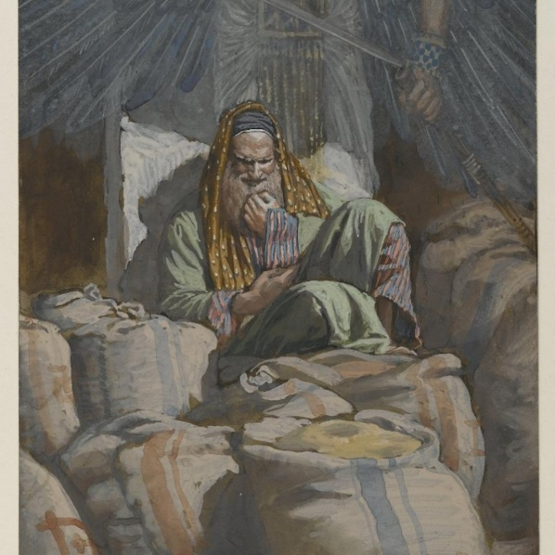
August 3rd, 2025
^{th} Sunday in Ordinary Time

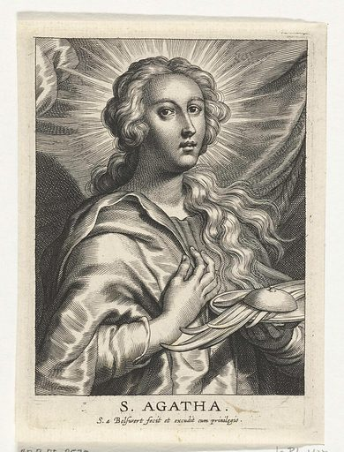

February 1st – The Feast Day of St. Agatha
There are so many myths about patron saints and who could be someone’s patron saint. A seventh grader once asked me about my patron saint; I mentioned St. Agatha as one of them. Then she wondered why a female saint would be my patron saint. She has always believed that female saints are for females and male saints are for males. I was glad I took that opportunity to teach the whole class about the saints. One of the things I taught them was that male or female, anyone can choose any saint as their patron.
Why St. Agatha? One of the most decisive moments in the history of my vocation was February 5, 2010. I visited my cousin, Father Ugonna Mbonu. That evening, I attended the daily Mass where he preached so passionately about St. Agatha. The story of her gentle yet unshakable fidelity to Christ sparked some mysterious desire for holiness that I started praying to St. Agatha for the same faith and love for Christ. During that period, my desire for priesthood got more intense so much that I finally entered the seminary later that fall.
St. Agatha stands before the Church as a radiant witness to faith, purity, and courageous love for Christ. A young woman of noble heart, she chose fidelity to God over comfort, power, and even life itself. In the face of brutal persecution, Agatha’s strength did not come from human resolve alone, but from her deep union with Christ, whom she loved above all things. Her suffering, though severe, became a testimony that no earthly force can extinguish the dignity of a soul rooted in God.
Agatha reminds us that holiness is not reserved for the powerful or the old, but often shines brightest in the young and vulnerable who entrust themselves completely to the Lord. Her life challenges Christians today to remain steadfast in faith amid trials, to guard the sanctity of the body and soul, and to trust that God transforms suffering into glory. Through St. Agatha, we learn that true freedom is found in unwavering fidelity to Christ.
As we begin our Lenten journey in a couple of weeks, I sincerely encourage us to take invite our patron saints to journey with us in this year’s Lent.
Fr. Peter Chineke

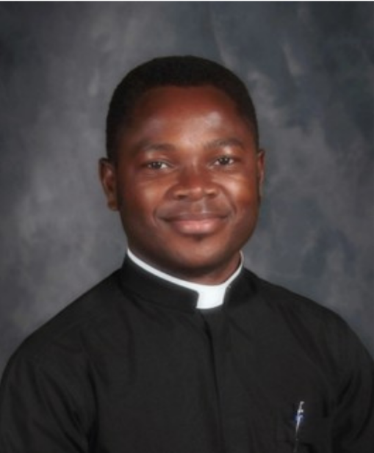

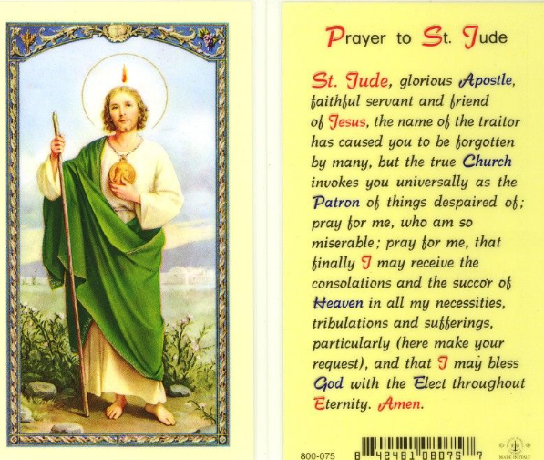
The St. Jude Social Concern Ministry is currently looking for people to help with the Aluminum Can Recycling and Food Donation distribution programs.
Food Donations are periodically left in the baskets in the back of the church. Volunteers are needed when the baskets are full to take the donations to the local food pantry at the Rochester Christian Church. Drop off at the Rochester Christian Church is Monday-Friday from 9 am-4 pm at the door labeled “church offices” off the North parking lot.
Volunteers are needed for food pickup/drop off for the months of April, August, and December 2026.
The Recycling program includes collecting aluminum cans from the large wooden box in the front of the Parish Center and taking them to Lake Area Recycling Services at 2742 S. 6th Street. The receipt and money can be placed in an envelope and marked RECYCLING and turned into the Parish Office or placed in the collection basket at the weekend masses.
Volunteers are needed for the Recycling Program for the months of June, August, and December 2026.
If you are interested in volunteering for either or both programs, please contact Kara Gray at (217) 341-2269 or kara.gray@comcast.net

Diocesan Victim Assistance Coordinator This is the liaison between the diocese and anyone with an allegation of sexual abuse of a minor. (217)-321-1155

This weekend we take up the Collection for the Church in Latin America! Many people in Latin America and the Caribbean lack access to church programs and ministries because of a rising secular culture, rugged rural terrain, and a shortage of ministers. Your generosity enables our brothers and sisters in Latin America and the Caribbean to share in the life of the Church and grow closer to Christ. Please be generous in the special collection!

ADULT FAITH FORMATION
During the six weeks of Lent, journey with us as we explore one of the greatest mysteries of the Christian Faith: the mystery of Jesus’ presence in the breaking of the bread. Our guide will be Dr. Grant Pitre, author of Jesus and the Jewish Roots of the Eucharist.
In our discussions, we will focus on three questions Dr. Pitre answers in his book.
What was the Passover like at the time of Jesus?
What was Jesus’ purpose in instituting the Eucharist at Passover?
What did Jesus mean when he said, “This is my body … This is my Blood”?
To assist us with planning, please sign up on the sheet, ADULT FAITH FORMATION, found in the foyer of the church OR contact Evelyn Deimel: 217.725.7339 or edeimel44@comcast.net.
We need your information by the 3rd of February so we can purchase the books and get them to you by 12 February. Our first session is the first Thursday after Ash Wednesday, 19th of February.
Thank you!

Intentional Discipleship
Because of the horrible weather last weekend, the planned commissioning of our Eucharistic Minsters was postponed until the weekend of February 7th and 8th. At all the Masses that weekend we will be recognizing those in our community who have answered the call to Intentional Discipleship by serving as Extraordinary Ministers of Holy Communion. We have received the Bishop’s mandate that allows these individuals to assist in the distribution of Holy Communion at Mass and to take Holy Communion to the sick and shut ins of our parish.
Each of these individuals is a great blessing to our parish family. It is with great joy that our parish family celebrates their Commissioning.

Mass Intentions & Times (†indicates deceased)
Saturday, January 31st
4:30pm Mass (Int: Carrie Haney)
Sunday, February 1st
8:00am Mass (Int: Trish Leach †)
10:30am Mass (Int: Virginia Chineke†)
Monday, February 2nd
5:30pm Mass (Int: Evelyn Conboy†)
Tuesday, February 3rd
7:15am Mass (Int: Greg Paek†)
Wednesday, February 4th
7:15am Mass (Int: Carol Downey†)
Thursday, February 5th
7:15am Mass (Int: Wilma Lewis†)
Friday, February 6th
7:15am Mass (Int: James Felts†)
Saturday, February 7th
4:30pm Mass (Int: Evelyn Conboy†)
Sunday, February 8th
8:00am Mass (Int: Delbert Collings† and Carolyn Carmichael)
10:30am Mass (Int: For the People)
______________________________________
Februry Volunteers: Week #1
Monday, February 2nd Counting Day:
Team #1
Church Dusters:
Barb Scheufele and Mary Duesterhaus
February Aluminum Cans Recycle
Barry Houmes
February St. Martin de Porres Food
Wuellner Family
Rochester Estates – 1st Sunday of the Month
Eucharistic Minister: Deona Kuntzman
Carriage Crossing – 1st Sunday of the Month
Eucharistic Minister: Dottie Anderson
Lasagna Fundraiser – Take & Bake
Lasagnas ordered using the church order form may be picked up after any Mass on January 31 or February 1. Orders placed through individual participants will be delivered by that participant.
Donut Sunday
Please join us for fellowship, donuts, fruit, juice, milk, and coffee on the following dates:
February 1st and February 15th
We look forward to seeing you!
Next Week Schedule
LITURGY SCHEDULE
Saturday, February 7th at 4:30pm
Eucharistic Ministers: Fr. Peter, M. Bruno,
B. Auxier, F. Yocum
Lectors: T. Bertrand, D. Day
Servers: A. and N. Horstman
Hospitality: J. Sponsler, R. and M. McClintock
Sacristan: Kay Foster
Sunday, February 8th at 8:00am
Eucharistic Ministers: Fr. Peter, Dcn. Ray,
N. and J. Calvert
Lectors: D. Anderson, D. Kuntzman
Servers: R. and E. Strawkas
Hospitality: YS. Martyn, D. and L. Wuellner
Sacristan: Zana Dahlkamp
Sunday, February 8th at 10:30am
Eucharistic Ministers: Fr. Peter, Dcn. Tom,
L. Fjelstul, S. Kerley
Lectors: E. Woehrmann, C. Schmit
Servers: E. Woehrmann, L. Batten, J. Powell
Hospitality: T. Bax, S. and D. Decker
Sacristan: Helen Crusen
SDCCW

“Heaven Meets Earth: A Journey through the Holy Mass” held February 24-25 at Villa Maria Conference Center on Lake Springfield. Led by Retreat Director Sr. Margaret Schreiber, OP, PhD. This retreat offers spiritual presentations, prayer, Holy mass, confession, fellowship, and time for quiet reflection.

Registation forms with cost and further information are available at the parish office or at dio.org/events.
Deadline to register is February 14th. For more information contact
Mary Ann Sullivan at (217)-822-1928
Janet Zimmerman at (217)-494-4743

Job Opening: Live Stream Mass Coordinator
St. Jude’s Catholic Church is seeking a reliable and detail-oriented individual to assist with live streaming weekend Masses. Responsibilities include setting up equipment, managing the live broadcast, and ensuring quality audio and video for our online parish community. Technical experience is helpful, but training will be provided.
If you are interested or would like more information, please contact the parish office.
Spiritual Support for the Sick
Request the Sacrament of Anointing of the Sick for yourself or a loved one facing illness or surgery. The Sacrament may be administered privately or after any Mass. If you or a loved one is in the hospital, Father would like to know so it is possible for him to visit. Please call the Parish Office at (217) 498-9197 for the anointing and/or a hospital visit.

Eucharistic Ministers taking communion to Carriage Crossing & Rochester Estates at 9:15am Sundays Frances Yocum is having a Communion Service at 2:30 pm on the 2nd Tuesdays at Rochester Estate
It is a privilege to pray for those who are ill. In hopes of keeping our list current, parishioners and parishioners’ family and friends will be on the prayer list for 1 month unless the office is contacted to notify us that additional time is necessary. We are happy to keep people on the list as long as needed.

Please remember the elderly and homebound
of our parish in your daily prayer.
God bless them all, and ….

Pray for Parishioners – Leroy Bozarth, JoAnn Camille, Ann Carell, Morgan Culbertson, Carrie Downey, Herta Duban, Gary Dumonceaux, Kaitlyn Galman, Henry Gartner, Noah Harney, Paul Harris, Jerry Jasinski, Marilyn Merkley, Andrea Miller, Scott Moss, Suzanne Moss, Ginger Rentschler, Ray Roland, Rene Runions, Brittany and Steve Smith and family, Owen Smith and his family (Kristin, Paisley, and Adam), Frances Tomashavich, Bill & Laurie White, Jill Whitney, Ehren Woehrmann

Pray for Family and Friends of Parishioners
Mary Aplington – sister of Beth Yong
John Aplington – brother of Beth Yong
Mary Barrow – sister of Leigh Ann Szabados
Carolyn Binion – friend of Paulette Dumonceaux
Tamie Bottoms-Smith – cousin of Char Weitekamp
John Brunsman – father of Laura Horstman
Steven Butts - brother of Michelle Bullock
Atticus Cassidy – cousin of Steve Decker
Leo Conway – father of Gary Conway
Eddie Cook – friend of Lenna DeGroot family
Chris Crusen – brother of Tom Crusen
Linda Curtis – sister of Connie Leach
Bill Davis – friend of Donald & Lou Ellen Markovitch
Kelly Diaz – niece of Stan & Mary Jo Duesterhaus
Leo J. Dougherty – brother-in-law of Frances Yocum
Sarah Egizio – daughter-in-law of Mary Ann Egizio
Frank Emerson- brother-in-law of Jean McDonald
Jason & Molly Everitt & Family – nephew & niece of Lenna DeGroot
Lynne (Auxier) Feece – sister-in-law of Beth Auxier
Carole Fulcher - friend of Pat Carlisle
Cindy Frericks- mother-in-law of Jennifer Frericks
Ken Frericks- father-in-law of Jennifer Frericks
Lauren Friedmeyer & her baby, Nellie – granddaughter & great granddaughter of Bill & Laurie White
Jennifer Harbeck - cousin of Brad Zack
Brandon Harris – grandson of Les & LuAnn White
Oaklynn Harrison – granddaughter of Stacey Harrison
Chad Kunkle – friend of Pat & Steve Jones and Family
Jim Kirbach – friend of the Hendricksons
Carol Kirby – friend of Ginger Rentschler
Kristine Lundburg – sister of Mary Gartner
Rochelle Lynam – daughter of Tom & Helen Crusen
Robin Mahnken – friend of Jerry & Mary Jo Jasinski
Ann Martin – sister of Betty Downey
Paula McDonald- sister-in-law to Jean McDonald
Merdith Messett – friend of Marie Ginter
Donna Meyers - mother of Kellie Brewer
Wayne Michels – friend of Beth Auxier
Cindy Murdock – aunt of Leanne Collings
Fred J. Naffziger – brother of Michele Naffziger
Theresa Oldani – friend of Diane Bortmess, friend of
Kelly Conlon & Family
Claudia Oller – Mary Bruno
Margie Palmatier – friend of the Hendricksons
Emily Parnell – daughter-in-law of Peggy Parnell
Father Zach Patibandla – our 2025 summer priest
Mike Patterson – father of Lori Farris
Mary Poeling – cousin of Maggie Patterson
Sabrina Rice – niece of Beth Auxier
Tom Ridley – nephew of Frances Yocum
Mark & Chris Riedle – family of Tess & David Riedle
Teresa Rouse – friend of Jane Molohon
*Joe Rupnick – friend of Hartzel & Mary Bruno
Bud Saputo- brother of Vito and Edna Saputo
Joe Saputo – brother of Vito & Edna Saputo
Special Intentions of Andy Mihelich
Special Intentions of Barb Scoggins
Special Intentions of Carol Mataya
Special Intentions of Steve & Pat Jones and Brian & Sherri Jones
Marlene Spurgeon – friend of Pat Carlisle
Russ Steil- father of Teresa O’Sullivan
Mary Stewart – friend of Suzanne Moss
Ron & Kim Thompson – friends of Emma Van Dyke
Cindy Usher – friend of Mary Bruno
Judy Waidman – aunt of Jim and Christina Lauwerens
Kathy Whitaker – friend of Peggy Parnell
Vicki Will – sister-in-law of Brian Sommer
Connie & Marc Wilson – niece and nephew of Ginger Rentschler
Sharon White- Laurie White Sister
Lorine Wallin-Friend of Helling Family
Tommy Regan- Friend of Frances Yocum
The Schieferdecker family and Grant - cousins of Jim and Barb Scheufele
Jody Frese - sister - in - law of Barb and Jim Scheufele
Richard Yong-Beth Yong

Burning of Palms for Ash Wednesday
As we prepare for the holy season of Lent, we invite parishioners to bring in the blessed palms from last year’s Palm Sunday Masses. These blessed palms will be burnt for the ashes used on Ash Wednesday. Please place your palms in the designated basket at the entrance of the Church.
We will be burning the palms on Tuesday Feb 17th. Please watch the bulletin for further information about The Burning of Palms Rite.

FEAST OF ST BLAISE FEBRUARY 3, 2026
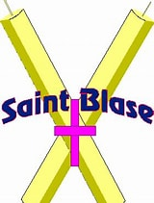
BLESSING OF THE THROATS AT 7:15 am DAILY MASS
St Blaise, was a physician and bishop in the early Church, believed to have lived in the 3rd century. He dedicated his life to serving both the physical and spiritual needs of his community.
Saint Blaise is widely venerated as the patron saint of throat ailments, thanks to a legendary event where he miraculously cured a boy choking on a fishbone.

NOTICE
There will be a delay in the mailing of the end of the year Parishioner giving statements of 2025. We ask for your patience and understanding during our office transition.

Thank you,
Office Staff

PSR January At a Glance

