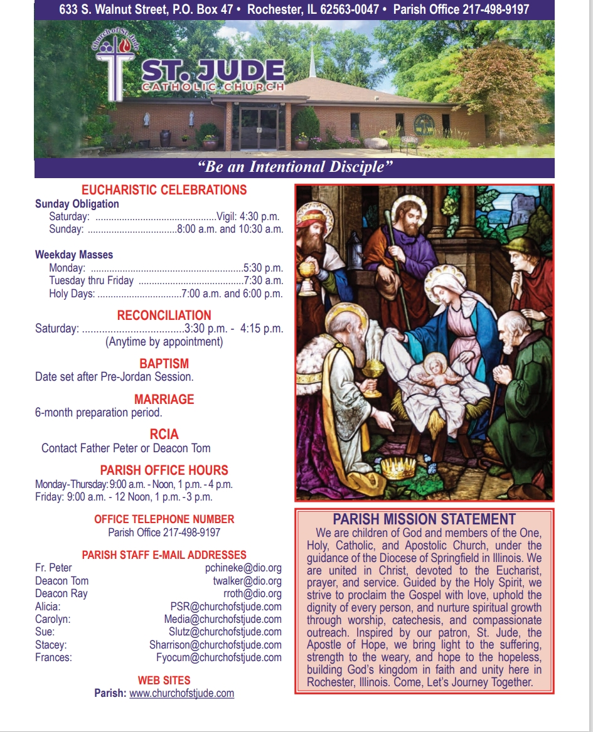

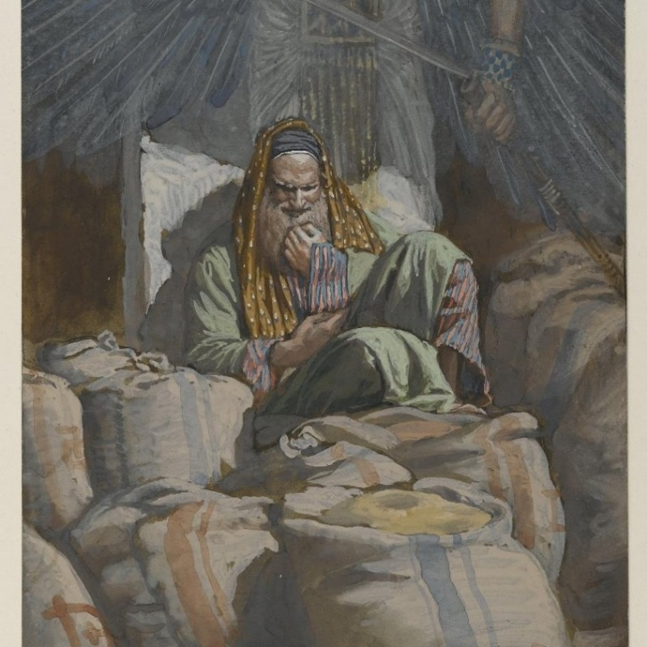
August 3rd, 2025
^{th} Sunday in Ordinary Time

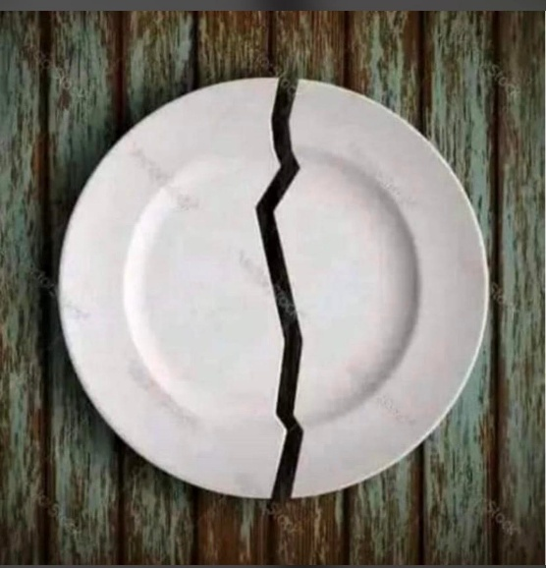
February 8th – The Broken Plate – A Symbol of Our Brokenness.
The image of the broken plate before us speaks quietly but powerfully about the human condition. Once whole, useful, and beautiful, it now bears a fracture that cannot simply be erased. No amount of glue can restore it to what it once was. In this woundedness, we recognize ourselves. We recognize our broken pieces. We recognize our woundedness. We also recognize how ontologically fractured our relationship with God and sometimes with fellow human beings have become. Sometimes because of our natural selfish inclinations, greed, biases, and irrational quest for bodily pleasures.
In life, we often believe that healing means returning to how things were before – before loss, betrayal, failure, unhealthy habits, or sin. Yet Scripture and experience teach us that some brokenness cannot be fixed in that way. There are wounds that change us permanently. Relationships that cannot be restored. Innocence that cannot be recovered. Like the plate, we may still exist, but the crack remains visible.
Christian faith does not deny this reality. Instead, it transforms it. God does not promise that every broken place will be repaired to its original state. Rather, He promises His presence within the brokenness. The risen Christ still bears His wounds; they were not erased but glorified. They became signs of love, sacrifice, and redemption.
Our broken or wounded places, then, are not failures of faith. They are spaces where grace enters. God works not by pretending the fracture is not there, but by meeting us in it. Our Lord Jesus meets us in our woundedness. He wants to meet us in it, to teach us humility, compassion, and dependence on Him. What cannot be fixed can still be redeemed. And what is redeemed, though broken, can still be holy.
AS WE APPROACH THE SEASON OF LENT, I ENCOURAGE US TO ENTER DEEP WITHIN OURSELVES AND FIND OUT OUR WOUNDEDNESS. CONFRONT IT. ADMIT IT. ASK THE WOUNDED JESUS TO COME AND HEAL OR REDEEM OUR WOUNDS.
Fr. Peter Chineke
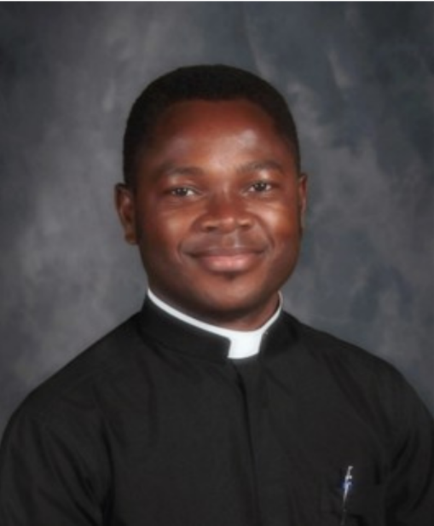
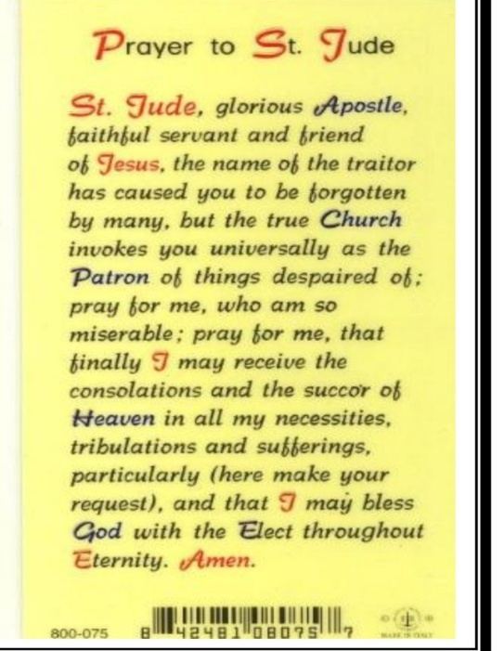
The St. Jude Social Concern Ministry is currently looking for people to help with the Food Donation distribution program.
Food Donations are periodically left in the baskets at the back of the church. Volunteers are needed when the baskets are full to take the donations to the local food pantry at the Rochester Christian Church. Drop off at the Rochester Christian Church is Monday-Friday from 9 am-4 pm at the door labeled “church offices” off the North parking lot.
Volunteers are needed for food pickup/drop off for the months of April, August, and December 2026. Please contact Kara Gray if you are able to help.
Kara.gray@comcast.net or (217) 341-2269.
Diocesan Victim Assistance Coordinator This is the liaison between the diocese and anyone with an allegation of sexual abuse of a minor. (217)-321-1155

Job Opening: Live Stream Mass Coordinator
St. Jude’s Catholic Church is seeking a reliable and detail-oriented individual to assist with live streaming weekend Masses. Responsibilities include setting up equipment, managing the live broadcast, and ensuring quality audio and video for our online parish community. Technical experience is helpful, but training will be provided.
If you are interested or would like more information, please contact the parish office.
SDCCW

“Heaven Meets Earth: A Journey through the Holy Mass” held February 24-25 at Villa Maria Conference Center on Lake Springfield. Led by Retreat Director Sr. Margaret Schreiber, OP, PhD. This retreat offers spiritual presentations, prayer, Holy mass, confession, fellowship, and time for quiet reflection.

Registration forms with cost and further information are available at the parish office or at dio.org/events.
Deadline for registering is February 14th. For more information contact
Mary Ann Sullivan at (217)-822-1928
Janet Zimmerman at (217)-494-4743

ASH WEDNESDAY
February 18th begins our observance of the season of Lent. Mass will be at 7:00AM and 6:00PM
Lenten Regulations on Fasting and Abstinence
Everyone 14 years of age or older is bound to abstain from meat on Ash Wednesday, all the Fridays of Lent and Good Friday.
Everyone 18 or older, and under 59 years of age, is bound to fast on Ash Wednesday and Good Friday.
On Ash Wednesday and Good Friday, only one full meatless meal is allowed. Two other meatless meals, sufficient to maintain strength, may be taken according to each one’s needs, but together they should not equal another full meal. Eating between meals is not permitted. Those individuals adversely affected by fasting or abstinence for health reasons are not bound by these norms.
If you have any questions about your particular situation please contact Father Peter.
Parish Day of Prayer and Recollection
Fast and pray as you can all day. We shall conclude together in the Church with Holy Hour of Adoration and Recollection on Wednesday, February 11th, from 6-7 pm.
50/50 DRAWING
The December drawing winner was ticket #402498 worth $251.00. The winner has not come forward yet.
The January winner was Lenna DeGroot for $255.00. Congratulations Lenna
The February sale of tickets is underway. Remember all proceeds go to support the upcoming Youth Group trips to Rome and to CHWC. For more information, please contact Jerry Calvert.
at 217-498-900.

Mass Intentions & Times (†indicates deceased)
Saturday, February 7th
4:30pm Mass (Int: Evelyn Conboy†)
Sunday, February 8th
8:00am Mass (Int: Delbert Collings†& Carolyn Carmichael †)
10:30am Mass (Int: For the People)
Monday, February 9th
5:30pm Mass (Int: Evelyn Conboy†)
Tuesday, February 10th
7:15am Mass (Int: Teresa Brewer†)
Wednesday, February 11th
7:15am Mass (Int: Teresa Brewer †)
Thursday, February 12th
7:15am Mass (Int: Teresa Brewer †)
Saturday, February 14th
4:30pm Mass (Int: Harry Nickles†)
Sunday, February 15th
8:00am Mass (Int: Greg Park†)
10:30am Mass (Int: For the People)
______________________________________
February Volunteers: Week #3
Monday, February 9th Counting Day:
Team #2
Church Dusters:
Laurie McWard & Zana Dahlkamp
February Aluminum Cans Recycle
Barry Houmes
February St. Martin de Porres Food
Wuellner Family
Rochester Estates – 2nd Sunday of the Month
Eucharistic Minister: Mary & Hartzel Bruno
Carriage Crossing – 2nd Sunday of the Month
Eucharistic Minister: Beth Auxier
Donut Sunday
Please join us for fellowship, donuts, fruit, juice, milk, and coffee on the following dates:
February 15th
We look forward to seeing you!
The Social Concerns Ministry will have a brief meeting in the Parish Center on Thursday, February 26th at 6:30 PM. Please email Kara Gray if you plan to attend. Thank you!
Kara.gray@comcast.net
Next Week Schedule
LITURGY SCHEDULE
Saturday, February 14th at 4:30pm
Eucharistic Ministers: Fr. Peter, Dcn. Tom, B. Scheufele, F. Yocum
Lectors: E. Prather, T. O’Sullivan
Servers: Douglas Sommer
Hospitality: c. Mataya, H. & M. Bruno
Sacristan: Isabel Long
Sunday, February 15th at 8:00am
Eucharistic Ministers: Fr. Peter, D. Kuntzmann, D. Anderson, C. Leach
Lectors: K. Blumhorst, L. Degroot
Servers: B. & J. Britz
Hospitality: K. Park, Y. Brandis, L. McWard
Sacristan: Zana Dahlkamp
Sunday, February 15th at 10:30am
Eucharistic Ministers: Fr. Peter, Dcn. Ray, S. Warren, M. Maynerich
Lectors: P. Szabados, S. Nelson
Servers: D., J., & M. Zucco
Hospitality: Brewer Family
Sacristan: Helen Crusen

Job Opening: Live Stream Mass Coordinator
St. Jude’s Catholic Church is seeking a reliable and detail-oriented individual to assist with live streaming weekend Masses. Responsibilities include setting up equipment, managing the live broadcast, and ensuring quality audio and video for our online parish community. Technical experience is helpful, but training will be provided.
If you are interested or would like more information, please contact the parish office.
Burning of Palms for Ash Wednesday
As we prepare for the holy season of Lent, we invite parishioners to bring in the blessed palms from last year’s Palm Sunday Masses. These blessed palms will be burnt for the ashes used on Ash Wednesday. Please place your palms in the designated basket at the entrance of the Church.
We will be burning the palms on Tuesday Feb 17th. Please watch the bulletin for further information about The Burning of Palms Rite.
Spiritual Support for the Sick
Request the Sacrament of Anointing of the Sick for yourself or a loved one facing illness or surgery. The Sacrament may be administered privately or after any Mass. If you or a loved one is in the hospital, Father would like to know so it is possible for him to visit. Please call the Parish Office at (217) 498-9197 for the anointing and/or a hospital visit.
Eucharistic Ministers taking communion to Carriage Crossing & Rochester Estates at 9:15am Sundays Frances Yocum is having a Communion Service at 2:30 pm on the 2nd Tuesdays at Rochester Estate
It is a privilege to pray for those who are ill. In hopes of keeping our list current, parishioners and parishioners’ family and friends will be on the prayer list for 1 month unless the office is contacted to notify us that additional time is necessary. We are happy to keep people on the list as long as needed.

Please remember the elderly and homebound
of our parish in your daily prayer.
God bless them all, and ….

Pray for Parishioners – Leroy Bozarth, JoAnn Camille, Ann Carell, Morgan Culbertson, Carrie Downey, Herta Duban, Gary Dumonceaux, Kaitlyn Galman, Henry Gartner, Noah Harney, Paul Harris, Jerry Jasinski, Marilyn Merkley, Andrea Miller, Scott Moss, Suzanne Moss, Ginger Rentschler, Ray Roland, Rene Runions, Brittany and Steve Smith and family, Owen Smith and his family (Kristin, Paisley, and Adam), Frances Tomashavich, Bill & Laurie White, Jill Whitney, Ehren Woehrmann

Pray for Family and Friends of Parishioners
Mary Aplington – sister of Beth Yong
John Aplington – brother of Beth Yong
Mary Barrow – sister of Leigh Ann Szabados
Carolyn Binion – friend of Paulette Dumonceaux
Tamie Bottoms-Smith – cousin of Char Weitekamp
John Brunsman – father of Laura Horstman
Steven Butts - brother of Michelle Bullock
Atticus Cassidy – cousin of Steve Decker
Leo Conway – father of Gary Conway
Eddie Cook – friend of Lenna DeGroot family
Chris Crusen – brother of Tom Crusen
Linda Curtis – sister of Connie Leach
Bill Davis – friend of Donald & Lou Ellen Markovitch
Kelly Diaz – niece of Stan & Mary Jo Duesterhaus
Leo J. Dougherty – brother-in-law of Frances Yocum
Sarah Egizio – daughter-in-law of Mary Ann Egizio
Frank Emerson- brother-in-law of Jean McDonald
Jason & Molly Everitt & Family – nephew & niece of Lenna DeGroot
Lynne (Auxier) Feece – sister-in-law of Beth Auxier
Carole Fulcher - friend of Pat Carlisle
Cindy Frericks- mother-in-law of Jennifer Frericks
Ken Frericks- father-in-law of Jennifer Frericks
Lauren Friedmeyer & her baby, Nellie – granddaughter & great granddaughter of Bill & Laurie White
Jennifer Harbeck - cousin of Brad Zack
Brandon Harris – grandson of Les & LuAnn White
Oaklynn Harrison – granddaughter of Stacey Harrison
Chad Kunkle – friend of Pat & Steve Jones and Family
Jim Kirbach – friend of the Hendricksons
Carol Kirby – friend of Ginger Rentschler
Kristine Lundburg – sister of Mary Gartner
Rochelle Lynam – daughter of Tom & Helen Crusen
Robin Mahnken – friend of Jerry & Mary Jo Jasinski
Ann Martin – sister of Betty Downey
Paula McDonald- sister-in-law to Jean McDonald
Merdith Messett – friend of Marie Ginter
Donna Meyers - mother of Kellie Brewer
Wayne Michels – friend of Beth Auxier
Cindy Murdock – aunt of Leanne Collings
Fred J. Naffziger – brother of Michele Naffziger
Theresa Oldani – friend of Diane Bortmess, friend of
Kelly Conlon & Family
Claudia Oller – Mary Bruno
Margie Palmatier – friend of the Hendricksons
Emily Parnell – daughter-in-law of Peggy Parnell
Father Zach Patibandla – our 2025 summer priest
Mike Patterson – father of Lori Farris
Mary Poeling – cousin of Maggie Patterson
Sabrina Rice – niece of Beth Auxier
Tom Ridley – nephew of Frances Yocum
Mark & Chris Riedle – family of Tess & David Riedle
Teresa Rouse – friend of Jane Molohon
*Joe Rupnick – friend of Hartzel & Mary Bruno
Bud Saputo- brother of Vito and Edna Saputo
Joe Saputo – brother of Vito & Edna Saputo
Special Intentions of Andy Mihelich
Special Intentions of Barb Scoggins
Special Intentions of Carol Mataya
Special Intentions of Steve & Pat Jones and Brian & Sherri Jones
Marlene Spurgeon – friend of Pat Carlisle
Russ Steil- father of Teresa O’Sullivan
Mary Stewart – friend of Suzanne Moss
Ron & Kim Thompson – friends of Emma Van Dyke
Cindy Usher – friend of Mary Bruno
Judy Waidman – aunt of Jim and Christina Lauwerens
Kathy Whitaker – friend of Peggy Parnell
Vicki Will – sister-in-law of Brian Sommer
Connie & Marc Wilson – niece and nephew of Ginger Rentschler
Sharon White- Laurie White Sister
Lorine Wallin-Friend of Helling Family
Tommy Regan- Friend of Frances Yocum
The Schieferdecker family and Grant - cousins of Jim and Barb Scheufele
Jody Frese - sister - in - law of Barb and Jim Scheufele
Richard Yong-Beth Yong

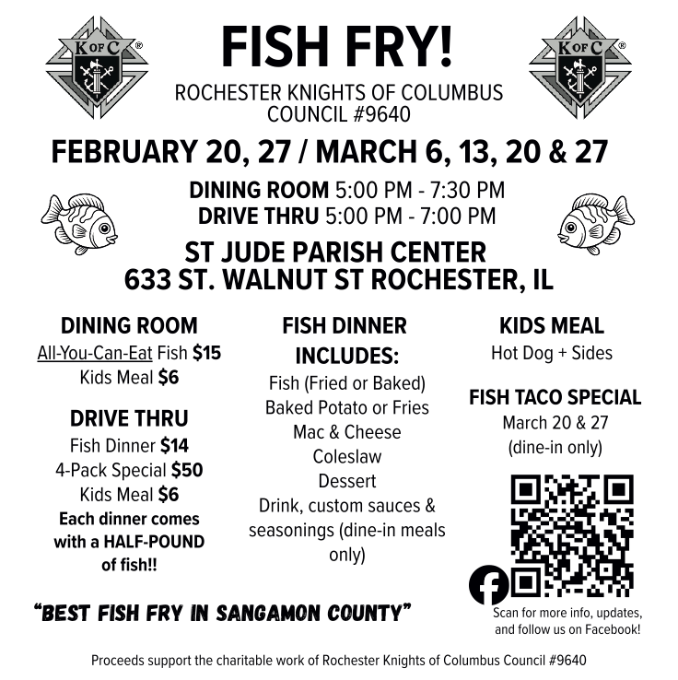

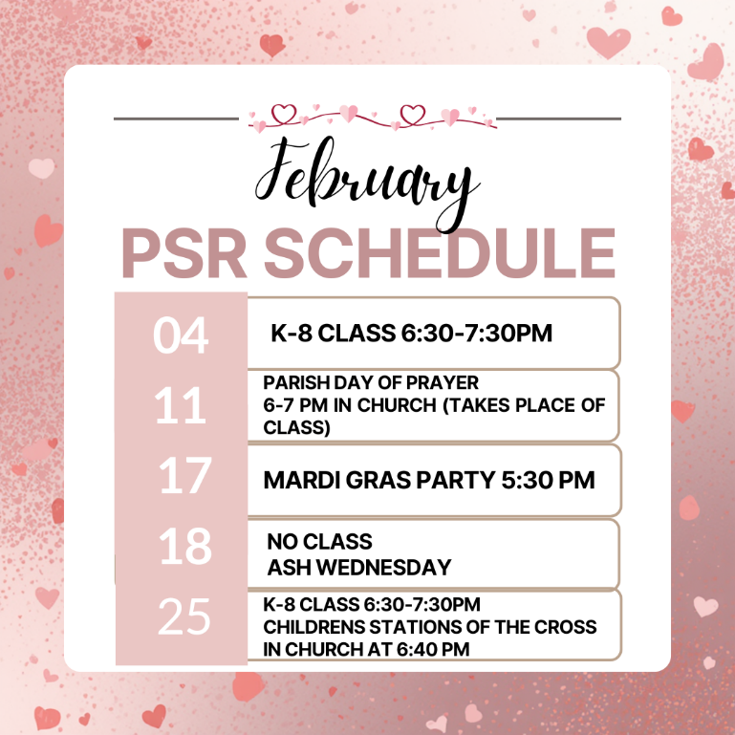

Adult Volunteers
Many parishioners join us in service at the fish fry; volunteer information is available through this link.
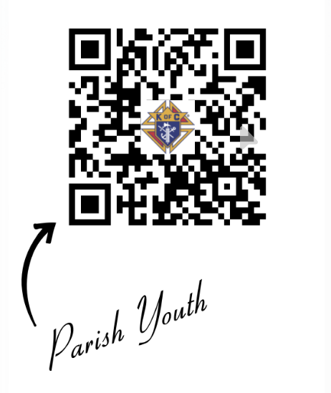
Youth Volunteers
Help our youth learn the value of service as their work is paid forward through charity for others. This includes financial support for their mission trips and pilgrimage.
PSR February At A Glance
Fr. Patrick Cahill Memorial Scholarship Announcement

Attention Graduating High School Seniors:
If you are a graduating H.S. Senior in 2026 and are interested in some extra money for college, please apply for the Father Patrick Cahill Memorial Scholarship. To apply, contact the Saint Jude Parish Office or go online to the Springfield, IL Catholic Diocese website to apply. Please submit applications by Wednesday April 15, 2026.

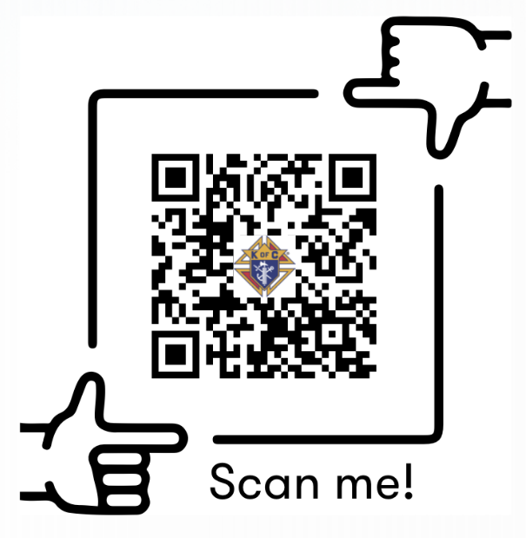
Thank you for your generous support for last week’s Collection for the Church in Latin America. As a parish, we collected $461 to share the faith with our brothers and sisters in Latin America and the Caribbean, so they in turn can share the Good News in their communities. If you missed the collection, it’s not too late to give! Visit usccb.org/latin-america. iGiveCatholic also accepts funds for this collection if you prefer to donate online.

