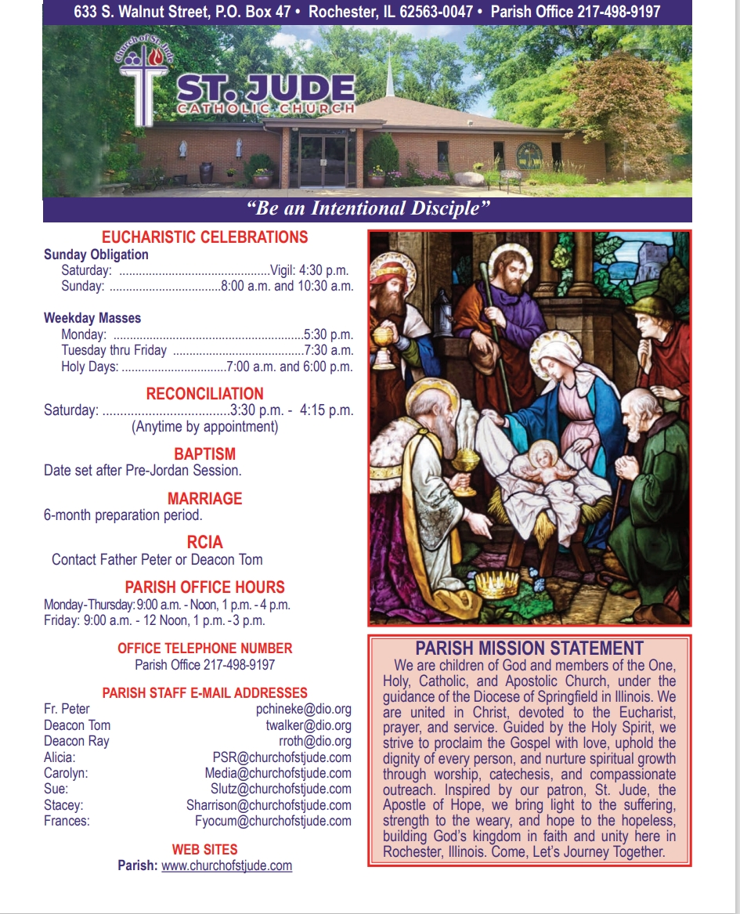

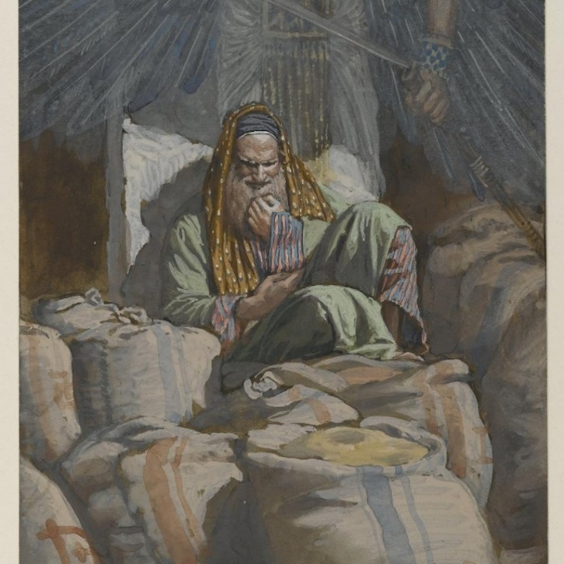
August 3rd, 2025
^{th} Sunday in Ordinary Time

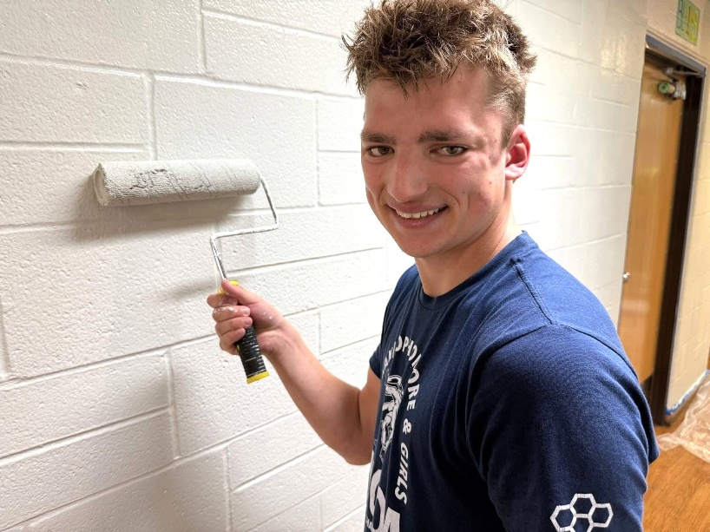
February 22nd - Live Like Jack!
The death of a young person always feels like a contradiction. At seventeen, life is supposed to be opening, not closing. Beginning, not ending. And yet in Jack’s short years, God allowed something many of us spend decades searching for — a heart already awake to eternity.
Jack did not simply attend church. He listened. He participated. He served. In youth group conversations and altar server trainings, he asked the kind of questions that do not come from curiosity alone but from longing: Why did God make us? What happens after death? How do I know I’m really close to Christ? These were not the questions of a boy filling time – they were the prayers of a soul preparing for heaven. The last question he asked just about ten days before he died was: “how do I express my Catholic Faith when I’m with my friends who are not Catholics?” As we mourn Jack, one of my biggest consolations is having walked closely with a young man who was real and intentional about his values and identities.
Sometimes holiness is quiet. It does not announce itself through miracles, but through sincerity. Jack served at the altar, but more importantly, he approached life like the altar – a place of offering. Every question he asked was a search for truth. Every act of service was a small “yes” to God. Without realizing it, he was already practicing how to belong fully to the Lord.
His death hurts because love hurts when separated. But faith whispers something stronger than grief: God never wastes a seeking heart. The young man who wanted to understand heaven now understands it better than any teacher or pastor could explain.

Jack’s life asks something of us. Not admiration – imitation. To pray honestly. To seek deeply. To serve faithfully. To live every ordinary day as preparation for meeting Christ.
Holiness is not about length of years, but depth of love.
So, we do not only mourn Jack.
We answer his witness.
We live like Jack.
Fr. Peter Chineke

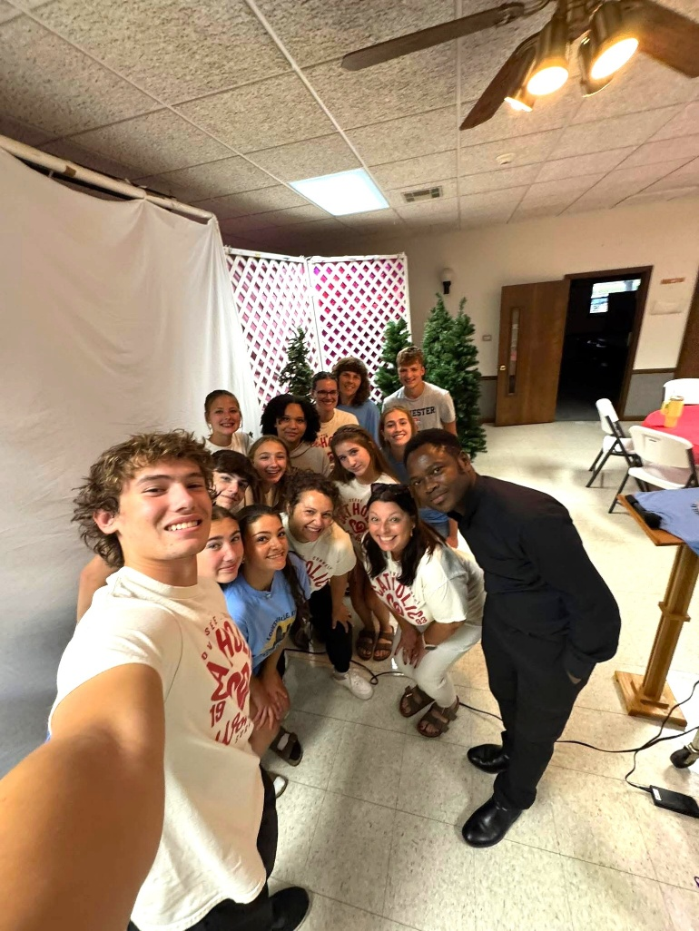

Diocesan Victim Assistance Coordinator This is the liaison between the diocese and anyone with an allegation of sexual abuse of a minor. (217)-321-1155

Lenten Regulations on Fasting and Abstinence
Everyone 14 years of age or older is bound to abstain from meat on Ash Wednesday, all the Fridays of Lent and Good Friday.
Everyone 18 or older, and under 59 years of age, is bound to fast on Ash Wednesday and Good Friday.
On Ash Wednesday and Good Friday, only one full meatless meal is allowed. Two other meatless meals, sufficient to maintain strength, may be taken according to each one’s needs, but together they should not equal another full meal. Eating between meals is not permitted. Those individuals adversely affected by fasting or abstinence for health reasons are not bound by these norms.
If you have any questions about your particular situation please contact Father Peter.
50/50 DRAWING
The December drawing winner was ticket #402498 worth $251.00. The winner has not come forward yet.
The January winner was Lenna DeGroot for $255.00. Congratulations Lenna
The February sale of tickets is underway. Remember all proceeds go to support the upcoming Youth Group trips to Rome and to CHWC. For more information, please contact Jerry Calvert.
at 217-498-900.

Donut Sunday
Please join us for fellowship, donuts, fruit, juice, milk, and coffee on the following dates:
March 1st, 15th, & 29th
We look forward to seeing you!
CRS Rice Bowl
The upcoming 2026 Catholic Relief Services Rice Bowl Program begins on Ash Wednesday, Feb. 18. This year marks the 51st year of the CRS Rice Bowl. This program gives Catholics across the U.S. the opportunity to assist the global human family through daily prayer, weekly fasting and almsgiving.
Catholic Relief Services, founded in 1943, is the official overseas relief and development agency of the U.S. Conference of Catholic Bishops and a member of Caritas International. CRS alleviates suffering and provides assistance to people in need in more than 100 countries without regard to race, religion or nationality.
Please pick up your family’s Rice Bowl from the table in the back of the Church.
Father Patrick Cahill Memorial Scholarship
Each year since 2004, the Knights of Columbus Council #9640 has awarded the Father Patrick Cahill Memorial Scholarship to a graduating high school senior. Scholarship information and application are available on the parish website (www.churchofstjude.com) or at the Parish Office during regular business hours. Scholarship applications must be submitted, completely, by 15 April 2026 (Wednesday). The Scholarship will be awarded at the annual Knights of Columbus Appreciation Dinner in May.
Father Patrick Cahill Scholarship Committee

Mass Intentions & Times (†indicates deceased)
Saturday, February 21st
4:30pm Mass (Int: Roberta “Bobbi” Hickey †)
Sunday, February 22nd
8:00am Mass (Int: Gil Deimel †)
10:30am Mass (Int: For the People)
Monday, February 23rd
5:30pm Mass (Int: Virginia Chineke†)
Tuesday, February 24th
7:15am Mass (Int: Jack Zucco†)
Wednesday, February 25th
7:15am Mass (Int: Jack Zucco †)
Thursday, February 26th
7:15am Mass (Int: Zucco Family †)
Friday, February 27th
7:15am Mass (Int: Zucco Family†)
Saturday, February 28th
4:30pm Mass (Int: Dan Connoly†)
Sunday, March 1st
8:00am Mass (Int: Lum Leach†)
10:30am Mass (Int: Evelyn Conboy†)
______________________________________
February Volunteers: Week 4
Monday, 23rd Counting Day:
Team #4
Church Dusters: Michelle Bertrand
February Aluminum Cans Recycle
Barry Houmes
February St. Martin de Porres Food
Wuellner Family
Rochester Estates –4th Sunday of the Month
Eucharistic Minister: Barb Scheufele
Carriage Crossing – 4th Sunday of the Month
Eucharistic Minister: Isabel Long

The Social Concerns Ministry will have a brief meeting in the Parish Center on Thursday, February 26th at 6:30 PM. Please email Kara Gray if you plan to attend. Thank you!
Kara.gray@comcast.net

Next Week Schedule
LITURGY SCHEDULE
Saturday, February 28th at 4:30pm
Eucharistic Ministers: Fr. Peter, Dcn. Walker, V. Walker, M. Mankowski
Lectors: B. Auxier, D. Day
Servers: Douglas Sommer
Hospitality: J. Sponsler, L. & F. Yocum
Sacristan: Isabel Long
Sunday, March 1st at 8:00am
Eucharistic Ministers: Fr. Peter, Dcn. Roth, L. DeGroot, C. Leach
Lectors: A. & O Rench
Servers: B. Howard, R. Roth
Hospitality: K. Park, Y. Brandis, L. McWard
Sacristan: Zana Dahlkamp
Sunday, March 1st at 10:30am
Eucharistic Ministers: Fr. Peter, S. Warren, S. Kerley, C. Leach
Lectors: L. Warren, M. Schudel
Servers: N. & R. Houmes, L. Batten, L. Schudel
Hospitality: Brewer Family
Sacristan: Helen Crusen

CAMPAIGN PLANNING STUDY
You may have heard about the St. Patrick Catholic School planning study to gauge support for the school’s sustainability. If you would like to participate, please complete a survey online using this QR code. Thank you in advance for participating and for your support of St. Patrick during this process.

Spiritual Support for the Sick
Request the Sacrament of Anointing of the Sick for yourself or a loved one facing illness or surgery. The Sacrament may be administered privately or after any Mass. If you or a loved one is in the hospital, Father would like to know so it is possible for him to visit. Please call the Parish Office at (217) 498-9197 for the anointing and/or a hospital visit.
Eucharistic Ministers taking communion to Carriage Crossing & Rochester Estates at 9:15am Sundays Frances Yocum is having a Communion Service at 2:30 pm on the 2nd Tuesdays at Rochester Estate
It is a privilege to pray for those who are ill. In hopes of keeping our list current, parishioners and parishioners’ family and friends will be on the prayer list for 1 month unless the office is contacted to notify us that additional time is necessary. We are happy to keep people on the list as long as needed.

Please remember the elderly and homebound
of our parish in your daily prayer.
God bless them all, and ….

Pray for Parishioners – Leroy Bozarth, JoAnn Camille, Ann Carell, Morgan Culbertson, Carrie Downey, Herta Duban, Gary Dumonceaux, Kaitlyn Galman, Henry Gartner, Noah Harney, Paul Harris, Jerry Jasinski, Marilyn Merkley, Andrea Miller, Scott Moss, Suzanne Moss, Ginger Rentschler, Ray Roland, Rene Runions, Brittany and Steve Smith and family, Owen Smith and his family (Kristin, Paisley, and Adam), Frances Tomashavich, Bill & Laurie White, Jill Whitney, Ehren Woehrmann

Pray for Family and Friends of Parishioners
Mary Aplington – sister of Beth Yong
John Aplington – brother of Beth Yong
Mary Barrow – sister of Leigh Ann Szabados
Carolyn Binion – friend of Paulette Dumonceaux
Tamie Bottoms-Smith – cousin of Char Weitekamp
John Brunsman – father of Laura Horstman
Steven Butts - brother of Michelle Bullock
Atticus Cassidy – cousin of Steve Decker
Leo Conway – father of Gary Conway
Eddie Cook – friend of Lenna DeGroot family
Chris Crusen – brother of Tom Crusen
Linda Curtis – sister of Connie Leach
Bill Davis – friend of Donald & Lou Ellen Markovitch
Kelly Diaz – niece of Stan & Mary Jo Duesterhaus
Leo J. Dougherty – brother-in-law of Frances Yocum
Sarah Egizio – daughter-in-law of Mary Ann Egizio
Frank Emerson- brother-in-law of Jean McDonald
Jason & Molly Everitt & Family – nephew & niece of Lenna DeGroot
Lynne (Auxier) Feece – sister-in-law of Beth Auxier
Carole Fulcher - friend of Pat Carlisle
Cindy Frericks- mother-in-law of Jennifer Frericks
Ken Frericks- father-in-law of Jennifer Frericks
Lauren Friedmeyer & her baby, Nellie – granddaughter & great granddaughter of Bill & Laurie White
Jennifer Harbeck - cousin of Brad Zack
Brandon Harris – grandson of Les & LuAnn White
Oaklynn Harrison – granddaughter of Stacey Harrison
Chad Kunkle – friend of Pat & Steve Jones and Family
Jim Kirbach – friend of the Hendricksons
Carol Kirby – friend of Ginger Rentschler
Kristine Lundburg – sister of Mary Gartner
Rochelle Lynam – daughter of Tom & Helen Crusen
Robin Mahnken – friend of Jerry & Mary Jo Jasinski
Ann Martin – sister of Betty Downey
Paula McDonald- sister-in-law to Jean McDonald
Merdith Messett – friend of Marie Ginter
Donna Meyers - mother of Kellie Brewer
Wayne Michels – friend of Beth Auxier
Cindy Murdock – aunt of Leanne Collings
Fred J. Naffziger – brother of Michele Naffziger
Theresa Oldani – friend of Diane Bortmess, friend of
Kelly Conlon & Family
Claudia Oller – Mary Bruno
Margie Palmatier – friend of the Hendricksons
Emily Parnell – daughter-in-law of Peggy Parnell
Father Zach Patibandla – our 2025 summer priest
Mike Patterson – father of Lori Farris
Mary Poeling – cousin of Maggie Patterson
Sabrina Rice – niece of Beth Auxier
Tom Ridley – nephew of Frances Yocum
Mark & Chris Riedle – family of Tess & David Riedle
Teresa Rouse – friend of Jane Molohon
Joe Rupnick – friend of Hartzel & Mary Bruno
Bud Saputo- brother of Vito and Edna Saputo
Joe Saputo – brother of Vito & Edna Saputo
Special Intentions of Andy Mihelich
Special Intentions of Barb Scoggins
Special Intentions of Carol Mataya
Special Intentions of Steve & Pat Jones and Brian & Sherri Jones
Marlene Spurgeon – friend of Pat Carlisle
Russ Steil- father of Teresa O’Sullivan
Mary Stewart – friend of Suzanne Moss
Ron & Kim Thompson – friends of Emma Van Dyke
Cindy Usher – friend of Mary Bruno
Judy Waidman – aunt of Jim and Christina Lauwerens
Kathy Whitaker – friend of Peggy Parnell
Vicki Will – sister-in-law of Brian Sommer
Connie & Marc Wilson – niece and nephew of Ginger Rentschler
Sharon White- Laurie White Sister
Lorine Wallin-Friend of Helling Family
Tommy Regan- Friend of Frances Yocum
The Schieferdecker family and Grant - cousins of Jim and Barb Scheufele
Jody Frese - sister - in - law of Barb and Jim Scheufele
Richard Yong-Beth Yong
Zucco Family – Parish Family

Decluttering with Purpose this Lenten Season

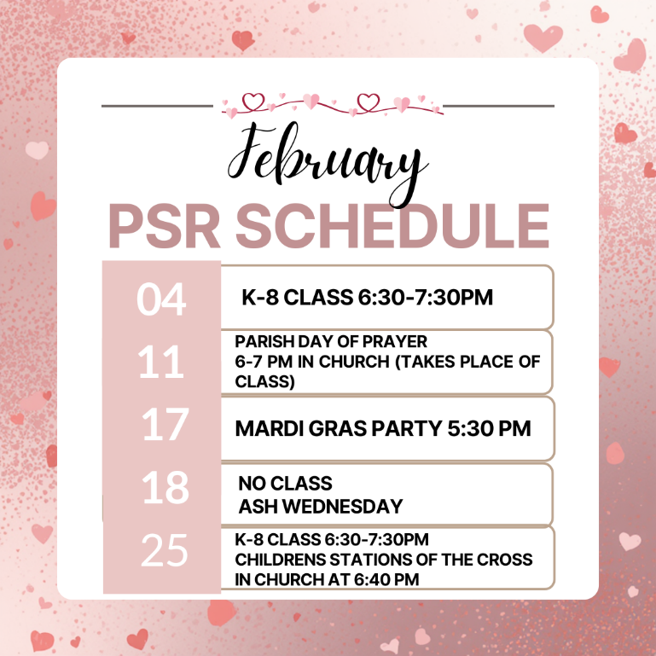
This Lent, our parish is inviting families and individuals to participate in 40 Days of Decluttering as a simple, meaningful Lenten practice. Each day of Lent, we encourage you to prayerfully choose one item (or one small category of items) to let go of. This practice helps us detach from excess, make room for God, and prepare our hearts for generosity.

All gently used items collected will be donated to support our Parish Rummage Sale April 24-25. Proceeds from the Rummage Sale go towards assisting our Youth Group in their mission trip.

When can I drop off items?
To help us stay organized, please hold onto your items during Lent. Donation drop-off will begin the week of April 20. Specific drop-off times and details will be shared closer to that date.

What kinds of items can be donated?
Gently used children's clothing, household goods, toys, books, and small appliances suitable for a rummage sale. Please, no adult clothing or large furniture items.

Do I have to do all 40 days?
Not at all. Participate as you are able — every act of generosity matters.

We appreciate your support

February PSR At a Glance

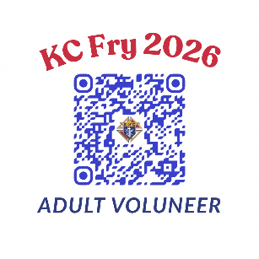

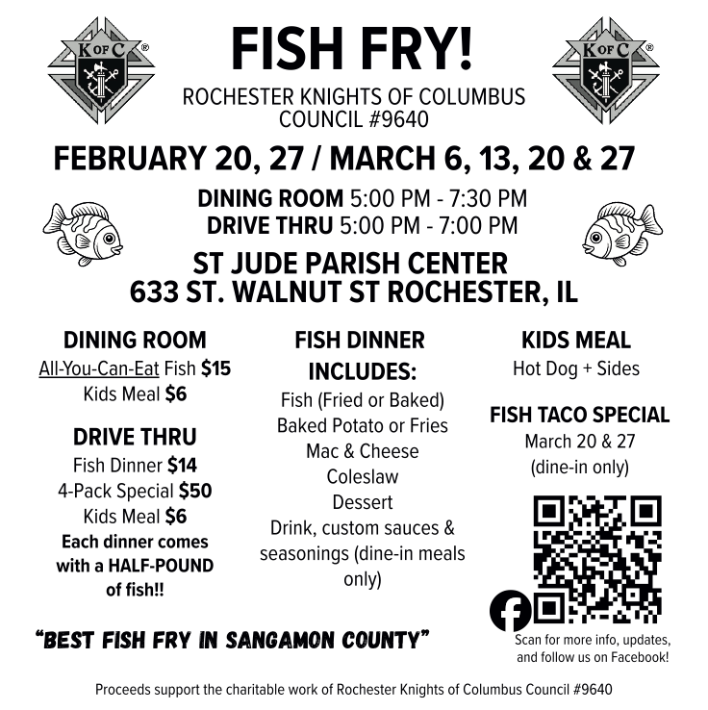
Adult Volunteers
Many parishioners join us in service at the fish fry; volunteer information is available through this link.

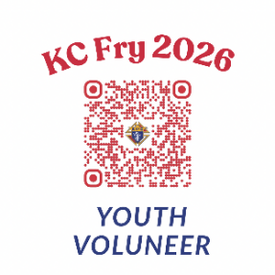

Youth Volunteers
Help our youth learn the value of service as their work is paid forward through charity for others. This includes financial support for their mission trips and pilgrimage.

