Dear Parishioners,
We are looking forward to hosting the Partners in the Gospel listening sessions over the coming month. These sessions will focus on the guiding question: “What opportunities and challenges exist for us?”
To help provide context for these conversations, we have gathered demographic, sacramental, and financial information for our parish family. This information is intended to offer a clearer picture of who we serve and where we currently stand in our ministries, finances, and physical locations. We ask that you prayerfully review the attached materials prior to attending a listening session for your parish. Listening sessions will be announced in upcoming communications.

Geographic Areas Served
Our parish family serves a wide geographic region, extending from the western shoreline of Skagit Bay and Padilla Bay to the Cascades, the border of the Diocese of Spokane. 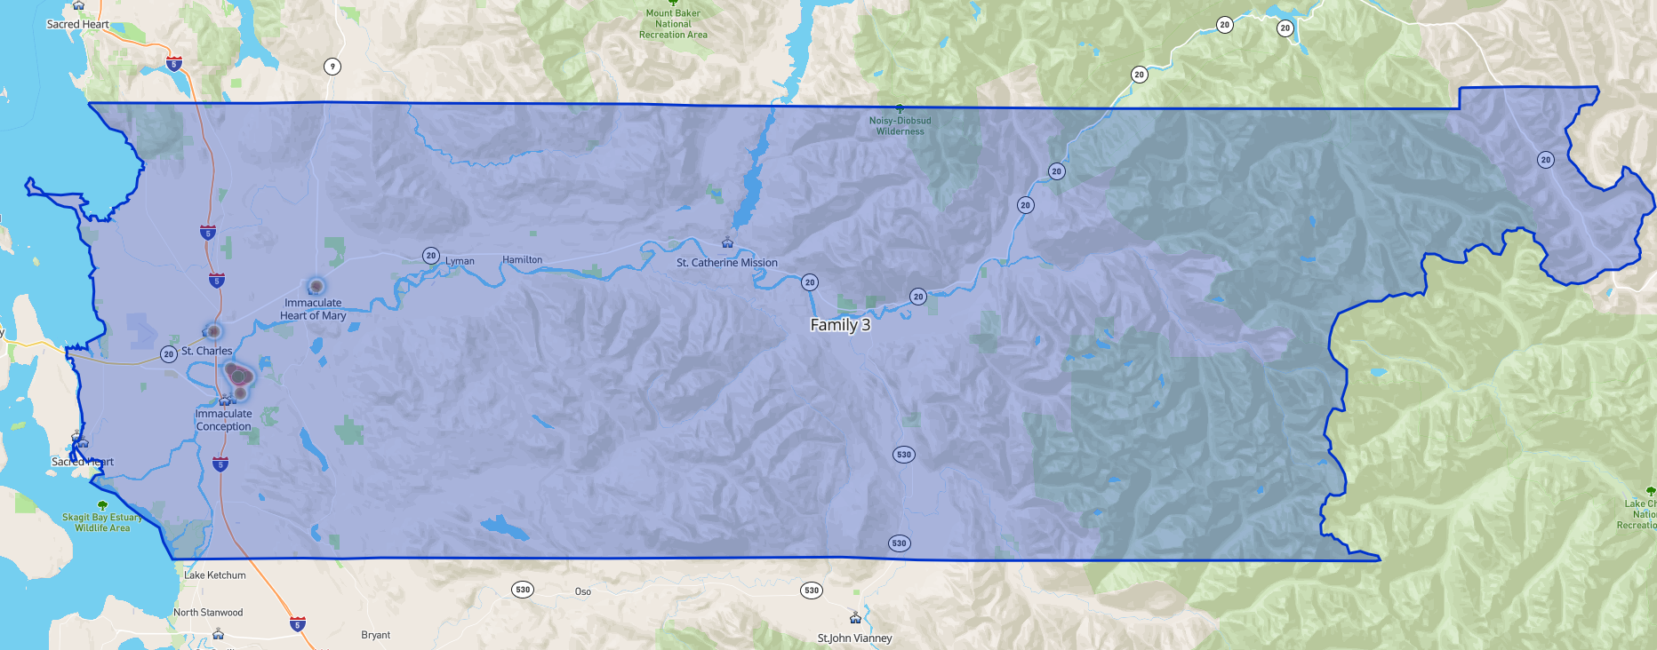

Populations Served
Our registered parishioners represent approximately 10% of the total population within our geographic area. The communities we serve are steadily growing, with continued population increases projected over the next decade.
Study Area Geography: Parish Families - Family 3
 | 2000 | 2010 | 2023 | 2028 | 2033
 | 81,779 | 93,526 | 103,954 | 108,958 | 115,005
Percent Change |  | 14.36% | 11.18% | 4.80% | 5.55%

It is also noteworthy that while the Hispanic population makes up more than 60% of parishioners in Mount Vernon and Burlington, the Hispanic population across the entire geographic area is approximately 21%, a percentage projected to remain stable over the next decade.
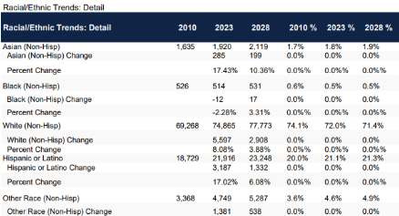

Sacraments Received and Faith Formation
Each year, our parish family continues to see strong participation in sacramental life, particularly at Immaculate Conception and St. Charles. Annually, we host three full-church Confirmation Masses at our largest parish to accommodate all confirmandi.
Faith Formation | Immaculate Conception | St. Charles | Sacred Heart | Immaculate Heart of Mary | St. Catherine
OCIA | 36 | 42 | 2
First Communion | 148 | 116 | 6 | 12
Faith Formation K-8 | 242 | 121 | 32
Youth Group - All Valley | 25
Baptisms | 120 | 133 | 6 | 27
Confirmations | 142 | 150 | 2
Funerals | 26 | 18 |  | 4
Marriages | 17 | 3
Individual Members | 3724 | 5388 | 590 | 398 | 38

Financial
Our parish family ended the most recent fiscal year with a positive net income. Our communities continue to be generous stewards, helping to keep our parishes financially sound.
Two parishes currently carry loans:
- St. Charles: $70,000 building improvement loan
- Immaculate Conception: $795,000 new church loan
Finances July 2024-June 2025 | Immaculate Conception | St. Charles | Sacred Heart | Immaculate Heart of Mary | St. Catherine
Income | 793,285 | 397,823 | 274,710 | 245,750 | 36,248
Expenses | 722,729 | 378,328 | 246,847 | 213,394 | 25,068
Net Income | 70,556 | 19,495 | 27,864 | 32356 | 11,180

Thank you for taking the time to review this information. Your prayerful reflection and thoughtful input are essential as we continue this important discernment process together.
With gratitude and prayers,
Shari Mentel
Skagit Valley Catholic Churches
Director of Operations

