The TIME Problem
Matthew 25:1-30
July 19, 2026
Introduction
Augustine talking about time said this
If no one asks me ‘what is time?’ - I know what it is
If I wish to explain it to him who asks me ‘what is time’ – I do not know
Our senses cant sense it, but we know it is real, the hourglass – we see a record of time
Time comes up as a question when Jesus walking with His disciples through Jerusalem…
D’s pointed out the Temple and other buildings on the Temple Mt.
JS replied in Mt24:2 … not one stone will be left upon another
Then these D’s ask Jesus a question about time – when will these things be? 24:3
Jesus’ answer is found in Matthew 24-25 and it is called the Mount of Olive discourse
24:4-14 discusses the end of the age
24:15-28 discusses signs of Jesus coming again
24:29-51 gets into the time or when of these things, specific 2nd coming
So far Jesus has said the following about the ‘when’ of these things
24:29-30 immediately after the tribulation of those days see
the Son of Man coming [a second coming]
24:33 when you see all these things [24:4-30] know that it is near
24:36 no one knows the day or hour
Ac1:6-7 1Th5:1-2 2Pt310 Rv3:3 16:15
24:40 you do not know the day or hour the Lord is coming
24:44 coming at an hour you do not expect
24:50 come on a day not looking and an hour not aware of
Let me give you a visual representation of the time problem, the hourglass if U will shows time
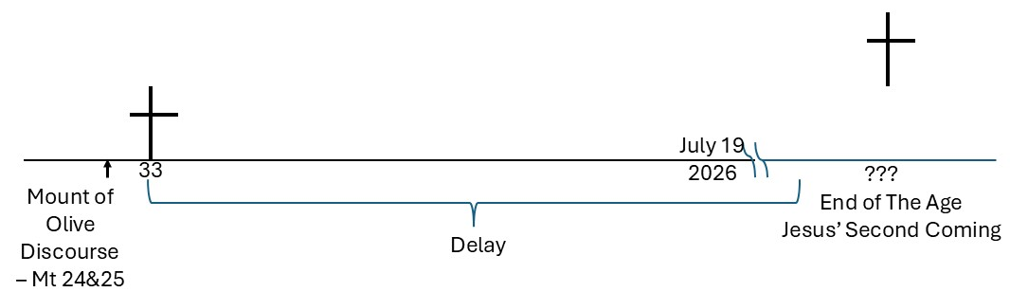
Delay = procrastination, unbelief, apathy, forgetfulness, laziness, loss of …i.e. problems
Today Mt25:1-30, Jesus tells two parables to address the time problem
Yes He is speaking to His D’s then, but His words are for every generation of Christian
1st Parable of 10 Virgins – Be Ready, No Second Chance When The Time Comes 1--13
A. Parable 1-12
Kingdom of heaven is like 10 virgins take lamps to meet bridegroom
5 were wise and took extra oil, 5 were foolish and took no extra oil
The bridegroom was delayed in coming
At midnight a cry announces the bridegroom is coming, all come to meet him
The virgins arose and trimmed their lamps
The foolish asked for oil from the wise
The wise replied that they would not have enough, go and buy
The bridegroom came after the foolish had left
The wise entered the wedding with the bridegroom and the door was shut
The foolish returned and said “Lord, Lord, open to us”
The Lord said – I do not know you

B. Points 13
In Matthew 13, Jesus used parables as a teaching tool about Kingdom of Heaven
Parables reveal some spiritual truth you can see in the story format
Mt9:14-15 Jesus is the bridegroom, John the Baptist is the friend of
Virgins or bridesmaids people who profess 2B waiting for Him, professing believers
Wise – those who prepared for a delay, patient, ready for a delay
First means being saved, then living the long view of life i.e. for God
Ac20:24 the gospel of grace of God, not put off, not procrastinate
Foolish – those not prepared for a delay, note preparedness not transferable
I do not know you, no fake Christians get into heaven, each buy their own oil
Destiny of the foolish – weeping and gnashing of teeth
Once the door is shut there is no second chance
Bridegroom arrival – long time in coming, sudden when he comes,
2K+ yrs = this is evidently the reality, no one know day or hour
V13 watch therefore – exhortation to be prepared, to keep watch, U do not know
the day or hour, are U spiritually prepared to meet Christ when He comes?
2nd Parable of Talents – Be Faithful, Do Your Duty Until The Time Comes 14-30
A. Parable 14-28
Man taking a journey 2a far country and calls his servants and gives them his talents
Talents here is money, weight not known but 1 talent Au about 70 pounds
According to their ability man gave 5, 2 and 1 talent to each servant
Man leaves
The servant w 5 talents traded and made 5 more talents
The servant w 2 talents gained 2 more talents
The servant w 1 talent buried the talent in the ground
Man returns after a long time and calls the servants to settle accounts
The one w5 who gained 5 - well done good and faithful, U were faithful
enter into the joy of your lord
the one w2 who gained 2 – same response as the one w 5
the one w 1 explains I knew you to be a hard man…I was afraid…I buried
here is your talent, you have what is yours
You wicked and lazy servant…U know…U ought to have…take fm him
And give to him…
B. Points 29-30
Jesus is the ‘lord’ who goes away for long time but returns unexpectedly
He gives to each ‘talents’ according to ability, goes away/comes back
‘talent’ in the parable is money, but lets think of it as anything God gives
They are responsible to do something with what given to them
People hv different abilities – some more capable, better than others, given more resource
5 talents, 2 talents, 1 talent, all U have given to U by the Lord
Reward for the faithful
Faithful use and invest their talents, do their duty, not passive, go to work
Acclaimed – well done good and faithful servant, faithful over few put you
over many, enter into joy of your lord
get more because of their faithfulness 29
Wicked and lazy servant - half the material of this parable on this one!!!
knows lord is hard, afraid and hid not invest, not use, just kept it hid
ought to have put in bank for interest than do nothing, wasted oppor.
29-30 we should use our resources for God, if not at least get interest on them
judgment, outer darkness, weeping and gnashing of teeth
Both parables fit together – The Time Problem
The 10 virgins the idea of being ready or prepared for the Lord’s return at any time.
The talents the idea of living faithfully and responsibly for the Lords return at any time
What are U doing w the time problem?AreU prepared, are U living 4 the time the Lord comes???

