The End of The Age
Matthew 24:1-14
June 14, 2026
Introduction
Dnsh Archaeolgist Christian Thomsen came up w th ‘three-age system’ periods of time
Stone Age, Bronze Age, Iron Age – classify objects w/o written historical records
Bronz age ~3300BC-1200BC came to end when means found make weapons/tools fm Fe
Iron ore has to be smelted to get elemental iron, high temperatures and carbon
But once Fe was available, no one wanted bronze anymore->bronze end Fe begin
The Bible gives us a written historical record, think of ‘age’ differently i.e. w/r to God
OT: theocracy came to end when Israel asked for a king 1Sm8:6
Monarchy came to an end when Judah went into captivity 2Kn25
NT: Jesus offered KOH Mt4:17, Jesus’ KOH rejected Mt21 tri entry, church age
Today Mt 24:1-14 look at Jesus answer to D’s question about the end of the age
D’s knew some prophecies needed 2Bfulfilled Is9:6-7 11:1-2 Jer30:7-10 Zc9:9 …
D’s still wondering about JS kingdom in Ac1:6
Context
Last week Jesus denounced the scribes and Pharisees as hypocrites, left the temple, Mt 23
Even in this Jesus left open something to come Mt23:39- till you say …
The Temple, 2nd Temple, Herod wanted magnificent
Big is better, platform 2Xsize of old ~35acres [~1000X1500ft], extend. ret walls
Temple: dressed marble, gold, limestone, carved wood 180’x75’x151’high
I. Signs of The End of The Age
A. The question about signs of the end of the age 1-3
Disciples show Him the temple buildings 1
Jesus states: assuredly I say to you, not one stone upon another…[stunning] 2
Temple destroyed in about 40 years AD70 by Romans
Disciples follow-up questions on the Mt of Olives 3
When will these things [Mt23:38/24:2]be?
What will be the sign of Your coming? Coming kingdom 21:5
[What will be the sign of] the end of the age?
Jesus’ answer in Matthew 24:4-25:46 is called the Mt of Olives discourse
What period of time is 24:4-14 describing???
This section about signs in the period of time before the end of the age
Note terms:end not yet⁶beginning of sorrows⁸to the end¹³and then the end will come¹⁴
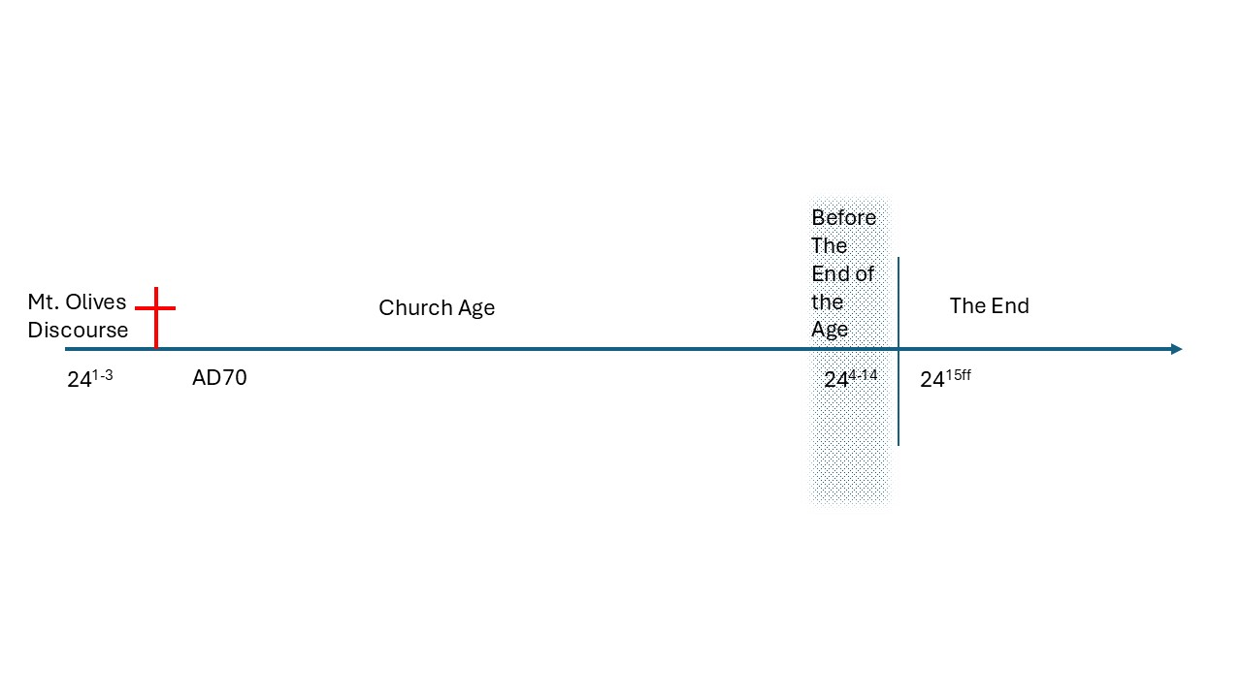 Vss 4-14 signs before the end of the age i.e. the church age we are in now B. Signs of the end of the age 1. many come in Jesus’ name many deceived 4-5
Take heed no one deceives you Take heed – warning, beware, be careful Deceives you – deceive, πλαναω, how they saw the planets, just wandering off the path, led astray
you – JS has in view future generations of ff, i.e. Christians
JS is talking to Jewish ff then, but future ff Christians could be Jew or Gentile
For many will come in My name saying I am the Christ
This pssg is usually taken to mean many saying they are the Christ
Charles Manson/Jim Jones/David Koresh/SunMyungMoon
This pssg also may Btakn 2mean mny com as representatives of JS
In this sense, it would cover the wide range of views of
Jesus Christ present in the modern church, many vu’s of JS
And will deceive many -lead them astray, be careful of ff personality
ff Scriptures
2. wars 6-7a [beginning of sorrows 8b]
Wars and rumors of wars – this sounds like history of the world any time
Do not be troubled, all these things must come, the end not yet
Nation rise against nation, kingdom against kingdom, perhaps inc. #’s
3. ‘natural’ disasters 7b
Famines, pestilences [Lkand earthquakes in various places
All these [wars and natural disasters] are the beginning of sorrows
These always happening, perhaps increasing #’s
4. tribulation 9-10
‘you’ will be delivered up to tribulation
Tribulation – great distress, suffering, severe trial
And kill you
And hated by all nations for My names [Christ] sake Mt5:11
Many be offended – caused to stumble
Betray one another
Hate one another
5. many false prophets deceive many 11
Many false prophets - proclaim false truth Mt7:15 sheep clothing but …
Show signs and wonders Mt24:24 – bcs it is a ‘wonder’ does not mean it
is from the Lord, Satan can also do ‘wonders’
false teachers bring in destructive heresies, deny the Lord 2Pt2:1
many false prophets gone out into the world 1J4:1
deceive many – many led astray
6. lawlessness abounds 12a
Lawlessness – with out law, without respect for laws of God and man
7. love of many grow cold 12b
Love growing cold – the time before the end will see the fervor for God
and things of God grow cold, people be indifferent, lukewarm
C. Trends of signs of the time of the end in 2026…
II. Preparing For The End of The Age
A. Take heed 4
open your eyes, be alert, study, get depth/training, learn to discern truth fm false
join a Bible study to sharpen yourself and help sharpen others
develop a substantial prayer life, Mt 26:40-41
B. Do not be troubled by signs of these things must take place before the end 6
Before the end, sorrowful times will come, we must not let troublesome times
trouble us excessively, God is working and this is what Jesus said would come
C. Need to endure 13
Endurance, perseverance to the end, i.e. through sorrowful times in the world
We cannot let troublesome times throw us off course
So hear of a new war, this may be part of the end of the age, consider that
D. Gospel preached in all the world 14
The great commission, we will see again in Mt28:18-20
Preach the gospel, must be preached as a witness to all the world and then the end
As a Christian U are an ambassador of Christ, U need to be able to share gospel

