Politics and Jesus
Matthew 14:1-13a
November 23, 2025
Introduction
I would like 2sho U 2scenes fm 1of my favorite movies: Mr Smith Goes To Washington
1st Scene U saw Mr. Smith …
2nd U saw Mr. Smith …
Whatever Uthink of politicians and politics,what they do will affect your life in some way
Tariffs will affect cost of things U might buy for Christmas
Renewable green energy will increase cost of your electric bill in the short term
Raising minimum wage increase of your purchase at any fast-food restaurant
Today look at one of the few passages in Scripture in which politics/politicians interacts
w JS, Mt 14:1-13a, last week hometown rejection, here political rejection
I. Politicians And Jesus 1-2
A. Politician - Herod the Tetrarch 1a
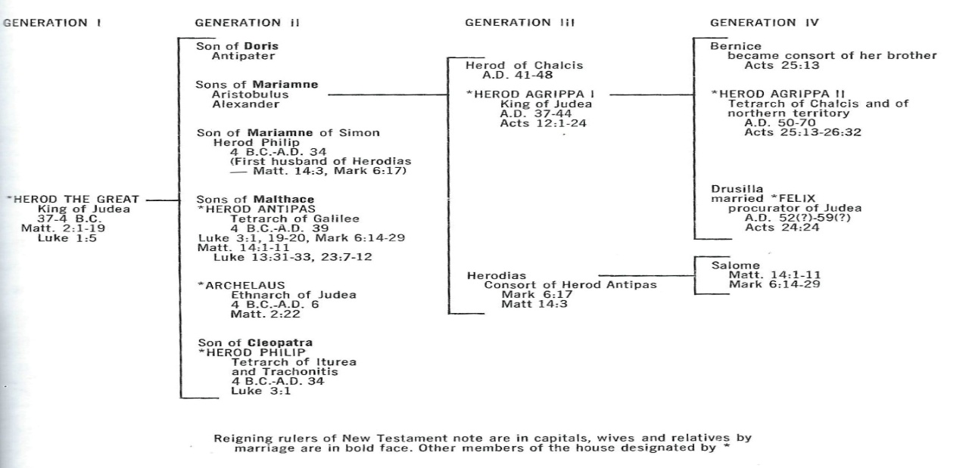
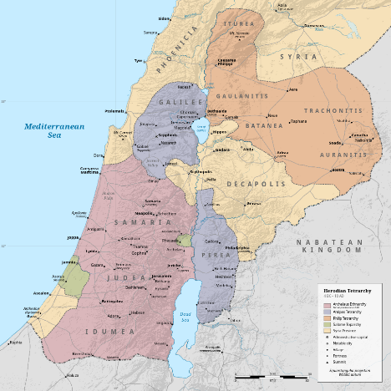
By Dega MD from Wikipedia
Archelaus Ethnarchy
Herod Antipas Tetrarchy
Herod Philip Tetrarchy
[or Philip]
Does this family sound like a dysfunctional family?
Pilate&the Romans wld constitute anther connection w secular Roman politicians
B. Politicians reading of Jesus 1b-2
Herod hears a report of JS – possibly of His powerful teaching, or a mighty work
Herod’s capital was Tiberias, Herod in his 32year of rule
Herod concludes that Jesus is John the Baptist risen from the dead – wrong view
Herod does nothing to investigate, he wants to see Lk9:9, but doesn’t go and see
Herod perhaps feels guilt, plenty to feel guilty about as we see in flashback

II. Politics And Jesus 3-12
This is a flashback, but it is presented here show intersection Herod, John, and Jesus
A. Politics – John the Baptist charge against Herod Antipas 3-12
Not a political issue for us, but Herod saw it as political
John said it was not lawful for Herod to have his brother Philip’s wife, Herodias
Herod had John arrested and imprisoned [probably in Machaerus]
Herod wanted to kill John but he feared popular support for John
Herod liked to listen to John Mk6:20
Herod’s birthday, after watching Herodias daughter [Salome fm Josephus]
sensuous dance, he makes a foolish vow
Salome asks for John’s head on a platter
Herod constrained by his oath and guests, he commanded John be killed and …
John’s disciples come and remove his body and buried it and tell Jesus
B. Politics and Jesus
I can only think of 5events in which politics/politicians and JS interact or intersect
1. Jesus birth
Caeser Augustus census, requires Joseph&Mary go to Bethlehem Lk2:1-7
King Herod orders slaughter of <2yr old males in Bethlehem Mt2¹⁶⁻¹⁸
2. JS traveling toward Jerusalem told by some P’s Herod wants to kill Him Lk13³¹
3. Pharisee Q of JS is it lawful to pay taxes to Caesar Mt22¹⁷,Mk12¹⁴,Lk20²²
4. JS trials and death sentence Mt27^{1-31. 62-66} Lk23¹⁻²⁵ J18²⁸⁻³⁸ 19¹⁻²⁴
5. Jesus hearing of John the Baptist’s death Mt14:1-13a, Mk6:14-29, Lk9:7-9
C. Nonpolitical connection of Jesus and John – connection of a religious/spiritual nature
Mt3 at JS baptism
Mt 4:12 hears of John being put in prison
Mt9:14 John’s disciples ask about fasting
Mt11:2 John’s inquiry if Jesus was the One or another coming
Here Mt 14 where the political aspect comes with Herod
III. Jesus And Politicians/Politics 13a
A. Jesus hears and departs to a lonely place by boat by Himself
He hears, He departs, He grieves John’s death
Nothing political in Jesus actions
B. Jesus and politicians/politics
Jesus ignores the politics associated with the arrest of John the Baptist.
Jesus does not speak about injustice and righting a wrong, freedom of speech…
Jesus was not perceived as a threat to Rome when Pilate asked if He was a king
Jesus avoided taking political positions, His interaction w Pilate was respectful
Lessons
1. Low morals may not be inevitable but is found in political families.
2. politicians may make foolish statements that they later have to live with the consequences.
3. Politically motivated people may use all means at their disposal to seek revenge and nurse
grudges.
4. Compromise is in the nature of the work of politicians, but Christians should be careful of any
compromise on moral issues i.e. issues relating to right/wrong in the sight of God.
5. Politicians view of Jesus may be based on the wrong facts or their interpretation.
6. Politicians may seek to use religious figures for political advantage or disadvantage
7. If we follow Jesus example, we will realize that it is not through political issues that
change is affected but through lives transformed by the gospel. This is not to say
that we should avoid politics. There were many political issues that Jesus did not
address: slavery, emperor worship, women’s rights, plight of the poor…
8. In Mt 14 we have the clearest example of Jesus interaction with the political world
over a political issue. To the secularist Herod Antipas, Jesus departs.
9. Jesus did not give direct guidance on how His followers should be involved in politics
and leading. Jesus was training His disciples as a spiritual minority in the world.
For them, God must always be central in their decision making and leadership.

