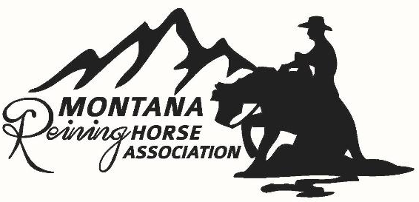
MONTANA REINING HORSE ASSOCIATION

New Date!! August 19-22, 2026 Majestic Valley Arena, Kalispell MT

The Montana Reining Horse Association is excited to again promote the growing sport of Reining in Montana. Providing the only large-scale reining show in the State, the committee is continuing to expand and innovate to create a Premier Event. We thank all our sponsors for their continued support and ask that you please consider financially supporting the MRHA. Generous sponsorships help the show have success, but also fund additional added money, prizes, and a broader promotion of the show. Without the support of our generous sponsors, we would not be able to produce a quality show and incentivize travel to our beautiful Montana. We sincerely appreciate everyone’s support!

Below are the sponsorship levels we hope you will consider. We are contacting you NOW to ensure that you can be promoted through our advertising materials, and digital media marketing campaigns. Remit payment now through our website, and/or pledge your support (through a future dedication of funds) by filling out the form and submitting it to the address below. Please contact Kathy Creighton Smith (406) 949-250. THANK YOU!

PREMIER SPONSORSHIP $4,000+

- Recognition of sponsorship in all Big Sky Reining classic promotional advertising and digital marketing.
- Live streaming feed with commercial opportunities
- FEATURED: Derby, Futurity or Maturity Class named after Sponsor. Sponsor name listed on NRHA show billing and engraved on NRHA Bronzes and trophies
- Prime positioning of arena banner for photo ops.
- Continuous acknowledgement over PA system throughout the show.
- Spotlight listing on Montana Reining Horse Association website and digital media at various times throughout the year.

PLATINUM SPONSORSHIP $2,500 +

- Recognition of sponsorship in all Big Sky Reining classic promotional advertising and digital marketing
- Live streaming feed recognition
- Non Pro Derby, Futurity and Maturity class named after Sponsor. Sponsor name listed on NRHA show billing and engraved on NRHA Bronzes and trophies
- Prime positioning of arena banner
- Continuous acknowledgement over PA system throughout the show
- Continuous listing on Montana Reining Horse Association website and digital media.

GOLD SPONSORSHIP $1,000+

- Recognition of sponsorship in all Big Sky Reining classic promotional advertising and digital marketing
- Live streaming feed recognition
- Arena banner placement
- Continuous acknowledgement over PA system throughout the show
- Listing on Montana Reining Horse Association website and digital media.

SILVER SPONSORSHIP $500+

- Sponsorship referenced on Big Sky Reining classic promotional advertising and digital marketing
- Live streaming feed recognition
- Arena banner placement
- Periodic acknowledgement over PA system throughout the show
- Listing on Montana Reining Horse Association website and digital media.

BRONZE SPONSORSHIP $250+

- Sponsorship referenced on Big Sky Reining classic promotional advertising and digital marketing
- Arena banner placement
- Periodic acknowledgement over PA system throughout the show
- Listing on Montana Reining Horse Association website

FRIEND OF MRHA under $250.

- With a generous contribution of up to $250, enables the Montana Reining Horse Association to continue to promote the sport of Reining in Montana. Thank you!

MONTANA REINING HORSE ASSOCIATION
SPONSORSHIP FORM 2026

Name of sponsorship: ___________________________________________________________________

Level of sponsorship: Premier Sponsor ($4,000+) $___________

Platinum Sponsor ($2,500+) $___________

Gold Sponsor ($1,000+) $___________

Silver Sponsor ($500+) $___________

Bronze Sponsor ($250+) $___________

Friend of MRHA Sponsor (up to $250) $___________

Are you part of a group making a sponsorship pledge? YES NO Group Name: __________________
Website address to link with Montana Reining Association website:___________________________

N/A or no preference.

PREMIER, PLATINUM & GOLD Sponsors please provide a high-quality digital copy of your LOGO to Grayson Buckner (gcott4@gmail.com) to be included in all advertising for the Big Sky Reining Classic.

N/A or not interested.

RV site with power needed? # of RV sites requested: __________

Name on each site: __________________________________________________________________________

Number of Stalls requested: ________________ (all cancellations must be completed 48hrs in advance of show.)

Number of paid warm-ups requested: __________________

Name: ________________________________________________________________

Address: ______________________________________________________________

City/State/Zip: __________________________________________________Contact phone:

Email Address: _________________________________________________________

Currently, early booking of RV sites and stall assignments are prioritized by sponsorship level and receipt of funds prior to July 1, 2026.

Please fill out and remit to:
Laura Bakker
2220 36th Avenue
Missoula, MT 59804
or online at montanareining.com, events, Big Sky Reining Classic, 2025 Sponsorship brochure.

Any questions please contact: Kathy Creighton-Smith 406 949-2505

