Kim’s Listening Registration Form

Swampy & Angel Pty Ltd trading as Kim’s Listening

ABN 17 638 218 309

**Client Demographic Information**

|  |  |
| --- | --- |
| **Client Name:**  **Date of Birth:** | |
| **Street Address:**    **Suburb: Post Code:** | |
| **Email address:** | |
| **Mobile phone:** | |
| **I identify my gender as:**  **Or My pronouns are:** | **Relationship status:**  **Number of children:** |
| **Referred by:**  **Or how did you find me?** | |
| **Emergency Contact Person:**  **Relationship or connection:**  **Emergency Contact Phone:** | |
| **Is there a history of drug use?**  **If yes, what is your choice of drug?**  **How often?** | |
| **Do you feel you self-medicate with alcohol?** | |

|  |  |
| --- | --- |
| **Any Professional diagnosis** | **Medication List** |
|  |  |

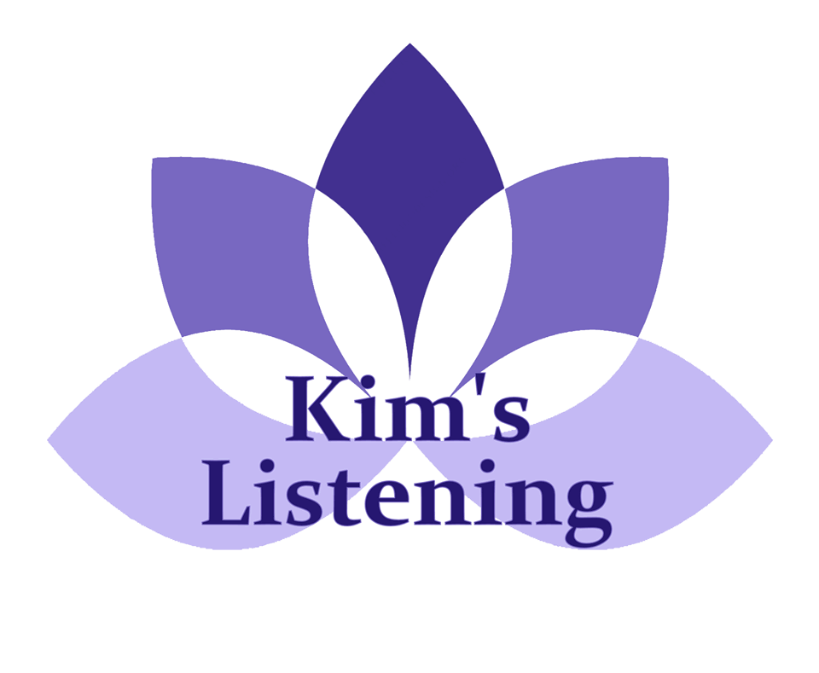

**Signature:** _______________________________________

**Date:** ___________________________________________