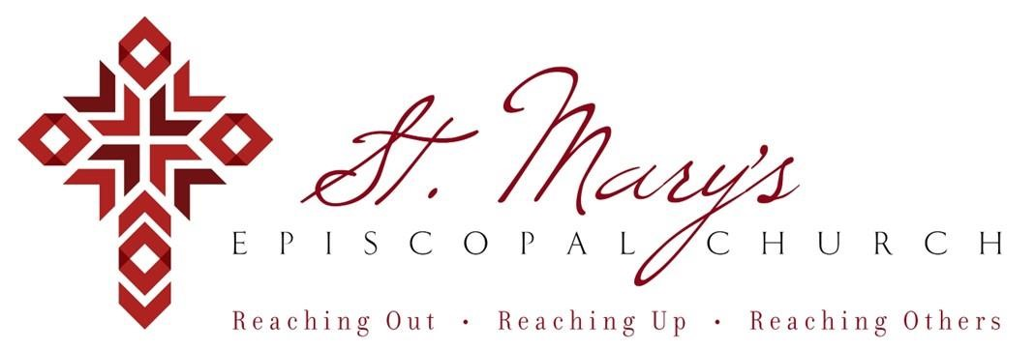

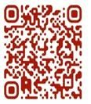 Welcome to St. Mary’s! If you are new to our parish, you may use your smartphone’s camera to open the QR Code. This will allow you to let us know that you were here. We will send you a return email, but we will not add you to any mailing list unless you explicitly ask to be added. Thank you for blessing us with your presence. Please come and share some coffee or tea and a conversation in the Parish Hall today after the 10 a.m. service.

**Receiving Communion**

We invite all baptized persons, regardless of age, to receive Holy Communion this morning. If you are not yet baptized, you are invited to come forward during Communion to receive a blessing from the priest.

**Weekday Morning Prayer**

Morning Prayer is a foundational part of Anglican/Episcopal spirituality.

All are welcome to join Father Mark at 9a.m. on Mondays, Tuesdays, and Thursdays. During the school year, Father Mark leads the chapel at our school on Wednesdays. Come and pray with Father Mark as you are able – he would love extra company during morning prayers.

**Weekly Prayers: September 21, 2025**

**Our Cycle of Prayer**

Please pray for Province of the Episcopal Church of South Sudan, Bishop Poulson, our Diocesan Bishop; and for Daniel, Bishop of our Companion Diocese of Uruguay and the Presiding Bishop, Sean Rowe, Justin, The Archbishop of Canterbury.

**For our World:**

Please remember the people in Gaza, Iran, Israel, Lebanon, Syria, Yemen, Ukraine, and Russia.

**For those in need:**

Kyle, Dorothy, Jimmie, Donna, Carol, Pam, Shirley, Dennis, Henry

**For those who have died:**

Tom, Janita, Linda, Vlad

**CHRISTIAN FORMATION:**

**Wired Word**

9:00 a.m. each Sunday

**Men’s Study Group**

Meeting Thursday’s at 7:00pm

Please join us in the faith development of the Church.

**MUSIC for Sunday, 9/21/25:**

H entrance hymn

H sequence hymn

H pre-communion hymn

H recessional hymn

Church Parishioners are welcome to enter the Chili Cook off

**Annual Pet Blessing**

**3p.m. on Sunday, October 5th**

**Save The Date ~ Saturday, Oct. 18th**

**Volunteering Opportunity**

9:30a.m. shift at the Regional Food Bank

~Wear your St. Mary’s Tee

**Baptism Day**

**Sunday, November 2nd**

November 2nd is the next baptismal day at St. Mary’s. Baptisms are a grand occasion for the church. The day is filled with hope, joy, and a statement of purpose for a community that is called to follow Jesus.

Blessings,

Mark+

**Save The Date ~ Sat, November 15th**

Send off for Father Mark will be held on

Saturday, November 15th

6p.m.at Oak Tree Country Club

**Join us weekly for Sunday Service at 8a.m. and 10a.m. ~ St. Mary’s 405-341-3855**