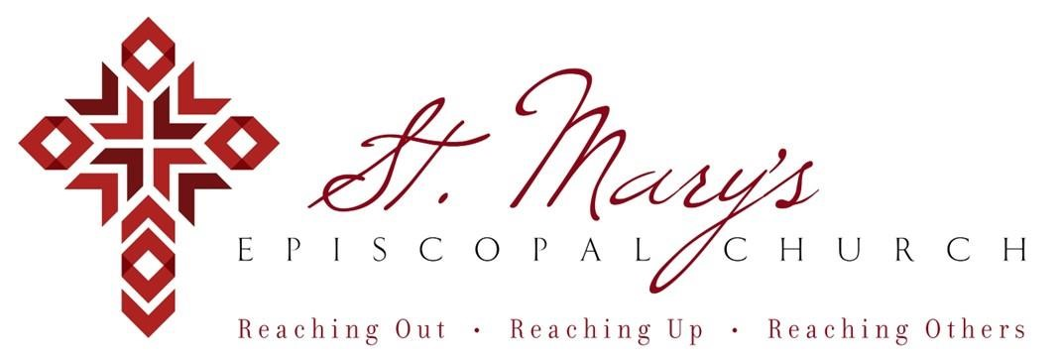

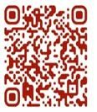 Welcome to St. Mary’s! If you are new to our parish, you may use your smartphone’s camera to open the QR Code. This will allow you to let us know that you were here. We will send you a return email, but we will not add you to any mailing list unless you explicitly ask to be added. Thank you for blessing us with your presence. Please come and share some coffee or tea and a conversation in the Parish Hall today after the 10 a.m. service.

**Receiving Communion**

We invite all baptized persons, regardless of age, to receive Holy Communion this morning. If you are not yet baptized, you are invited to come forward during Communion to receive a blessing from the priest.

**Weekday Morning Prayer**

Morning Prayer is a foundational part of Anglican/Episcopal spirituality.

All are welcome to join Father Mark at 9a.m. on Mondays, Tuesdays, and Thursdays. During the school year, Father Mark leads the chapel at our school on Wednesdays. Come and pray with Father Mark as you are able – he would love extra company during morning prayers.

**Weekly Prayers: October 12, 2025**

**Our Cycle of Prayer**

Please pray for The Church of the Province of Uganda, Bishop Poulson, our Diocesan Bishop; and for Daniel, Bishop of our Companion Diocese of Uruguay and the Presiding Bishop, Sean Rowe, Justin, The Archbishop of Canterbury.

**For our World:**

Please remember the people in Gaza, Iran, Israel, Lebanon, Syria, Yemen, Ukraine, Sudan, and Russia.

**For those in need:**

Kyle, Janet, Andrea, Diane, Silas, Emily, Danny, Tim, Rosaleen, John, Joyce, Sloan

**For those who have died:**

Jimmie, Stanley

**CHRISTIAN FORMATION:**

**Wired Word**

9:00 a.m. each Sunday

**Men’s Study Group**

Meeting Thursday’s at 7:00pm

Please join us in the faith development of the Church.

**MUSIC for Sunday, 10/12/25:**

H493 entrance hymn

H628 sequence hymn

H411 pre-communion hymn

H655 recessional hymn

**Share A Meal**

It's no fun to cook for just 2 people, so it's nice to have Millie's Table prepare a meal for you.  Please consider contributing to the Dennis & Janet Weigand's fund at Millie's Table.  You may pop by or call them to donate.  Then weekly, Janet can call in her orders and have a delicious meal.

Thanks for considering helping to provide a meal for our long-time wonderful members.

Millie's Table

[1333 N. Santa Fe Ave](https://www.google.com/maps/search/1333+N.+Santa+Fe+Ave+%0D%0A+%0D%0A+Edmond,+OK+73003?entry=gmail&source=g)

[Edmond, OK 73003](https://www.google.com/maps/search/1333+N.+Santa+Fe+Ave+%0D%0A+%0D%0A+Edmond,+OK+73003?entry=gmail&source=g)

(Danforth and Santa Fe behind CVS)

405-330-9156

**Father Mark’s Farewell Dinner**

**Sign up ~ Sat, November 15th**

Scan the evite QR code below and join us!

**FREE MUSIC**

**Sunday, November 23rd**

The University of Central Oklahoma School of Music will be having its 2025 Winter Choral Concert at St. Mary’s Episcopal Church on Sunday, November 23, 2025, 4:00 p.m.  The concert will feature the University Choir, Cantilena and Concert Chorale, directed by Keegan Rose and Dr. Karl Nelson.  In addition to a combined performance of the 20th Century masterpiece, Gloria by Francis Poulenc, the choirs will also perform works by Gjeilo, Stanford, Vaughan Williams and more.  Join us for an afternoon of beautiful choral music with the UCO Choirs.

**Join us weekly for Sunday Service at 8a.m. and 10a.m. ~ St. Mary’s 405-341-3855**