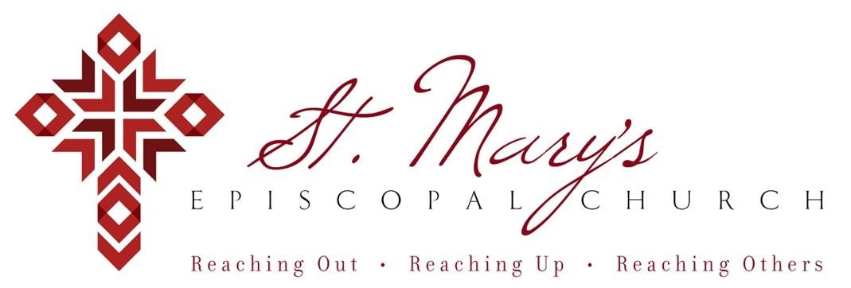

 Welcome to St. Mary’s! If you are new to our parish, you may use your smartphone’s camera to open the QR Code. This will allow you to let us know that you were here. We will send you a return email, but we will not add you to any mailing list unless you explicitly ask to be added. Thank you for blessing us with your presence. Please come and share some coffee or tea and a conversation in the Parish Hall today after the 10 a.m. service.

Receiving Communion
We invite all baptized persons, regardless of age, to receive Holy Communion this morning. If you are not yet baptized, you are invited to come forward during Communion to receive a blessing from the priest.

Weekday Morning Prayer
Morning Prayer is a foundational part of Anglican/Episcopal spirituality.
All are welcome to join Father Mark at 9a.m. on Mondays, Tuesdays, and Thursdays. During the school year, Father Mark leads the chapel at our school on Wednesdays. Come and pray with Father Mark as you are able – he would love extra company during morning prayers.

Weekly Prayers: November 2, 2025
Our Cycle of Prayer
Please pray for The Church of the Province of West Africa, Bishop Poulson, our Diocesan Bishop; and for Daniel, Bishop of our Companion Diocese of Uruguay and the Presiding Bishop, Sean Rowe, Justin, The Archbishop of Canterbury.

For our World:
Please remember the people in Gaza, Iran, Israel, Lebanon, Syria, Yemen, Ukraine, Sudan, and Russia.
For those in need:
Kyle, Andrea, Diane, Danny, Silas, Emily, Sloan, Tim, Joyce, John, Annette, Laura
For those who have died:
Stanley, Dick, Ann

CHRISTIAN FORMATION:
Wired Word
9:00 a.m. each Sunday

Men’s Study Group
Meeting Thursday’s at 7:00pm
Please join us in the faith development of the Church.

MUSIC for Sunday, 11/2/25:
H287 entrance hymn
H279 sequence hymn
H293 pre-communion hymn
H618 recessional hymn
Mission Opportunity
Let’s help raise money for St. Silas Church in Nigeria, Charity Ibe’s hometown Church.

- Make your checks payable to St. Mary’s
- Designate St. Silas in the memo
- Please return the checks by Nov. 2nd!

LADIES NIGHT OUT
Friday, November 7th @6:30p.m.
Interurban
Join us if you can!

MEN’S DINNER
Friday, November 7th @7:00p.m.
Steak in our Parish Hall

PILLOWCASE MINISTRY
Wednesday, November 12th
10a.m. Canterbury Room
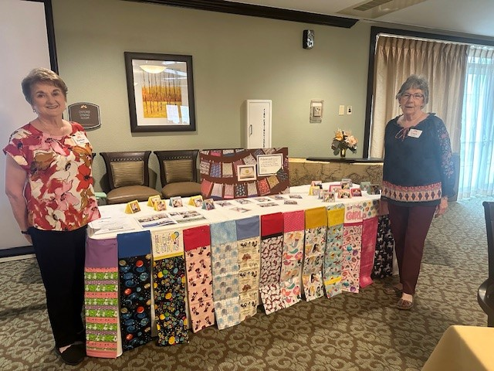

FREE MUSIC
Sunday, November 16, 2025 – 5:00 p.m.
Choral Vespers & Prelude Recital at Our Lady of Perpetual Help Cathedral in Oklahoma City
The choir will sing works by Walford Davies, Ernest Bullock, and Herbert Howells. The prelude recital will be played by Olivia Burke, Director of Music at St. Mary’s Episcopal Church, Edmond.

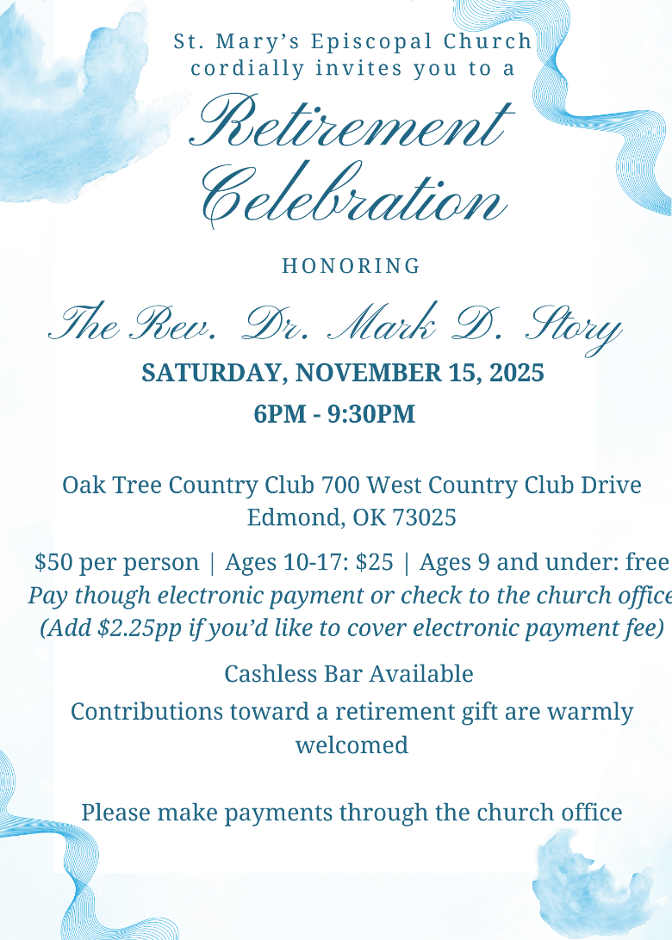


FREE MUSIC
Sunday, November 23rd
The University of Central Oklahoma School of Music will be having its 2025 Winter Choral Concert at St. Mary’s Episcopal Church on Sunday, November 23, 2025, 4:00 p.m. The concert will feature the University Choir, Cantilena and Concert Chorale, directed by Keegan Rose and Dr. Karl Nelson. In addition to a combined performance of the 20th Century masterpiece, Gloria by Francis Poulenc, the choirs will also perform works by Gjeilo, Stanford, Vaughan Williams and more. Join us for an afternoon of beautiful choral music with the UCO Choirs.

Join us weekly for Sunday Service at 8a.m. and 10a.m. ~ St. Mary’s 405-341-3855

