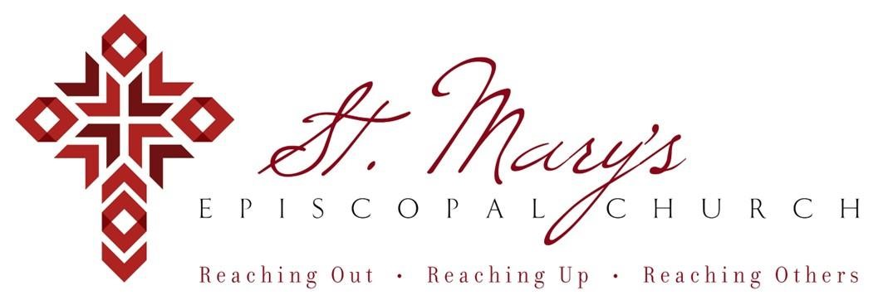

 Welcome to St. Mary’s! If you are new to our parish, you may use your smartphone’s camera to open the QR Code. This will allow you to let us know that you were here. We will send you a return email, but we will not add you to any mailing list unless you explicitly ask to be added. Thank you for blessing us with your presence. Please come and share some coffee or tea and a conversation in the Parish Hall today after the 10 a.m. service.

**Receiving Communion**

We invite all baptized persons, regardless of age, to receive Holy Communion this morning. If you are not yet baptized, you are invited to come forward during Communion to receive a blessing from the priest.

**Weekday Morning Prayer**

Morning Prayer is a foundational part of Anglican/Episcopal spirituality.

All are welcome to join Father Mark at 9a.m. on Mondays, Tuesdays, and Thursdays. During the school year, Father Mark leads the chapel at our school on Wednesdays. Come and pray with Father Mark as you are able – he would love extra company during morning prayers.

**Weekly Prayers: July 27, 2025**

**Our Cycle of Prayer**

Please pray for The Anglican Church of Papua New Guinea, Bishop Poulson, our Diocesan Bishop; and for Daniel, Bishop of our Companion Diocese of Uruguay and the Presiding Bishop, Sean Rowe, Justin, The Archbishop of Canterbury.

**For our World:**

Please remember the people in Gaza, Israel, Ukraine, Lebanon, Syria, Yemen, Russia, and Iran.

**For those in need:**

Kyle, Lois, Bob, Donna, Dominique, Lawrence (Wayne), Diane, Linda, Kimberly, Annabelle, Pascolina, Richard

**For those who have died:**

Ron & Vivian, Janae, Roger and Evalyn, Launi

**CHRISTIAN FORMATION:**

**Wired Word**

9:00 a.m. each Sunday

**Men’s Study Group**

Meeting Thursday’s at 7:00pm

Please join us in the faith development of the Church.

**MUSIC for Sunday, 7/27/25:**

H488 entrance hymn

H47 sequence hymn

H635 recessional hymn

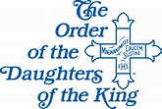

**SAVE THE DATE – August 10th**

The Daughters of the King is an International Order of women who vow their prayers and service to God. At St. Mary's, we have a chapter named Emmanuel. The Emmanuel Chapter of Daughters of the King invite all the church women to a DOK Tea Party right after church on Sunday, August 10, in the Canterbury Room. We will share with you some goodies and what it means to be a member of the Order of Daughters of the King, and answer questions about the order and the process of becoming a Daughter. We hope you will be able to join us. We scheduled it right after church in hopes that if you have family with you, perhaps they can have a good time and enjoy treats in the Parish Hall while waiting for you. It will last about 30 to 45 minutes. We look forward to seeing all of you there!

**Directory Photos**

Come to the Cranmer Room for your photos today, Sunday, July 27th at 9:45am – 11:45am or pop into the office one day soon.

**BASEBALL**

Sign up today for a night out for a baseball game with St. Mary's Church.  $25.00 per ticket includes all you can eat and drink (softdrinks) from 6pm - 7:45pm, with a 7:05pm game start time.  There will be a free hat and wristband to go through all you can eat area on the 2nd floor terrace near the 3rd baseline.  Look out for the name recognition on the monitors too.

Sign up on the weekly update email or call the office and we can assist. Get the payment to the office and we will email you the tickets!



**Listening to the Gospels**

**Creating a Spiritual Habitus**

Sign up on our website for Father Marks sessions on studying the bible. Tuesday Aug 12, 19, & 26 @10:45a.m. or Thursday Aug. 14, 21, & 28 at 6:45p.m. We hope to see you there!

**Join us weekly for Sunday Service at 8a.m. and 10a.m. ~ St. Mary’s 405-341-3855**