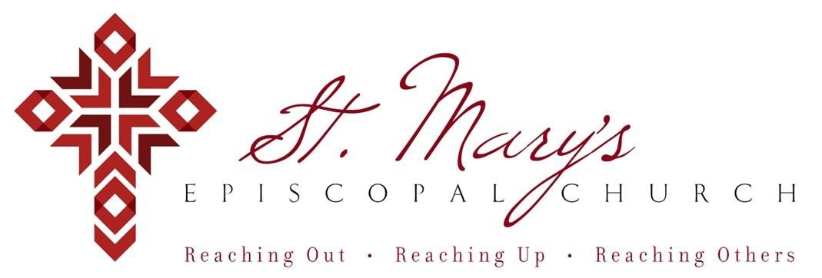

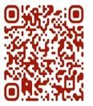 Welcome to St. Mary’s! If you are new to our parish, you may use your smartphone’s camera to open the QR Code. This will allow you to let us know that you were here. We will send you a return email, but we will not add you to any mailing list unless you explicitly ask to be added. Thank you for blessing us with your presence. Please come and share some coffee or tea and a conversation in the Parish Hall today after the 10 a.m. service.

Receiving Communion
We invite all baptized persons, regardless of age, to receive Holy Communion this morning. If you are not yet baptized, you are invited to come forward during Communion to receive a blessing from the priest.

Weekly Prayers: December 14, 2025
Our Cycle of Prayer
Please pray for Igreja Episcopal Anglicana do Brasil, Bishop Poulson, our Diocesan Bishop; and for Daniel, Bishop of our Companion Diocese of Uruguay and the Presiding Bishop, Sean Rowe, Justin, The Archbishop of Canterbury. For our supply clergy, Dwight and Dion.

For our World:
Please remember the people in Gaza, Iran, Israel, Lebanon, Syria, Yemen, Ukraine, Sudan, and Russia.

For those in need:
Kyle, Diane, Annette, Annabelle, Lois, Phylis, Deb. Laura, Beverly, Greg, Albert

For those who have died:
Rev. Edwin, John Hayes

CHRISTIAN FORMATION:
Wired Word
9:00 a.m. each Sunday

Men’s Study Group
Meeting Thursday’s at 7:00pm
Please join us in the faith development of the Church.

MUSIC for Sunday, 12/14/25:
H76 entrance hymn
H64 sequence hymn
H640 pre-communion hymn
WLP724 recessional hymn
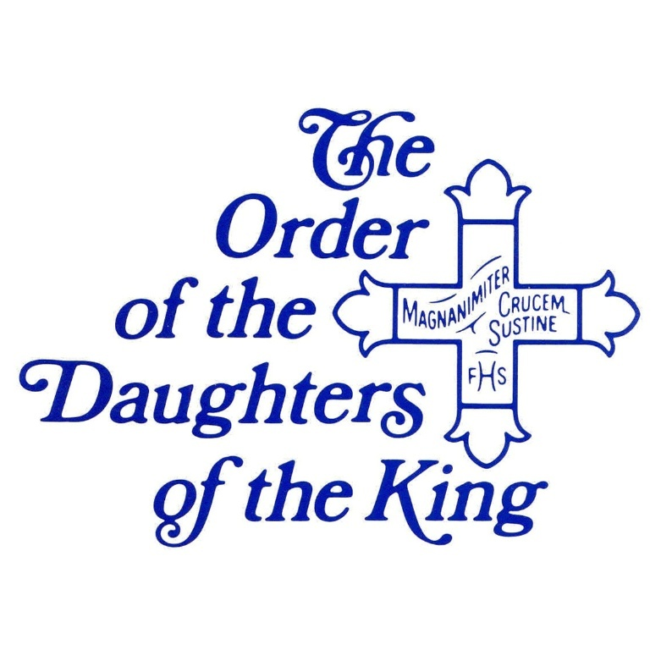
Please consider adopting a child this Christmas by taking an angel from the tree and returning the gifts unwrapped with Angel (the letter and number) as soon as possible.

CHRISTMAS PAGEANT NEWS:
We are excited to begin planning our St. Mary's Christmas Pageant. Last year, we were so happy to have over twenty children and grandchildren from our parish (from toddlers to teens) help us tell the story of the birth of Jesus. We would love to see everyone participate again and look forward to inviting students and families from St. Mary's School to join us in this Christmas Eve tradition.

Please contact Cindy McCook at clfmccook@gmail.com or call/text 214-773-4913 to let her know if you can participate and she will get back to you with details.

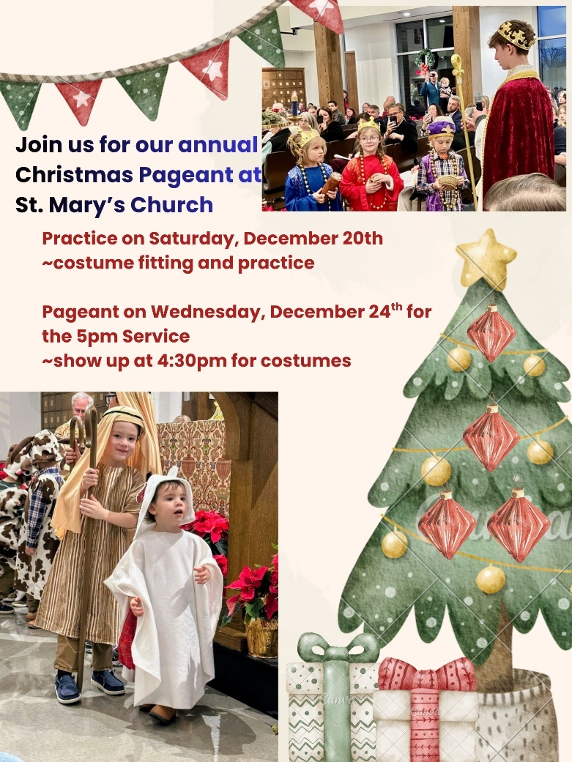

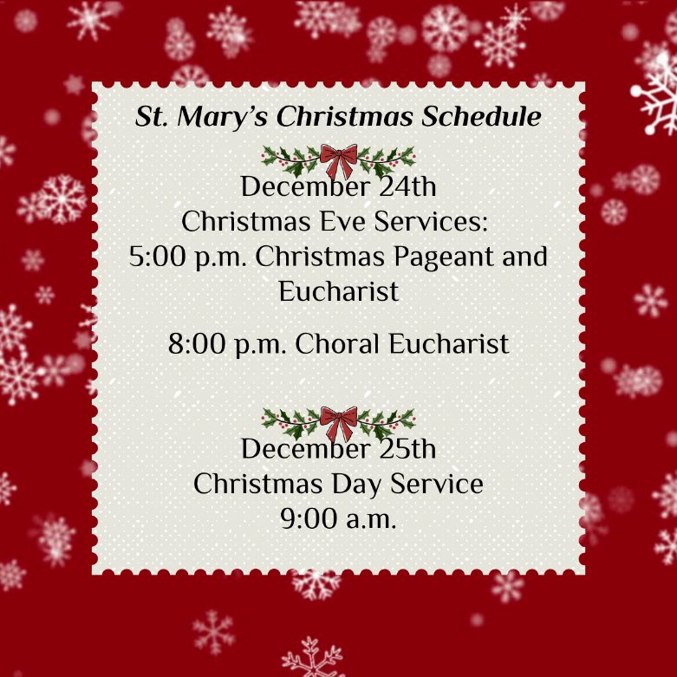

Join us weekly for Sunday Service at 8a.m. and 10a.m. ~ St. Mary’s 405-341-3855

