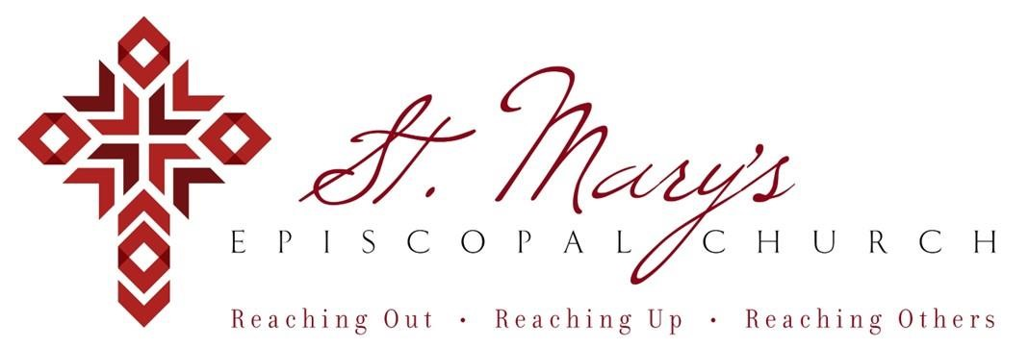

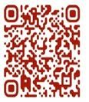 Welcome to St. Mary’s! If you are new to our parish, you may use your smartphone’s camera to open the QR Code. This will allow you to let us know that you were here. We will send you a return email, but we will not add you to any mailing list unless you explicitly ask to be added. Thank you for blessing us with your presence. Please come and share some coffee or tea and a conversation in the Parish Hall today after the 10 a.m. service.

**Receiving Communion**

We invite all baptized persons, regardless of age, to receive Holy Communion this morning. If you are not yet baptized, you are invited to come forward during Communion to receive a blessing from the priest.

**Weekday Morning Prayer**

Morning Prayer is a foundational part of Anglican/Episcopal spirituality.

All are welcome to join Father Mark at 9a.m. on Mondays, Tuesdays, and Thursdays. During the school year, Father Mark leads the chapel at our school on Wednesdays. Come and pray with Father Mark as you are able – he would love extra company during morning prayers.

**Weekly Prayers: August 17, 2025**

**Our Cycle of Prayer**

Please pray for the Scottish Episcopal Church, Bishop Poulson, our Diocesan Bishop; and for Daniel, Bishop of our Companion Diocese of Uruguay and the Presiding Bishop, Sean Rowe, Justin, The Archbishop of Canterbury.

**For our World:**

Please remember the people in Gaza, Iran, Israel, Lebanon, Syria, Yemen, Ukraine, and Russia.

**For those in need:**

Kyle, Lois, Bob, Annabelle, Pascolina, Richard, Dorothy, Jimmie, Donna, Carol

**For those who have died:**

Norma

**CHRISTIAN FORMATION:**

**Wired Word**

9:00 a.m. each Sunday

**Men’s Study Group**

Meeting Thursday’s at 7:00pm

Please join us in the faith development of the Church.

**MUSIC for Sunday, 8/17/25:**

H366 entrance hymn

H636 sequence hymn

H344 recessional hymn

**Listening to the Gospels**

**Creating a Spiritual Habitus**

**~Beginning this week**

Father Marks sessions on studying the bible are on Tuesday Aug 12, 19, & 26 @10:45a.m. or Thursday Aug. 14, 21, & 28 at 6:45p.m. We hope to see you there!

**St. Mary’s T-Shirts**

Our new St. Mary's T-shirts are in and ready for distribution. On Sunday, please stop by the table in the Parish Hall to pick up yours. If you have not yet paid, bring cash or a check to get your shirts. We also have some extra tees on hand for anyone who wants to purchase now. The price is $18.00 per shirt, with select sizes available. Questions? Contact Anne Rener at 214-725-8438 or [writesideout@yahoo.com](mailto:writesideout@yahoo.com).

**Save The Date - Sunday, August 24th 5p.m. ~ Parish Hall**

**Saints and Sinners Dinner Group**

The Saints and Sinners dinner groups will start up in the fall (September) following a potluck dinner on August 24th at 5:00 p.m. in the Parish Hall.

If you would like to join a group or have questions, contact either Jackie Shields (405-403-8251), Amber Austin (405-623-9175) or Kathy Alvarez (405-206-7815). We will be delighted to talk with you.

We look forward to another season of fellowship together. A list of groups will be sent prior to the kick-off potluck in August. Bring your favorite dish (does not matter what) and you will sit together with your new group.

 ~Jackie, Amber & Kathy

**Save The Date - Sunday, Sept. 7th 11:30a.m. ~ Parish Hall**

End of the summer get-together luncheon. Hotdogs & Hamburgers provided and cooked by the Men’s Dinner Group.

**Baptism Day**

**Sunday, November 2nd**

November 2nd is the next baptismal day at St. Mary’s. Baptisms are a grand occasion for the church. The day is filled with hope, joy, and a statement of purpose for a community that is called to follow Jesus.

Blessings,

Mark+

**Save The Date ~ Sat, Nov 15th**

Send off for Father Mark will be held on Saturday, November 15th

@6p.m.

**Join us weekly for Sunday Service at 8a.m. and 10a.m. ~ St. Mary’s 405-341-3855**