

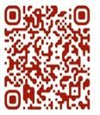 Welcome to St. Mary’s! If you are new to our parish, you may use your smartphone’s camera to open the QR Code. This will allow you to let us know that you were here. We will send you a return email, but we will not add you to any mailing list unless you explicitly ask to be added. Thank you for blessing us with your presence. Please come and share some coffee or tea and a conversation in the Parish Hall today after the 10a.m. service.

Receiving Communion
We invite all baptized persons, regardless of age, to receive Holy Communion this morning.

If you are not yet baptized, you are invited to come forward during Communion to receive a blessing from the priest.

Weekly Prayers: February 8, 2026
Our Cycle of Prayer
Please pray for Iglesia Anglicana de Chile, Bishop Poulson, our Diocesan Bishop; and for Daniel, Bishop of our Companion Diocese of Uruguay and the Presiding Bishop, Sean Rowe, Justin, The Archbishop of Canterbury. For our supply clergy, Dwight and Dion. For our interim Rector, The Rev. Nancy Cox.

For our World:
Please remember the people in Gaza, Iran, Israel, Lebanon, Syria, Yemen, Ukraine, Sudan, and Russia.

For those in need:
Kyle & Emily, Diane, Laura, Greg, Julie, Albert, Penny, Michelle, Dennis, Aubin, Lee

For those who have died:
Caroline, MaryRose, John, Otto, Carl

CHRISTIAN FORMATION:
Wired Word
9:00 a.m. each Sunday

Men’s Study Group
Meeting Thursday’s at 7:00pm
Please join us in the faith development of the Church.
TOPIC - Parables - The Mysteries of God's Kingdom Revealed through the Stories Jesus Told.
Author - John MacArthur

Children’s Formation
9:00a.m. each Sunday

MUSIC for Sunday, 2/8/26:
H372 entrance hymn
H601 sequence hymn
LEVAS 158 pre-communion hymn
H610 recessional hymn
ANNUAL MEETING
TODAY, Feb 8th

Please plan on joining us to vote and listen to the year in review from 2025.

See you today!

PANCAKE SUPPER
Tuesday, February 17th 6p.m.

Please sign up!
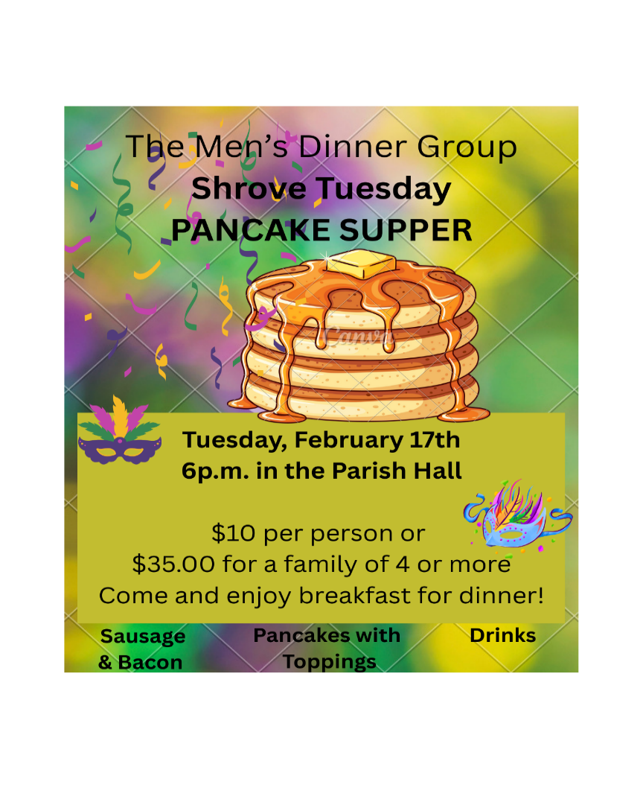
Save the Date
Sunday, 2/22/26 @11:30a.m.
Introduction to the study by Dr. Huneke PhD, Associate Professor of History and Geography from UCO
He will provide an introduction to a 6-week speaker series being presented on Wednesday nights 2/25 through 4/1 in memory of Dr. Richard Peters. Stay to hear if you’d like to attend!

Lenten Soup and Study – beginning 2/25
Wednesdays 5:30pm
Join up on the signup genius
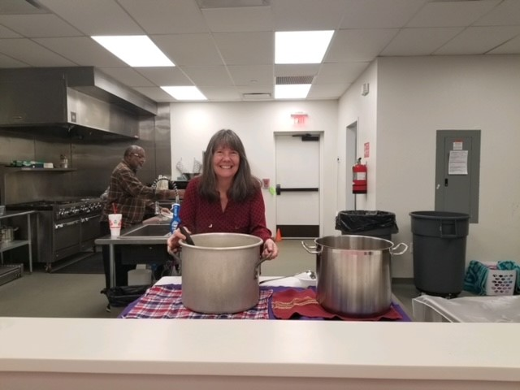


Saints & Sinners
Pot Luck Dinner will be held on Sunday, February 22nd – 5:30p.m. in the Parish Hall

Baptisms for 2026
- Easter Day, April 5th
- May 24th
- November 1st

Contact the office or Deacon Nancy if you are interested in a baptism.

Join us weekly for Sunday Service at 8a.m. and 10a.m. ~ St. Mary’s 405-341-3855

