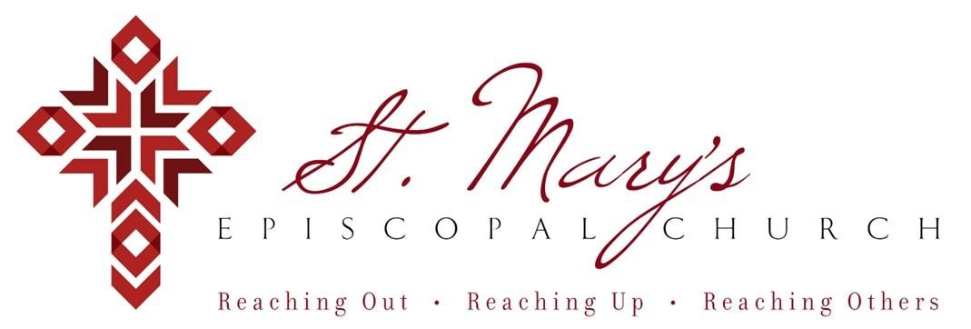

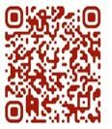 Welcome to St. Mary’s! If you are new to our parish, you may use your smartphone’s camera to open the QR Code. This will allow you to let us know that you were here. We will send you a return email, but we will not add you to any mailing list unless you explicitly ask to be added. Thank you for blessing us with your presence. Please come and share some coffee or tea and a conversation in the Parish Hall today after the 10a.m. service.

Receiving Communion
We invite all baptized persons, regardless of age, to receive Holy Communion this morning.

If you are not yet baptized, you are invited to come forward during Communion to receive a blessing from the priest.

Weekly Prayers: February 22, 2026
Our Cycle of Prayer
Please pray for The Church of Ireland, Bishop Poulson, our Diocesan Bishop; and for Daniel, Bishop of our Companion Diocese of Uruguay and the Presiding Bishop, Sean Rowe, Justin, The Archbishop of Canterbury. For our supply clergy, Dwight and Dion. For our interim Rector, The Rev’d Nancy Cox.

For our World:
Please remember the people in Gaza, Iran, Israel, Lebanon, Syria, Yemen, Ukraine, Sudan, and Russia.

For those in need:
Kyle & Emily, Diane, Laura, Greg, Julie, Albert, Penny, Michelle, Dennis, Aubin, Lee, Kathy

For those who have died:
John, Otto, Carl

CHRISTIAN FORMATION:
Wired Word
9:00 a.m. each Sunday

Men’s Study Group
Meeting Thursday’s at 7:00pm
Please join us in the faith development of the Church.
TOPIC - Parables - The Mysteries of God's Kingdom Revealed through the Stories Jesus Told.
Author - John MacArthur

Children’s Formation
9:00a.m. each Sunday

MUSIC for Sunday, 2/22/26:

H148 sequence hymn
H147 pre-communion hymn
H143 recessional hymn
Introduction to the study by Dr. Huneke PhD, Associate Professor of History and Geography from UCO
Sunday, 2/22/26 @11:30a.m.
Please stay to hear about this series

He will provide an introduction to a 6-week speaker series being presented on Wednesday nights 2/25 through 4/1 in memory of Dr. Richard Peters. Stay to hear if you’d like to attend!

Lenten Soup and Study – beginning 2/25
Wednesdays 5:30pm
Join up on the signup genius
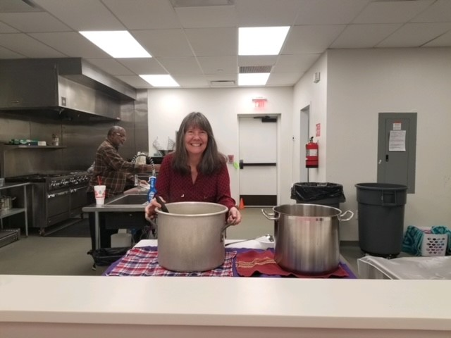

The topics for the remaining weeks are:
• Wednesday, March 4 at 6:30 p.m.: Michael Springer, Ph.D. will speak about religious migration and national identity, focusing on the Dutch Church in London in the seventeenth century and the work that UCO students have been doing there.
• Wednesday, March 11 at 6:30 p.m.: Erik Huneke, Ph.D. will deliver a lecture titled "The Historical Roots of the Alternative for Germany Political Party."
• Wednesday, March 18 at 6:30 p.m.: Sophia Clark, Ph.D. will deliver a lecture titled "Fairy Tale Films in East Germany."
• Wednesday, March 25 at 6:30 p.m.: Andrew Magnusson, Ph.D. will speak about the Israeli-Palestinian conflict.
• Wednesday, April 1 at 6:30 p.m.: Teresa Pac, Ph.D. will deliver a lecture titled "Social, Cultural, and Political Changes in Polish Nationalism from the Nineteenth Century to Modernity.

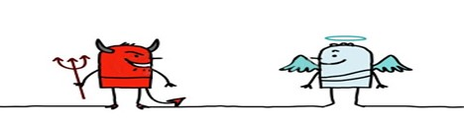
Saints & Sinners
Potluck Dinner TONIGHT, Sunday, February 22nd – 5:30p.m. in the Parish Hall

Baptisms for 2026
- Easter Day, April 5th
- May 24th
- November 1st

Contact the office or Deacon Nancy if you are interested in a baptism.

Join us weekly for Sunday Service at 8a.m. and 10a.m. ~ St. Mary’s 405-341-3855

