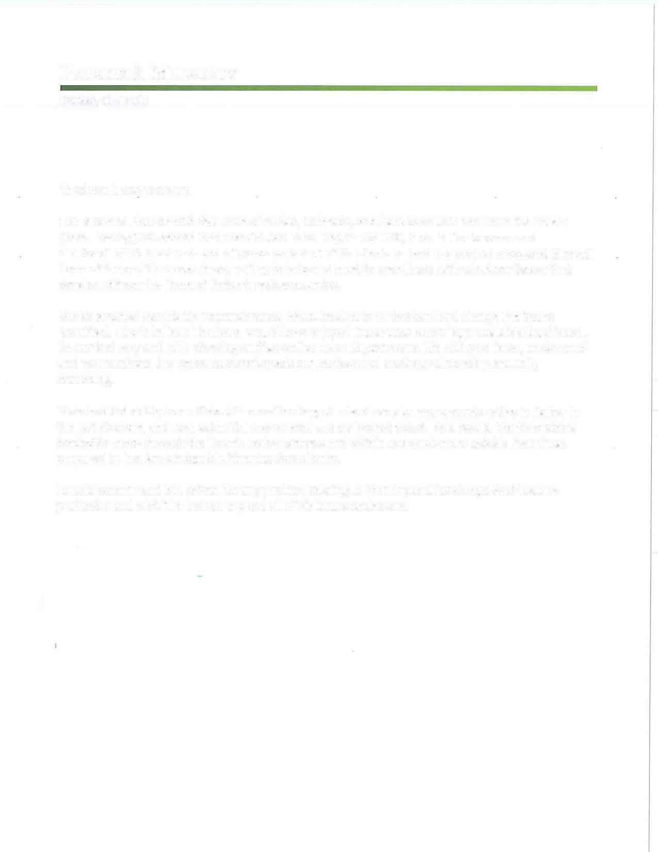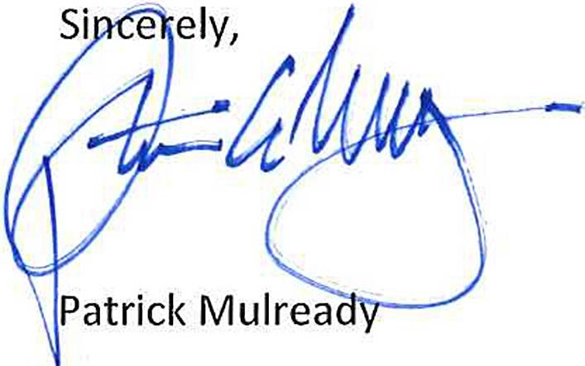PATRICK S. MULREADY

Pal'kel', Colorndo

To whom it may concern,

I am a Senior Planner with the Town of Parker, Colorado, and have been with the Town for sixteen years. Having just learned that Mark Wilson is no longer with THK, I would like to commend
him for all of his hard work and diligence on behalf of his clients on land use project processed through Town of Parker. Mark was always willing to help and meet to coordinate with whatever issues that developed from the Town of Parker's review agencies.

Mark's greatest asset is his responsiveness. Were he slow to understand and change the issues identified, I don't believe his clients would have enjoyed the success rate of approvals Mark achieved. He worked very well with planning staff as well as Town departments. His ability to listen, understand and communicate the Towns concern's made our professional working relationship mutually rewarding.

Mark had the ability to multi-task three of the largest mixed use planning projects active in Parker in the last six years, and each submittal was concise and well-constructed. As a result, Mark's projects tended to move through the Town's review process and obtain approvals more quickly than those prepared by less knowledgeable Planning Consultants.

I would recommend Mr. Wilson for any position relating to Planning and Landscape Architecture profession and wish him luck on any and all of his future endeavors.


United States Department of the Interior

IN REPLY REFER TO:
A3415 (GATE - DGS) June 30, 1995
NATIONAL PARK SERVICE
Gatewav National Recreation Area Headquarters Building 69
Flm·d Bennett Field Brookiyn, N.Y 11234

Mr. Dick Marshall OHM, Incorporated
1660 17 Street, Suite 400
Denver Colorado 80202 Dear Mr. Marshall:
It was with great regret that I received the telephone call from Mark Wilson last Friday letting
me know that he has accepted a position with another firm in the Denver area. We relied heavily on the skills and talents that Mark lent to the team that OHM, Inc. created to prepare planning and construction documents for our development projects here at Gateway.

Mark brought to the planning table an insight and freedom of thought that enabled our planning charettes to be thoughtful, highly productive, and always relevant. The synergy between the participants was often due to the cooperative spirit and willing ways that he added. He was always well prepared for his presentations to park management and his work conveyed well the essence of what we were trying to convey in the planning charettes. Creativity and imagination were always evident in his work.

We were fortunate to have him working with us because, surely, much of what we have been able to accomplish was due in a large part to his contributions. I wanted you to know these thoughts on Mark's departure from our efforts and your organization. I have wished him well in his new venture and I look forward to continued good work and relations from OHM. Inc.
r (
_5tncr·, - /-- ,-
/ ---{ \ : •Ji- • /

I• \ • • t-
, ' I ·,,

\ I '/1\,1 -\0 i \1 \ t.·.0\1>/ / ,
" t"
hurL Ste rt, '-· • --
Deputy General Superintendent

CC: Mark Wilson

51 05 OTC PARKWAY - SUITE 240 - GREENWOOD VILLAGE, CO 801 11 - 720.482.7707 - WWW.SDI-US.COM

September 27, 2016

To Whom It May Concern:
Our company has worked with Mark Wilson, as the primary planner, for over three years on the Hess Ranch Project in Parker, Colorado. We have appreciated all of his efforts, talents and hard work on the project.
Mark coordinated with all design and engineering team and was present at every meeting necessary to assist with planning and landscape architectural needs.
He developed several lotting studies as well as utility corridor studies that were instrumental in the 1,535 acres planned unit development Hess Ranch Project being successfully annexed and zoned into the Town of Parker.
Mark was always willing to help with the most difficult tasks and assist with the multitude of sub-projects that occur throughout the annexation and zoning process. He was quick to respond to us and the staff at the Town of Parker. His work efforts and the quality of his various work products was instrumental in obtaining unanimous Planning Commission and Town Council public hearings and votes. Mark's attention to details and creative and innovative ideas for parks and landscaping for the project were of great help while working with town staff. throughout the entire development process His efforts and plans working on the Hess Ranch Project enabled our development plans to be approved without any public comment.
It is a rare feat to get through any planning process in the Town of Parker without any negative public comment. I would recommend Mark for any additional planning assignments.

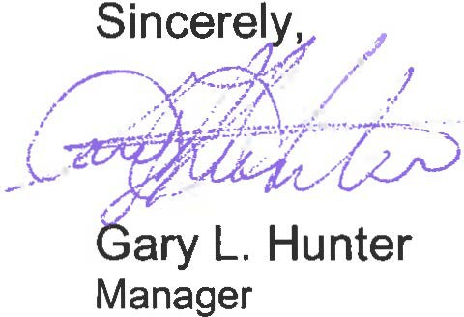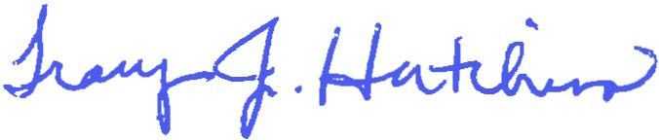

SRO, LLC

5105 DTC Parkway, Suite 240,
Tel: 720.482.7707
Tracy J. Hutchins
Director of Governmental Relations

SRO, LLC.

Greenwood Village, CO 80111
Fax: 720.482.7717

Reference: Mark Wilson
As a principal of OHM Design I hired Mark Wilson for a position with the firm as a Landscape Architect. Mark was a Senior Associate with the firm for over a decade (1985 to 1996). His responsibilities covered all aspects as a senior member of the firm. The duties ranged from conceptual design to construction document production and construction field review. Mark supervised a team of landscape architects with client responsibilities for deadlines and quality control. His people skills enabled him to deal with clients in both the private and public sectors. The projects under his supervision ranged from park and trail design to projects across the country for the National Park Service. His respect and environmental ethic were of prime concern on his work at Mount Rushmore National Memorial a $40 million renovation project for site improvements to design and planning at Gateway National Recreation Area in New York. He was also a team leader for the Platte River Greenway trail system in Denver, Colorado.
I would highly recommend Mark as a true professional in the field of Landscape architecture. Sincerely,

Robert W. Smith, FASLA Principal Emeritus
720-635-3069
Registered Landscape Architect - Colorado

GREEN

January 27, 2017

Re: Letter of Recommendation for Mark Wilson

To Whom It May Concern,

I am pleased to have the opportunity to write this letter of recommendation for Mark Wilson, RLA, a long- standing colleague. I first met Mark in 1988 while we were both volunteers at 10,000 Trees, a Volunteers for Outdoor Colorado project in Littleton, CO. Over the course of two summers, this landscape restoration project re-introduced thousands of native trees and shrubs along a multi-mile stretch of the South Platte River for which Mark and others at DHM Design had prepared the construction documents and were overseeing volunteer planting efforts. Over the course of the 10,000 Trees project I got to know Mark and others at DHM and was quite impressed with the wide range of DHM's projects and accepted a position in 1990.

Over the next five years I had the pleasure to work with Mark on several projects and also became familiar with other projects for which Mark was responsible for the design and project management. It is easy to be impressed by Mark's passion for design. He has exceptional conceptual design abilities that show through to the final design and implementation of his projects. Additionally, his knowledge of construction methodology translates to highly detailed, complete and organized contract documents.

Mark is an outgoing and positive person and an accomplished and passionate landscape architect. Over the course of his career he has taken on many challenges resulting in positive outcomes. I have full confidence that Mark will continue to impress others with his professionalism and abilities in the future.

Sincerely,
William R. Bobzien, RLA, CLARB, LEEDAP
Principal

Green Line Studio, LLC
841 S. Arbutus St. Lakewood, CO 80228 P: 303.523.7882

