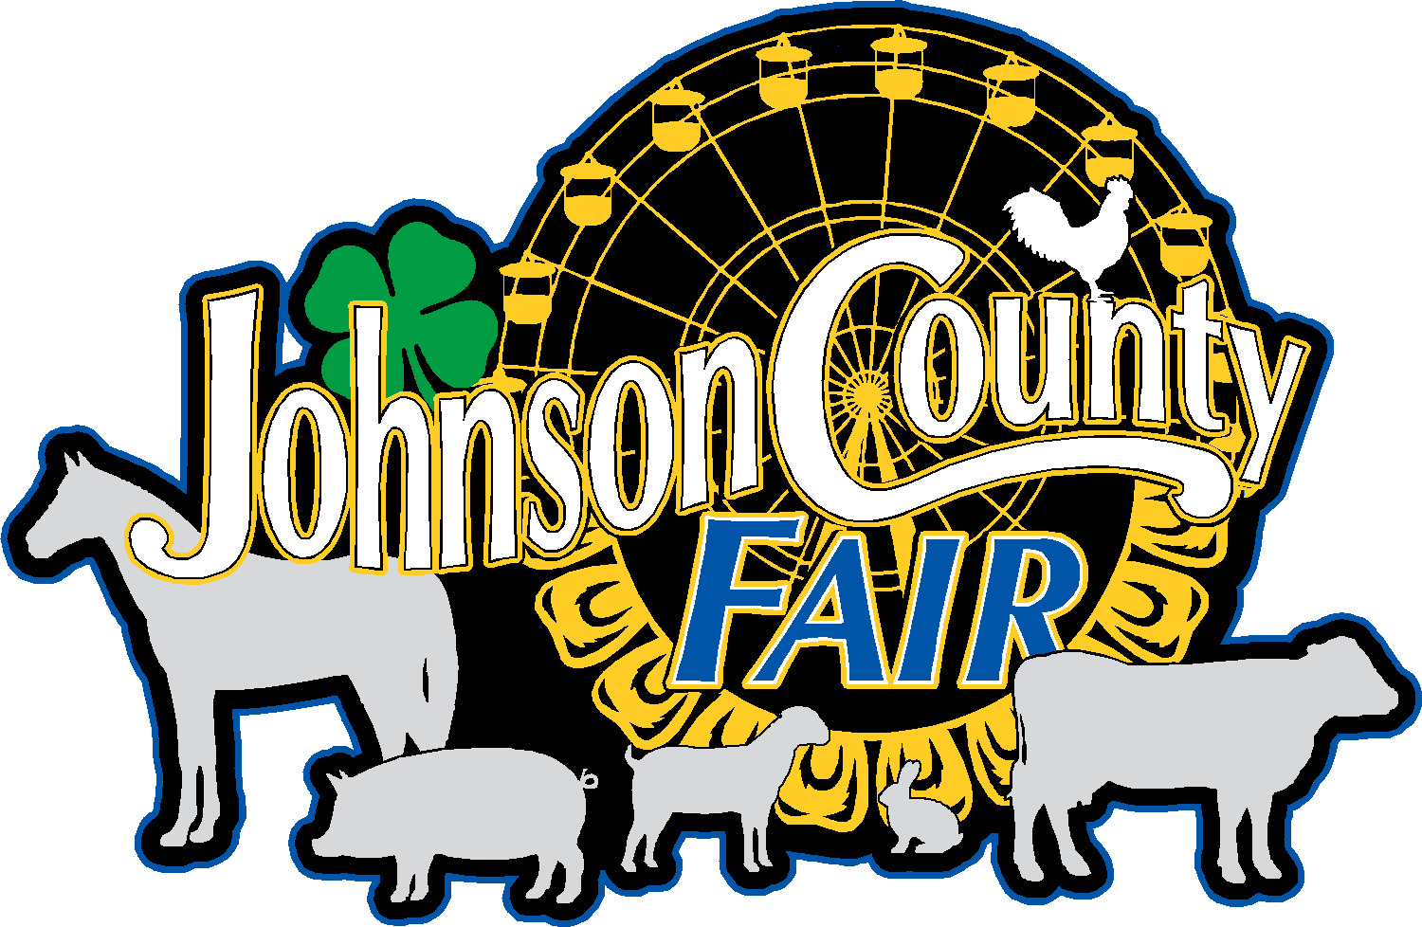
Food Vendor Application
2026 Johnson County Fair

We are going to limit our food vendors this year, so please get your applications in asap. Once received we will figure out what we have and what we need as vendors. Our goal is to provide the best variety without overlapping what is being served. You will be contacted promptly once your contract is received. Thank you.
Name of Booth: __________________________________________
Contact Person: __________________________________________
Address: ________________________________________________
City: _______________________ State: __________ Zip: _________
Phone: ______________________ Cell Phone: _________________
Email address: ___________________________________________
Type of Food: (Please give a detailed list all that you wish to serve): _________________________________________________________________________________
_________________________________________________________________________________
Set Up Hours:
Friday July 24, 2026, 2:00 pm - 8:00 pm
Saturday July 25, 2026, 6:00 am – 10:00 am
Display for Vendors: (Close no earlier than 8:00 pm)
Saturday July 25, 2026
Sunday July 26, 2026
Monday July 27, 2026
Tuesday July 28, 2026 (You may tear down beginning at 9 PM)
Wednesday July 29, 2026 (Not mandatory to stay, fair will release projects at 2 pm)

Tear Down Completed by July 30, 2026 (Tear down completed by noon)
Please check one: ______With electrical hook-up $250 _____Without electrical hook-up $200

Signed this __________day of __________________________.
By: __________________________________________
Approved by: ___________________________ Date: ________________
Rules and Regulations:
- The $200.00 without electrical or $250 with electrical hook-up charge for the week shall be payable at the time this contract is signed.
- All vendor’s vehicles and storage trailers must be out of the vendor spots by 8:00 am and moved to the parking lot.
- Any representative of the Fair Association shall always have access to leased premises.
- All buildings, tents, enclosures, or partitions put up by exhibitors MUST be approved by the Fair Board.
- The Fair Association reserves the right to close any exhibit or concession if it does not approve of its operation.
- Space assigned shall be attractively decorated and maintained in a neat and orderly manner. Please use non-flammable materials for decorating.
- Space contracted cannot be assigned or sublet without the consent of the Fair Board.
- Distribution of advertising materials is permitted at the site only. Everyone is expected to help in controlling litter.
- No give-away items may be distrusted without first clearing the item and procedure for distribution with the Fair Board.
- No loudspeaker, amplifier, radio, or other sound device can be used, except in such a manner as not to be a public nuisance or disturbing to a neighbor. The rule will be strictly enforced. Be a good neighbor.
- Prices of items offered for sale shall be prominently displayed.
- Commercial/concessionaires agree to abide by all State, County and City regulations, not to infringe upon the rights and privileges of others, to not sell or handle any commodity or transact any business whatsoever upon and within said premises of Fairgrounds except that which is here stipulated and contracted for and will confine transactions to the space and privilege provided for herein.
- No items that are deemed dangerous by the Fair Board shall be sold. Included are any type of fireworks, smoke bombs snaps, sparklers, etc. Any type of items that can be thrown and may cause a person injury are included in the: an example is “stars”.
- It is agreed that these rules and regulations herein are an integral part of this contract and signing this contract signifies acceptance of these regulations.
- Guard and Police Patrols will be assigned to all areas during the fair. However, the Fair is not responsible for any loss or damage to any exhibit or property of any exhibitor that may come about during or in connection with the Fair.
- Exhibitors/Concessionaires hereby agree to release the Johnson County Fair Board and Grounds, Iowa City, Iowa and its agents and employees from any and all responsibility and liability and hold them harmless against any and all claims arising from the use of any fairgrounds facilities. The Fair must be listed as an additional insured on your certificate of insurance.
- Any violation of this contract shall void the same and rental paid shall be forfeited to the Fair.

