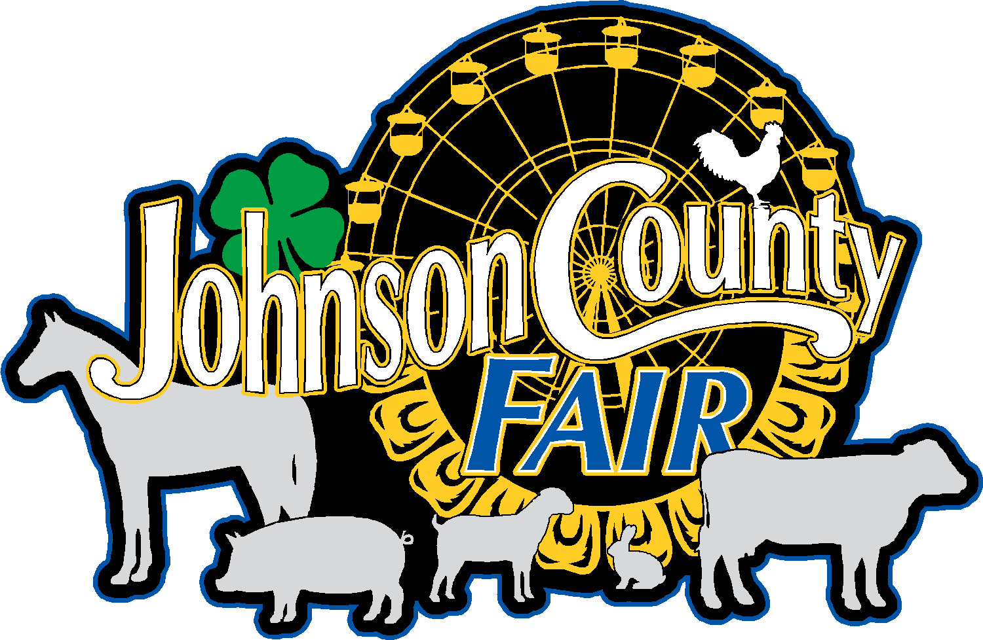

To: FULL WEEK INSIDE/OUTSIDE COMMERCIAL EXHIBITS

Plans are underway for the 2026 Johnson County Fair which starts on Saturday, July 25th at 10 AM through Wednesday, July 29th at 2:00 pm.

We would like you to consider a vendor space in the Commercial Exhibit Buildings C, Building D, or outside areas. Building B will not be used this year for Commercial Exhibits.
Things you need to know:
- Booth Spaces are 8’ x 10’ and will include one 6 ft table and two chairs. (You will need to bring your own accessories such as: extension cords, tablecloths, adapter, etc.)
- If you are an Outside Vendor, please advise us of space necessary.
- Booth space fee is $200/booth indoor space or $200/booth outdoor space.
- On Tuesday night, booths need to be dismantled, and your display area cleared of all materials and trash after 7:00 pm and before Noon Wednesday. Your area must be clean of all debris. We will have a dumpster available on the south end of the building for disposal. This dumpster will be available daily for your use as well.
- You will need to provide the fair board with a copy of your liability insurance along with your contract, as well as any special licensing required for your business.
- The Johnson County Agricultural Association and/or Fair Board Directors will not be held responsible for accidents or theft.
- Contracts must be received in the fair office by June 15, 2026. All qualified applicants will be contacted to confirm your spot. Indoor vendor spots are limited this year to please plan accordingly and plan early.
- If you are a food or beverage vendor, please see the Food Vendor Form on our website or contact us for more info.
- We look forward to seeing you at the fair. Please contact the Fair Office via email (johnsoncofair@gmail.com) or at 319-325-4049, if you have questions.

Set Up Hours:
Friday July 24, 2026 4:00 PM - 8:00 PM
Saturday July 25, 2026 6:00 AM - 8:00 AM

Display for Vendors: (Open at 8:00 am and close no earlier than 7:00 pm)
Saturday July 25, 2026 (10 AM to 7:00 PM)
Sunday July 26, 2026
Monday July 27, 2026
Tuesday July 28, 2026 Begin tear down after 7:00 PM
Wednesday July 29, 2026 Indoor booths torn down by Noon

Rules and Regulations:
- The $200.00 per booth space charge shall be payable at the time this contract is signed. $200.00 for outdoor space.
- Vendors are NOT guaranteed the same location as previous times.
- All vendor’s vehicles and storage trailers must be out of the vendor spots by 8:00 am and moved to the parking lot.
- Electricity for normal lighting is included in the rent. Additional charges will be made depending on usage.
- Any representative of the Fair Association shall always have access to leased premises.
- The Fair Association reserves the right to close any exhibit/concession if it does not approve of its operation.
- Space assigned shall be attractively decorated and maintained in a neat and orderly manner. Please use non-flammable materials for decorating.
- Space contracted cannot be assigned or sublet without the consent of the Fair Board.
- Distribution of advertising materials is permitted at the site only. Everyone is expected to help in controlling litter.
- No give-away items may be distrusted without first clearing the item and procedure for distribution with the Fair Board.
- No loudspeaker, amplifier, radio, or other sound device can be used, except in such a manner as not to be a public nuisance or disturbing to a neighbor. The rule will be strictly enforced. Be a good neighbor.
- Commercial/concessionaires agree to abide by all State, County and City regulations, not to infringe upon the rights and privileges of others, to not sell or handle any commodity or transact any business whatsoever upon and within said premises of Fairgrounds except that which is here stipulated and contracted for and will confine transactions to the space and privilege provided for herein.
- No items that are deemed dangerous by the Fair Board shall be sold. Included are any type of fireworks, smoke bombs, snaps, sparklers, etc. Any type of items that can be thrown and may cause a person injury are included in the: an example is “stars”.
- It is agreed that these rules and regulations herein are an integral part of this contract and signing this contract signifies acceptance of these regulations.
- Guard and Police Patrols will be assigned to all areas during the fair. However, the Fair is not responsible for any loss or damage to any exhibit or property of any exhibitor that may come about during or in connection with the Fair.
- Exhibitors/Concessionaires hereby agree to release the Johnson County Fair Board and Grounds, Iowa City, Iowa and its agents and employees from any and all responsibility and liability and hold them harmless against all claims arising from the use of any fairground’s facilities. The Fair must be listed as an additional insured on your certificate of insurance.
- Any violation of this contract shall void contract and rental paid shall be forfeited to the Fair.

VENDOR APPLICATION:

Business Name: ______________________________________

Email: ______________________________________________

Contact Name: _______________________________________

Phone #: ____________________________________________

Address: ____________________________________________

City, State, Zip: _______________________________________

Booth Electricity: Yes ________ No ________

Cash & Carry Items: Yes _______ No _______

# of Booths requested: _______ (indoor booth numbers per Exhibitor may be limited this year)
Check which applies: Indoor____ Outdoor_____

Special Request: _________________________________________________________

_______________________________________________________________________

_______________________________________________________________________

Iowa Sales Tax #: _____________________________________

Vendor Fee Included: __________________________________

Certificate of Insurance Included: _________________________

Amount Enclosed: _________________

Signature: _________________________________________________________

Print pages for your record. Attach your check to this form or you can use a credit card by contacting the office at 319-325-4049.
Mail to:
Johnson County Agricultural Association
Attn: Commercial Exhibit
4261 Oak Crest Hill Rd SE
Iowa City, Iowa 52246

