We deliver!
We can deliver up to 6 yards of Soil or 8
yards of Mulch in one trip with our local truck, fees are below. We deliver plants!
Larger loads can be quoted individually!
Standard Delivery Prices
Bangor $60.00
Brewer, Hermon, Glenburn $70.00 Levant, Carmel, Orono, Veazie, and Orrington $80.00
Old Town, Holden, Dedham, Newburg, Winterport $90.00
Other distances can be quoted individually!

***Please note that during peak season our delivery schedule is busy, and we cannot guarantee a specific delivery time. Please have specific dumping instructions and markers (like a tarp) ready for our driver. We cannot back up off the tar or driveway to dump as our trucks are heavy.

Come Pick Up!
Please call to make sure we are open for
loading! You must pick up bulk materials in an open bed truck or trailer.

Bark Mulches
Aged .00/yd
Dark Bark Mulch $38
Natural Hemlock Mulch $56.00/yd
Midnight Black Mulch $48.00/yd

How much do you need?
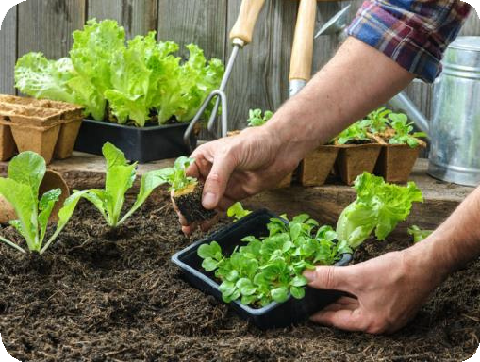
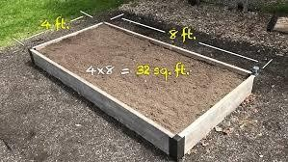
Measure Accurately measure your area and remember the height if
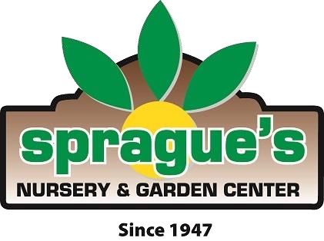
you have raised beds.
Use the following coverage chart.

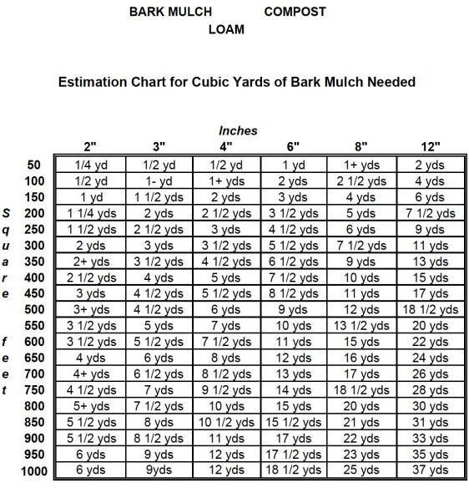
Sprague’s Nursery
&
Garden Center

2026
Bulk Mulches, Soils, Amendments & Soil Blends

Bulk Soil Descriptions & Prices per yard
Bulk soil can be picked up on site and are sold with a 1 yard minimum

Screened Loam- $40-
Loam is typically used for lawn installation, repair or to fill low areas. Not rich in nutrients, a starter fertilizer and lime should be used for lawn installation for best results.
Loam can be used as a base for other soil mixes.

Kinney Organic Compost- $110- This nutrient rich certified organic compost is a soil amendment of Fish and Cow ingredients. The compost is heated to 130-160 degrees for 30 days to kill off weeds. Use 25-30% of this compost in beds or use as a top dress to garden beds and use small applications of liquid or pelletized all- purpose fertilizer for best results.
Kinney is a Maine based company!

Composted Cow Manure- $50-
This rich, aged cow manure is great for adding nitrogen and other enriching nutrients to your soil. This should be blended in the first six inches of soil as a top dress or mixed throughout for a more nutrient dense soil.

Sprague’s Penobscot County Leaf Compost (Brown) $ $50-
Made from aging Bangor Area’s reclaimed garden leaves, this sustainable leaf compost is excellent for amending soil and topping garden beds. 25-30% of this leaf compost should be blended with your garden soil or topsoil and used with applications of organic fertilizer containing Nitrogen! Please be aware that due to the recycled nature of the product, some minor impurities may be present!

When life gives you compost…
GROW A GARDEN!

Peat Moss- $40.00
Our Maine Peat Moss is a great amendment for hard clay and dense soils. Peat will help fluff up any soil and will aid in water retention.

Grow Mix- $50.00
1 Part Cow Manure, 2 Parts Peat Moss, 2 Parts Natural Brown Bark Mulch
This is our loam-less blend which we use for potting perennials and amending pre- existing soil. This should be tilled in!

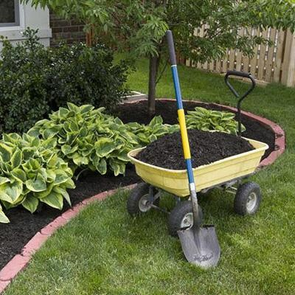
Landscapers Mix- $50.00
1-part enriched planting soil with 1-part loam. This blend is best used for building new garden beds and is great for all landscape plants! This was our old standby for raised bed gardens. If used for food hungry veggies use an application of organic fertilizer containing nitrogen.

Raised Bed, Veggie Mix $85.00

1-part Kinney Compost with 1-part landscaper’s mix. This rich mix is great for raised beds and veggie gardens. Developed just for you, no mixing needed. Fertilizing with an all-purpose fertilizer is still required for food hungry veggies and proper growth of heavy blooming plants! We recommend using a good dose of 10-10- 10 along with a good organic fish emulsion liquid feed like Neptune’s Harvest or any Espoma brand plant food.

