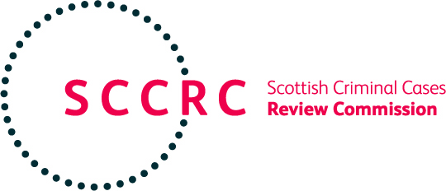

NEWS RELEASE

The Scottish Criminal Cases Review Commission (“the Commission”) has this week published its 2024-25 Annual Report and Annual Accounts.

The Commission’s Annual Report and Annual Accounts for 2024-25 have been laid before the Scottish Parliament. The Annual Report confirms that the Commission conducted its busiest year as regards the number of new applications received (213) and cases concluded (226). Of the 40 cases concluded after a stage 2 review, three were referred to the High Court for determination and 11 people ultimately had their convictions quashed under operation of the Post Office (Horizon System) Offences (Scotland) Act 2024. The High Court determined five appeals proceeding upon our referrals, four of which the Court granted and one it refused.

During the year the Commission examined its resilience and ability to deal with the ever-increasing case numbers. The Scottish Government approved funding for an additional legal officer position in 2025-26. The extra funding will enable the Commission to maintain the 2025-26 case targets at their 2024-25 level and will assist the Commission in reviewing its cases properly and timeously.

The Commission’s Chief Executive, Michael Walker, said today:

“The Commission is a collegiate decision-making body. It is the input from Commission staff and its eight Board Members, each of whom has different experiences of and perspectives on the criminal justice system in Scotland, which enables the Commission to review cases properly and to make informed decisions.

The Commission continues to demonstrate strong financial management and control, operating efficiently and effectively within the constraints of the financial resources allocated to it and within budget for the year.

I acknowledge the ongoing dedication and hard work of Commission staff and Board Members, without whom this level of performance could not have been achieved.”

Notes for Editors

The Scottish Criminal Cases Review Commission was established in 1999 by Part XA of the Criminal Procedure (Scotland) Act 1995 as an independent public body to review alleged miscarriages of justice in Scotland. The Commission has the power to refer cases to the High Court for determination if it believes that a miscarriage of justice may have occurred and that it is in the interests of justice that a reference should be made. Any Commission referral to the High Court proceeds as a normal appeal.

The Commission operates with a Board of 8 Members, one of whom is the Chairperson, a Chief Executive, a Director of Corporate Services, 2 Senior Legal Officers, 5 Legal Officers and administrative support staff.

For any further general information about the Commission please contact:

Mr Chris Reddick,
Director of Corporate Services,
SCCRC,
4th Floor,
Portland House,
17 Renfield Street,
Glasgow,
G2 5AH

Tel: 0141 270 7030,

e-mail: info@sccrc.org.uk or visit the Commission’s website at www.sccrc.co.uk.

