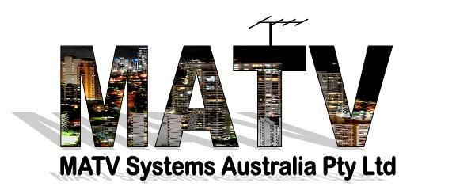

What is an MATV System? What makes a good MATV System?
MATV stands for Master Antenna Television. A MATV system usually derives it signals from one TV antenna and / or one Satellite Dish but that is not always the case. It enables TV signals to be distributed to a large number of TV receivers ( could be >1000 ) in a Hi Rise, Village, ACF, Gated Community, Retirement Village etc
In simple terms, an MATV system is a network of cables and specifically designed components that process and amplify TV signals, then distribute them from one central location to all TV Outlets
MATV systems are separated into two parts, the ‘Head End’ and the ‘Distribution System’. It is essential to carefully plan and engineer both parts using the best MATV equipment and best practice installation techniques to ensure the correct amount of DVBT signal is distributed to each and every wall plate with minimal loss of quality.
Without a MATV system, any premises that require multiple TVs would need to install and maintain an antenna and / or satellite dish per unit/villa. This would be expensive, not to mention unsightly. The TV reception could also suffer, because multiple antennas ( say on the roof of an MDU) could interfere with each other, causing signal issues.

An MATV system can carry digital television signals received by an aerial and / or satellite dish (both free-to-view and subscription television), FM radio and DAB (Digital Audio Broadcasting) as well as any modulated add on services

How a typical MATV system works:
- A UHF or VHF TV antenna ( depending on the Transmission site) or a combination of both and /or satellite dish is appropriately positioned to receive digital TV signals (DVBT)
- Signals received by the aerial or dish are then processed using the Head End equipment.
- A distribution network consisting of Amplifiers, Taps, Splitters and trunk cables ( typically RG11 Quad , .500 Hardline or more recently single mode fibre) and drop cables ( typically RG6 Quad) then delivers all television signals to wall outlets in each apartment / room. Configuration of the distribution network will depend on the number of dwellings ( in a Horizontal site and / or floors at the premises.( Vertical site )
For expert advice on your MATV needs, why not call us now (insert link to phone no) to arrange for one of our friendly MATV system Experts to help design a new MATV solution customised to suit your situation.
For a more in-depth look at the components of an MATV system, see below.

Modulators
Many commercial premises such as hotels, retirement villages, and holiday parks now utilise their MATV system to supply additional services or “in house” programmes and information services to their customers. The channels could be Village / ACF / Resident information, ethnic or religious programs, PAY TV channels, CCTV cameras etc. These modulated channels can be SD ( Standard Def) or HD ( High Def)
Additional DVBT “channels” can be modulated ( using a programmable modulator (s) )onto a 7Mhz carrier and integrated in to the MATV System. This carrier can consist of a MUX of several channels that the TV receivers can unpack and allocate as individual channels with individual LCNs ( Logical Channel Number)

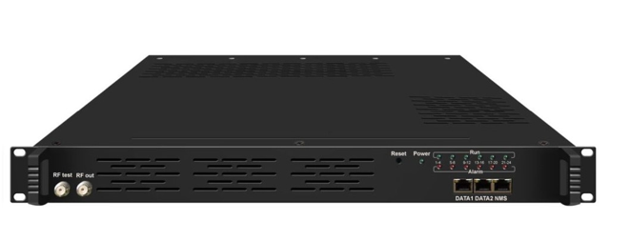
12 Input HDMI Modulator

MATV Head End
The Head End of a MATV system usually consists an AGC Amplifier ( Single Channel or Processor) that receives the broadcast signals and processes them to filter unwanted signals ( LTE or fortuitous broadcasts ) These processors can shift frequencies if required. They can also allow combining of any modulated services or use more than one TV Antenna to combine.
AGC ( Automatic Gain Control) is essential in any large MATV System as it locks the output irrespective if the input signal varies up and down with weather conditions of the like. Also included in the headend maybe a Launch Amplifier to amplify the signals to compensate for distribution losses before further amplification that maybe required in the system. In a large system there maybe many Line Amplifiers.

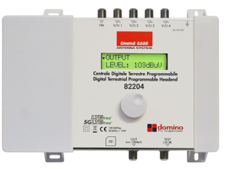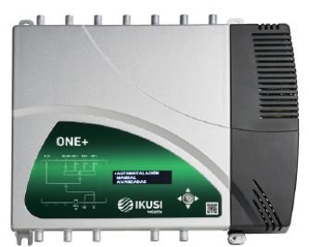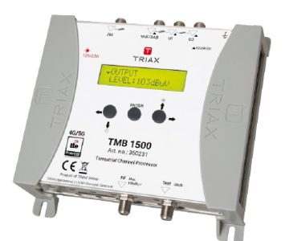
Examples of agile AGC Processors

Regeneration MATV Headends
One of greatest allies in areas where the FTA Terrestrial signal isn’t good enough to work with on one or all channels. A regeneration Headend can be utilised. It takes the poor signal and rebuilds it and modulates it onto a clean carrier. It can take a signal that is completely unusable and restore it to near perfect MER and BER.
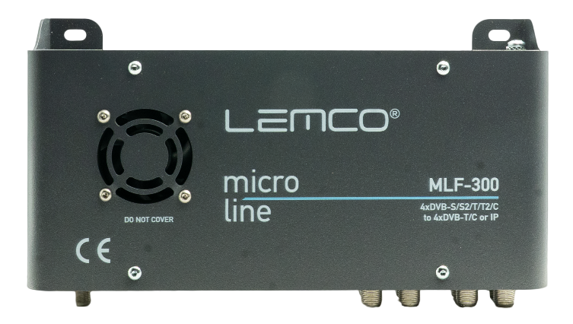
4 Channel Regenerator from Kingray ( also has built in Streamer)

Antenna
The quality of TV reception can be no better than the quality of the signal from the antenna. It is vital that the correct antenna be selected for the intended location.
The quality and strength of any signal is ( measured using a Professional FSM ( Field Strength Meter) The FSM must be capable of measuring Power (in db/uv), MER (in db) , Carrier to Noise ( in db ) and Pre and Post BER.

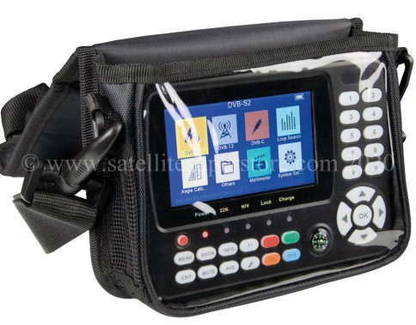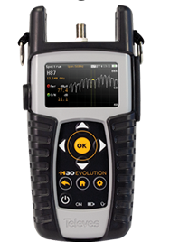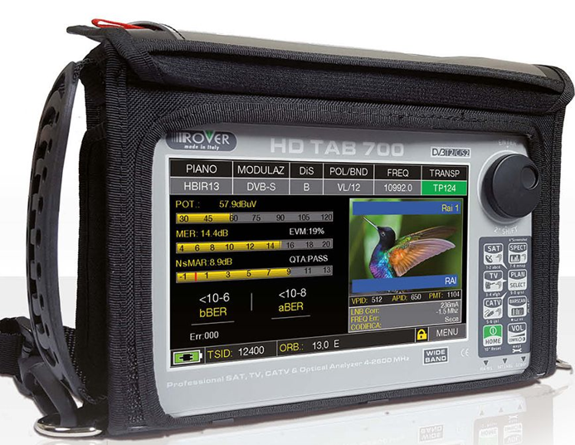
Examples of Professional Quality Field Strength Meters

The location and type of antenna to use are determined by the following:
- Proximity to the transmission tower
- Power of the transmitter
- Quality of the transmission
- Line of sight to the transmission tower
- Weather conditions
- Interference from power lines or LTE
- Directional characteristics and orientation of the antenna
- Gain and directivity of the antenna
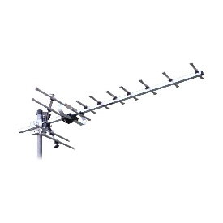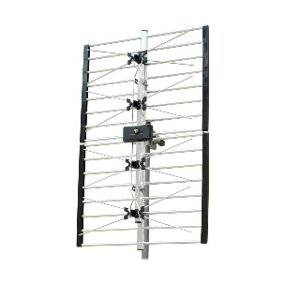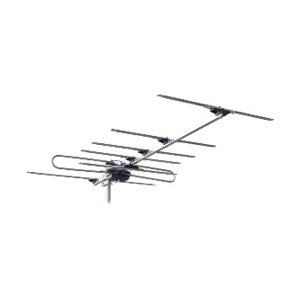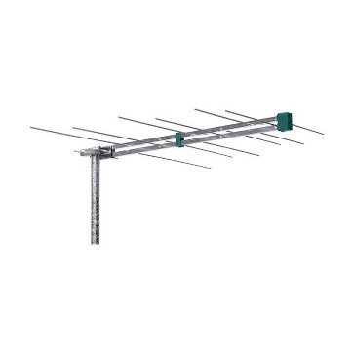
UHF Yagi 28 – 50 UHF Phased Array VHF Yagi 6 –12 VHF Log Periodic 6 - 12

Signal Survey
Completing a signal survey before installing the system will avoid many potential problems. By using a Field Strength Meter and test antenna, you can measure the amount of signal received on each channel. There are a number of types of antennas namely, Yagis, Phased Arrays and Log Periodic. Each has different traits and experience tells us which one we would recommend

Masthead Amplifiers
If you find you are in a weak signal area, all is not lost! A Masthead Amplifier can amplify the signal before it reaches the distribution amplifier. A low noise, low gain Masthead is typically the best one to get the signal to the headend. If the received signal is too low, errors too high and MER too low then there is a limit to the magic that a masthead amplifier can do.

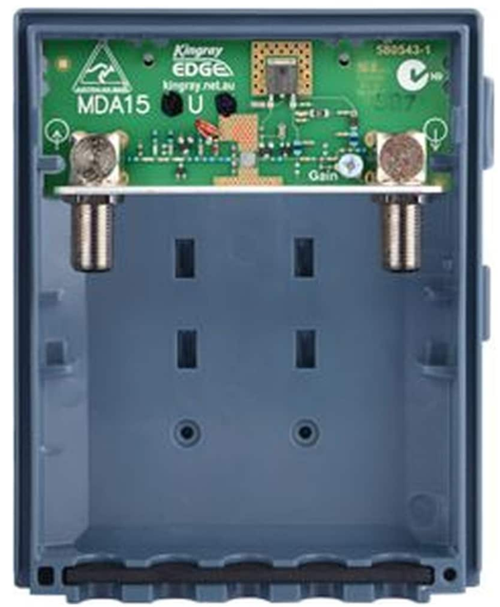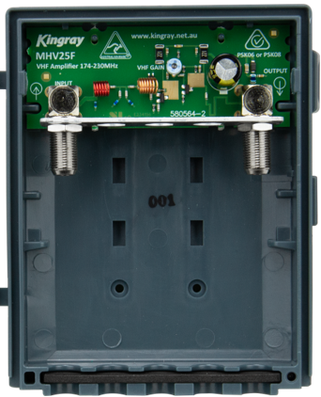
MHU15 Kingray 15db UHF MHV25 Kingray 25db VHF

VAST Headend
In areas where FTA Terrestrial signal is not workable ( and even a Regeration Headend can’t solve) we can use a VAST Headend which receives FTA services via satellite (DVBS / S2 ) from the same Satellite that Foxtel use and modulates them as DVBT channels. Typically around 20 actual channels. The main channels from each Network can be selected.

Front and rear panels of VAST headend showing 3 CAM slots for Card Access

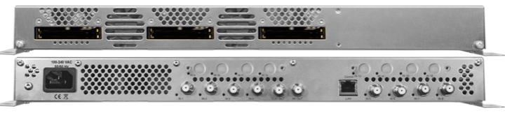
MATV Trunk and feeder ( sometimes called drop or lateral cables)
The most common trunk cable used in MATV Systems is RG11 Quad Shield cable. As the name suggests it is a fully shielded cable with 2 layers of foil and 2 layers of braid. A centre conductor of copper clad steel, extruded foam dielectric, then four layers of shielding and then the outer jacket. Good quality “compression” F Connectors are essential.
In large underground MATV Systems the trunk could be Hardline, aluminium conduit shielded copper clad Aluminium centre conductor. Typical sizes are .500 ( ½ inch ) .625 (5/8 inch) or .750 (¾ inch ) These cables use special 2- & 3-piece compression connectors which need special tools to prepare the cable. Very rigid cable that has to be used carefully when bending.
Some older MATV Systems use an older type underground cable. Known as CT125 RBS it is about the size of .500 Cable. It has a large copper centre conductor with copper foil shielding. Outer jacket is green plastic ( looks similar to a garden hose ) and the dielectric is “air spaced”. This cable is still usable as long as there is no water in the air spacing. Special connectors are required to terminate this cable.
The industry standard for drop cables is RG6 Quad or RG6 Tri shield. Older systems may utilise RG59 or RG6 Dual Shield. Single shield cables , typically air spaced, are a performance issue and must be avoided.

MATV Cable Connectors
The best type of connector in and MATV System from the Antenna to the user wall plate is, correctly terminated , “compression F Type” for all sizes of cable. Screw on, push on, twist on connectors is a definite “ don’t ever use”
RG11Q compression connectors feature an integrated pin as the cables centre conductor is too thick to mate with female connector of the tap. Splitter, amplifier or wall plate
RG6 Q and RG59 Q use the centre conductor to connect.

MATV Distribution Components.
To guarantee a good signal at every TV receiver connected to the system, the MATV distribution system must be well designed. Splitters, Taps and Line Amplifiers are used in the distribution system to provide the necessary signal level ( typically Signal level of > 55 db/uv and < 78db/uv and > 27db MER) and to maintain the correct impedance to each of the outputs. Calculations of losses associated with splitters, drop taps, and cable are required.
Screw and saddle splitters and taps and even amplifiers must not be used and if upgrading a system all need to be replaced with shielded F Type devices as shown in pic below. They have significant insertion loss and drastic return loss (RLR) problems
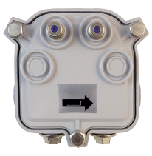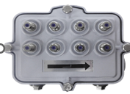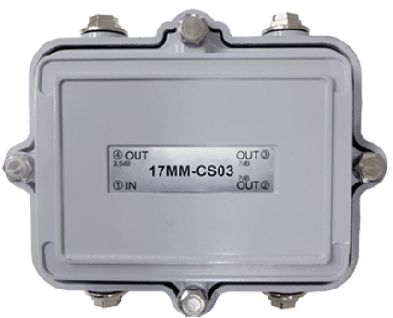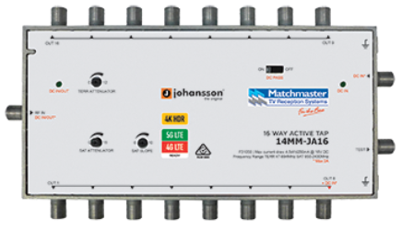
2 Way CATV 8 Way CATV 3 Way CATV 16 Way Active Tap

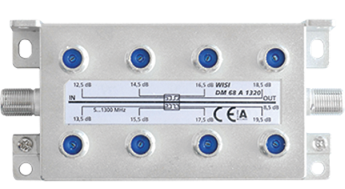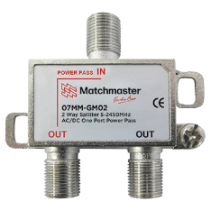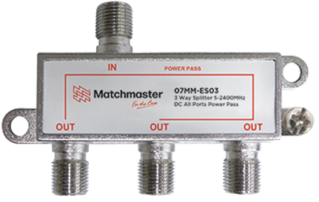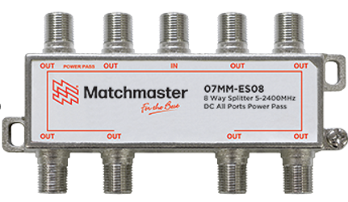
8 Way MultiTap 2 Way Splitter 3 Way Splitter 8 Way Splitter

Amplifiers
Line Amplifiers are used to increase the signal strengths to a level greater than the losses in the distribution system. Signal increase is determined by the amplifier gain, but most important is the amplifiers output.
Amplifier specs will show the maximum gain and the maximum output usually for 2 channel carriers. Most systems in Australia have at least 5 carriers ( the 5 TV Networks). Every time you double the number of carriers the output of the amplifier has to be derated by 3db. Amplifiers further down the line also have to be derated by 3db each time one is added. The input level of an amplifier is critical as is the balance level of the input. A difference of 6db between any carriers at the input will grossly affect its performance.
Too much signal going in to an amplifier causes overloading and corruption of the data streams which will result in pixelation or complete loss of picture. This input can be rectified with the use of attenuators ( available in various values)
Examples of Hi Output Distribution Amplifiers
