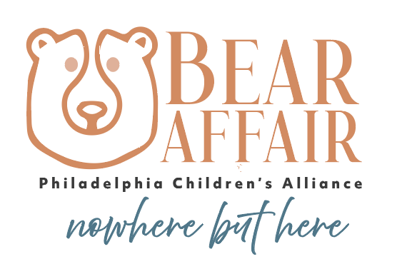
October 22, 2025

Dear [Name],
I am excited to reach out to you today to introduce you to the Philadelphia Children’s Alliance (PCA) and to share an opportunity for [Company Name] to play an important role in the fight against child sexual abuse.
On Thursday, May 7, 2026, PCA’s annual fundraiser – the Bear Affair – will take place at the National Constitution Center. Sponsors of this event celebrate alongside the PCA family, which includes special guests from the Philadelphia Eagles, PCA’s city partners, and leaders and representatives from every part of Philadelphia’s unique community.
The work of PCA is truly incredible. This organization pursues justice for children who have been sexually abused and provides a support system for their entire healing journey, as well as research-based prevention programs and resources which are available citywide. On the ground, PCA provides comprehensive care to more than 2,000 child victims every year – including highly specialized mental health therapy, forensic interviews, medical services, and caregiver support. PCA is the only organization of its kind in Philadelphia, and it serves as a national model for other child advocacy centers.
Enclosed you will find sponsorship opportunities for the 2026 Bear Affair that demonstrate some of the ways that we plan to mark PCA's essential mission, and I hope you'll consider signing on. If you have any questions about benefits or would like to discuss what sponsorship level may be right for you, please do not hesitate to reach out.
A sponsorship from [Company Name] will help to ensure that PCA can continue its work and expand its lifesaving services. Your commitment will also allow us to start spreading the word of your generous partnership in the first communications for the event, which will be coming shortly.
Thank you for your consideration. I hope to hear from you soon.
Best,
[Your Name]

