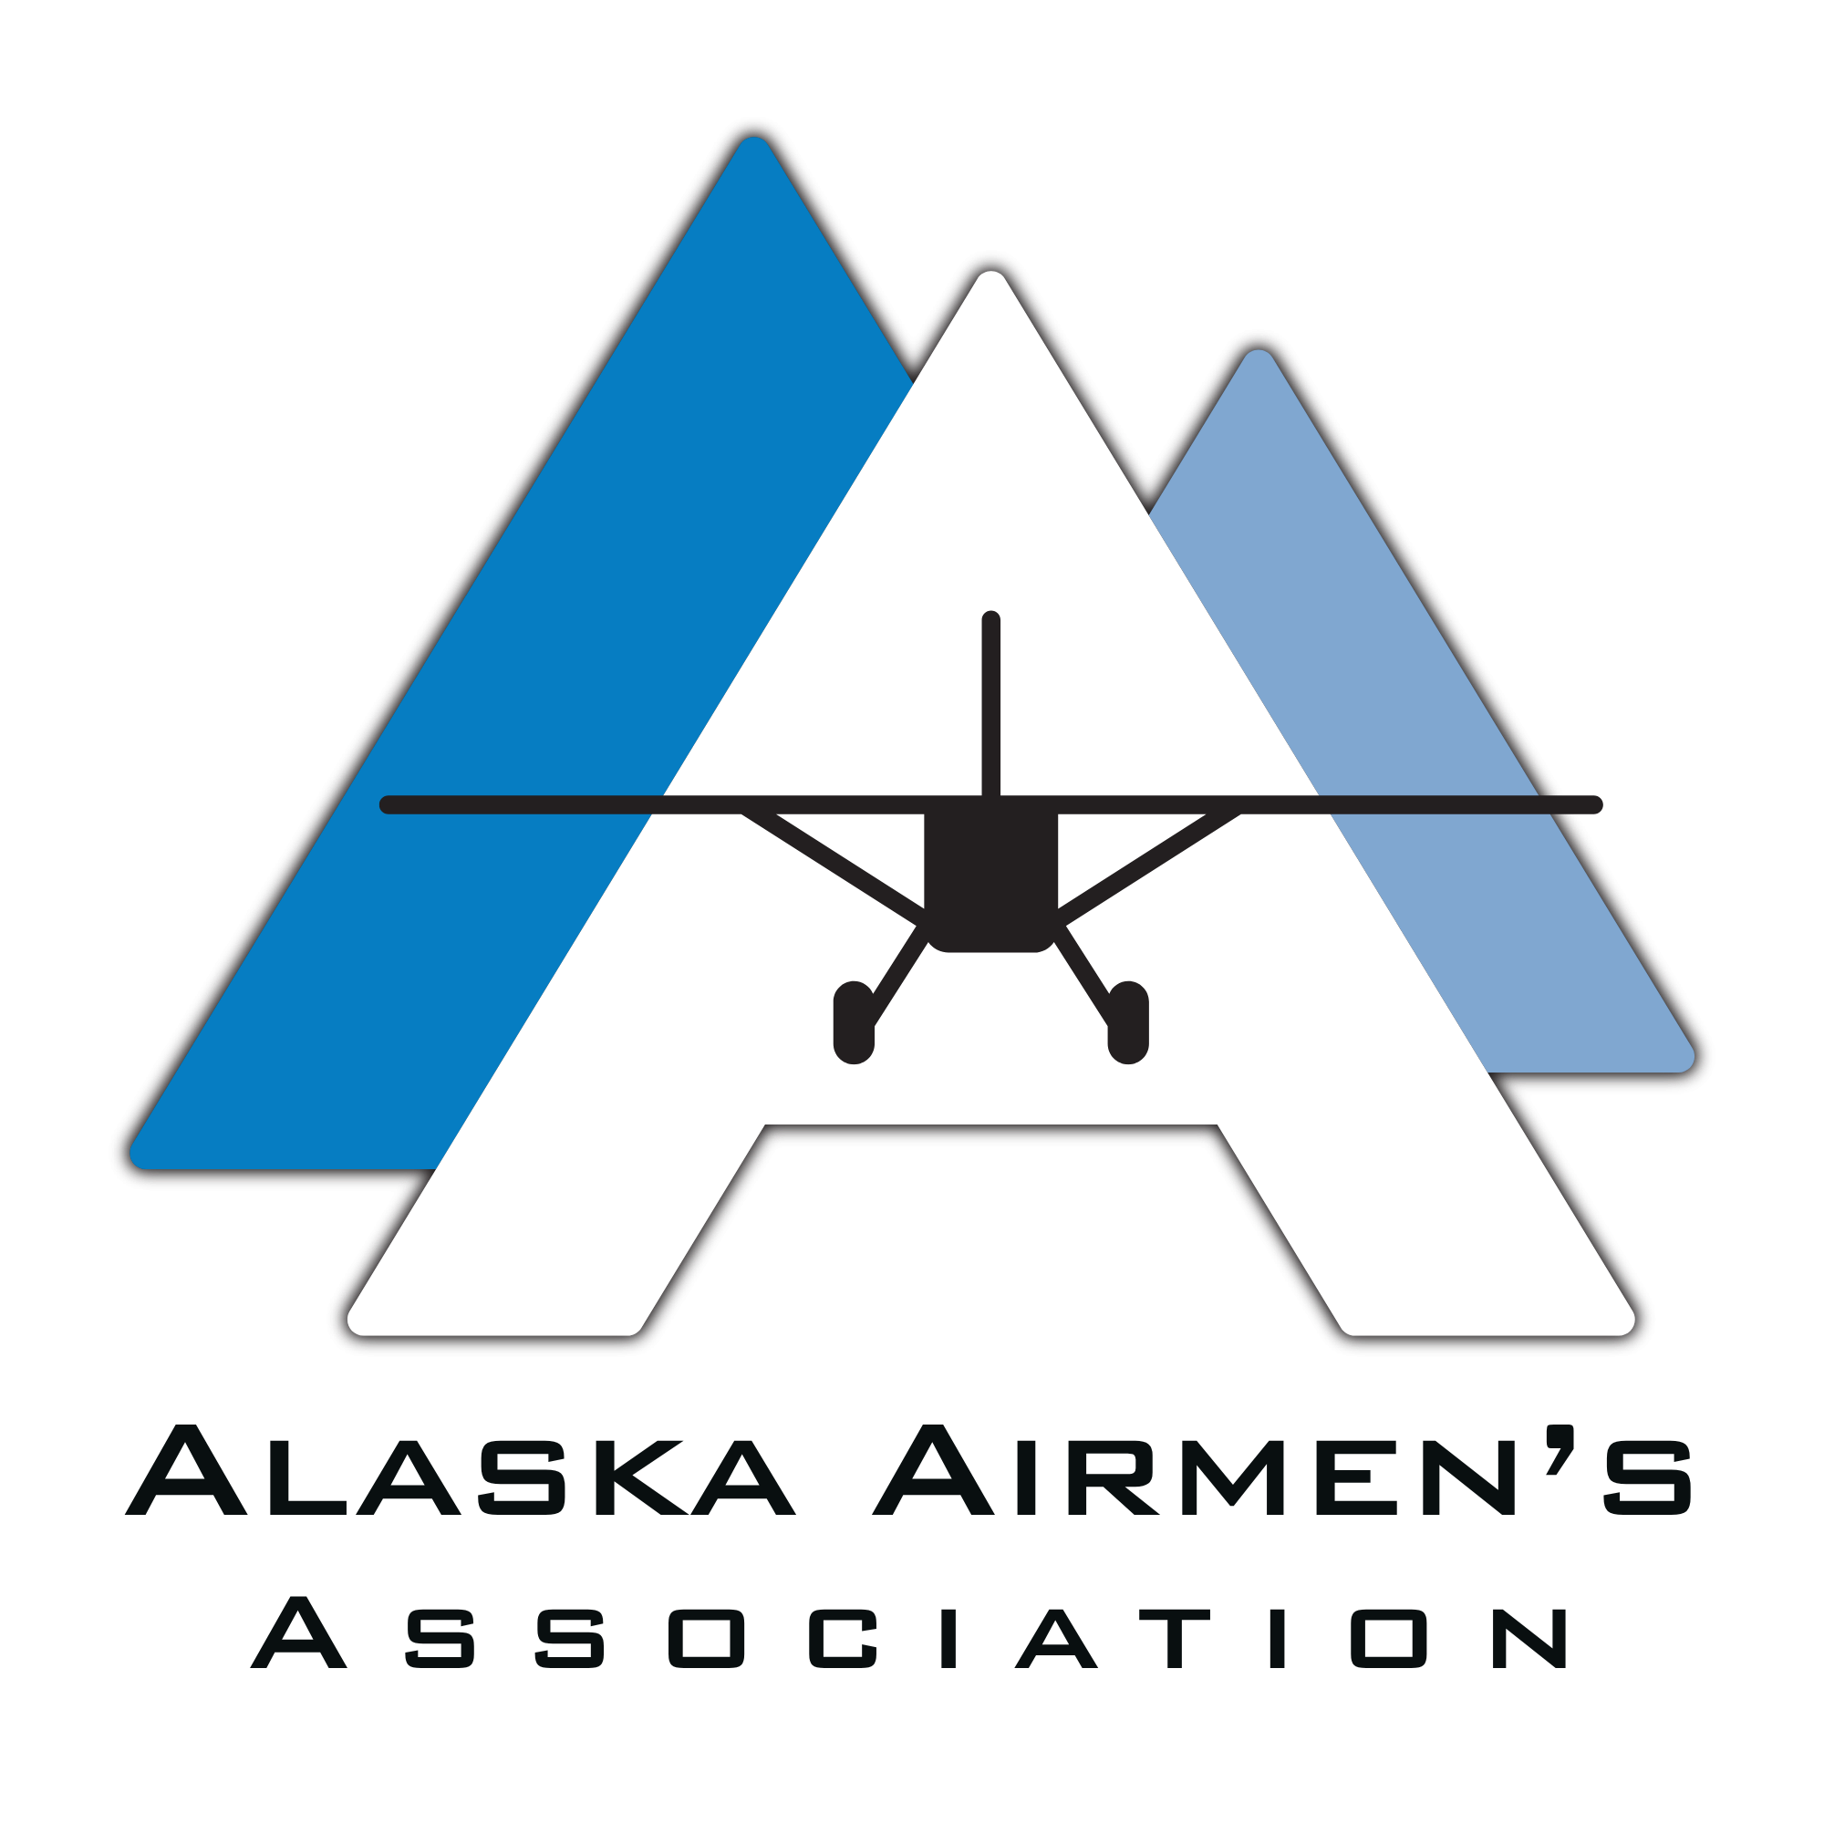

SCHOLARSHIP APPLICANT GUIDE
Alaska Airmen's Scholarships
What to know before you apply

Start here: Apply online at apply.alaskaairmen.org. Create one profile, then submit a separate application for every scholarship category in which you want to be considered.

SPRING  All categories | FALL  Maintenance only | DEADLINE  5:00 p.m. AK Time | ELIGIBILITY  Alaska resident + member

You may attend an eligible school or training program in Alaska or outside the state.

Your application path
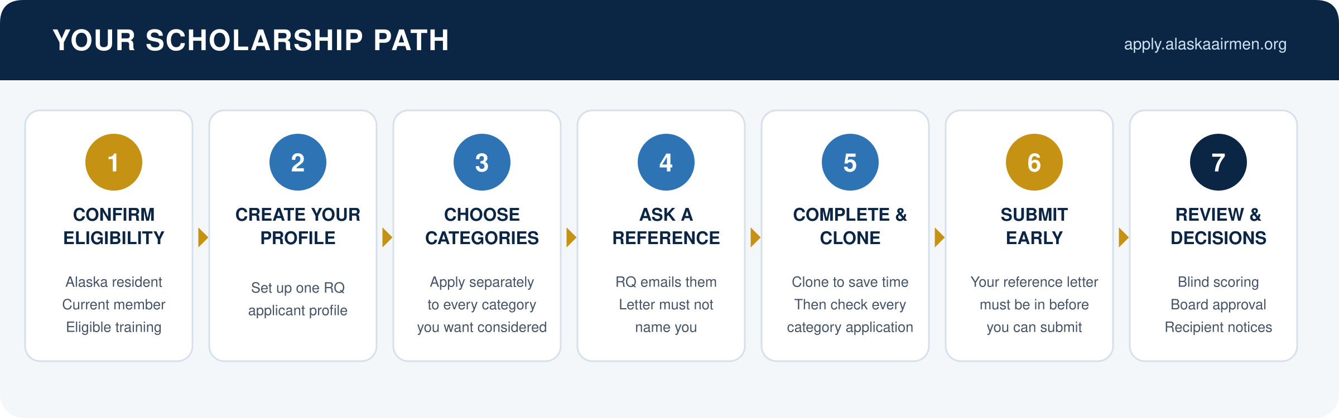

Build a complete application
- Confirm that you are an Alaska resident and a current Alaska Airmen's Association member by the published application deadline.
- Create one applicant profile in the RQ application system at apply.alaskaairmen.org. Apply separately to every category you want considered for; the clone feature can save time, but review and complete every cloned application for that category.
- Ask your reference early. RQ sends the reference an email, and your application cannot be submitted until the recommendation letter has been submitted.
- Tell your reference that scoring is blind. The letter must not use your name; it should use wording such as 'the applicant' or appropriate pronouns.
- Write responses in your own voice. The Airmen's strongly recommends that applicants not use AI to write responses because authentic, specific answers are more useful to reviewers and generic AI-written answers generally score lower.
Submit early: Do not wait until the final day. Connectivity, device, browser, software, or late-reference problems may prevent submission and do not qualify for a deadline extension.

Deadline rule: The published deadline changes only if the Alaska Airmen's or RQ identifies an organization-side technical error that materially prevents submission. Staff cannot accept a late application or recommendation letter for an applicant-side problem.

Season dates and applicant support
Season | Who may apply | Typical application window
Spring | Applicants for all current scholarship categories | Opens on a staffed business day in January. Target close: February 15 at 5:00 p.m. Alaska Time.
Fall | Applicants for maintenance-only scholarships | Opens on a staffed business day in September. Target close: October 15 at 5:00 p.m. Alaska Time.

Check the posted date: The exact opening and closing dates are published annually, and both will be staffed business days. Follow the posted closing date and 5:00 p.m. Alaska Time deadline for the current season.

Scholarship clinics
The Airmen's hosts applicant clinics at the Airmen's building, Juneau, Fairbanks, UAA, and the Mat-Su Career Center. Dates vary by year and are promoted with the spring application season. Clinics explain the process, show applicants how to use RQ, and answer administrative questions.

How review and selection work
- Staff verifies Alaska residency, current membership, recommendation completion, and category requirements. Applicant identities are hidden for blind scoring.
- Three reviewers are assigned to each category. The same three reviewers score the entire category independently, rating each required area from 1 through 5.
- RQ tabulates the scores and ranks applicants. Scholarship category requirements and available funding are considered before recommendations are finalized.
- The Board of Directors approves the recipients, individual amounts, category breakdown, and total awards before notifications are sent. Spring approval is generally in April; fall approval is generally in November.

How award amounts are set: Scholarship funds are built from donors, raffles, silent auctions, and the Airmen's annual scholarship allocation. The total funding available helps determine the amounts awarded each year.

If you receive a scholarship
- Spring recipients are normally notified 2-3 weeks before the Great Alaska Aviation Gathering and are invited to a Saturday midday awards ceremony during the Gathering. Fall recipients are notified before year-end.
- Use the active calendar-year Scholarship Disbursement and Reimbursement Request Form to request direct payment or reimbursement. Reimbursement requests must include receipts, and the form collects the payee information and supporting documents needed to process payment.
- You must use the scholarship within two years of the date it is awarded. Any unused balance is forfeited after that date.
- Please send progress reports, milestone updates, photos, and success stories to marketing@alaskaairmen.org. With your permission, the Airmen's may highlight your progress in its newsletter or The Transponder.

Final applicant checklist
Done | Before you submit
[ ] | My Alaska Airmen's membership is current through the application deadline.
[ ] | I meet the Alaska residency requirement.
[ ] | My RQ profile is complete and accurate.
[ ] | I submitted a separate, complete application for every category I want considered for.
[ ] | My reference knows an RQ email is coming and understands the blind, name-free letter requirement.
[ ] | My recommendation letter has been submitted in RQ.
[ ] | My responses are specific, accurate, and written in my own voice.
[ ] | I submitted before the deadline and saved or verified my submission confirmation.

Ready to apply: Go to apply.alaskaairmen.org and follow the exact opening date, closing date, and 5:00 p.m. Alaska Time deadline published for the current season.

