ATIC Accessibility
To support the accessible community in making informed travel decisions for their individual needs

This report prepared for:
Business name: | Browns Plains Motor Inn
Address: | 30 Anzac Avenue
Town: | Hillcrest
Contact for enquiries: | Stuart Hesketh
Contact Number: | 07 3802 4222
Contact Email: | admin@brownsplainsmotorinn.com.au
Website: | www.brownsplainsmotorinn.com.au
Date: | 2025-11-24 10:51

ATIC Accessibility
The following pages provides travellers with information on the businesses facilities and amenities which aims to support the traveller to make an informed decision on whether the business is suitable for their individual needs.
OVERVIEW 4
Business Overview 4
Bookings 6
Emergency Management 6
Communications 6
Other Information 7
Guide Dog and Service Animals 7
GENERAL 8
Pre-arrival, arrival and reception 8
Cognitive Impairment Support 8
Car Park and Access amenities 8
External Paths 9
Ramps 9
Public Toilets/Adult change facilities 9
ACCOMMODATION 11
Bedrooms 11
Room Amenities 12
Bathrooms 13
COMMON AREAS 15
Swimming pools, spas and waterparks 15
Report Disclaimer 18

OVERVIEW

Business Overview

The business has the following products/services available
- Accommodation

Our business caters for the following disability types:
- Blind or low vision
- Deaf or low hearing
- Limited mobility
- Wheelchairs or mobility scooters
- Cognitive or people on the Autism Spectrum
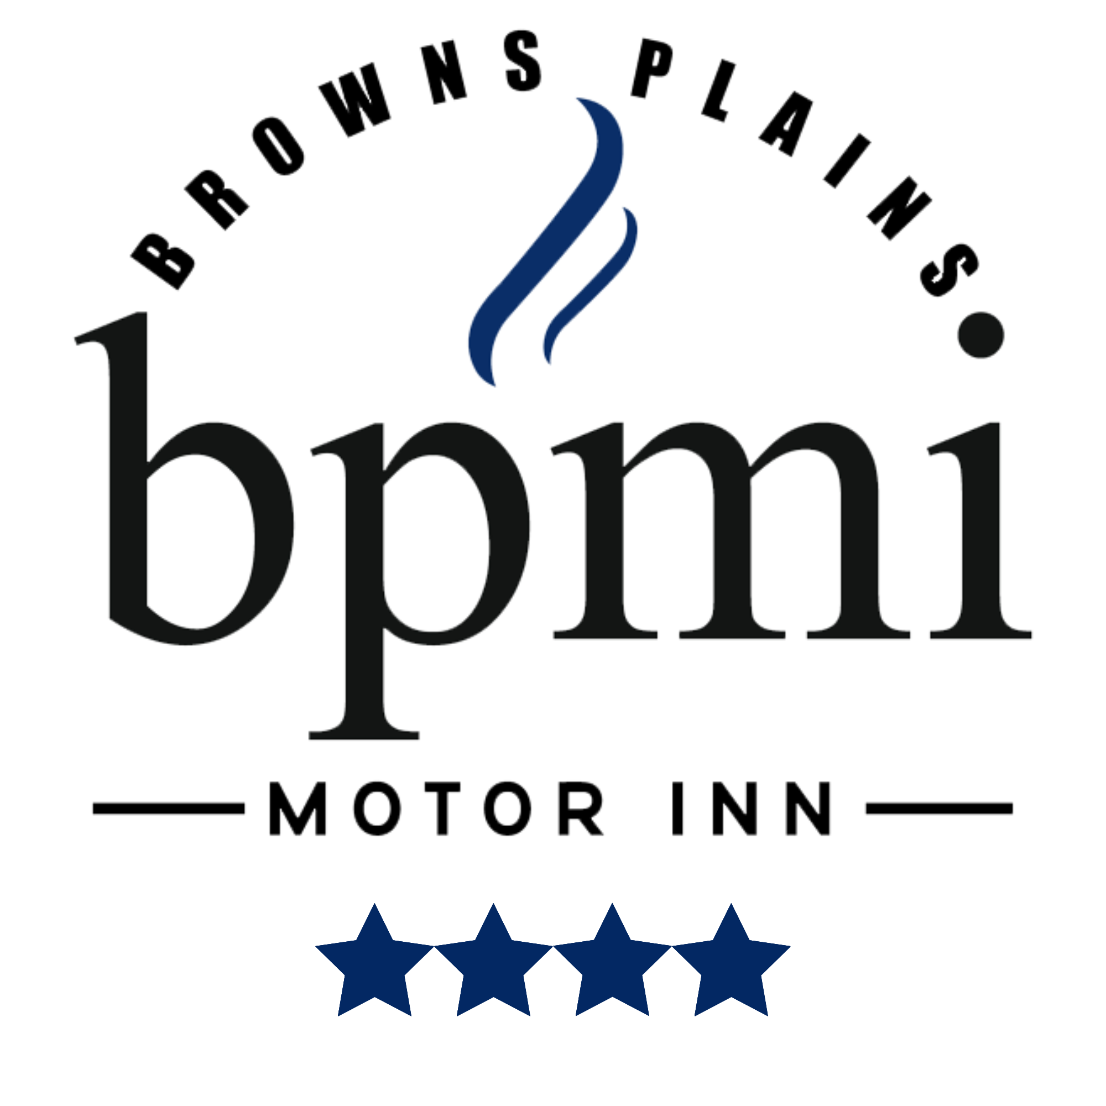

Bookings

The business offers the following methods for bookings and enquiries:
- Phone
- Email
- Webportal
- Our website supports Screen Readers
- Our forms have high contract boxes and submit boxes
- Staff have undergone disability awareness and training

Emergency Management
- The business has an emergency management and evacuation plan for guests with a disability
  - A copy of the plan is available on request.
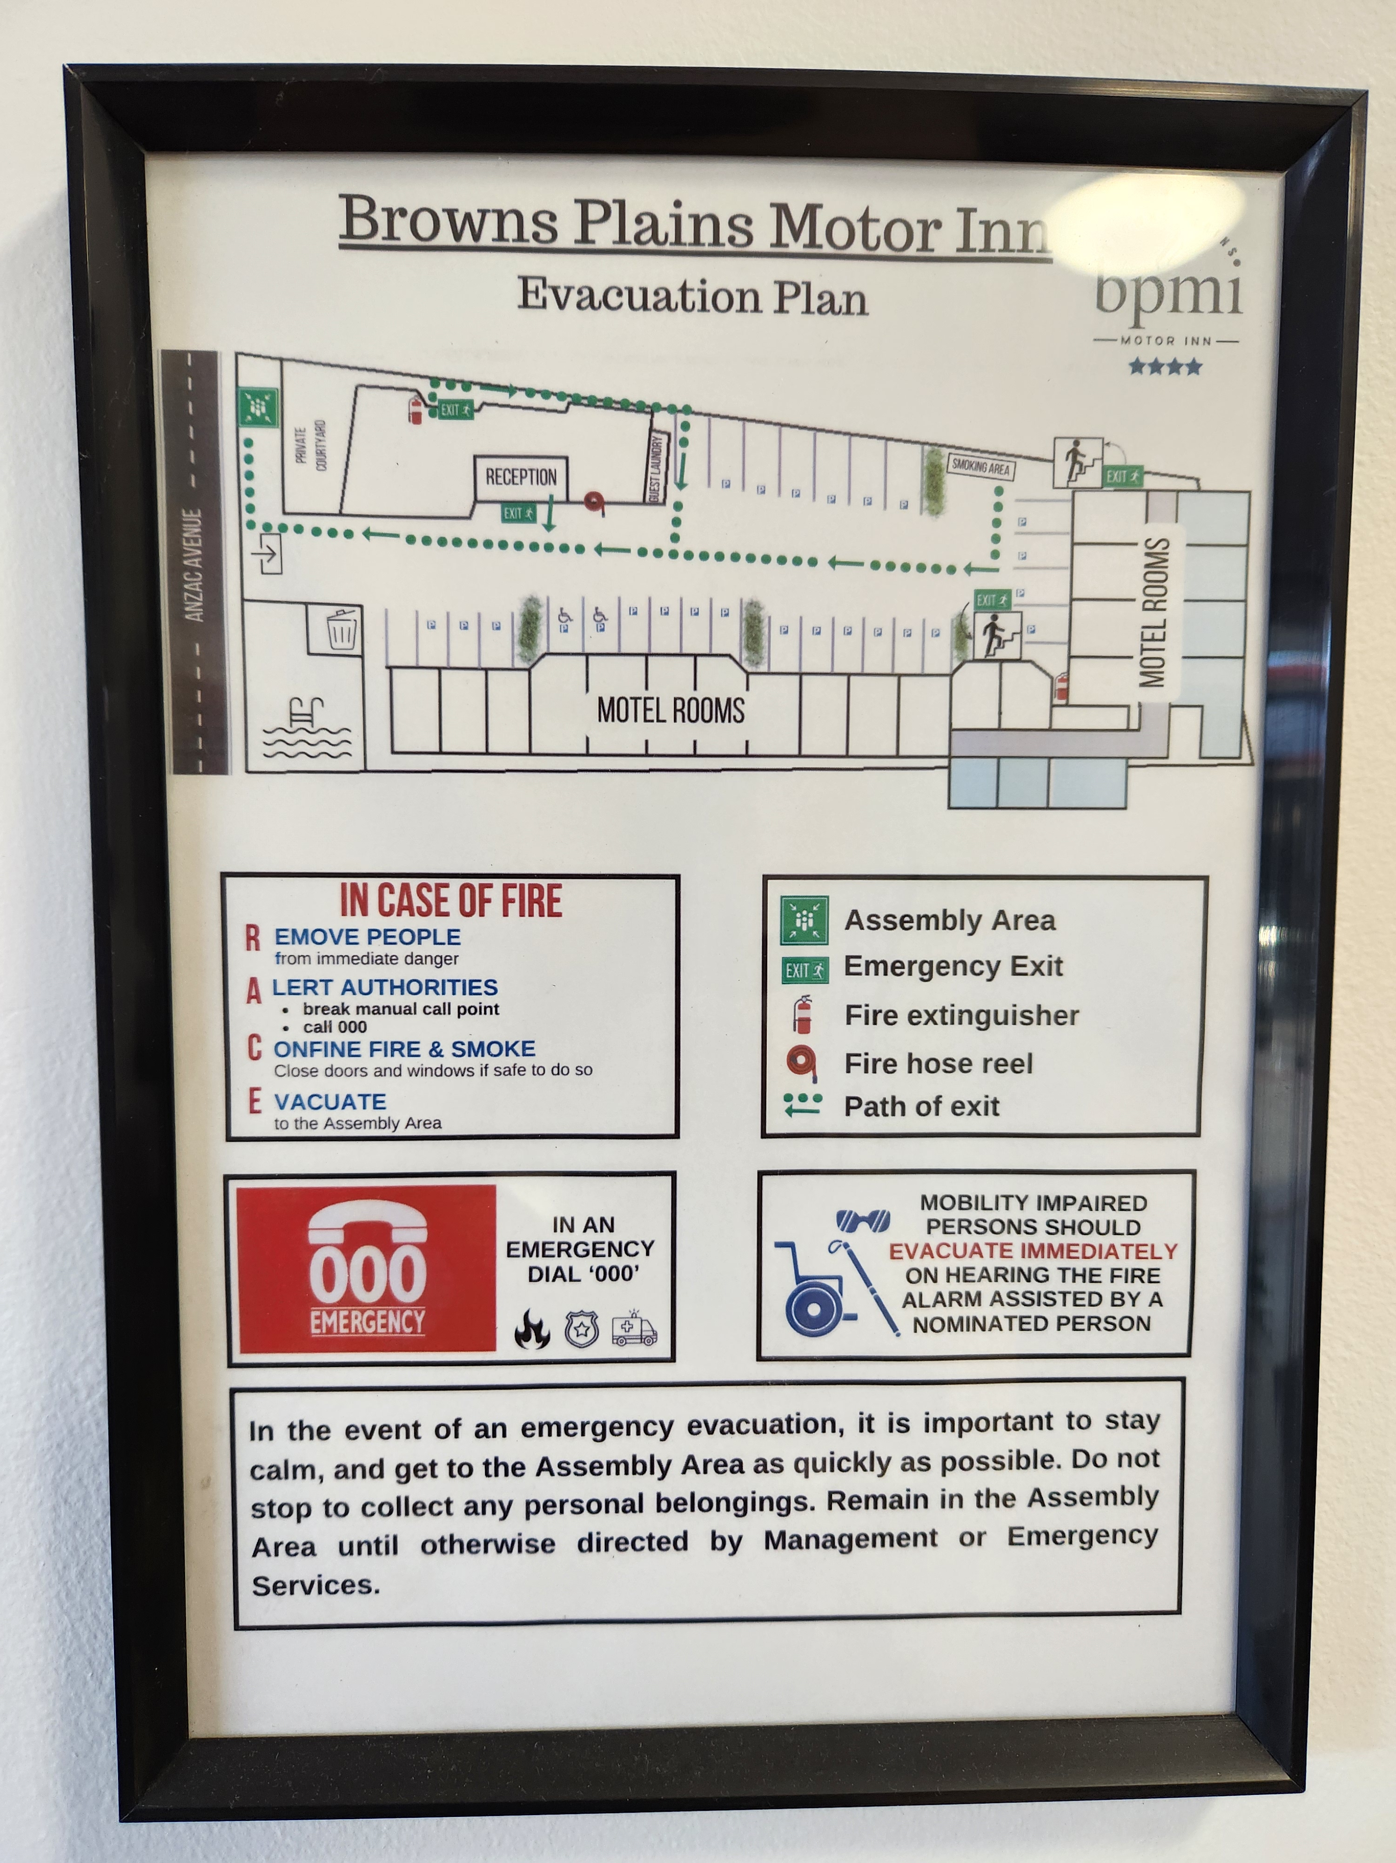
Evaculation Plan
- Guests with disabilities are noted in the guest log book for emergency and evacuation purposes

Communications
- Our website meets WCAG 2.0 accessibility standards
- Our business offers the following alternative communication methods
- Plain English

Not specified
- There is easy to read signage and information (e.g. menus and emergency information)

Other Information
- For bookings made onsite, the ticket booth/counter/box office is accessible for people using a wheelchair

Guide Dog and Service Animals
- The business provides a secure area with shade and water for service animals
- The business provides a toilet area for service animals
The business provides the following services for services animals:
Not specified

GENERAL

Pre-arrival, arrival and reception
The business has the following in place to support guests during pre-arrival, arrival and reception
- Booking information and websites are compatible with screen readers
- There is a reception/public entryway.
- Seating available at reception
- A clipboard to allow check-in/ticket purchase whilst seated
- Lighting in the reception area is even and glare free
- Large print information sheets and registration forms
- Information and maps are available in written form
- A familiarisation tour
- Keys are available for each guest
- Luggage assistance
- In addition, the following further information can assist guests:
Our boutique style motel does not have extended wait times. &nbsp;We do however offer accessible seating in our reception area for all guests and staff are trained to be able to prioritise guests with additional needs.
- In addition, the following further information can assist guests:
N/A

Cognitive Impairment Support
- Documents are available in plain English for people with cognitive impairment (This may include instructions, guides, menus and general information)

Car Park and Access amenities
The business has the following Car Park and Access amenities
- A drop off zone
- Designated disabled parking bays
- Level or ramped access from the car park to the entrance
- The accessible entrance is clearly signed from the parking bay
- Kerb ramps are in place where a pavement or walkway needs to be crossed
- In addition, the following further information can assist guests:
N/A

External Paths
External paths of travel have the following amenities are in place
- Surfaces are concrete, asphalt, smooth paving or hard packed fine gravel (max aggregate size 13mm)
- Paths or slopes longer than 15 metres have resting places or seats
- Pathways are wider than 900mm
- Step free routes clearly signed
- In addition, the following further information can assist guests:
N/A
- In addition, the following further information can assist guests:
N/A

Ramps
Ramps have the following amenities are in place
- There are ramps.
- All fixed ramps are 1:14 or less
- Long ramps (more than 10m) are 1:20 or less
- Temporary ramps are available
- Temporary ramps are in place for the duration of the guests stay
- In addition, the following further information can assist guests:
N/A

Public Toilets/Adult change facilities
Public Toilets/Adult change facilities have the following amenities are in place
- There is an accessible toilet for public use
- The door is at least 850mm wide
- There is 800mm mm beside the toilet
- The toilet seat is 460mm above the floor
- There is 170cm mm of clear space in front of the toilet
- The toilet seat of a contrasting colour to the floor
- The toilet seat is460mm above the floor
- In addition, the following further information can assist guests:
N/A

ACCOMMODATION

Bedrooms
The bedrooms have the following facilities/amenities in place
- There are 2 rooms available to guests who use a wheelchair
- Bedroom furniture can be re-arranged on request

Not specified
  - Layout of room Image(s)
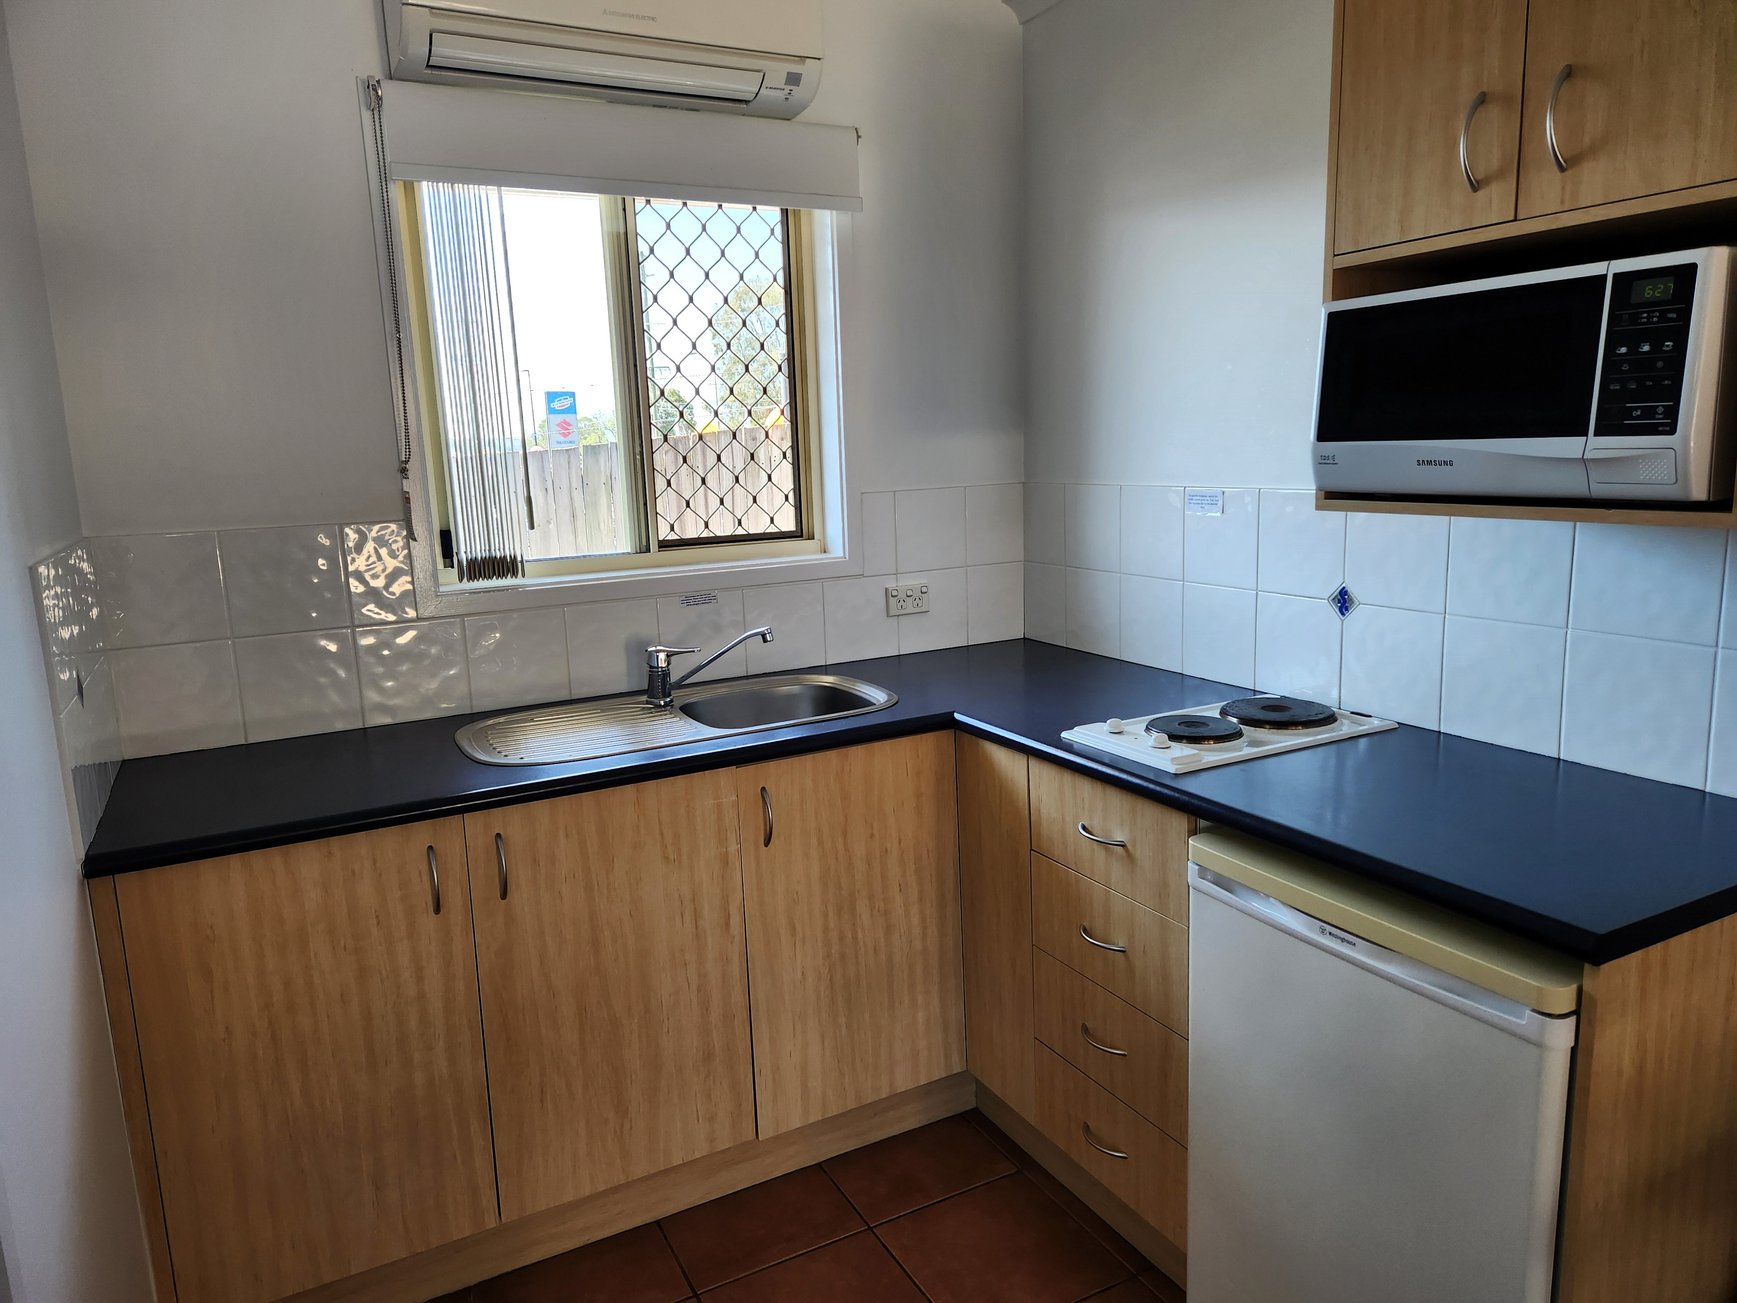
Accessible Room 235 Kitchenette
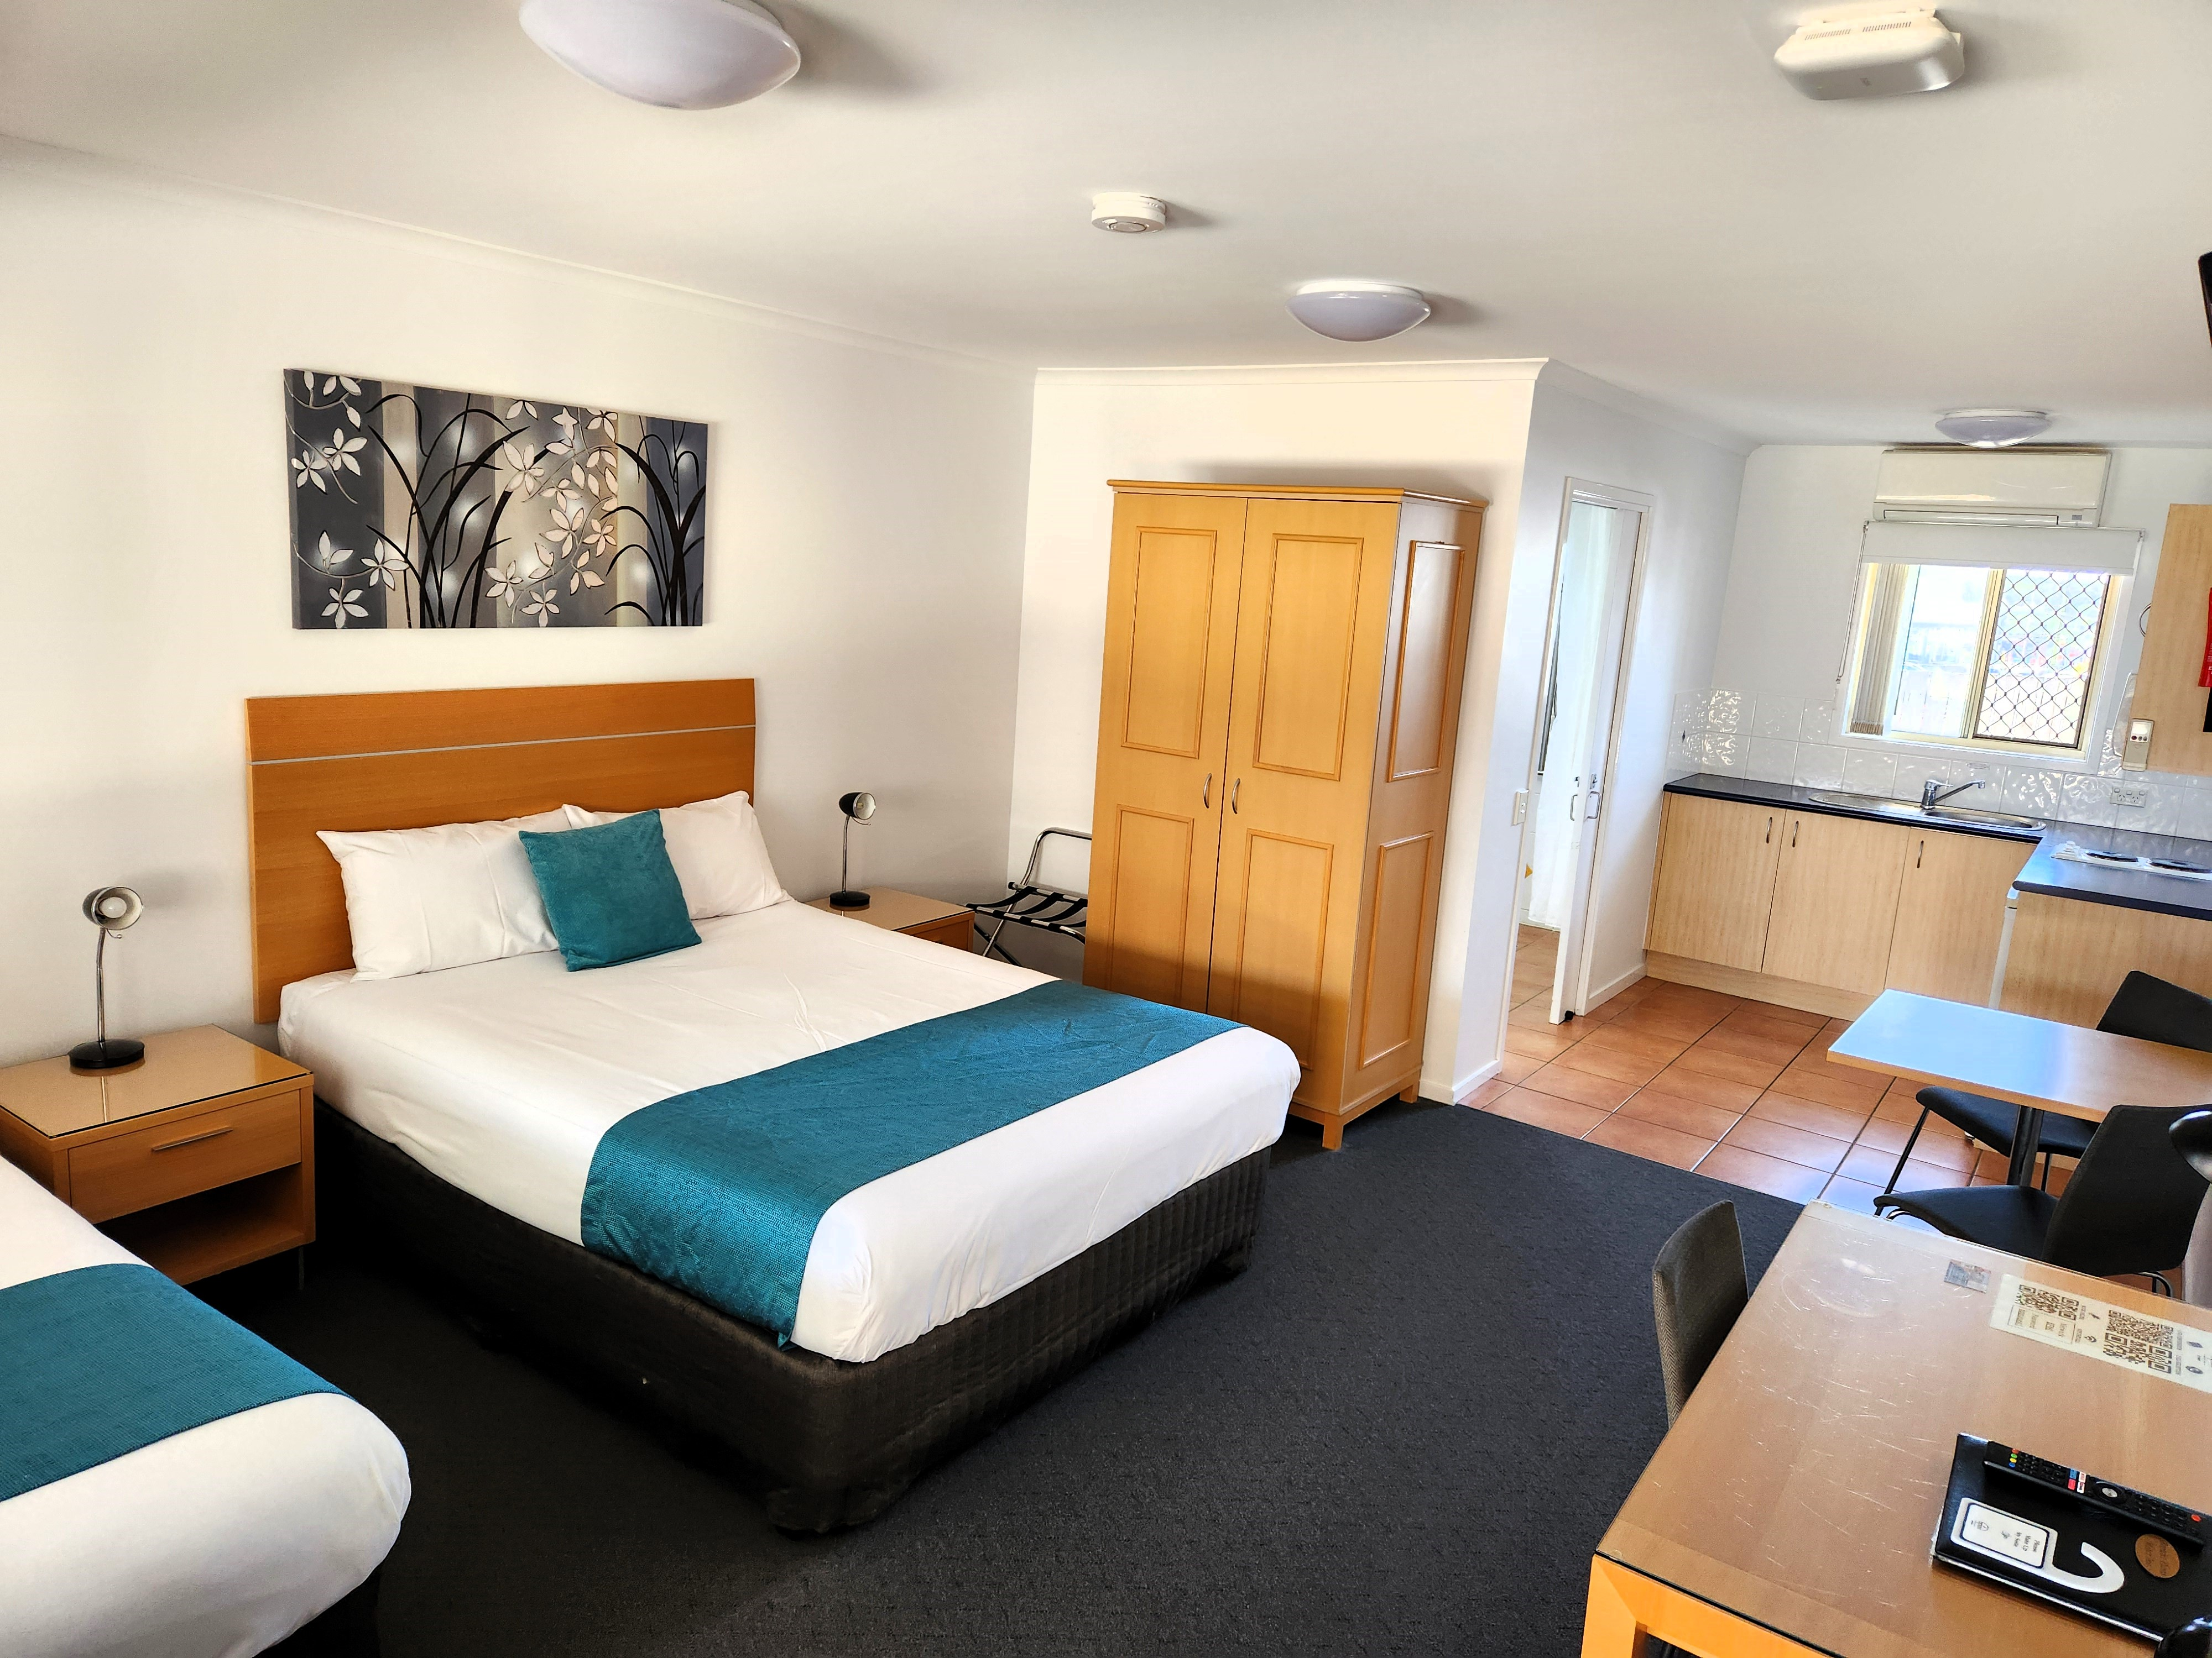
Accessible Room 235 Main Room1
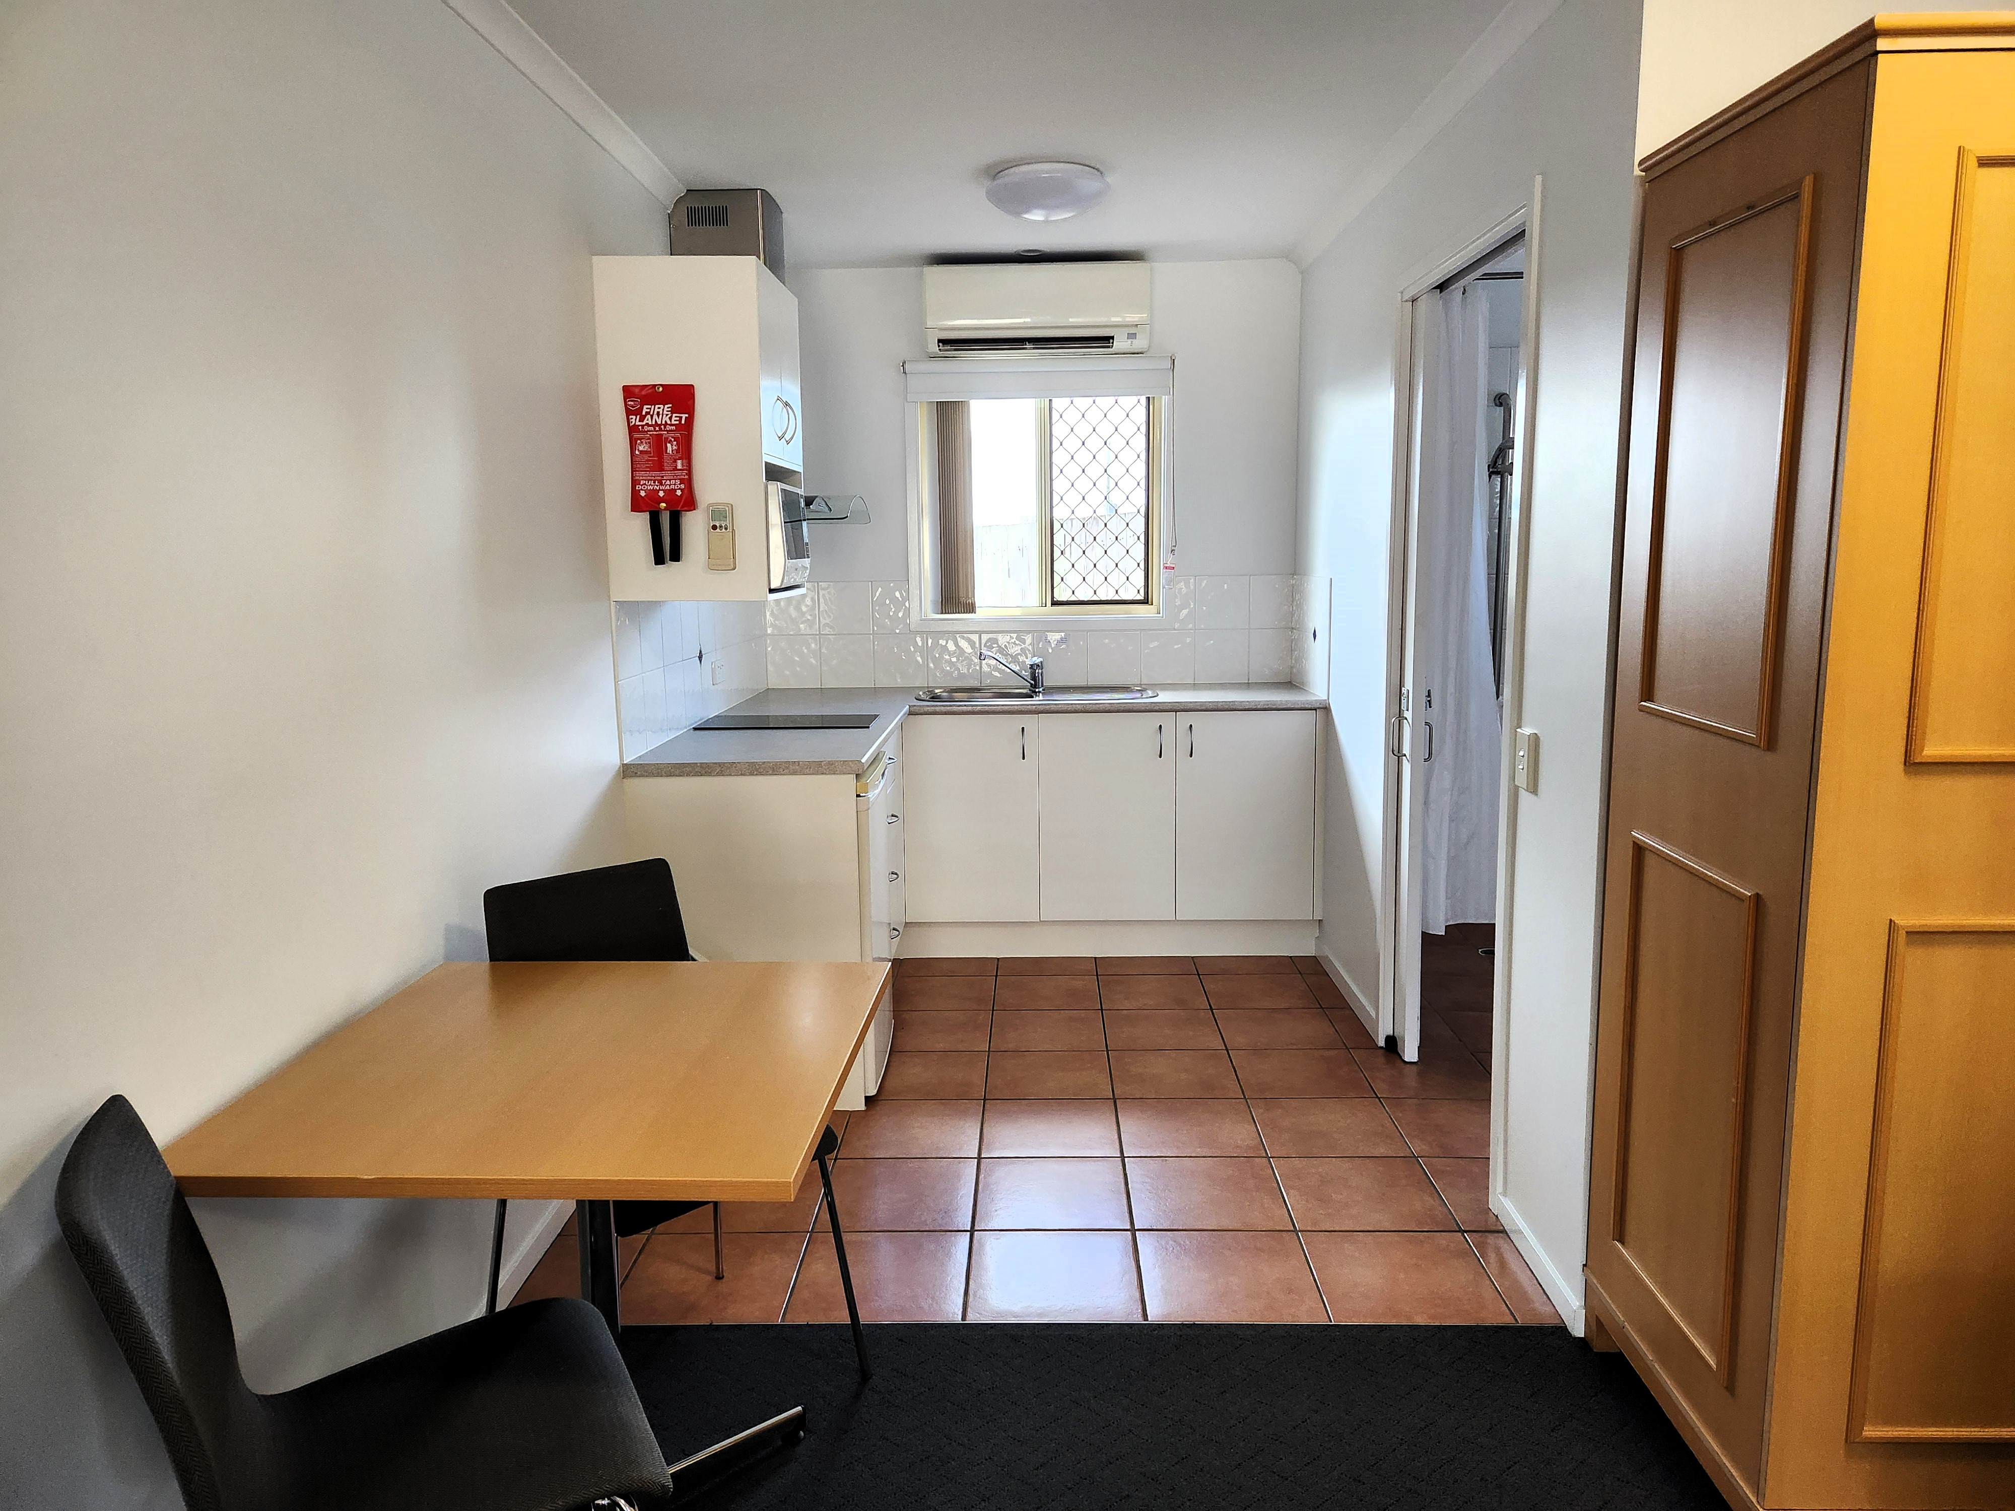
Accessible Room 234 Kitchenette
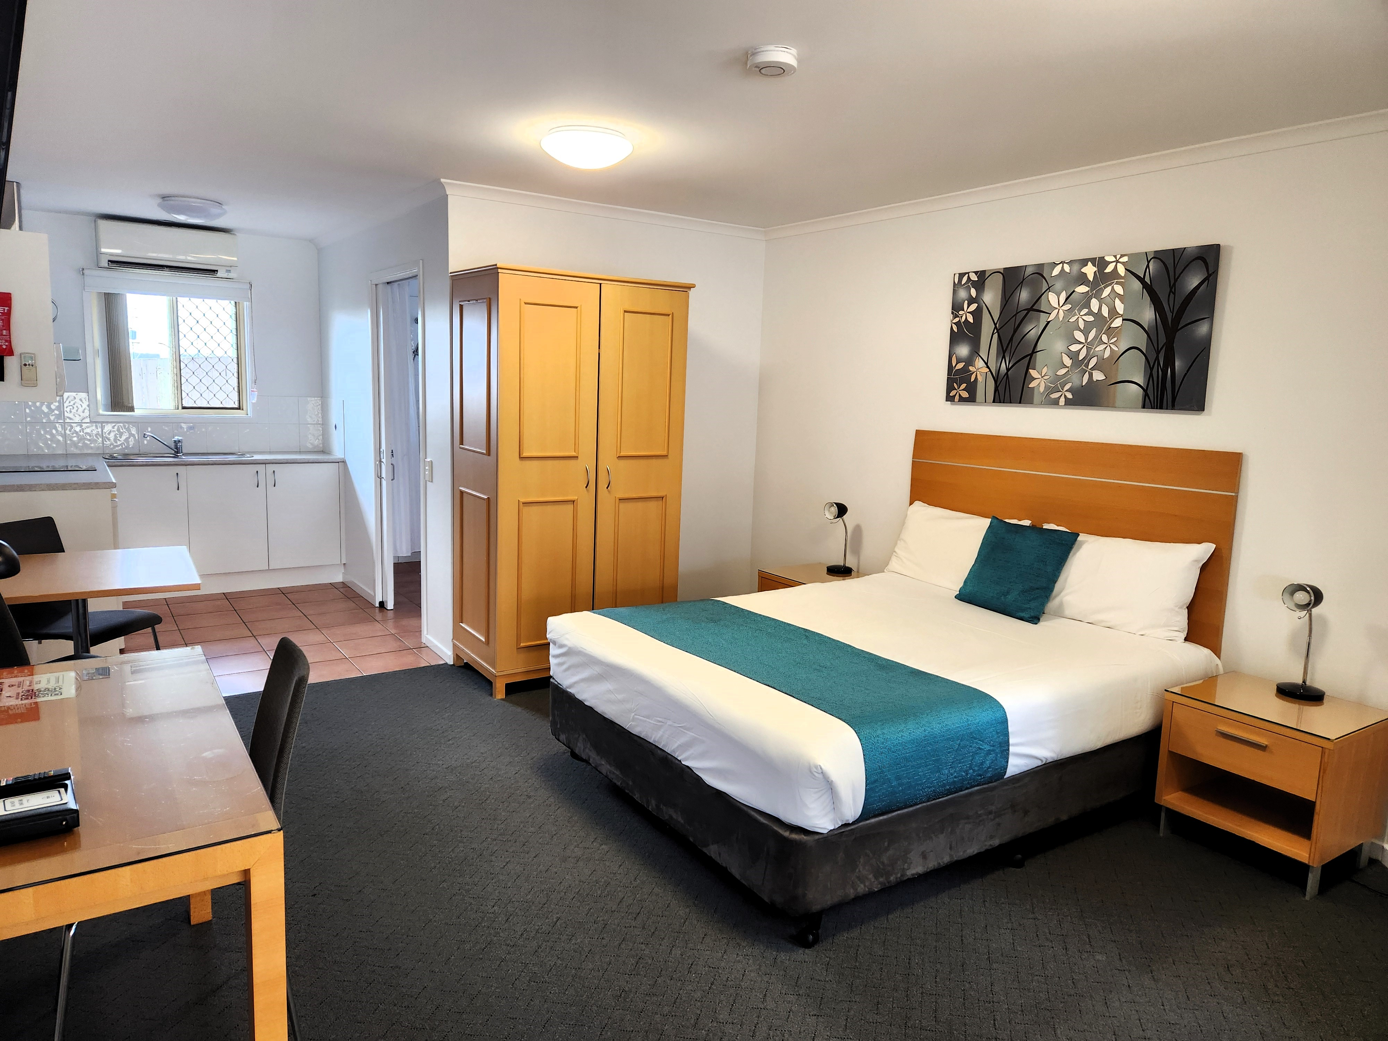
Accessible Room 234 Main Room
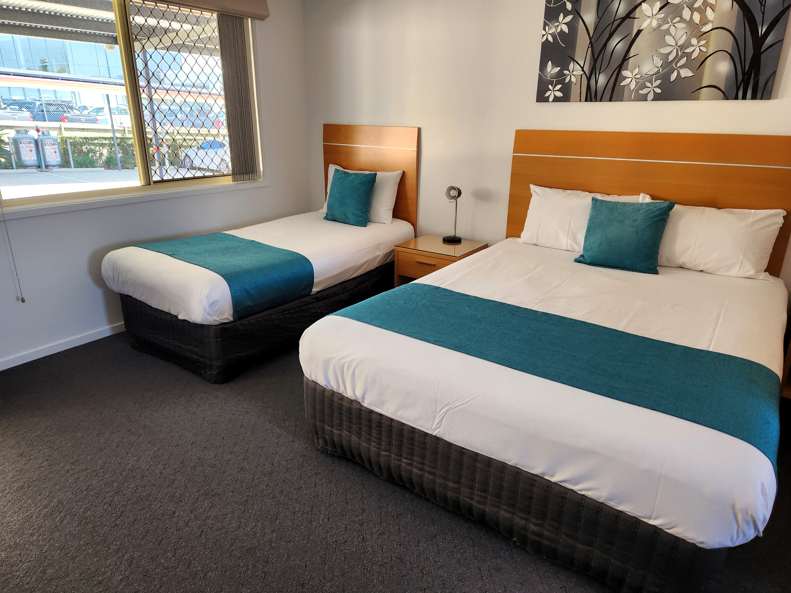
Accessible Room 235 Main Room2

Room Amenities
- Visual alarm is fitted to the room
- Televisions are equipped with closed captioning capability
- There is contrast between the walls, skirtings, floor and furniture
- There is a clear path through the room
- Wardrobe handles are a contrasting colour to the doors and draws
- Housekeeping procedures instruct staff not to reposition furniture that has been moved
- Doors open fully against the adjoining wall
- There is a clear opening at least 850mm wide
- Wardrobe and drawer handles are easy to grip
- The bedside lamp switch is easy to reach from the bed
- There is at least 850mm clear space beside the bed
- The bed height is no higher than 680mm from the floor
- In addition, the following further information can assist guests:
N/A

Bathrooms
The bathrooms have the following facilities/amenities in place
- All heating appliances and hot water pipes are protected or insulated
- All shower, bath and basin taps are clearly differentiated between hot and cold
- Fixtures and fittings have rounded edges
- The hot water is thermostatically controlled to 41 degrees
- The width of the door is 800mm.
- There is a minimum of 850mm beside the toilet
- Handrails are fitted
- There is a minimum of 1400mm of clear space in front of the toilet
- The toilet seat is a contrasting colour to the floor
- The toilet seat is 460mm above the floor
- There is a roll-in shower with fold down fixed seat or a shower chair
- There is a portable shower head on flexible hose
  - Bathroom Image(s)
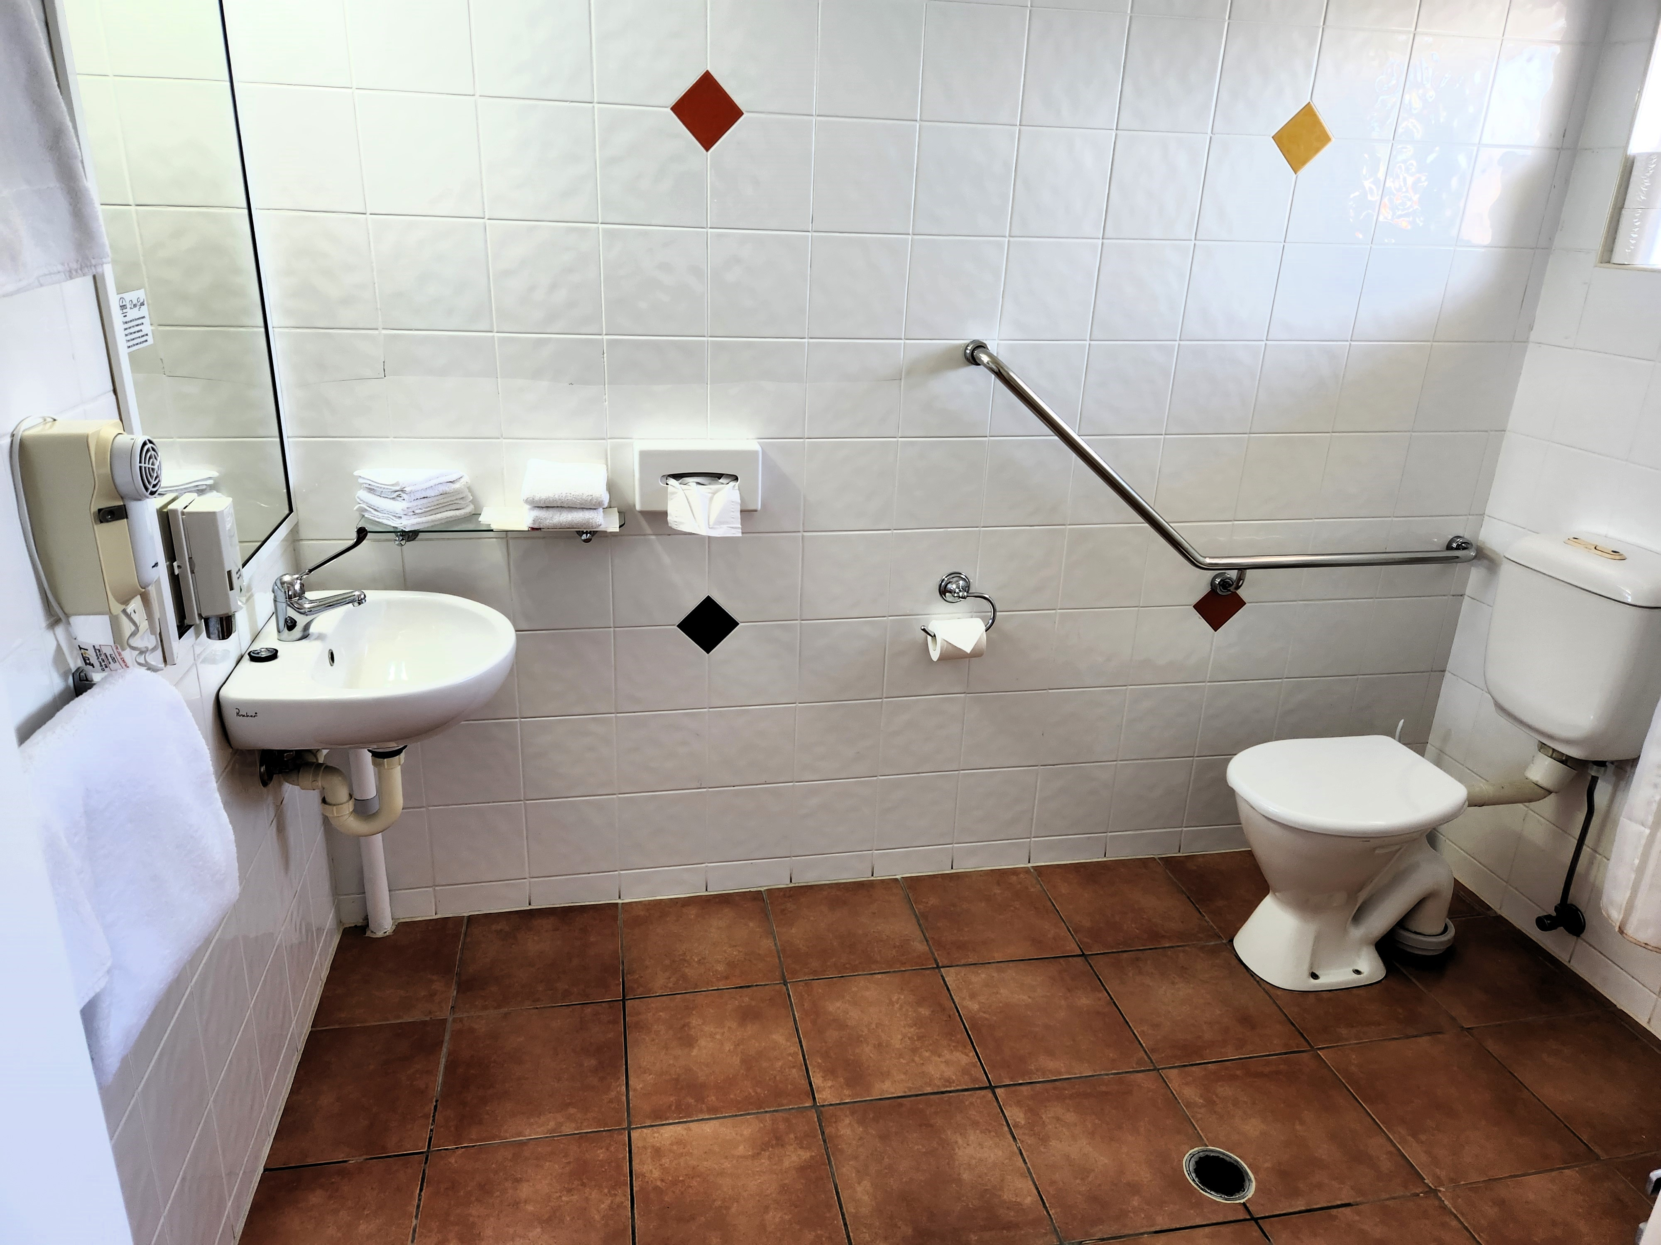
Accessible Room 235 Bathroom
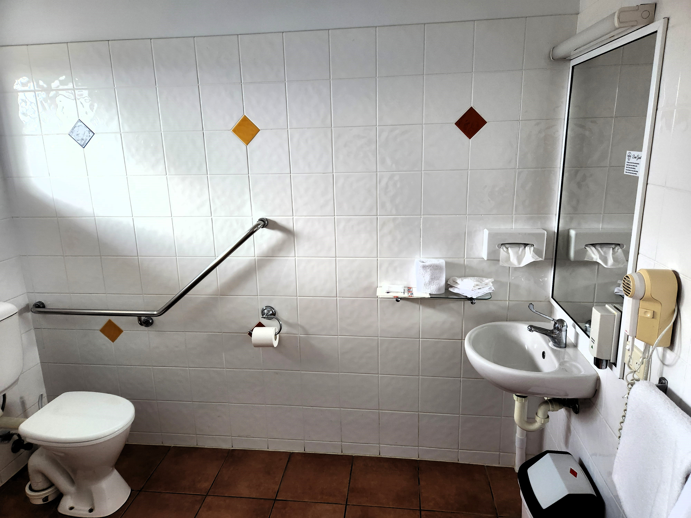
Accessible Room 234 Bathroom
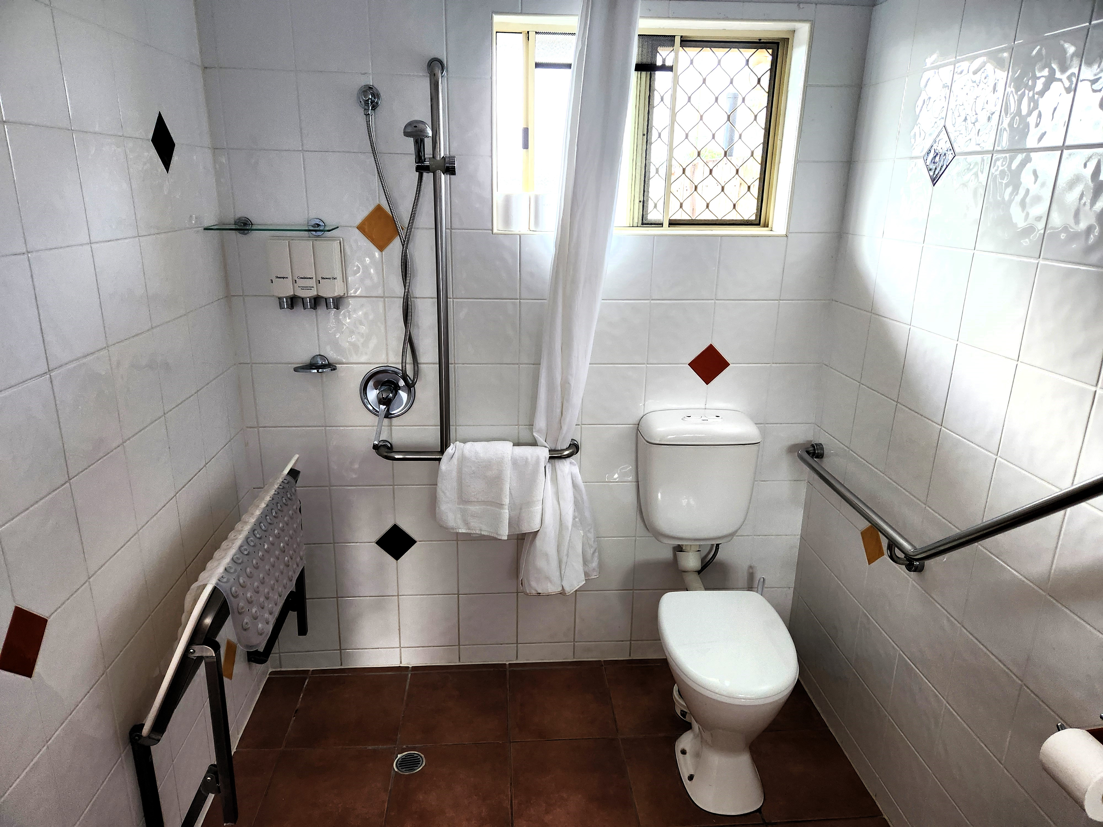
Accessible Room 234 Shower
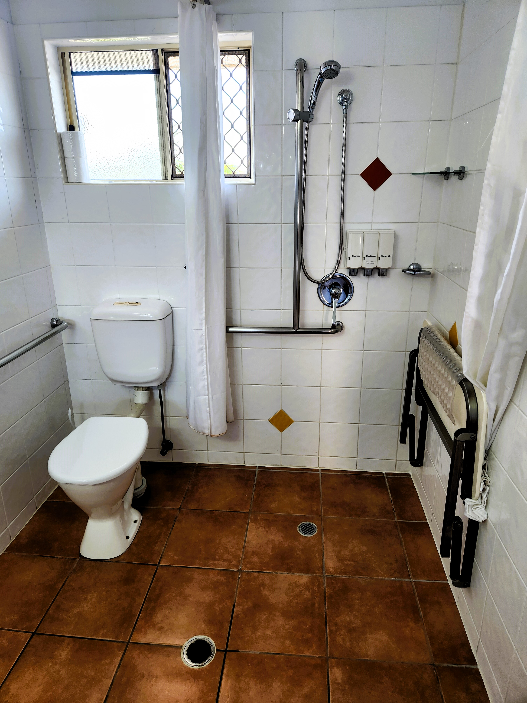
Accessible Room 235 Shower

COMMON AREAS

Swimming pools, spas and waterparks
- The following swimming pools, spas and waterparks amenities are available
- The park map includes a step free route
  - Pool Access Image(s)
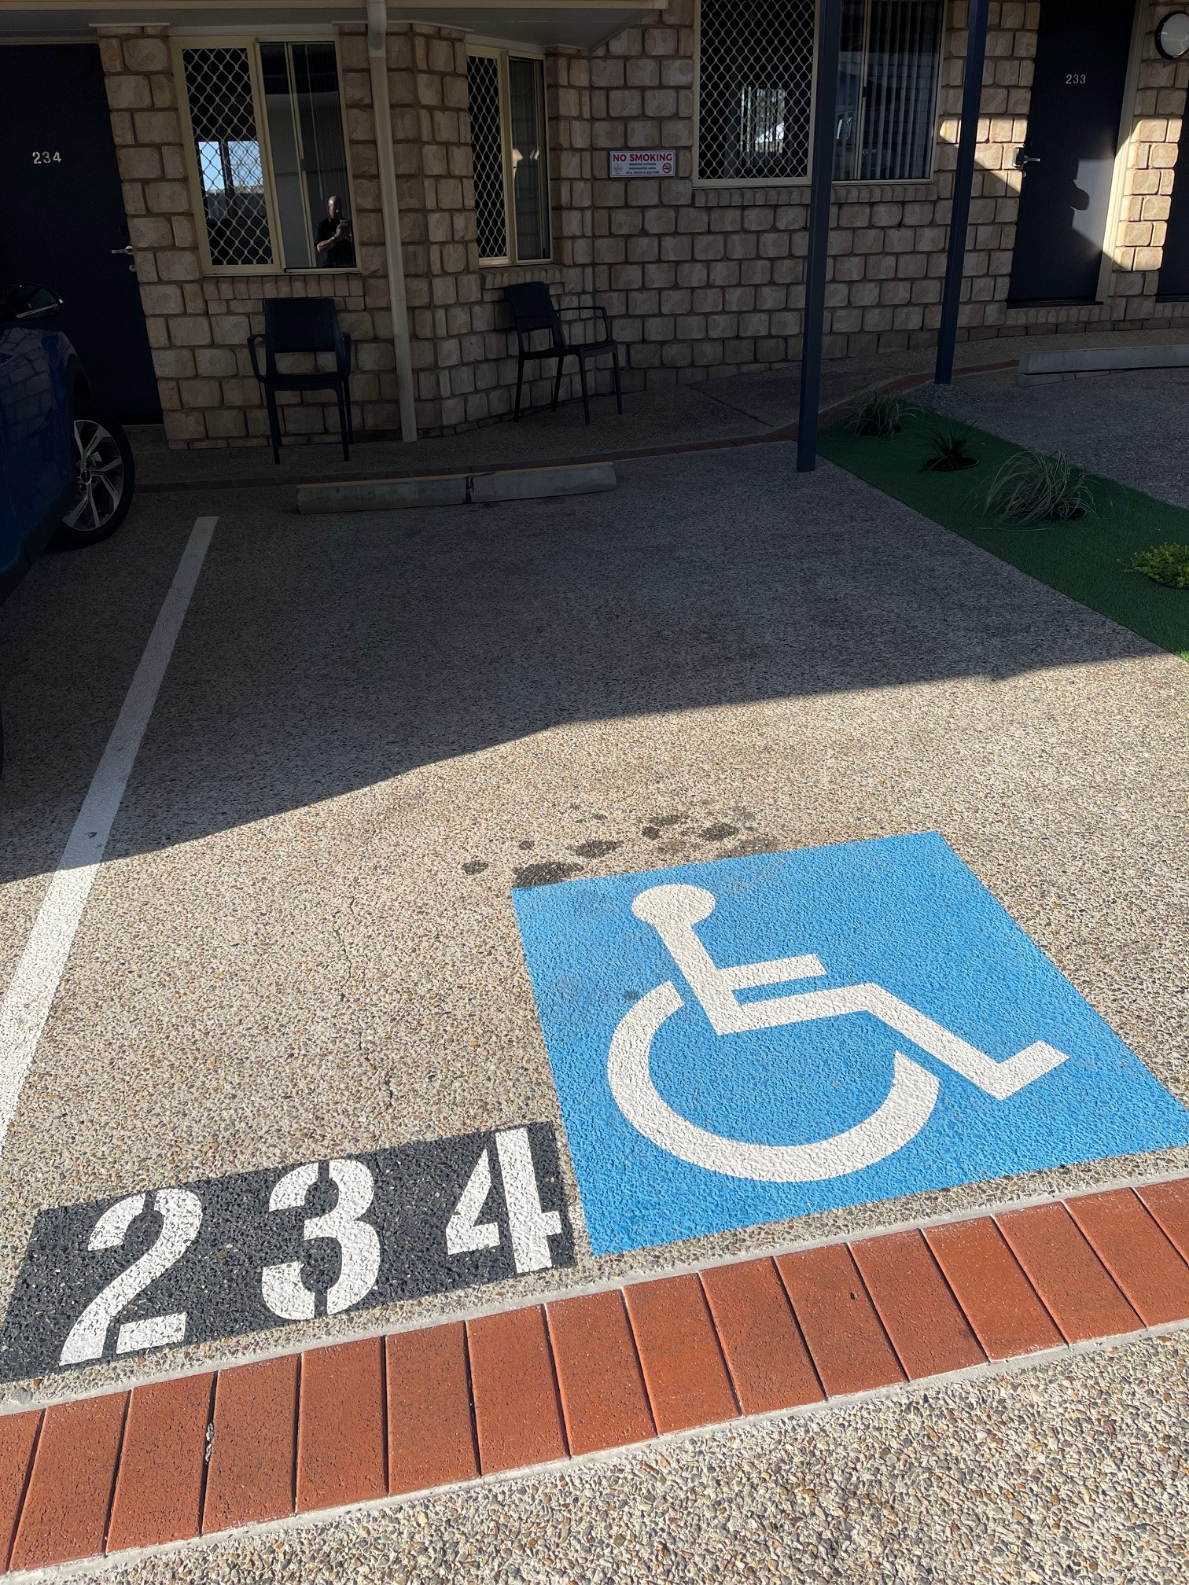
Accessible Car Park
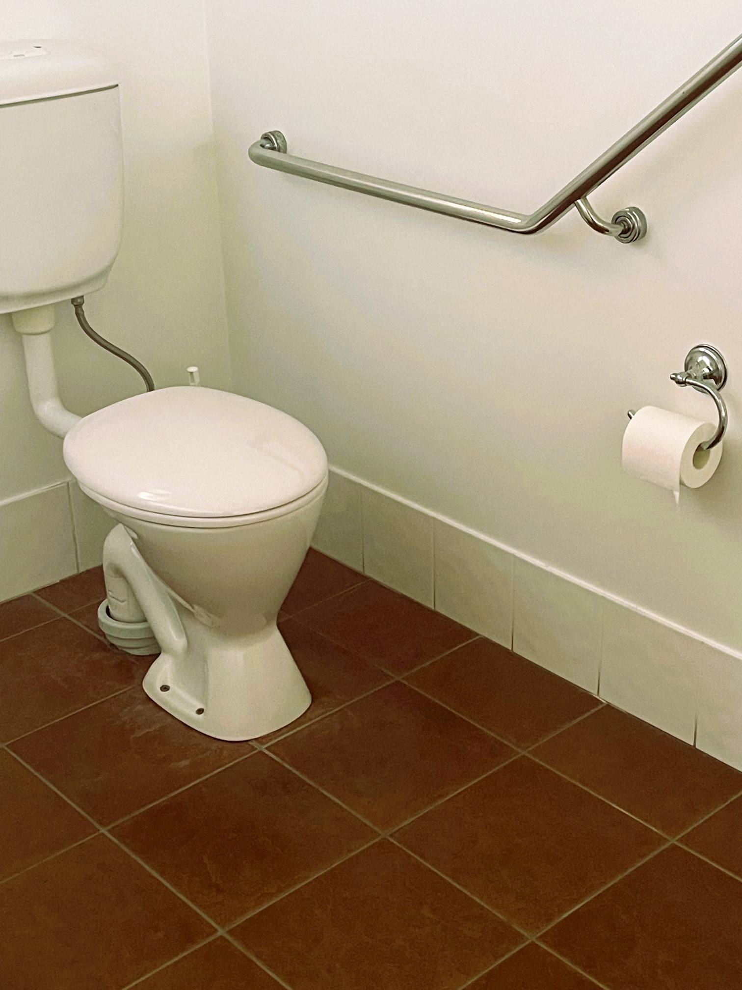
Accessible Toilet
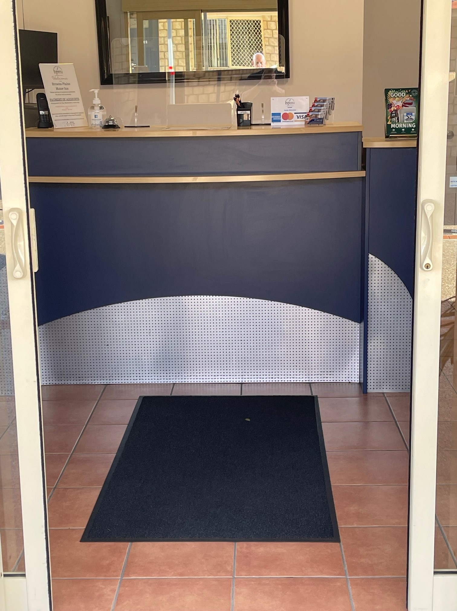
Reception Area
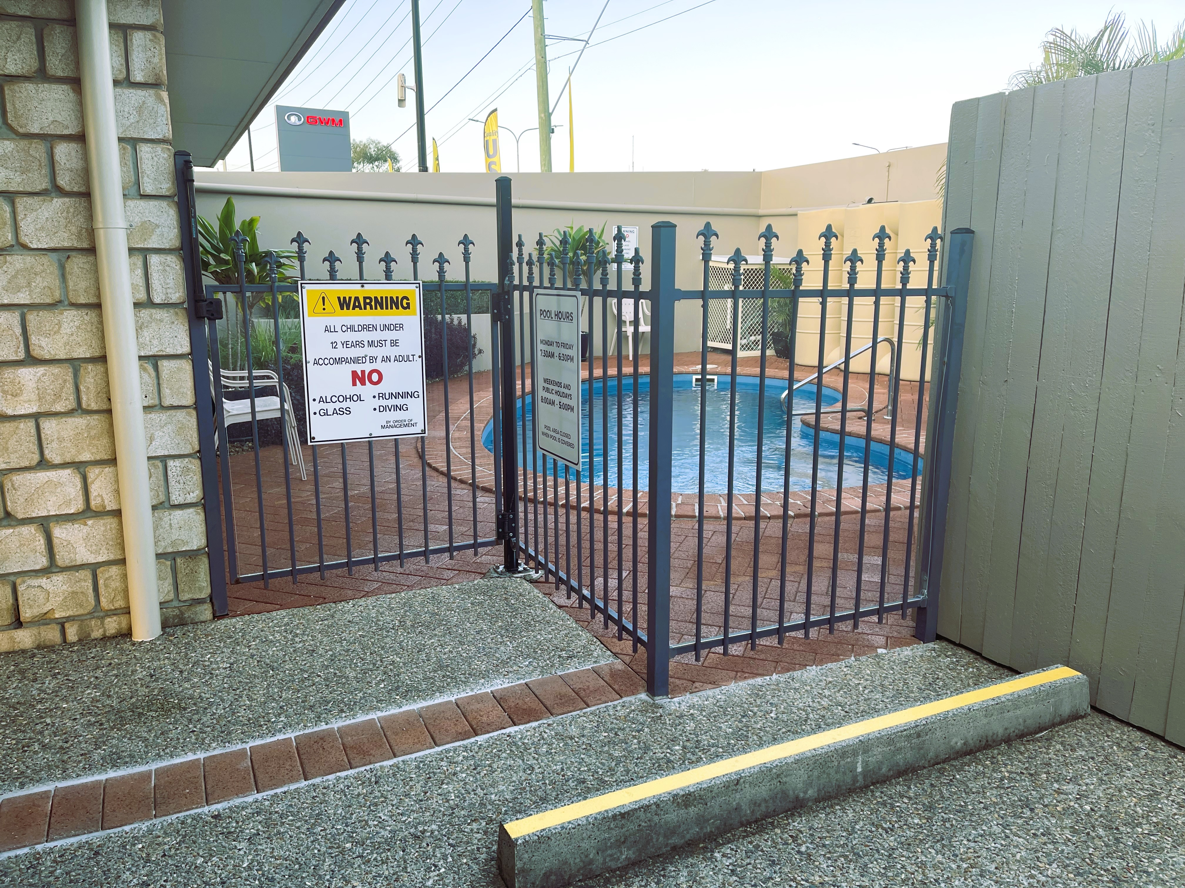
Pool Entry
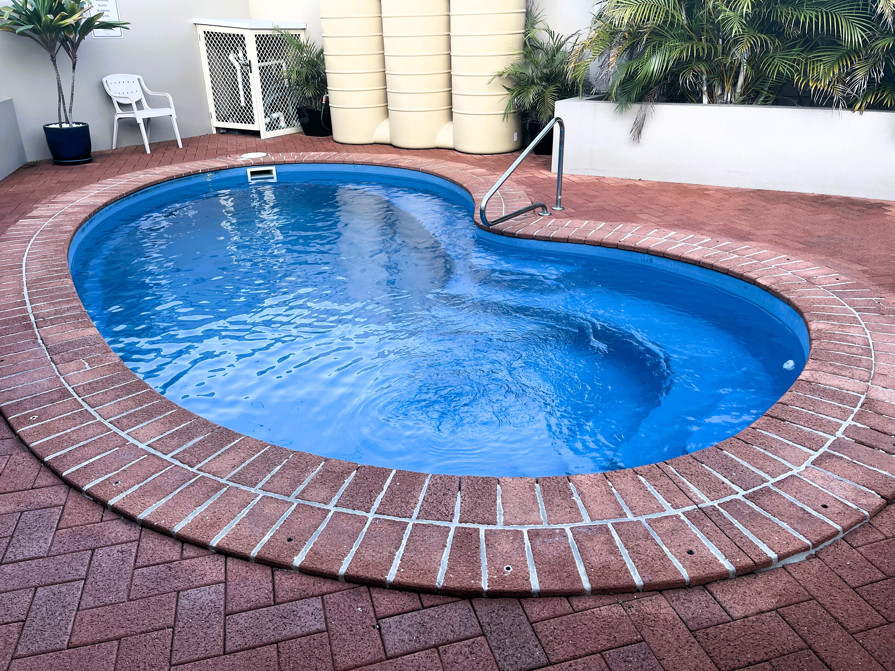
Swimming Pool

Report Disclaimer
Please note that this business report, provided as a result of the use of the diagnostic assessment, is for information purposes only.
Australian Tourism Industry Council (ATIC) cannot guarantee the accuracy of respondent’s answers, or that they are fully representative of your business. Therefore, ATIC does not warrant or guarantee any particular outcome in respect of your businesses self-assessment.
This report is intended as guidance only for your business and should not be relied on for future marketing considerations. ATIC recommends that you seek your own independent advice as well as the results from the diagnostic.
Links to external web sites are inserted for convenience and do not constitute endorsement of material at those sites, or any associated organisation, product or service.
ATIC does not:
- Assume any legal liability for the accuracy, completeness, or usefulness of any information from this report or any links provided; or
- Accept responsibility for any loss associated directly or indirectly from the use of this report.

