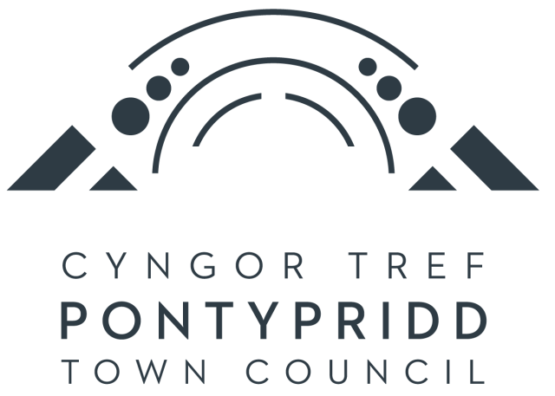
COLLECTIONS AND EXHIBITIONS OFFICER
PERSON SPECIFICATION

 | Essential | Desirable
1. Educational qualifications | 2 A-levels and 5 GCSEs or equivalent (including Maths and  English).  Educated to HND or degree level in a relevant subject (including but not limited to Archaeology, History, Geology, Natural Sciences, History of Art) OR a minimum of 2 years’ experience in a similar role. | Post graduate qualification in Museum Studies.
2. Work Experience | Experience of working with historical collections in or with the public/museum sector.  Experience at developing permanent and temporary exhibitions.  An understanding of archival methods and knowledge of Spectrum standards.  Experience of administration work including databases and website updating.  Experience in social media in terms of publicising events and activities. | Experience of researching and developing permanent exhibitions.  Experience of using Modes Complete.  Experience of applying for grants and adhering to monitoring requirements.
3. Skills/knowledge and aptitude | Knowledge of local history of the Pontypridd area as well as the history and culture of Wales.  Excellent IT/computer skills.  Ability to work under pressure and to tight deadlines.  Excellent verbal and interpersonal skills.  A creative approach to problem solving. | Some understanding of the work of a Town/Community  Council.  Some basic ability in Welsh or a commitment work towards conversational Welsh.

4. Personal Attributes | Able to organise your workload efficiently.  Able to attend evening and weekend events and play a part in ceremonial and related activities and events.  Able to work on Saturdays as part of a staff rota to ensure the museum is open to the public 6 days a week.  Be able to demonstrate a positive and enthusiastic attitude.

