

Agenda

Policy and Finance Committee – Thursday 12th June 2025 @ 5pm (via Zoom)
_______________________

- Election of Chair for 2025-26.

- Election of Vice Chair for 2025-26.

- Apologies for absence.

4. Declarations of Interest.

To receive disclosures of personal/prejudicial interests from Members:

Note: Members are requested to identify the item number and subject matter to which their interest relates and to signify the nature of the personal interest; and where Members withdraw from the meeting as a consequence of the disclosure of a prejudicial interest, they must notify the Chair when they leave.

5. Well-Being of Future Generations (Wales) Act 2015

To note the Well-Being of Future Generations (Wales) Act 2015 imposes a duty on public bodies including the Town Council to carry out sustainable development in accordance with the sustainable development principle and to act in a manner which seeks to ensure that the needs of the present are met without compromising the ability of future generations to meet their own needs.
6. Chief Executive’s Report. (pages 1-79)

6.1 Social Value Evaluation Tool
6.2 Museum Retaining Wall
6.3 Graig Community Centre – Rent Concession
6.4 Graig Community Centre – Legal Claim
6.5 Community Asset Transfer – Land at Coedylan School
6.6 List of Accounts – May 2025
6.7 Small Grants x 3

Committee Members

Councillor S. Pritchard Councillor L. Tomkinson
Councillor C. Thomas Councillor C. Lisles
Councillor L. Davies Councillor D. Paul
Councillor H. Fychan Councillor S. Presse
Councillor E. Griffiths Councillor C. Roberts
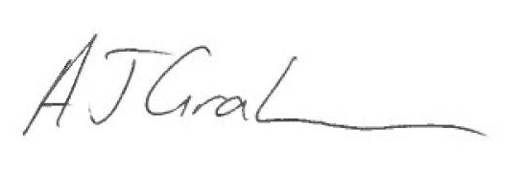

Tony Graham
Chief Executive/Town Clerk
6th June 2025

The zoom link for the meeting is available on request by emailing info@pontypriddtowncouncil.gov.uk

Please Note
If there are any specific details you wish to raise regarding, for example, background information or require additional detail, it would greatly assist if you could contact the office in advance so that the information and answers can be made available at the meeting.

