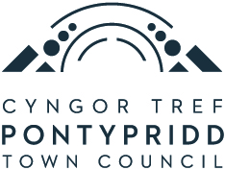

FRONT DESK AND PUBLICITY OFFICER
PERSON SPECIFICATION
 | Essential | Desirable
1. Educational qualifications | 5 GCSEs or equivalent (including Maths and English). | 2 A Levels.
2. Work Experience | Previous experience in administration and office responsibilities.  Experience of dealing with the public and community groups. | Experience in a front facing customer services environment.  Experience of helping to organise events.  Experience of working in or with the public/museum sector would be helpful but is not essential.
3. Skills/knowledge and aptitude | Ability to work under pressure and to tight deadlines.  Excellent verbal and interpersonal skills.  A creative approach to problems.  A personality that engages positively and enthusiastically with members of the public. | Excellent IT/computer skills especially in regard to producing publicity material.  Excellent social media skills along with a knowledge of website updating.  Some understanding of the work of a Town/Community  Council.  Some basic ability in Welsh or a commitment work towards conversational Welsh.

4. Personal Attributes | Able to organise your workload efficiently.  Able to cover evening and weekend events and to work at least one Saturday at the museum per month on a rota basis.  Be able to demonstrate a positive and enthusiastic attitude.

