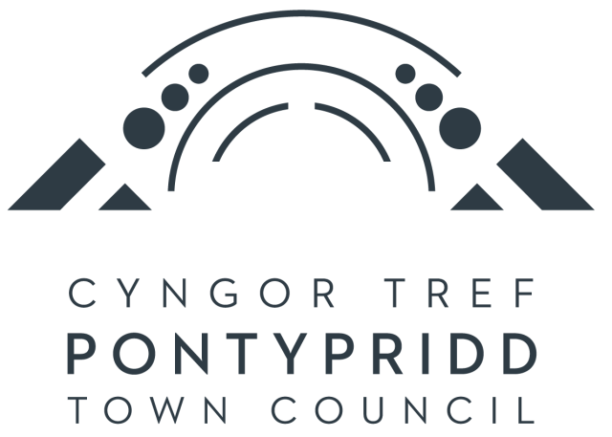

Collections and Exhibitions Officer

Salary £28,598-£30,518 (NJC SCP 12 – 16)
subject to qualifications and experience. A pay award is pending.

Main Duties and Responsibilities

This position at the Museum will draw together a curatorial role alongside the capacity to prepare regular exhibitions. It will suit someone with a passion for overseeing a historical collection but also a desire to display objects and ideas in a creative and exciting manner.

The individual will have a hard working, team ethic and a desire to work with the Museum Manager and the Chief Executive to develop the Museum to be one of the foremost visitor attractions in the area.

The successful candidate will work with the Museum Manager to ensure that the Museum plays a key role in the cultural, educational, and community life of Pontypridd through purchase of objects and the development, redisplay, reinterpretation and promotion of the museum’s collection.

Line Manager

Museum Manager.

Supervisory Responsibilities

‘Collections’ Volunteers (at the instruction of the Museum Manager).

Specific Responsibilities

1) To work with the Museum Manager to maintain all standards and memberships of professional associations required for Museum Accreditation.

2) To research, develop and install permanent and temporary exhibitions within the Museum and develop touring exhibitions as directed by the Museum Manager.

3) Working with the Museum Manager to expand and care for the museum collections, including arranging loans to and from other organisations, maintaining Modes database records, documenting, accessioning, monitoring, and providing preventative conservation for museum objects.

4) To assist in the application for grants from external agencies to support the development of the Museum.

5) To carry out research on the collections and local history and produce publications, lectures and seminars relevant to the purposes of the museum.

6) To work under the Museum Manager’s supervision and instruction to develop the museum, answer public enquiries regarding the collection and the area’s history, and promote and publicise the museum’s activities through all available media.

7) To assist in collaborating with local and national agencies and organisations to achieve the Council’s objectives.

8) To work with other staff including the Schools and Community Liaison Officer and to assist in the educational, community and outreach work, of the Museum and the Town Council.

9) To attend training courses relevant to the work of the Collections and Exhibitions Officer as required by the Museum Manager and/or the Town Council.

10) To be a registered key holder for alarm and security purposes.

11) To work a rota to enable six-day opening. This will include working on Saturdays usually on a monthly basis.

12) To meet Health and Safety requirements by taking care of self and others and to work within the Town Council’s policies and procedures to this end.

13) To undertake other tasks considered appropriate by the Town Council having regard to the salary scale.

