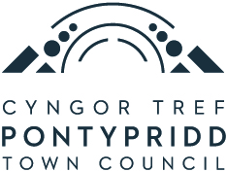

Agenda

Full Council – Thursday 25th June 2026 @ 6pm (Hybrid Meeting)
_______________________

Presiding Member: Cllr C. Thomas Town Mayor: Cllr A. Kabid

1. Apologies for absence.

2. Declaration of Members interests.

To receive disclosures of personal interests from members.

Note: Members are requested to identify the item number and subject matter to which their interest relates and to signify the nature of the personal interest; and where Members withdraw from the meeting as a consequence of the disclosure of a personal interest, they must notify the Chair when they leave.

3. Well-being of Future Generations (Wales) Act 2015.

To note the Well-being of Future Generations (Wales) Act 2015 imposes a duty on public bodies including the Town Council to carry out sustainable development in accordance with the sustainable development principle and to act in a manner which seeks to ensure that the needs of the present are met without compromising the ability of future generations to meet their own needs.

4. To allow the public (if present) to speak on any item on the agenda or ask questions (3 mins max).

5. Minutes.

To approve the following minutes:

Policy and Finance Committee – 14th May 2026
Council Meeting – 21st May 2026
Policy and Finance Committee – 11th June 2026

6. Town Mayor Announcements.

7. Chief Executive’s Report (pages 1-31)

7.1 Amended Earmarked Reserves 2026-27
7.2 Annual Governance and Accountability Return (AGAR), Audit and Accounts 2025-26
7.3 Maesycoed Governing Body – Vacancy
7.4 Election – Town Ward
7.5 To consider a motion to exclude the press/public (if required)
7.6 Upper Gallery Tenders / Welsh Government Grant Update

8. Planning Applications (pages 32-38)

9. Correspondence Received (pages 39-57)

- OVW RCT, Merthyr and Caerphilly area meeting minutes - 08.04.26

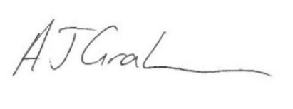

Tony Graham
Chief Executive/Town Clerk
18th June 2026

The zoom link for the meeting is available on request by emailing info@pontypriddtowncouncil.gov.uk

Please Note

If there are any specific details you wish to raise regarding, for example, background information or require additional detail, it would greatly assist if you could contact the office in advance so that the information and answers can be made available at the Meeting.

Any members of the public wishing to ask questions, may do so by setting out their questions in writing and sending it to the Council at least 3 clear days prior to the Council meeting.

