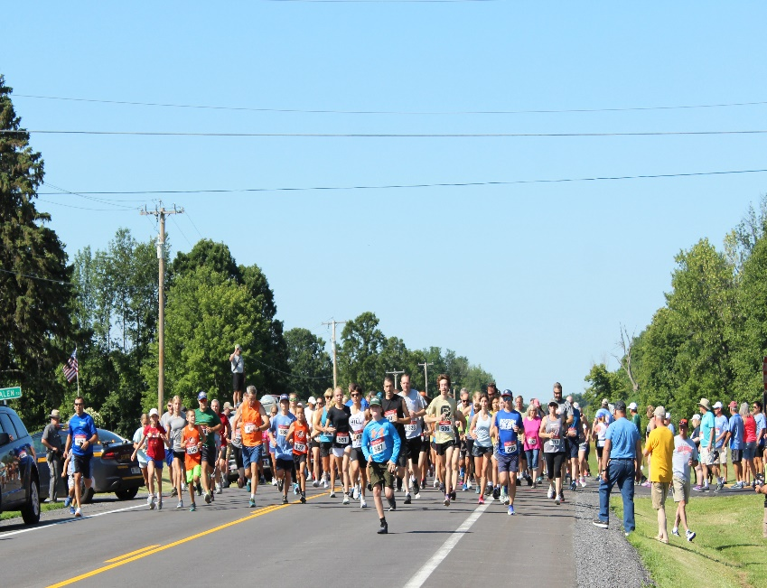
Race Route:
Can be viewed on Town of Louisville web site – https://www.louisvilleny.gov
Awards:
Medals to 1st place male / female winners per age group: 15 and under; 16-29; 30-39; 40-49; 50-59; 60-69, & 70 +
T-shirts to 1st 250 who register. Must pre-register by July 6 in order to guarantee t-shirt size.
Entry Fee: Registration Fee: $30 adult; $6 children 11 years old & under.
Registration form can be printed from the Town of Louisville web site or you can register on-line at runsignup.com/Race/NY/Massena/WilsonHillTurtleTrotRunWalk
Make checks payable to the Wilson Hill Association
Mail Check to:
Nancy W. Foster
4 Butternut Ridge
Massena, NY 13662

Race Information:
Contact Nancy W. Foster
E-mail: nlfoster@twcny.rr.com
Phone: 315.764.1289


ALL PROCEEDS OF THE RACE TO GO TO LOUISVILLE VOLUNTEER FIRE DEPARTMENT

When: Saturday, July 25, 2026

Where: Whalen Park Louisville, NY
Located 1.5 miles west of the River Course at Louisville Landing Recreation on State Route 131. Race course is a 3.4 mile flat, fast, scenic route along the beatutiful St. Lawrence River

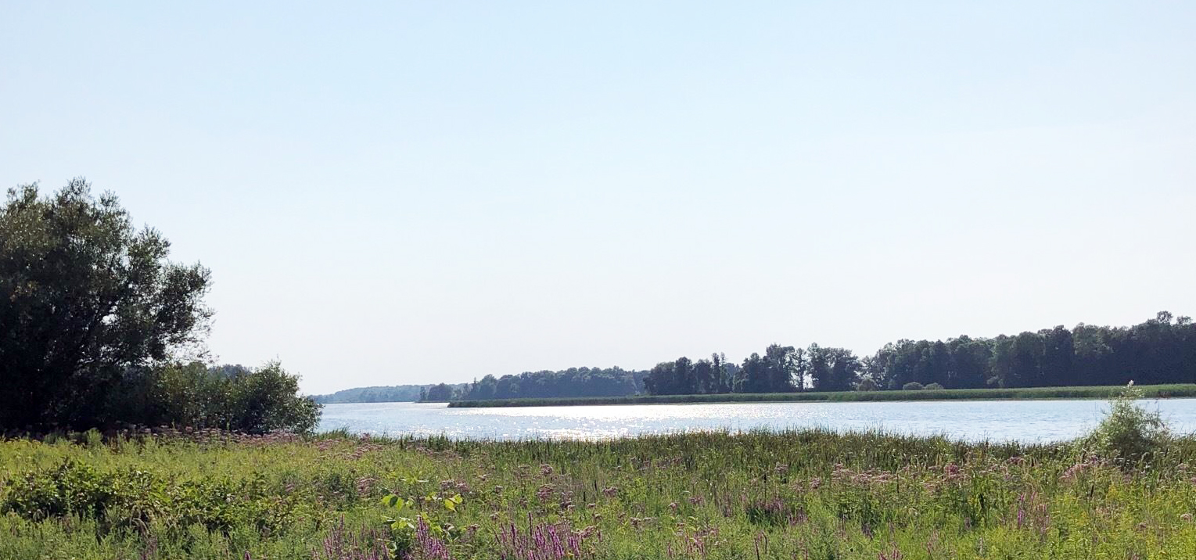

Start Time: 9:00 AM
(same day registration at 7:30 AM)

