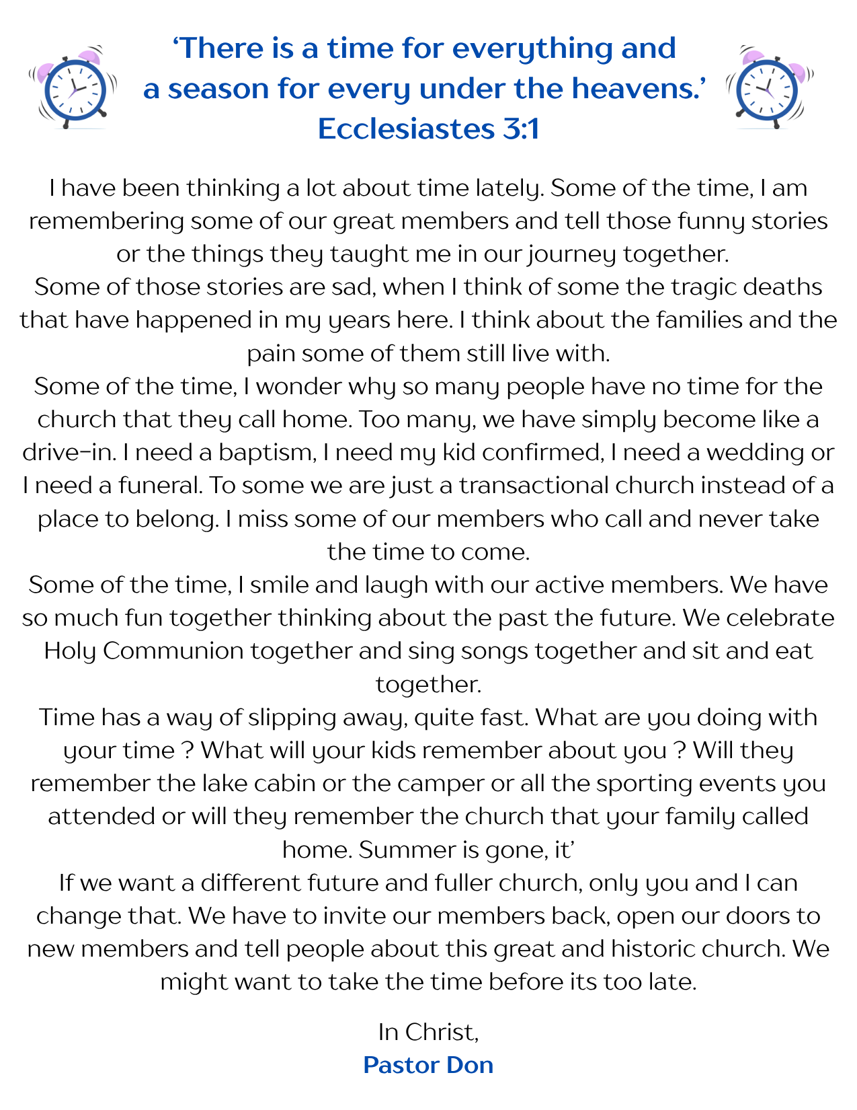

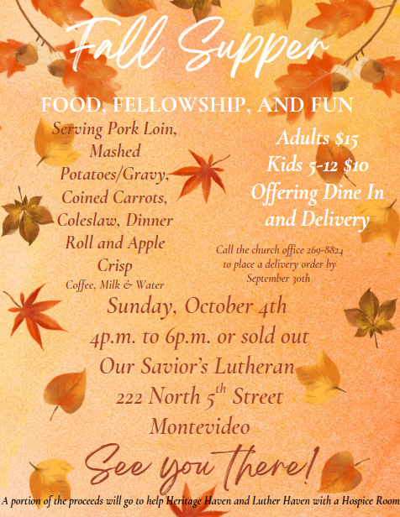

The 

September 2026
Worship
9:00am
Newsletter of Our Savior’s Lutheran Church
Montevideo, MN · 320-269-8824

Email: oursaviors@oslcmonte.net Webpage: oslcmonte.com



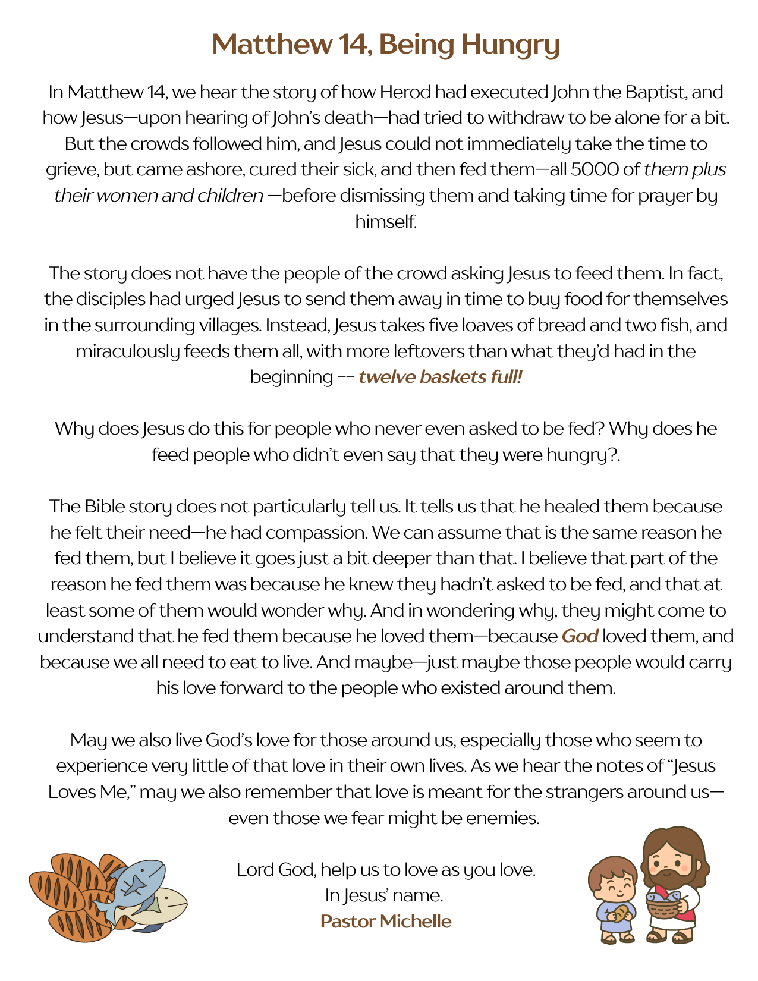


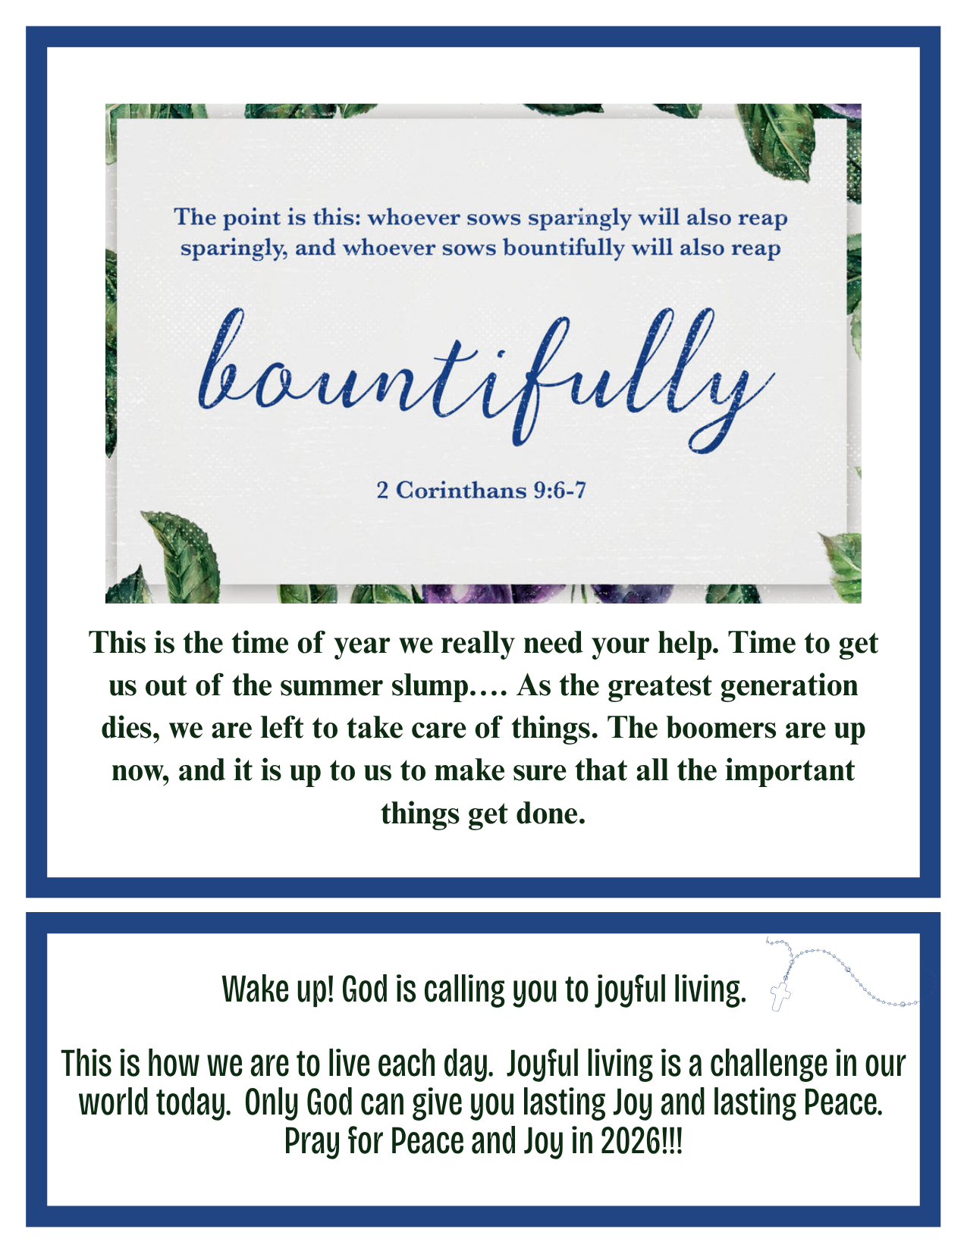



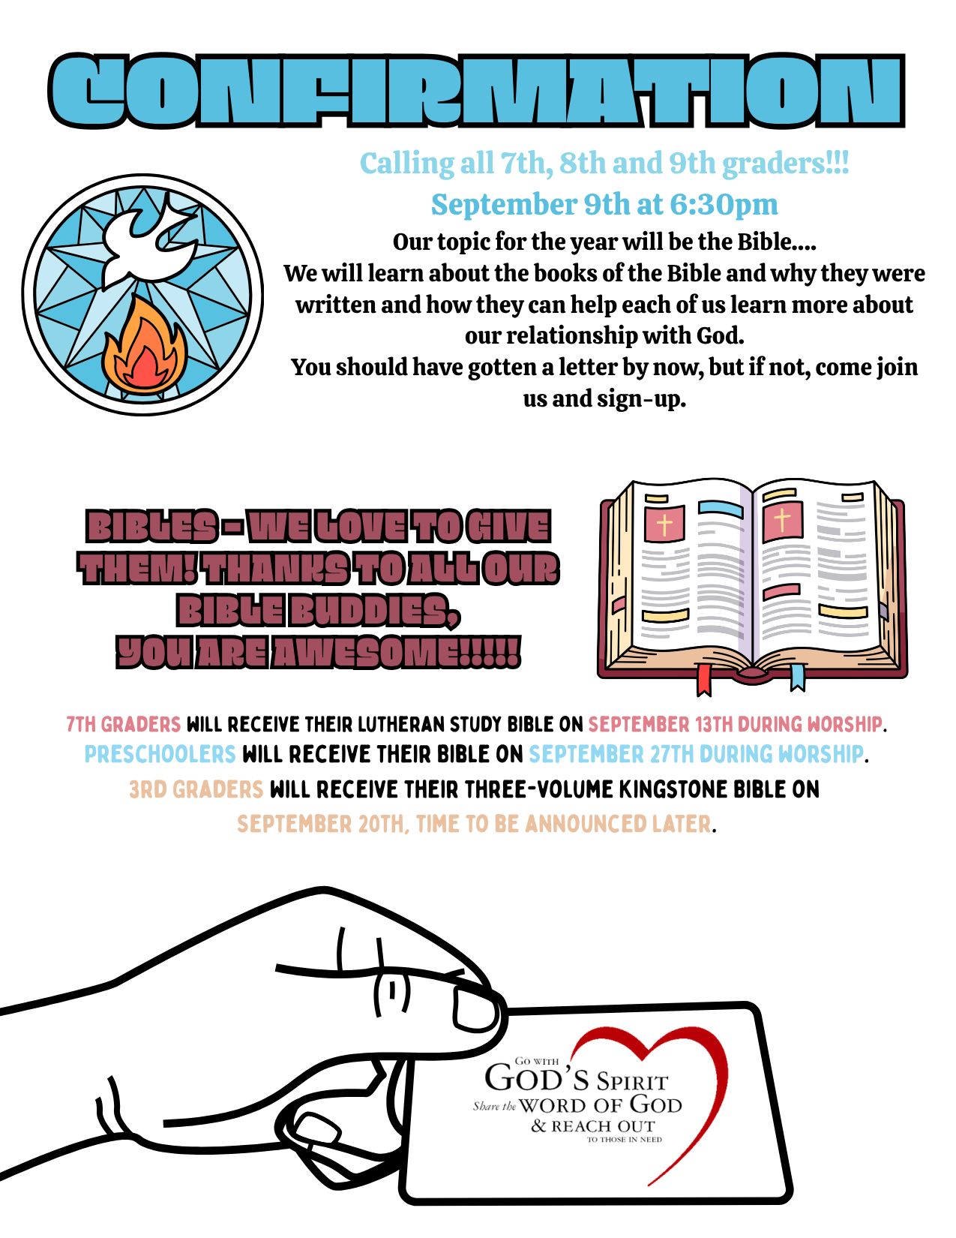

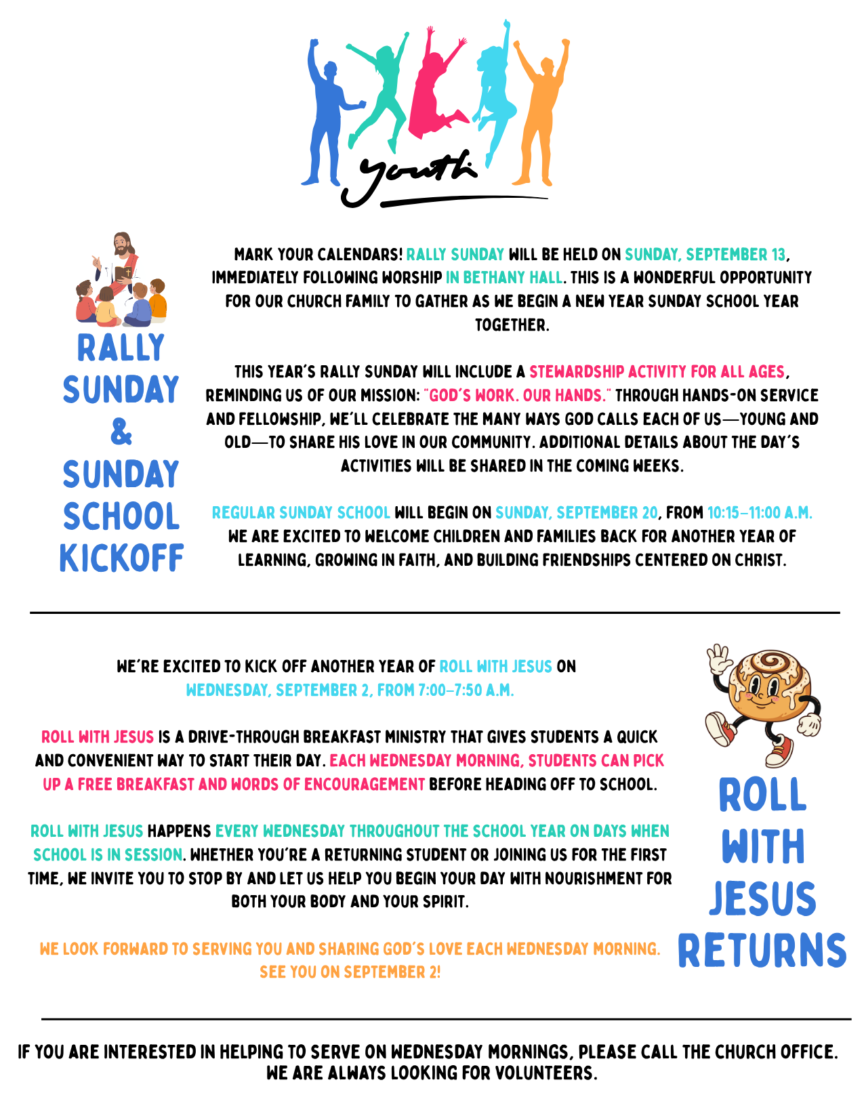
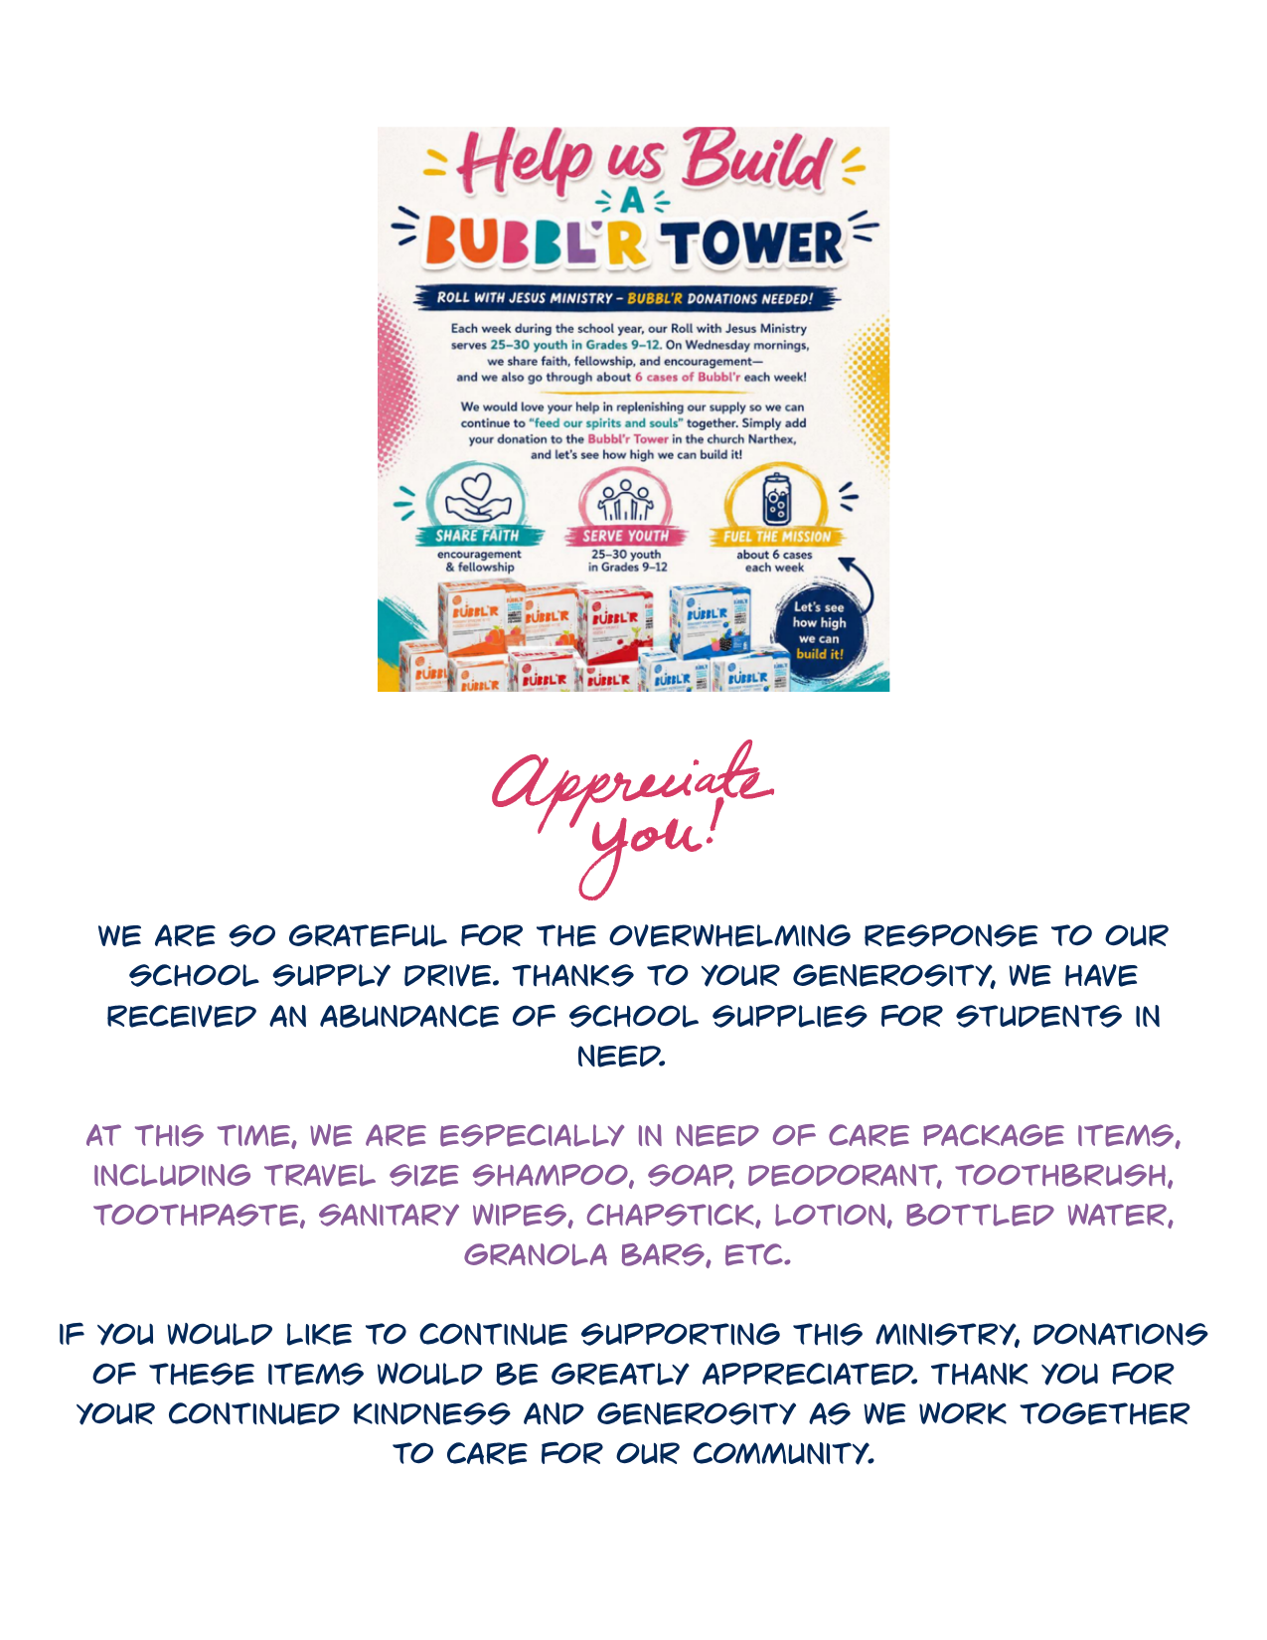

If you Could Only Imagine By: Ed Delf

Do You ever let your imagination run wild? I mean really go outside your box of comfort? Sometimes when a situation or event happens that we just can't seem to process normally, such as a loved one's untimely passing, a job loss, maybe a medical situation, you get the idea, we can easily slip into this imagination mode just to cope.

I can remember when I was still working, I had situations where my decisions on which direction to take could make or cost my company many thousands of dollars. I had to imagine as many possible outcomes as possible and hopefully make the right decision. As you would guess, because I didn't always have all pertinent information, it sometimes caused a less than favorable outcome for me. But that was just part of doing business. Unlike my situation as I've described, or perhaps yours, we have a whole book of pertinent information to rely on, the Bible. We need to have this information to really understand the results of not acting on what we have been told.

So that said, do you ever imagine what our lives would be like if God had not sent His Son to atone for our sins? As sinners, we're given a pretty good idea of what our fate would be as we're told in the Bible. The amazing thing to me is that we have a choice in how things play out but still may not act on it.

We're told many stories in the Bible about the Apostle's and their journey with Jesus. I have a hard time imagining their struggles. I would venture that most of us can hardly imagine living in the wild west much less those times. But I think that our struggles though are no less relevant to us than theirs was to them.

The interesting thing to me about wondering if those Bible stories are true is the physical evidence that continues to be found that connects places with the stories. As I let my imagination run wild, I think that there will be more sites and artifacts found that will validate more of the Bible's stories, as not abstract, but factual.

In the end though, we don't have to imagine that the turmoil we see playing out in our world today is just temporary, we know it is. After all, we're given an outline of how things play out in Revelations. We're all given the pertinent information needed to make our decision. By God's Grace, it has been made possible
As for me, I like to imagine the new Jerusalem.


