

**‘You shall love the Lord your God, with all you heart and all your soul and all your mind and your neighbor as yourself’**

This is the commandment Jesus gave us. It is clear and concise and straight forward. I was talking with someone the other day and I realized we all look at sin differently. Some sins trigger deep emotions within us and others some think they are not so bad. So, what is it that triggers your judgment and disdain for people?

As I have read the Bible a sin is a sin and there is no distinction. Swearing is as bad as gossip and is as bad as treating your parents badly. We could list all the sins that we could think of and in God’s view of the world, they are all ways that separate us from God. We are the ones who make distinctions on which sins are the worst. Not God, all sins separate us from God plain and simple.

So, then this sin or that sin triggers us and then we judge people unfairly. Now, I am not saying that this is easy. I want to remind you that we live by grace and forgiveness. We think or at least I do, ‘I am not as bad as the person who does this.’ In God’s eyes each of us is and we are condemned for this sin. However, God sent Jesus to save us from that sin and offer us new life.

I just wanted to offer this to think about…. We all fall short of the glory of God and yet God loves us and saves us and offers us grace. This brings joy to my heart and keeps me some days from judging others…. All of us are still works in progress…. thank God for that…. tomorrow I will do better.

Triggers and judging many times keep us away from worship and God. Thus, the sin of judging also separates. I come to worship knowing that I am broken and need a Savior. I sometimes just relish the thought in church of how I am saved and how much God loves me and you…. You are always welcome at worship, a place of welcome and grace.

**Pastor Don**



September Senior Lites Event

The 

**September 2025**

**Worship**

**9:00am**

Newsletter of Our Savior’s Lutheran Church

Montevideo, MN · 320-269-8824

**Email:** [**oursaviors@oslcmonte.net**](mailto:oursaviors@oslcmonte.net) **Webpage: oslcmonte.com**

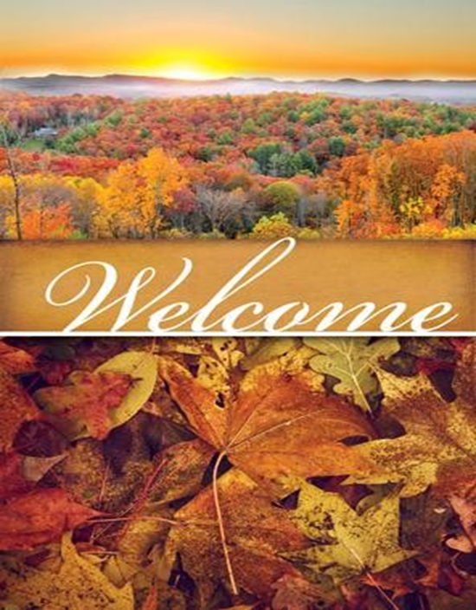



While on vacation in early August, I worshiped at a congregation in Washington near where my daughter lives. The pastor began the message by saying the next month would be filled with a series of sermons being recycled from years past, because one of the pastors had recently moved, leaving those remaining responsible for more Sundays than expected.

The recycled message was about being vulnerable, and how we generally want to avoid appearing vulnerable, or needing help from anyone. The best example in the message, I believe, was the preacher admitting that the personal story of vulnerability had been told, the first time around, as if it had been experienced not personally, but by a friend. We do not want to admit to being vulnerable to needing help.

The story was related to the Bible story where Jesus was asleep on the cushion in the boat while the storm raged around them. The disciples, experienced fisherman, did all they could to make things as safe as possible – other than waking Jesus…they didn’t wake him until they were all expecting to die.

“Why are you afraid?” Jesus asked. It was as if their fear stemmed from being vulnerable, of being not completely self-sufficient.

Today, we seem to want to expect everyone to be self-sufficient, to need no help from anyone, to pay their own way. In reality, though, we live in a community, and we are meant to love our neighbors, to care for them, whether threatened by a storm on the sea, or by various circumstances of life. How do we teach ourselves to provide and to request help among those with whom we live in community, who are called love us, as God calls us all to love?

Let us all strive to do this, in Jesus’ name.

**Pastor Michelle**

**Baptisms:**

Isley Quinzel Zawacki 8/7/2025

Roxy Michelle Dahl 8/9/2025

**In memory of:**

Jim Wik Kitchen Fund $350.00

James Sjolie Undesignated $20.00

**Financial Information:**

July Income: $29,093.80

Expense: - $58,633.33

**- $29,539.53**

**Go For The Gold**

Many times in life we watch sports teams going for the gold, to be #1.  We want this as well for our congregation.  We want to be #1 in giving, in our generosity.

Will you help us with a ‘Go For The Gold’ extra gift?

**Thank you in Advance for your gifts keeping us out of the red….**

**GIFTS TO HERITAGE HAVEN**

We are waiting for the state to approve the plumbing and heating plan and then we will move forward again. We will also have to do some landscaping… the rain revealed some issues for us. We are working with as many local people as possible.

Contact Pastor Don if interested in funding a piece of our renovation work. You can give through our Go Fund Me Page – Heritage Haven Montevideo or you can give locally at the CO-OP Credit Union directly to Heritage Haven.

**THANK YOU FOR YOUR GIFTS!**

We have many ways you can give. We offer auto-giving through your bank. Please contact Sue in the office to arrange for this to happen.

We have a drop-box outside the front door of Mason Hall. You may put your offering in an envelope and slip it in the slot.

**We have online giving through Tithe.ly. Just scan the QR code here and it will take you to our page.**

We have our regular offering envelopes that are sent to you

bi-monthly for you to fill and bring to worship.

Finally, we have Pew Envelopes at the end of each pew for you to use during church. You can specify on that envelope where you want your special gift to go.



**Our Mission Statement:**

**Reflect on the ways that you can put this mission into action….**

Mission Statement:

In Jesus' name God is sending us into the community to find and express the joy of God's love. God is challenging us to overcome fear and take risks; to welcome, help, and give to others.

We are promised all the energy we need by gathering around God's word and sacrament for worship and study.

God reminds and encourages us to trust, listen, love, and rejoice together,

***Wake up! God is calling you to joyful living.***

**BELLS AND CHIMES!!!**

Bells and Chimes will begin practicing again Wednesday, September 10th with Chimes at 5:00pm followed by Bells at 6:00pm. If you are interested in playing the Bells or Chimes, please contact the church office at 269-8824. Dustin Boyum will be the director for both. Hope to see you there!

**CHURCH CHOIR!!!**

Church Choir will be starting again on Wednesday, September 10th at 7:00pm in the balcony. We welcome all those who enjoy singing. Please call Barb Smith (269-9652) with questions. We would love to have you join us!

**Upcoming September Bible Events**  
We are excited to share two special moments with our youth this September!

📖  **Sunday, September 7th** – We will be presenting Bibles to our **7th Grade students** during Worship.

📖  **Sunday, September 14th** – Our **3-year-olds** will receive their Bibles during Worship.

We look forward to seeing you there as we celebrate and encourage our youth in their faith journey by sharing the Word of God with them.

**Will you be a Bible Buddy?**

As each child is baptized, a promise is made to place the scriptures into their hands. Our Savior’s plays an important part in this promise. We present a Rhyme Bible to all 3-year-old children, The Kingstone Bible Trilogy to all 3rd graders and a Study Bible to all 7th graders as they enter the confirmation program. This year we have approximately 27 kids for whom we will provide God’s Word. The total cost of this gift to our children will be $1150.

We are asking members of the congregation to consider sponsoring a child in this ministry and becoming a Bible Buddy. Anyone can sponsor a child. All donations are welcome. If you wish to help our children with this gift, you may make your check payable to OSLC and write “Bible Buddy” on the memo line and put it in the offering plate or stop by the church office with it. We thank you in advance for your generous gifts.

**Confirmation begins for our 7th, 8th and 9th graders on September 10th with our Parents Meeting at 6:30 pm.**

**This fall we will be studying the 10 Commandments. Our youth will also be in Worship to take sermon notes and help with services.**

**Thank you for your support of our program.**

Youth Stuff! W.O.W!!!

Worship on Wednesdays is an opportunity for youth grades 9-12 to gather for light supper, worship, and games.

7:00 Worship in the Youth Room

Roll With Jesus!

Beginning Wednesday, August 27th

For all 9-12 graders



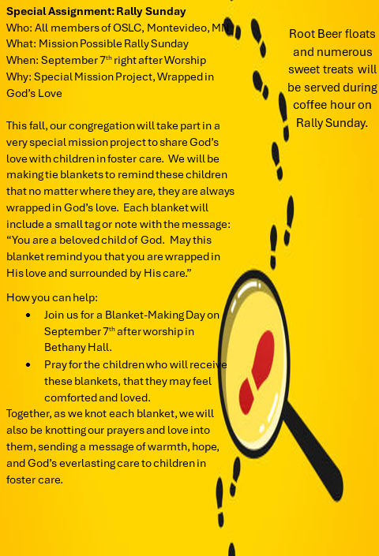

This year’s Rally Sunday will look a little different as we embrace the theme **"Mission Possible."**

Our goal is to encourage everyone to look beyond themselves and remember: ***God’s Word, Our Hands to Do His Work.***

Instead of outdoor activities, we’ll gather in the church basement for a meaningful and fun intergenerational event.

**Activities will include:**

* Music
* Mission projects
* Coloring kindness rocks for our garden
* Tying quilts
* Sweet treats and coffee

We will also have a **Blessing of the Backpacks** during Rally Sunday Worship. Children are invited to bring their school backpacks to receive a special blessing for a successful school year filled with hope and encouragement.

* There will be an opportunity to register for Sunday School as well. *

**Rally Sunday will be held on September 7th following worship from 10:15 - 11:15. We ask that you also bring 1-2 canned goods to help stock our community food shelf.**

The first day of Sunday School will be **September 14th**.

**All ages are welcome—come be part of the mission!**

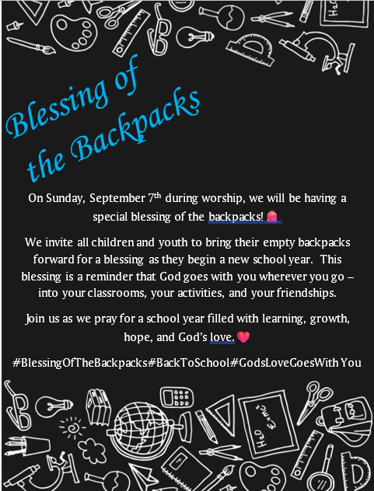

**WORDS from WELCA**

Work group updates: This summer we have updated the work groups. We have removed those who are no longer with us or those who are no longer able to work. We have also added new member names.

“When the sabbath was over, Mary Magdalene, and Mary the mother of James bought spices, so that they might go and anoint Jesus.” Mark 16:1

Today we no longer do this. The funeral home does this. We as a congregational family still have an important part to play. We provide support to the grieving family by providing a place to gather and mourn the person and his or her memory. We provide coffee, lemonade, ham buns, and bars or cake to strengthen them.

Please answer the call when your work group calls you. If you cannot serve, offer to come for an hour and set tables, fold napkins, butter buns, or make a cake or bars. Offer to come after lunch and help clean up. If no one answers, the caller will leave a voice mail with her name, phone number, and who the funeral is for. Please return the call!

**Many thanks to those of you that help make our mission work so gratifying.**

**Blessings,**

**Margit Bonnema**

**WELCA President**