

‘Dealing with the Saints above will be all glory, glory, dealing with the Saints below, well that is a different story…’

A friend of mine gave me this quote. I began to think how true this is, not only for us but for God. Imagine being in Heaven at the throne of God, singing with the angels and simply being in the presence of God. The glory that one will experience has to be mind blowing.
Now, imagine what it is like for God dealing with us day to day. We whine and complain about how things are not going our way. We fill our bodies with chemicals that are potentially harmful and yet we think we are going to live forever. We ask for forgiveness and then jump back into the pit of sin before the marker board can even be wiped clean. Well, this is my experience, it may not be yours and it makes me sad to think of the pain and suffering I have caused my Creator, my Redeemer and my Sanctifier.
Now imagine what life can be and how we might do it differently. If we choose to live with faith and trust, then we can focus on the things above and work towards that end. We do this by worship, Bible reading, devotions and prayer. It is something we must work at each day, trying to live out who God has called us to be.
Not one of us is perfect but most of us have met at least one person who seems to have faith somewhat figured out. They reflect the love of God each day and live that out. I have met a few of those along the way and the thoughts of them remind me of what we have to work towards. So, thanks God for putting up with us in our moods that do not reflect your glory and thank you for those who have it somewhat figured out and shine with your glory. It is a reminder of the Glory that awaits all of us through Jesus Christ our Lord….
In Christ,
Pastor Don

Happy Hat Loomer Group is looking for more members to join them to make stocking hats during the fall and winter months.

The hats are SO EASY, quick and fun to make!

Hats are donated to people that are in need within our community and surrounding areas.

The weaving loom and yarn are provided from grants the group has applied for and received.

The group meets bi-weekly on
Wednesdays at 1:00pm in the Fireplace Room

We will meet on Wednesday, October 7th
Please call the church office at 269-8824 if you are interested.

The 

October 2026
Worship
9:00am
Newsletter of Our Savior’s Lutheran Church
Montevideo, MN · 320-269-8824

Email: oursaviors@oslcmonte.net Webpage: oslcmonte.com



Matthew 28, All Nations
Matthew’s Gospel has some really great material. In Matthew 5 we have the Beatitudes, speaking blessing for so many people who had believed for so long that their suffering meant that they were cursed. Matthew 6 has the Lord’s prayer, and cares for the birds of the air and the grasses of the field. And Matthew 28:19-20 has what we call the Great Commission: “Go therefore and make disciples of all nations, baptizing them in the name of the Father and of the Son and of the Holy Spirit and teaching them to obey everything that I have commanded you. And remember, I am with you always, to the end of the age.”
As we read Mathew’s entire Gospel, though, there is much that comes across as judgement and warning. Sometimes, in Matthew, it seems difficult to find the good news. Matthew is written to encourage good behavior among the people—but can sometimes come across as very harsh. Some recent Gospel readings have ended with sentences that don’t sound particularly Gospel-like!
Yet, at the very end, where this Great Commission is recorded, Jesus adds one more line—not dependent upon our ability to be perfect doers of God’s word. Here Jesus says, “Remember, I am with you always, to the end of the age.
Always we can be reassured that Jesus is with us, in all that we do, in all that we are, in all that we say. As imperfect as we are, in Christ we become complete, and we are blessed to be blessings to others.
In Jesus’ name
Pastor Michelle
Opening soon!
We edge ever closer to an open date.
We are thankful for all our local workers, and we give thanks for the work of Ron Gilbertson on this project.
We will let you know about the grand opening.
If you have not given…we could use those big and small gifts to finish the remodel…. thank you!
HERITAGE
HAVEN
We need your help to meet our summer budget!
Please take a moment to bring your pledge current or to make a special summertime contribution.
Thanks to all of you for your wonderful gifts!
General Fund Operating Budget
YTD Income: $577,262.21
YTD Needed: $588,973.70
2026 Financial Snapshot
“The heart of a giver makes the gift dear and precious.”
Martin Luther
August Funerals:
Ronald Mark Gilbertson 08/24/2026
August Weddings:
Michael Steven Milander &
Kaitlynne Lorraine Enevoldsen
08/22/2026

THANK YOU FOR YOUR GIFTS!

We have many ways you can give. We offer auto-giving through your bank. Please contact Sue in the office to arrange for this to happen.
We have a drop-box outside the front door of Mason Hall. You may put your offering in an envelope and slip it in the slot.

We have online giving through Tithe.ly. Just scan the QR code here and it will take you to our page.


We have our regular offering envelopes that are sent to you
bi-monthly for you to fill and bring to worship.

Finally, we have Pew Envelopes at the end of each pew for you to use during church. You can specify on that envelope where you want your special gift to go.

Wake up!
God is calling you to joyful living
This is how we are to live each day.
Joyful living is a challenge in our world today.
Only God can give you lasting Joy & lasting Peace.
Pray for Peace and Joy in 2026!!!
This is the time of year we really need your help. Time to get us out of the summer slump…. As the greatest generation dies, we are left to take care of things. The boomers are up now, and it is up to us to make sure that all the important things get done.


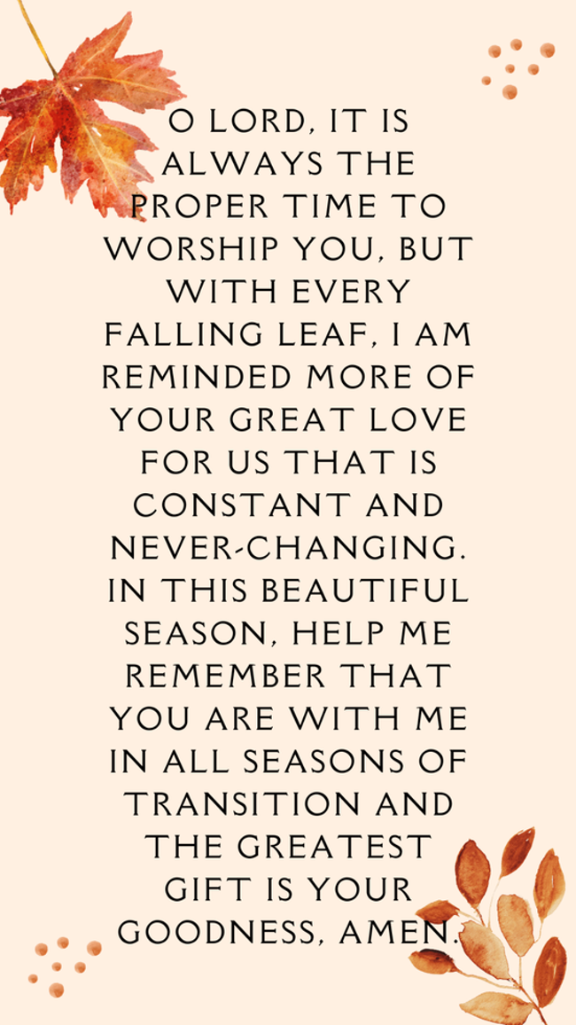
If Today Was the Day, is your bag Packed and Ready?
By: Ed Delf

Most of us go through life thinking, "We Got This." I'm as ready as I'll ever be.
I mean I have been Baptized, Confirmed, and I'm pretty good at going to church. Besides, I've heard so many times that the "Day" was just around the corner by those who said they had an inside track to when it would happen. Although, based on past history, results show their sources weren't as creditable as they thought. That said, if you're like me, you probably are saying, "I don't have the time to worry about that today. It'll happen when it'll happen regardless of what I do."

That's a point well taken and we've all been there I'd suppose. Maybe we've become desensitized to the message we've been told. That is to be aware and vigilant because we don't know when the Master will come. We know the "Day" will come, but probably not today. Anyway, we can rationalize to ourselves, I'm a good person and shouldn't have a problem. I'll review my options maybe tomorrow if I have time, etc.

As you'd guess, there's several problems with that thought process. The first is that God is the only one that knows the day and time. A good guess based on current events or intuition just won't cut it. Another problem is that we have all been given a time period. We have no guaranties that we'll be given a little more time to prepare, not even a second, even if we ask God.

Funny thing about preparing for something that's important. We just know that there's going to be an effort that someone is going to have to make to make something happen. We take it as a given. If your kid wants to be on the baseball team they will practice with friends, or by themselves, to get good enough to play and be on the team. If a work project summary must be written, there is a lot of work that will need to be done before the actual writing begins, a lot of preparing. In short, most of life's reachable goals, the important stuff in our lives, require that you prepare, however that may be.

I find it interesting that from Baptism on we are being prepared for our journey of faith, and yet, many times that journey seems to get detoured to a side road. Maybe, just because it seems easier. The camel story that Jesus talked about in the Bible reminds me that saying, "I'm a Christian," and being a Christian, is hard work. Getting that camel through the eye of the needle is going to take some serious preparation.

Personally, I find it hard to be at the top of the game every day. It just isn't easy most days just because of all the stuff that's thrown our way. That doesn't mean we should just say it's one or the other. I think it does mean we can do both but also understand what the real priority needs to be in our lives. As we prepare for our earthly endeavors, which are important, we should also continue to prepare for what will be a life-changing experience. There really isn't a second chance when that "Day" arrives.

Only God knows if our "Day" is just around the corner. Are you prepared
Confirmation began for our 7th, 8th, and 9th grade students on September 9th with our Parent Meeting.
This fall we are studying the Old Testament. Our youth will also be in Worship to take sermon notes and help with running the PowerPoint as well as Acolyting. Thank you for your support of our program.
confirmation news!
Start your Wednesdays with us at OSLC!
Join us for our Drive through
Roll with Jesus Breakfast
7:00am – 7:50 am
A nourishing reminder that you are loved!
high schoolers!
sunday school!
We would love for you to
join us for Sunday School!
10:15 am Sunday Mornings!
Hope to see you there!

Calling all quilters!
Are you looking for a creative and fun community?

Our quilters will be starting up again this month, and we’d love for you to join.

Quilting meets on the last Monday & Tuesday of the month at 9:00 am in Bethany Hall.

Hope to see you there!

We will welcome Pastor Bob
Dahl preaching for worship this day, and will
have special music followed by coffee fellowship with freshly baked cinnamon rolls!
Sunday, October 18 - Blessing of the Years
The Hallelujah Hooligans will provide entertainment. People who have seen this group have given very positive reviews!
We are planning to serve a Baked Potato Bar with various fixings and a variety of desserts.

(There might be some scarecrows—or not.)
Fall décor will add to the festivity of the occasion!
Thursday, October 22 - Fall Kick-Off at 5:00 p.m.
Upcoming Senior Lites Events

If Today Was the Day, is your bag Packed and Ready?

SUNDAY, OCTOBER 25TH IS
REFORMATION SUNDAY.
This is the Sunday we celebrate the work of Martin Luther who reminded us that it is Grace alone, Faith Alone and Scripture Alone. We are proud to be Lutherans who talk about Grace and Faith not judgement and damnation. Thank you, Luther, for helping us discover God’s grace as found in the Bible.
COMING, NOVEMEBER 1ST
This will be the Sunday we celebrate All Saints.
We remember all the saints who have gone before us and all the newly baptized saints in our midst.
Join us for a great Sunday.
