

**What Is the Reformation?**

The Reformation was a movement that challenged the Catholic Church in the 1500’s over several issues. There were two really big issues.

First, the Bible, the Word of God and who can read it. Catholics at that time felt only the Priest could read and understand the Bible. Martin Luther felt that everyone could read the Bible on their own and pray to God for understanding. Martin Luther then translated the Bible into German and put it on the printing press so that everyone could have a copy. It changed how people learned about God as they each read the pages.

Second, Martin Luther challenged the Catholic Church about the whole issue of Grace. Catholics believed and still harbor feelings that a person is saved by works that they do. Lutherans believe that we are saved by Grace through faith. This is the hallmark of what we believe to this day. Catholics finally admitted or agreed to a statement on Grace not so long ago, the late 1990’s.

The end of October is Reformation Sunday. We are always reforming and finding new ways to be church. It is time we took this seriously and participated in worship. It might also be a good time to start reading your Bible again and anew.

Martin Luther, the great church reformer gave us the gift of being able to hold God’s Holy Word and the gift of the reminder that we are saved by Grace. Don’t waste these precious gifts….

In Christ,

**Pastor Don**

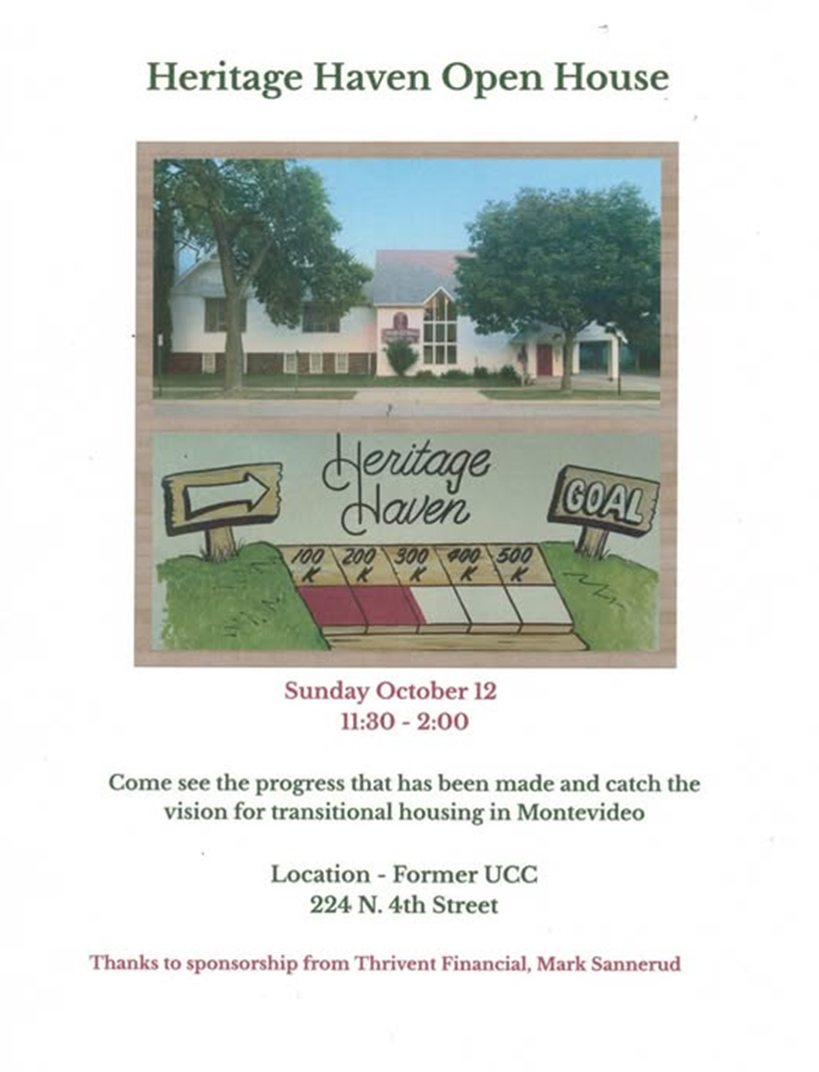

The 

**October 2025**

**Worship**

**9:00am**

Newsletter of Our Savior’s Lutheran Church

Montevideo, MN · 320-269-8824

**Email:** [**oursaviors@oslcmonte.net**](mailto:oursaviors@oslcmonte.net) **Webpage: oslcmonte.com**

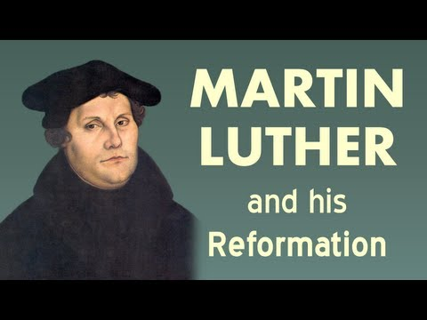

**October!**

October is the middle month of meteorological autumn, marked by falling leaves and kite-worthy breezes (and often a bit of snow). It’s also the month we observe the impetus of the Reformation with Martin Luther’s nailing of the 95 Theses on the Abuses of Indulgences on the door of Castle Church in Wittenberg. He did this on the eve of All Saints’ Day, also known as “All Hallow’s Eve,” from which comes the name of today’s Halloween.

There are a multitude of stories that make Halloween into something dangerous and scary, as if evils are more potent on this day than on any other. In truth, this day is as holy as any other, especially as we remember that God is all-powerful ***all the time!*** God does not go to sleep and ignore what is happening in the world on Halloween or any other day or time.

Luther had a history of being afraid of God’s wrath, but finally learned to trust instead in God’s grace. Let us be encouraged by this to trust also in the grace and goodness of God every day of the year, every season of the calendar, and every year of our lives. Whether leaves are falling, absent, budding, or fully unfurled, God is present and loving you. This we celebrate!  
In Jesus’ name,

Pastor Michelle



2025 Financial Snapshot

**General Fund Operating Budget**

**YTD Income: $ 320,887.00**

**YTD Need: $ 399,786.64**

**Thank you for your continued support! The General Fund is essential to the life of our congregation, enabling us to carry out the ministry that reflects the vision and values of Our Savior’s. It covers the maintenance of our buildings, staff salaries, and day-to-day operational costs, which are essential for ministry. Regular contributions are the foundation of this fund. Your generous giving is greatly appreciated, and the Church Council is diligently monitoring expenses to ensure that our ministries remain strong and aligned with our goals.**

**GIFTS TO HERITAGE HAVEN**

The plumbing and heating work has begun… We will also have to do some landscaping, we need about $1000.00 for this part of the project…. We are working with as many local people as possible.

Contact Pastor Don if interested in funding a piece of our renovation work. You can give through our Go Fund Me Page – Heritage Haven Montevideo or you can give locally at the CO-OP Credit Union directly to Heritage Haven.

**THANK YOU FOR YOUR GIFTS!**

We have many ways you can give. We offer auto-giving through your bank. Please contact Sue in the office to arrange for this to happen.

We have a drop-box outside the front door of Mason Hall. You may put your offering in an envelope and slip it in the slot.

**We have online giving through Tithe.ly. Just scan the QR code here and it will take you to our page.**

We have our regular offering envelopes that are sent to you

bi-monthly for you to fill and bring to worship.

Finally, we have Pew Envelopes at the end of each pew for you to use during church. You can specify on that envelope where you want your special gift to go.



**Our Mission Statement:**

**Reflect on the ways that you can put this mission into action….**

Mission Statement:

In Jesus' name God is sending us into the community to find and express the joy of God's love. God is challenging us to overcome fear and take risks; to welcome, help, and give to others.

We are promised all the energy we need by gathering around God's word and sacrament for worship and study.

God reminds and encourages us to trust, listen, love, and rejoice together,

***Wake up! God is calling you to joyful living.***

**Confirmation began for our 7th, 8th and 9th graders on September 10th with our Parents Meeting.**

**This fall we are studying the 10 Commandments. Our youth will also be in worship to take sermon notes and help with services.**

**Thank you for your support of our program.**

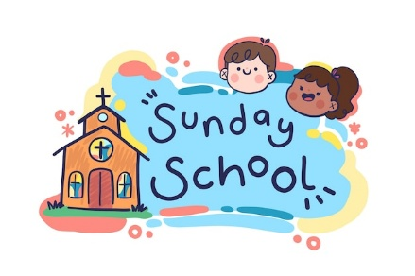

WE WOULD LOVE FOR YOU TO JOIN US

FOR SUNDAY SCHOOL!

10:15AM SUNDAY MORNINGS!

**Calling all quilters and hat makers🧶**

Are you looking for a creative and fun community? Our Quilters and Happy Hatters will be starting up again this month and we’d love for you to join. Quilting meets on the last Monday & Tuesday of the month at 9:00 am in Bethany Hall.

Happy Hatters meet on Tuesdays at 1:00 pm in the Fireside Room.

Hope to see you there!

Senior Lites Kickoff  
Thursday, October 16th  
Meal at 5:00

We will gather for a nostalgic meal to nourish our bodies, combined with a fine display of vintage aprons from several of our members. Sign up in the church office by October 10th.

After the meal we’ll move upstairs to have our spirits nurtured with music provided by the **Building Bridges Choir**.

**Free Event!**All ages welcome.  
Be sure to sign up so we have a count for supper!

Menu: Scalloped potatoes, meatballs, Jello, corn, coleslaw, bread, pickles, apple pie (with ice cream), coffee, lemonade, and water.

**Senior Lites  
Blessing of the Years**

**9:00 Sunday Morning,  
October 12, 2025**

We have an exciting program planned for Blessing of the Years.

St. Paul Jazz artist, Dorothy Doring, will be presenting us with some of her musical selections woven through our worship service, which will emphasize   
God’s presence in all of life.

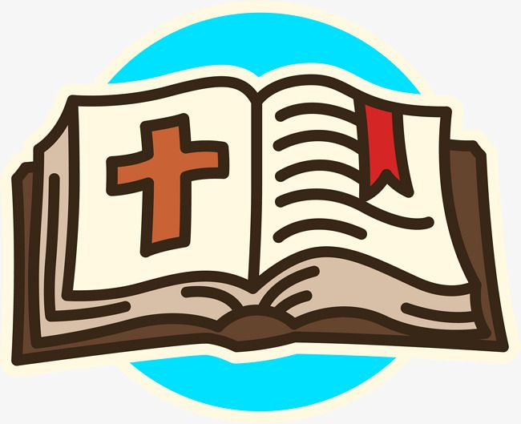

**Pre-schoolers were presented with**

**Rhyme Time Bibles during Worship on**

**Sunday, September 14th.**

**Thank you to all our Bible Buddies.**

* **Wrenlee Augeson** daughter of Chase Augeson and

Molly Wright

* **Evie Brandon** daughter of Ross Brandon
* **Edith Briones** daughter of Eleazar and Chelsea Briones
* **Cora Olson** daughter of Derek and Jennifer Olson
* **Georgia Peters** daughter of Phillip and Nicole Peters
* **Seraia Tetzloff** daughter of Brooklynn Dahl and

Brad Tetzloff

* **Suttyn Tollakson** daughter of Jordan and Aleese Tollakson



**7th Graders were presented with Bibles during Worship on Rally Sunday. A big thank you to everyone who donated to the Bible Buddies. Your generous donations help these youth continue in their faith journey.**

* **Jase Dack** son of Josh and Beth Dack
* **Brielle Dennis** daughter of Tricia Haas
* **Gavin Dineen** son of Kari Tadd
* **Brynnlee Eichorn** daughter of Eric and Tasha Eichorn
* **Jasper Enger** son of Christina Enger
* **Lainey Reiffenberger** daughter of Corey and Kayla Reiffenberger
* **Maci Schroeder** daughter of Rick and Tasha Schroeder
* **Soren Shelstad** son of Carrie Shelstad
* **Maryn Stanley** daughter of Cory and Kristi Stanley
* **Zeik Terning** son of Cole Terning
* **Levi Walter** son of Zach and Cindy Walter