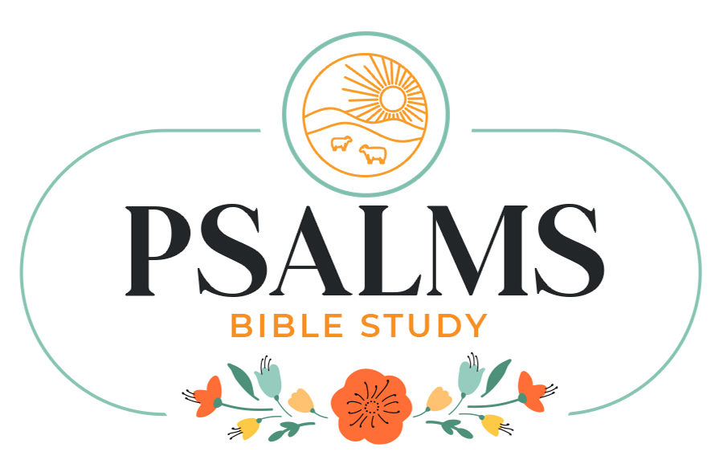



‘Give Thanks in all things, for this is the will of God for you in Christ Jesus.’
1 Thessalonians 5:18
Each fall, the Synod Pastors, Associates in Ministry (AIMS) and Synodic ally Authorized Ministers (SAMS) gather for a time of learning and resting. It is normally for about 2 days. This year we gathered to listen and learn from Mark Allen Powell. He is a retired Professor who has written many books on the Bible and Lutheranism.
About ½ of his time was spent talking about how to be happy. He did an experiment with one of his classes before he retired. He told them that he would work with them to be the 2nd happiest people in the world. Each time they met, they had to think of something to be thankful for because the 2nd happiest people in the world are people who are grateful.
Wanna know who the happiest people in the world are? They are grateful people who grow into generous people. Generous people are, from all studies done, the happiest people. What is amazing is that generosity is not about how much you have but what you do with the little you have or the much you have.
So, might I suggest you quit chasing the happiness dream and learn to be grateful people who then will become generous people who are the happiest people in the world.
As your Pastor, I get to see firsthand, the happiness that comes by being generous with your time and your talents. Do you know what makes generous people happy…. they are content with what they have and they give to others of their time and talents.
Sounds like a great prescription for a wonderful life. God be with you as you work on happiness.
In Christ,
Pastor Don

Join Pastor Don beginning on Sunday, November 2nd at 10:15 am in the Fireside Room. Pastor Don will lead a four-week Bible Study on The Psalms. This will be a bible study that brings hope, comfort, guidance and peace to believers.

Themes:
Week One: Finding Comfort in the Psalms
Week Two: Psalms for Receiving Guidance
Week Three: Psalms for Expressing Gratitude
Week Four: Psalms for Finding Wisdom

All are welcome!

The

November 2025
Worship
9:00am
Newsletter of Our Savior’s Lutheran Church
Montevideo, MN · 320-269-8824

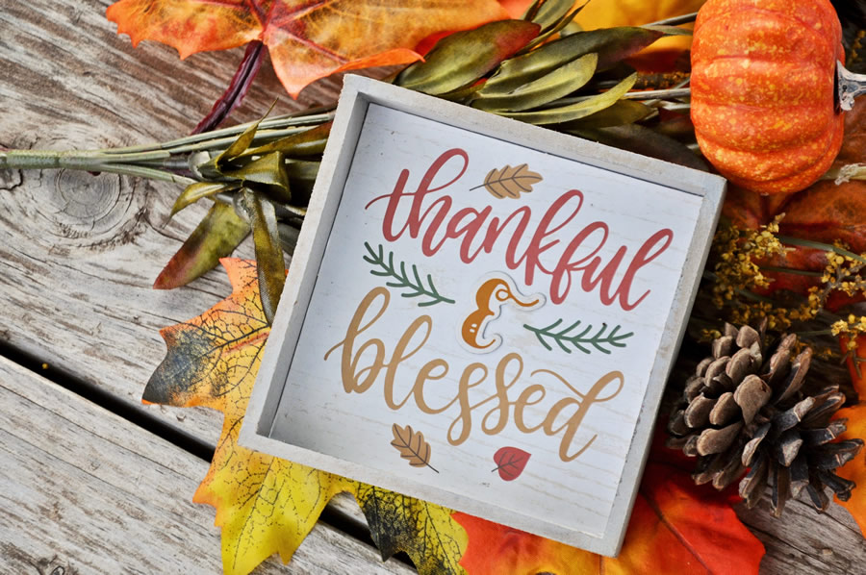
Email: oursaviors@oslcmonte.net Webpage: oslcmonte.com



Hope and Community
November brings us the celebration of All Saints’ Day, the Thanksgiving holiday, and the beginning of Advent this year. We remember and honor those who have gone before us in faith. We give thanks to God. We begin the traditional anticipation of the greatest Gift of all with themes of waiting and hoping.
Perhaps we feel as if we miss out on the best parts of these observations, as our focus is riddled with distractions. Will we be able to give the gifts we want to give this year, to our family, our friends, ourselves? How are world events affecting us—and our neighbors? How do we count on security when things seem to be changing in so many different ways?
Pastor Don reminded us at council last month that cemeteries should be seen as places of hope, as we note the messages of faith on the tombstones. We can let this kind of hope permeate all our celebrations—and all our observations, even when they bear shadows of less-than-honorable actions.
Some people seem to emphasize the shadows of history to the exclusion of anything that is good. I hope that we can acknowledge the shadows, but raise up what is good, so that people will see the hope in which we live. Let us honor the frailty and the generosity of the previous generations and learn from them how to gather together and to share God’s bounty, for God continues to give to all creation, and to call us together.
In Jesus’ name,
Pastor Michelle


2025 Financial Snapshot
General Fund Operating Budget

YTD Income: $ 429,889.42
YTD Need: $ 449,759.97

Thank you for your continued support! The General Fund is essential to the life of our congregation, enabling us to carry out the ministry that reflects the vision and values of Our Savior’s. It covers the maintenance of our buildings, staff salaries, and day-to-day operational costs, which are essential for ministry. Regular contributions are the foundation of this fund. Your generous giving is greatly appreciated, and the Church Council is diligently monitoring expenses to ensure that our ministries remain strong and aligned with our goals.

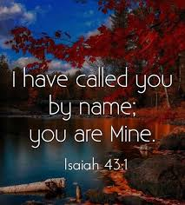
Baptism:
Parker John Stevens 9/28/2025

Funeral:
Dale Dean Olsen 9/20/2025

HERITAGE HAVEN
This is the gift of Transitional Housing for those in need.
We continue to rehabilitate the building.
Funding is needed!
We thank our local contractors for making this a reality for those in need.

Maybe you can give a gift?



THANK YOU FOR YOUR GIFTS!

We have many ways you can give. We offer auto-giving through your bank. Please contact Sue in the office to arrange for this to happen.
We have a drop-box outside the front door of Mason Hall. You may put your offering in an envelope and slip it in the slot.

We have online giving through Tithe.ly. Just scan the QR code here and it will take you to our page.


We have our regular offering envelopes that are sent to you
bi-monthly for you to fill and bring to worship.

Finally, we have Pew Envelopes at the end of each pew for you to use during church. You can specify on that envelope where you want your special gift to go.



Our Mission Statement:
Reflect on the ways that you can put this mission into action….

Mission Statement:
In Jesus' name God is sending us into the community to find and express the joy of God's love. God is challenging us to overcome fear and take risks; to welcome, help, and give to others.
We are promised all the energy we need by gathering around God's word and sacrament for worship and study.
God reminds and encourages us to trust, listen, love, and rejoice together,

Wake up! God is calling you to joyful living.

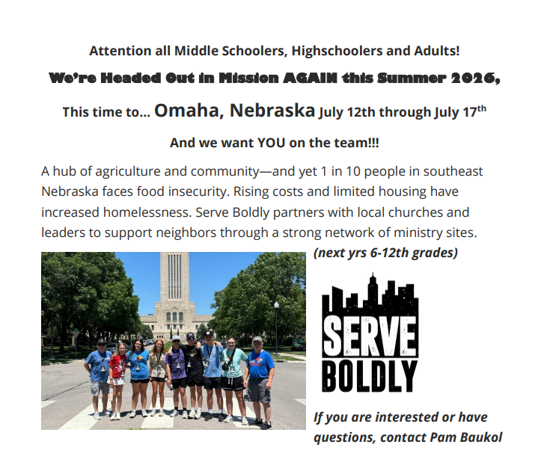

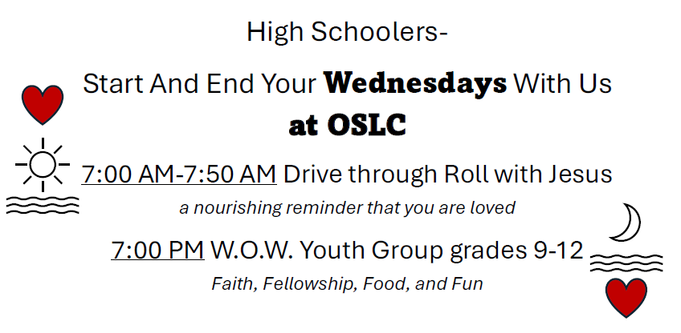



Senior Communion
Thursday, December 11th
Worship at 11:00
Meal follows
Communion is served by intinction in the pews.


Senior Lites Christmas Party
Thursday, December 18th
Meal at Noon
Come for food, community, entertainment, and prizes!
Please sign up so we are sure to have enough food and prizes available.
Church Council Corner
Just Thoughts/Plain Talk: Time Zones
By: Ed Delf-Vice President

Time zones for most of us would mean where we are in reference to what part of the country we live in, and then of course, what time it is for us.

Time can mean the above, or bring to mind the time paradox, that seems we all have a problem with. You've probably said something along the lines of "I can't believe where the time has gone?" or "If I only had a little more time" or "I'll get at that later when I have more time period."

I don't know about you, but no matter how hard I've tried, I just can't stretch the time to get more time.
I remember in my youth, I had all the time in the world. Time stretched before me as far as my eyes could see. I really gave no thought to how much I had. Did I make the most of my time? I'd have to say, if I was honest with myself, not always.

As I got older, kids, middle age, my job, house related jobs (which is a story in and of itself and better not to be dwelled on) took up my time, and well, there just wasn't enough time in the day to do it all it seemed.

I thought that when the stress of middle age was gone that I'd have more time to do more of what I wanted to do. So now I'm in what my father-in-law used to call the fourth quarter slide. Time takes on a whole different meaning from when I was in my youth to where I am today. Now I look back and ask myself, did I use my time wisely? If I could redo the time, would I make the same or different choices than I did? Was I so wrapped up in me time that spiritual time, although on the list, was not as high up as it could, or should have been?

That said, time remains constant. God tells us in Matthew 6:27 "Which of you by taking thought can add one cubit unto his stature?" To paraphrase, you got what you got. There's no time like the present.

God also tells us in Proverbs 27:1 "Boast not of thyself for tomorrow; for thou knowest not what a day may bring forth."
I really like this verse because it reminds me that there are no guarantees on more time. Kind of like use it or lose it.

Like so many of us, it's just so easy to get caught up in the "I'll get at it later, or I'll do it tomorrow mindset." We were going to tell our spouse that you love them but, there's always tomorrow. We were going to spend more time with our kids but there's always something else that squeaks louder. Maybe we were even going to volunteer to be on a church board, or go to a Bible study, or find ways to use our time and treasure to help support our church and God's mission. That all sounds pretty great, except there's not enough time, but there's always tomorrow we tell ourselves.

Perhaps we're timing things to finish our barn. Kind of like the one that God tells us about in Luke 12:16-21. In a parable He talked about a rich man that decided that, because his crops were going to be too much to get in his current barns, he'd take the time to build new ones and then enjoy the fruits of his labor. God said that this very day his soul would be required of him. He wasn't going to have any time to enjoy what he had, but others would.

As I mentioned earlier, time is constant for everyone. There's no guarantee on tomorrow as the rich man found out. He had no more time and all he had accumulated someone else would enjoy. Unfortunately, we see this tragedy play out still today.

If you're building yourself a bigger barn, I hope you're going to include some space and time, for the bounty of riches that God has freely given you, and that you can share with your neighbors, both new and old. If you're reading this, good news, you still have time.

God's command to us is to love our neighbor as ourselves. Maybe it might require us to take another look at how we spend our time, talent, and treasures in order for us to fulfill that command.

To put everything in a nutshell, 2 Peter 3:8 probably sums it up best. We're told to be aware of one thing, that one day is with the Lord as a thousand years, and a thousand years as one day.

Makes it a lot easier to decide in which time zone you might want to be in.

Ed Delf

