
Give Thanks with a Grateful Heart’
I just do not hear many people who are thankful these days.
The news media has convinced us all that things are really bad
and getting worse by the moment. Now, I do not have my
head stuck in the sand, I know some things are bad but in the
midst of it all, God’s blessing still abound.
I have been blessed with pretty good health. Now, that is not
to say that I do not have any issues. As I age some of those
aging things show up but for the most part currently all the
things I have wrong they could fix… I know that this is not
true for everyone and I pray for many of you daily. I am
thankful for health.
Second, I am thankful for what I do. Some days this job is
hard and ridden with grief but I am thankful for all these years
and how well I know people. I get to walk with people in
those good moments and those bad moments and provide a
word of hope from a God who love us beyond measure.
Third, I am thankful for each of you. Whether you worship in
person or online, thanks for your commitment to Our Savior’s.
Together we are the Body of Christ. Together we give
offerings and volunteer our time to make this world a better
place.
So, thanks for what you do for the Kingdom and I hope in this
month you find something to be thankful for. God might like a
thank you instead of …this is what I need today from you….
In Christ,
Pastor Don

An Opportunity to Give!

If you have Thrivent Choice Dollars available, please consider directing them to Our Savior’s Lutheran Church before the end of the year.

Your Choice Dollars are a wonderful way to support the ministry and mission of our congregation at no additional cost to you. Every gift helps us continue sharing God’s love and serving our community.

Please remember to designate your choice dollars before the end-of-the year deadline.

Thank you for your generosity and continued support of our church ministry.


Matching Funds Available!
Help us support Heritage Haven and the Food Shelf! We have $250 in matching funds available to match your donations.

If you are able, please consider making a donation. Your gift can go twice as far and help support those in need in our community!

Thank you for your generosity and support!



November 2026
Newsletter of Our Savior’s Lutheran Church
Montevideo, MN ~ 320-269-8824
Email: oursaviors@oslcmonte.net Webpage: oslcmonte.com

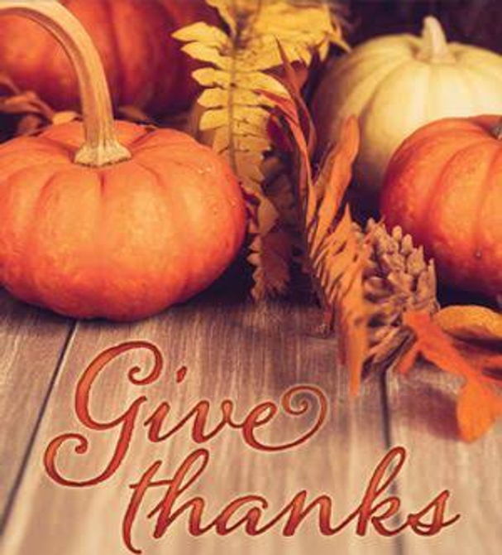

All Saints
November begins with the All Saints holy day on November 1. In our practice, we observe this day with worship and prayer, celebrating those baptized within the past year, and honoring those who have died since the last All Saints’ Sunday. This year, the date of the holy day occurs on Sunday, but on other years we observe the rites on the following Sunday, so it is always part of our regular worship experience. We observe this day with reminders of the promises of God, of a resurrection that reunites us with the faithful of all generations… though without the suffering aspects we experience in this world. Though our Lutheran practice describes this day as a festival, in my experience few gather for a feast on this day. Some of our neighbors do create more festive celebrations and may teach a closer relationship with those who have already died. In our faith practice, we rarely think of ourselves as saints. We expect saints to be those who are always doing righteous things, who never err in any significant way. However, even the best among us err (sometimes often!). Paul writes that “all have sinned and fall short of the glory of God” (Romans 3:23). Yet, we teach that all believers are saints not because of our actions, but because of God’s promises. Paul follows the statement that all have sinned by saying we are “now justified by [God’s] grace as a gift, through the redemption that is in Christ Jesus” (Romans 3:24). On All Saints’ Day, let us celebrate this gift of God, for ourselves and for all generations. Maybe we can do more saintly things and spread God’s love more generously in all the world.
In Jesus’ name.
Pastor Michelle

AUGUST/SEPTEMBER WEDDINGS


Michael Steven Milander & 08/22/2026 Kaitlynne Lorraine Enevoldsen

Curtis Nagel & Kirsten Clark 09/26/2026


2026 General Fund Operating Budget

YTD Income: $633,056.06
YTD Needed: $651,832.32
Through faithful giving, churches can support ministries, care for people in need, spread the message of the Gospel and create opportunities for the community to grow in faith. Every gift, regardless of its size, can make a meaningful difference when it is given with a willing and generous heart.

Thank you for your faithfulness, generosity, and commitment to helping our church fulfill its mission. May God bless you abundantly for all that you give and do!


HERITAGE
HAVEN
OPENING SOON…WE EDGE EVER CLOSER TO AN OPEN DATE…WE ARE THANKFUL FOR ALL OUR LOCAL WORKERS AND WE GIVE THANKS FOR THE WORK OF RON GILBERTSON ON THIS PROJECT. WE WILL LET YOU KNOW ABOUT THE GRAND OPENING!





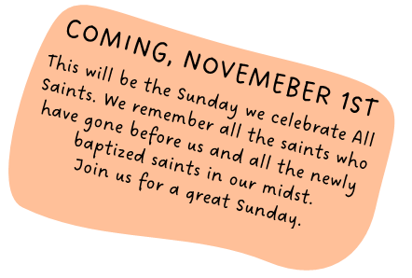



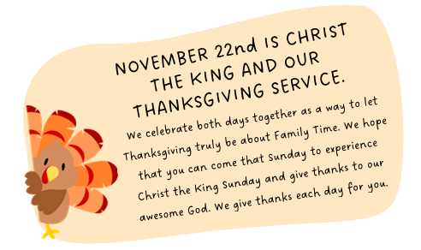





HATS AND COATS AND BOOTS AND MITTENS
Barb McKee and Ashley will be collecting gently used hats and coats. We will also take monetary donations to buy new items for those in need.
If you can help or donate…you know who to call or call the church office at 269-8824 and we ill get you to the right person so you can donate.


Generosity and Stewardship
In your mail you will receive a letter, if you did not pick yours up at the church. We ask you to prayerfully consider what gifts you can share with us. We need your help to make our budget each year. We are trying to find ways to save money.

We also want you to know that 79 cents of each dollar stays here to help Montevideo and the surrounding area.


A HUGE THANKS….
TO ALL WHO MADE THE CHURCH FALL SUPPER A SUCCESS. IT HAS BEEN MANY YEARS SINCE WE DID A CHURCH SUPPER AND SO IT WAS LIKE STARTING OVER. WE COULD NOT HAVE DONE IT WITHOUT EACH OF YOU!



THANK YOU FOR YOUR GIFTS!

We have many ways you can give. We offer auto-giving through your bank. Please contact Sue in the office to arrange for this to happen.
We have a drop-box outside the front door of Mason Hall. You may put your offering in an envelope and slip it in the slot.

We have online giving through Tithe.ly. Just scan the QR code here and it will take you to our page.


We have our regular offering envelopes that are sent to you
bi-monthly for you to fill and bring to worship.

Finally, we have Pew Envelopes at the end of each pew for you to use during church. You can specify on that envelope where you want your special gift to go.


ROLL WITH JESUS!
REMINDER TO JOIN US FOR ROLL WITH JESUS EVERY WEDNESDAY MORNING
FROM 7-7:50 AM.
FREE DRIVE THRU BREAKFAST FOR ALL
FOR STUDENTS IN GRADES 5–12.


SUNDAY SCHOOL!
JOIN US FOR SUNDAY SCHOOL EVERY SUNDAY IMMEDIATELY FOLLOWING WORSHIP AT 10:15 AM.


Wake up! God is calling you to joyful living.
This is how we are to live each day. Joyful living is a challenge in our world today. Only God can give you lasting Joy and lasting Peace.
Pray for Peace and Joy in 2026!!!



Stewardship-Church Survival and The Cheerful Giver
By: Ed Delf

So, church survival, on its face, seems like a pretty serious thing to say. In any case what does Stewardship have to do with church survival anyway? Might we ask, with tongue in cheek, are they somehow related? We've heard that scary "S" word many times and we might even find ourselves tuning out because we know what's coming. It's gonna be ANOTHER ASK.

I looked up a dictionary meaning of Stewardship, paraphrasing, it means it's the careful and responsible management of something entrusted to us. That seems pretty straight forward, and we probably wouldn't argue with that.

If I asked you to put a meaning on Stewardship, in reference to OSLC and how it affects us, how would you answer that? As I thought about that question, Biblical and Spiritual Stewardship came to mind.

Biblical Stewardship is the responsibility of individuals to manage all that God has put under His care and recognizing Him as the ultimate owner of everything. That's right, all the things you think you've accomplished and earned, are just yours by the Grace of God.

Spiritual Stewardship is all that, plus we're also told to find and seek out new opportunities to proclaim His Glory and to serve others with our gifts. All said and done, there's a lot of parts to Stewardship.

I think that what that boils down to is that the core concept of Christian Stewardship is acknowledging that everything we have, whatever talents we have, belong to God. We are but caretakers of these gifts. As such, Stewardship responsibility falls on each of us.

Stewardship is not just the other guy's job; It's just not if it's convenient for us; and it's not thinking that what you do will probably not be enough anyway. God just asks you to share what's been given freely to you.

Our church-your church, in order to thrive and grow, needs the Stewardship of your time, your talents, and yes, your treasure if we are to continue to fulfill our church's mission statement which is to:
Go with God's spirit
Share the word of God
Reach out to those in need
Each of us has a role to play in this mission statement.

So, the question we ask ourselves shouldn't be something like, should I or shouldn't I, but rather how can I, with the gifs I've been given further the Glory of our Lord.

Whatever path you take, choosing to do nothing, doing the bare minimum, or giving back as you've been blessed, leads to the same ending. We come into this world with nothing, and we will leave it the same way with the exception of knowing that the choices we've made have made a difference and will live on.

1 Peter 4:10 encourages believers to use their gifts to serve others as faithful stewards of God's Grace to us.

Each of us comprise the Body of God's Church. God's word is free, but all the other stuff requires you to make it happen. If you're thinking the other guy has got this, I'd
ask you to take another look at what Stewardship means and ask yourself if you're carrying your share of the load or if you're part of the load being carried.

GOD’S CREATION

CALENDARS & COOKBOOKS

$20.00 FOR COOKBOOKS
$10 FOR CALENDARS

God’s creation calendars and cookbooks are now available for purchase!
These make wonderful gifts for family and friends and are a great way to celebrate God’s blessings and the beauty of His creation.
Please stop by the office and pick up your copy today. Thank you for supporting this ministry!

