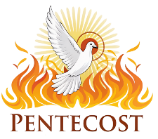

PENTECOST: A TIME OF GROWTH
Did you know that the color green on the Altar, Pulpit and Lectern is the color of the Pentecost season, and it was done on purpose? It reminds us that this is a time of growth. It is a time of growing our faith. Now most people think of June and July as Summer months or Lake months or Vacation months, but in the church, this is the time you are to take some time to grow in your faith.
Advent is a time to let you know about Jesus. Epiphany is a time to let the light of Christ shine through you. Lent is a time to reflect and consider your faith and the price Jesus paid for you. Easter is the season to celebrate that Jesus lives. Pentecost Day, which include red altar cloths is about God sending the Spirit to fill our lives and then the Pentecost Season is about taking all of that and growing in your faith.
Too many people just take the summer off from Church. Now, that does not mean that we don’t think about church, but it seems to be a back burner issue.
Now, I know a bit about farming and summer is no time to put your crops on the back burner. I know many farmers who track the growth of the crops, see if they need to be sprayed for some insect or weed. They watch the crops grow and wait for the harvest.
This summer lets take special attention to growth and faith. Maybe then we can all come together in the Fall, ready for a great harvest and a revival like never before.
I was talking to someone the other day about a community issue, and I reminded them that the state or federal government will not save any organization, we must do that locally ourselves. Same at the church, you and I make the future here. We all must grow to be better servants……
Pastor Don


Senior Communion June 11th
Our Senior Communion event will be on Thursday, June 11th at 11:00 a.m., followed by a meal including chicken/pasta salad, fresh fruit, croissants, and strawberry shortcake parfaits.
This event is intended for Senior members, and for those for whom it is difficult to attend worship at our regular time on Sunday mornings.
Communion will be served in the pews by intinction, and wine and juice will
both be available.
If you require gluten free bread, please let Pastor Michelle
know ahead of time.
Looking forward to this opportunity to gather together with the group!

The

JUNE-JULY
Worship
9:00am
Newsletter of Our Savior’s Lutheran Church
Montevideo, MN · 320-269-8824

Email: oursaviors@oslcmonte.net Webpage: oslcmonte.com

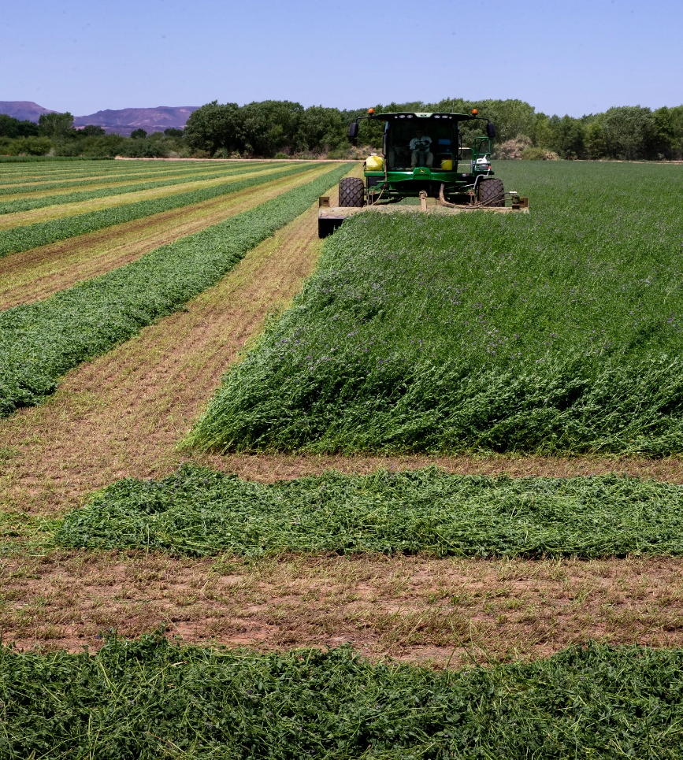

Plowing the Field
In the last part of Luke, chapter nine, Jesus says, “No one who puts a hand to the plow and looks back is fit for the kingdom of God.” He’s responding to someone who promised to follow Jesus but wants to wait until he has buried his father. (The text does not tell us whether the father has already died.)

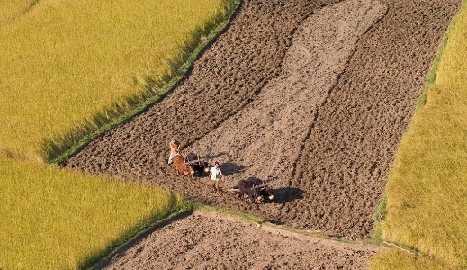
The thing about looking back when you plow is that your rows will be much straighter if you focus forward. Today, many people are able to use equipment that does much of that focusing for them, and the plowing and planting equipment is able to take care of many perfectly parallel rows at a time!

Life, however, does not always turn out perfectly parallel. Relationships take unexpected turns, people leave, or they die, or their goals won’t align with ours. Or diseases invade our bodies, and we can’t fulfill the plans we’d made for travel or time with family. Or a job is suddenly done. And we look back over our lives and find all kinds of swerves and bends leaving a field that isn’t pretty at all!

But we can’t go back and change what has already happened. We can learn from our pasts to plan for a better future, but unexpected things can still happen to interfere with our best-laid plans. Yet, we don’t have to worry about those curves and bends and boulders, because we have a gracious God who forgives what needs forgiving, who heals what needs healing, and walks with us through every trial and joy and event, expected or not.

We don’t need to turn back and lament over all that has happened in the past (except to attempt to make amends to those we may have harmed). Instead, we focus on what good we can accomplish for God’s kingdom today.
Pastor Michelle



Senior Lites July Event
On Saturday, July 18, we will be taking a ride on the Hiawatha! This will be a train ride on the historical Hiawatha to Granite Falls and back. We will leave at 9:00 in the morning from the depot in Montevideo for a 1.5-hour tour along the Minnesota River and surrounding bluffs. Afterwards, we plan to gather at The Rivers for lunch (lunch at participants’ expense). Please call the church to reserve your spot! (320)269-8824


Senior Lites Upcoming Events
Thursday, August 20-Picnic in Smith Park (Lunch time)
Sunday, September 20-The Barn Theatre in Willmar
“The Cemetery Club” Showtime at 2:00,
bus leaves from church at approximately 12:30.
Thursday, October 22-Fall Kick-off at 5:00 p.m.

THANK YOU FOR YOUR GIFTS!

We have many ways you can give. We offer auto-giving through your bank. Please contact Sue in the office to arrange for this to happen.
We have a drop-box outside the front door of Mason Hall. You may put your offering in an envelope and slip it in the slot.

We have online giving through Tithe.ly. Just scan the QR code here and it will take you to our page.


We have our regular offering envelopes that are sent to you
bi-monthly for you to fill and bring to worship.

Finally, we have Pew Envelopes at the end of each pew for you to use during church. You can specify on that envelope where you want your special gift to go.


2026 Financial Snapshot
General Fund Operating Budget
YTD Income: $ 291,068.18
YTD Needed: $ 302,764.82

We want to share openly with you that our church is currently facing a financial shortfall, and we need your help. Our ministry depends on the faithful support of our congregation, and recent giving has not fully met our needs. We are committed to being good stewards of what we have, carefully managing expenses while continuing the work that matters most in our community. At this time, we ask you to prayerfully consider how you might support the church—whether through increased giving, a one-time contribution, or other forms of assistance. Every gift, no matter the size, makes a meaningful difference. Together, with a shared commitment and sense of purpose, we trust that we can meet this challenge and continue moving forward in faith. Thank you for all that you do for Our Savior’s!


CHURCH MEMBERS WHO HAVE PASSED AWAY:

Gayle Jean Jensen 4/09/2026
Arden Allen Anderson 4/13/2026
Marvis Ione Ketelsen 4/23/2026

HERITAGE HAVEN
We are coming along really well and we hope to show some pictures of our progress soon. Sheet Rock is done and now it is on to painting and then flooring and a dropped ceiling….we are moving now.
Blessings to all who have given and blessings to those who are considering a gift.
Wake up! God is calling you to joyful living.

This is how we are to live each day. Joyful living is a challenge in our world today. Only God can give you lasting Joy and lasting Peace.
Pray for Peace and Joy in 2026!!!


ENDOWED CHAIR FOR YOUTH AND FAMILY

- As you make your life decisions and your end-of-life decisions, would you consider a gift to Our Savior’s?

- Gifts can be made out to the Endowment Fund, Endowed Chair. Thank you for what you are doing to make this happen.

- Please give as you have been blessed. We are thankful for what we have gathered as we grow this important piece of our ministry. Thanks for what you will do in this area. Together, we have everything we need.

- Each member is very important to us and so we want to make sure we can minister to them, thus the need for these funds.

FOR A FORM OR OTHER INFORMATION, CONTACT PASTOR DON AT 320-269-8824

Church Council Corner
Just Thoughts/Plain Talk: Our Endowment Fund-It's a Game Changer
By: Ed Delf

If You've a member of OSLC you've heard of the Endowment Fund. You are also probably aware of some of the things the fund helps pay for, but not the full scope of what it supports. The fund's returns, or ROI, are used in many areas of OSLC's missions. Without the money the fund generates, many of our missions just wouldn't happen. Ongoing support, in all its forms, needs the growth of the funds principal to generate the ROI needed for mission funding. Our funds numbers, although generous, are not finite. Without principal growth the fund doesn’t just stay the same, it actually is eroding in value.

Some years ago, and you can ask Pastor Don about start details, we had several members think outside of the current needs of OSLC and gave gifts to establish a fund that provided some income streams for future generations. From that start, we have had several members who have done the same, and today this fund is just over a million dollars.

Wow! You'd probably say that's a lot of money, and I agree, it is. However, looks can be deceiving as what you see is not what you may get in today's reality world. The fund's ROI has guidelines on how and where it can be used. As with all investments, not every year is a high five one as anyone who watches the stock market will verify. Simply, for some years the money we have become dependent on to help pay for our mission support areas, just isn't there. Prioritizing of missions takes on a whole new meaning. Each mission area is important, and if you've got to cut, the thought might be, it's the other guy's missions that must be cut back on. Meanwhile, in the background, Peter and Paul each have their handout and want to get paid. Kind of darned if you do and darned if you don't situation.

Anyway, the reality world of today suggests that the missions we support, both in and out of church, are getting more expensive. For example, one area, like mother nature's wrath, could expose us to potential out of pocket costs exceeding hundreds of thousands of dollars due to new insurance deductible limits. That's based on the value of our building and our exposure vs the insurance kick in. Basically, it works like your car insurance where you might pay out-of-pocket the first 500 or 1K before insurance pays. Also, normal maintenance issues, like our homes, are also a continuing drain on our dollars.

At our annual meeting in January, OSLC provides a breakdown of the past year's expenses and a budget for the new year is presented, discussed, and we are asked for our approval. Among some of the detailed information that is provided for review is what the Endowment Fund has helped pay for in the past year. At first glance usually gets a "that's a lot of stuff" reaction, and a thumbs up. Many of us may not have realized the extent of how the fund does support our missions for OSLC, but the fund, as I've said, is not finite

Bequeaths from wills, RMD's, and general budget gifts have slowed for several reasons. I think that that one reason might just be lack of knowing what you and I can do to help. I know most of us don't want to talk about end-of-life issues, but that doesn't change the inevitable outcome. Maybe you have thought about doing something but just don't know where to start, or for that matter, what it might mean for your estate. You might be very surprised at the resources available that will help you with making decisions and how to go about it. FYI, Pastor Don and the Endowment Board members can help get you started.

The long and short of is that if you have ever wondered how a lot of what we do gets paid for, it does with the help of our Endowment Fund. Any type of gift to the fund can be restricted, you specify what it can be used for, or non-restricted, which goes into a general category and is used where best needed. Either way, the monies provide long term support for the church and a lasting legacy for you.
You've heard the old saying "You can't take it with you" but you sure can decide to do what you want, with what you have, while you're still here. Think about it. It's a win-win for you and God's mission.



Our Graduates
"Trust in the Lord with all your heart and lean not on your own understanding; in all your ways acknowledge Him, and He will direct your path."
Proverbs 3:5-6

- 🎓Lauren Albertson
- daughter of Dustin and Courtney Albertson

- 🎓Jade Bahl
- son of Jason and Melanie Bahl

- 🎓Nels Baukol
- son of Eric and Pam Baukol

- 🎓Danica Buseman
- daughter of Terry and Michelle Schuldt and
Andy Buseman and Meagan Johnson

- 🎓Brody Dack
- son of Josh and Beth Dack

- 🎓Ben Dehne
- son of Jason and Danelle Dehne

- 🎓Annelise Jahn
- daughter of Chuck and Elizabeth Jahn

- 🎓Karina Jahn
- daughter of Chuck and Elizabeth Jahn

- 🎓Addison Jerve
- daughter of James and Melissa Bulman and Eric Jerve

- 🎓Kylieann Johnson
- daughter of Brian and Darlene Johnson

- 🎓Macey Kling
- daughter of Rick and Tasha Schroeder and Justin Kling

- 🎓Camden Schroeder
- Son of Melissa Schroeder and Rick and Tasha Schroeder




Summer Office Hours
The church office began summer hours on Monday, May 25.
Summer office hours will be:
Monday – Thursday:
7:30 AM – 4:30 PM
Friday: Closed

We appreciate your understanding and wish everyone a safe and blessed summer!
~~~~~~~~~~~~~~~~~~~~~~~~~
“Don’t let your faith take a summer vacation! As attendance shifts during the summer months, your giving makes a difference—please consider using the enclosed envelope.”

~~~~~~~~~~~~~~~~~~~~~~~~~

Our Summer Coffee Fellowship is a wonderful time to gather, connect, and enjoy refreshments together after worship. However, this tradition can only continue if we have volunteers to help host.
If you’re willing to provide treats and assist with setup/cleanup on a Sunday this summer, please sign up on the fellowship board in Bethany Hall (or contact the church office).
If we do not have enough people sign up, Coffee Fellowship will be paused for the summer months.
Thank you for helping make this time of fellowship possible!

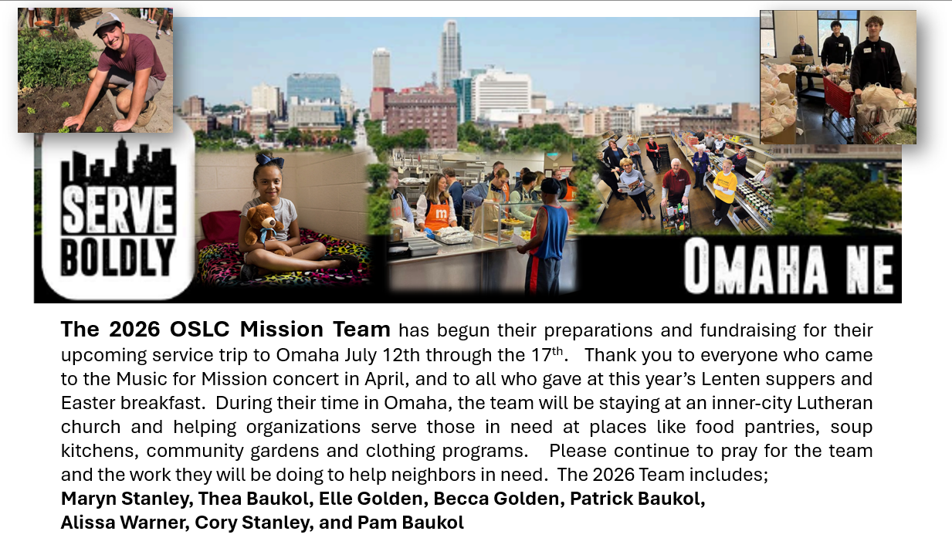
HAPPY FATHER’S DAY!!

I know the joy of being a dad and the challenges that it can be. I am thankful for all the dads who love and help their kids grow. I thank God for all the dads who modeled faith to their children. What you do as a dad is a gift to your children, and they will take your love and support with them as they grow.

Thank you!
PD





