

‘To you, a child is born, a Son is given and he shall be called Wonderful Counselor, Mighty God, Everlasting Father, the Prince of Peace.’ Isaiah 9:6

Christmas and New Year’s is a tradition that most of us love to be part of. Be it family time, opening presents or just celebrating, most of us love this time of year.

When Isaiah wrote these words, the world was a mess. Chaos and death and destruction were all around and God’s people had forgotten how to follow. These words from Isaiah were words of hope for a world in trouble.

As I think about the world that we live in, I wonder if times are so different. Imagine living in Isaiah’s time, 740 B.C. and only considering the coming of a Savior. Now, think of our time and the fact that Jesus has walked on this earth and provided us with everything we need to follow. Yet, we flounder for many reasons.

My prayer for you is that this Christmas and New Year’s is a time of love and hope and peace. We cannot control the world, but we can control what we say and do about it. We need to pray more often for our world. We need to live more Christ-like for all to see.

We have the message that will change lives. We just have to keep telling the old, old story. Lives do change when people realize how powerful God’s love it.

Go, tell it on the mountain, over the hills and everywhere!!!

In Christ,
Pastor Don

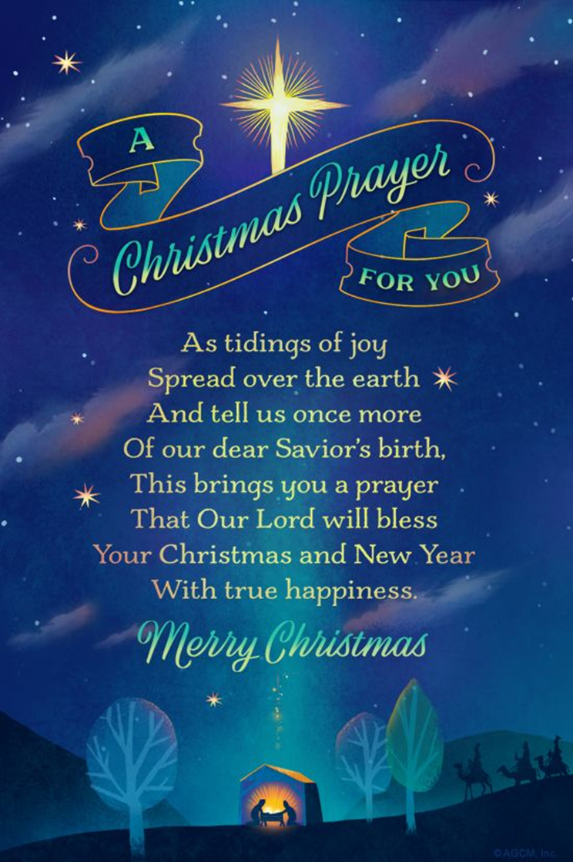

The

December 2025 – January 2026
Worship
9:00am
Newsletter of Our Savior’s Lutheran Church
Montevideo, MN · 320-269-8824

Email: oursaviors@oslcmonte.net Webpage: oslcmonte.com

Join Us for Christmas Eve Worship @ 3:00 pm and 5:30 pm
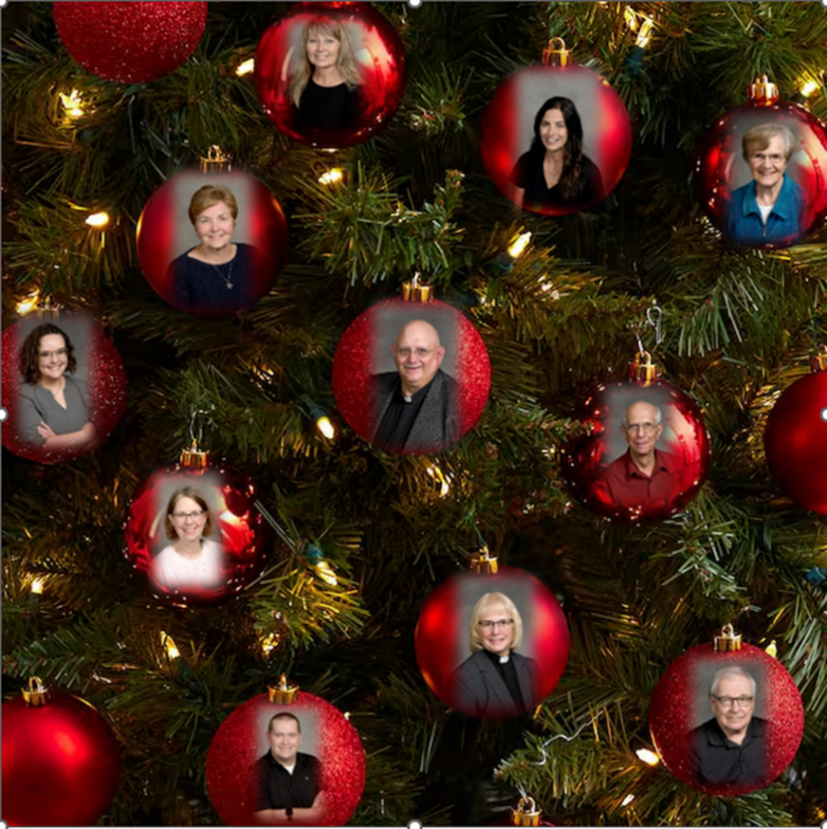
Merry Christmas and Happy New Year
from all of us at OSLC!
The Present and the Presence
Most of December in our church calendars is focused on waiting and preparation for the Christmas Season, which itself does not begin until the Eve of December 25th. Then the season of Christmas lasts for 12 short days, and most of January brings us the season of Epiphany, as Jesus’ life and purpose begins to be fully revealed to the world.
That 12-day Christmas season celebrates the gift—or the present—that God gives in the birth of Jesus Christ. Before that, we have the anticipation, and following, we revel in the presence of God among us.
I usually try to be careful in using the words present and presence, because they can easily be misinterpreted when hearing them. Present can mean either “gift,” or “I’m here!” and while presence always means “being here,” it sounds just like presents, which means “gifts.”
Today, though, I’d like to play with that confusion, because God’s presence is God’s present. God being here with us is God’s gift in Jesus Christ, and we celebrate that presence not only as the gift of the Christmas season, but as God’s loving care for all time.
Every day, we live with the gift—with the present of God’s presence with us; and every day, we have the opportunity to share this present, to share this presence, with those we encounter in everyday life. We can share this presence with our enemies in the hope that they will experience and be inspired by God’s love through us. We can share this presence with strangers. Most of all, we share this presence with our loved ones, because they are the ones with whom we spend the most time. Let us joyously learn to share God’s gift—God’s presence—with everyone—all the time!

In Jesus’ name,

Pastor Michelle


2025 Financial Snapshot
General Fund Operating Budget

YTD Income: $ 474,155.36
YTD Need: $ 499,733.30

Thank you for your continued support! The General Fund is essential to the life of our congregation, enabling us to carry out the ministry that reflects the vision and values of Our Savior’s. It covers the maintenance of our buildings, staff salaries, and day-to-day operational costs, which are essential for ministry. Regular contributions are the foundation of this fund. Your generous giving is greatly appreciated, and the Church Council is diligently monitoring expenses to ensure that our ministries remain strong and aligned with our goals.

Funerals:

Ardyce Jean Johnson 10/16/2025

HERITAGE
HAVEN

It is the end of the year; it is time for a gift from you for this great mission. We continue to work on this project, and we need you and your financial support to make this happen.
Blessings to all who have given and blessings to those who are considering a gift.

God gave us the gift of a Son; might your gift match that??

THANK YOU FOR YOUR GIFTS!

We have many ways you can give. We offer auto-giving through your bank. Please contact Sue in the office to arrange for this to happen.
We have a drop-box outside the front door of Mason Hall. You may put your offering in an envelope and slip it in the slot.

We have online giving through Tithe.ly. Just scan the QR code here and it will take you to our page.


We have our regular offering envelopes that are sent to you
bi-monthly for you to fill and bring to worship.

Finally, we have Pew Envelopes at the end of each pew for you to use during church. You can specify on that envelope where you want your special gift to go.


Remember to return your 2026 Generosity Pledge sheets. You may place them in the Pledge Box at the back of the church, bring them to the church office, put them in the drop box outside of the Mason Hall door or simply mail them back to the church.
Thank you

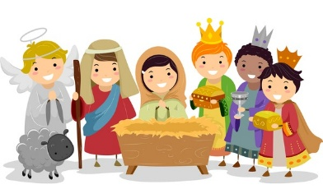

DECEMBER 21st
This Christmas, join us for a fun and heartwarming children’s play, Mission Possible: The Search for Baby Jesus. Follow our team of secret agents as they go on a top-secret mission to find the newborn Savior. Along the way, they meet shepherds, angels, and wise men, discovering that God’s greatest mission was sending His Son—and that we all have a part in sharing His love with the world. Don’t miss this festive celebration of faith, fun, and the true meaning of Christmas


CHRISTMAS EVE SERVICES
Christmas Eve falls on a Wednesday this year. Our services will be at 3:00pm and 5:30pm. The 3:00pm service usually fills up quickly. The 5:30pm service might have more seats available. Join us for our joyous celebration this Christmas Eve. We look forward to worshiping with you here in our beautifully decorated sanctuary.


OUR OFFICES WILL BE CLOSED WEDNESDAY-FRIDAY, DECEMBER 24^{TH –} 26th, AND THEN AGAIN, THURSDAY-FRIDAY, JANUARY 1ST-2ND.
We will be open after Christmas to receive
your end-of-the-year gifts.
We are always blessed by your generosity. Over the years, you have made this congregation a wonderful place of beauty and a wonderful place where the Gospel is heard.
Thank you for all you do for the Kingdom.

I would like to purchase a Poinsettia to share with
Our Savior’s Lutheran Church for the Christmas Holidays!

In Memory of _____ In Honor of _____

Name: _______________________________________

Given by: _____________________________________

I will purchase my own and deliver it to the church _____

The church will order my plant for me ____

Enclosed is my payment of a check made out to OSLC for:
$18.00 for a 6” plant ____
$35.00 for an 8” plant ____
I prefer: Red _____ Pink _____ White _____
No preference _____

Orders need to be in by December 8th.

If you are purchasing your own poinsettia, please have your plant and the above information to the church office no later than December 16th, so that we can acknowledge your Poinsettia in the church bulletin.

Thank you for helping make our church beautiful as we celebrate the birth of the Christ Child.



Wake up! God is calling you to joyful living.

Boy, do we need to live this out each day. The news is so negative, and the outlook is not so good, but God is calling you to joyful living
today and every day.

Celebrating the Season!!!!

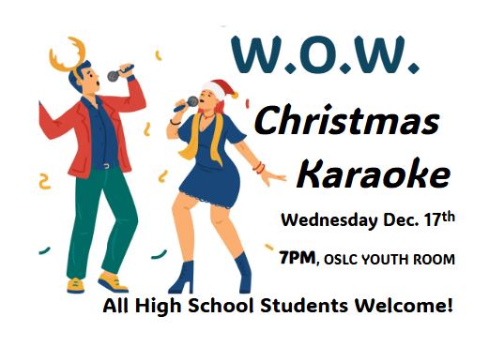

Ways To Give!


The Giving Tree Is Here!
This Christmas season help share God’s love with families in need and Heritage Haven through our annual Giving Tree. Starting November 30th, you’ll find the tree in Bethany Hall decorated with tags listing gifts to help members in need as well as support Heritage Haven. Please take a tag (or two!), purchase the gift, and return it – unwrapped – to the church office by December 22nd. Together, we can bring hope and joy to our neighbors this Christmas!


Chippewa County Food Shelf needs your help to stop Holiday Hunger! Let’s end hunger in our community and support our local food shelf. This campaign will run through the end of the year. Checks should be made payable to: Chippewa County Food Shelf. Please bring your monetary donations to the church office. Food donations can be placed in the grocery cart in the Narthex. Let us be generous in our giving. The greatest reward is knowing that you have answered God’s call to feed the hungry and care for those in need.


Luther Haven will only be accepting monetary gifts for Christmas this year until December 5th. They will be putting together a personalized gift for each resident. You may drop off your monetary gift at Luther Haven’s front desk, mail it to them directly or place it in the offering plate on Sundays. Please make your check out to Luther Haven.

Thank you!


Barb McKee and Ashley as part of a Thrivent Action Team Project are gathering gently used coats and accepting donations towards new hats, gloves, boots and coats for people in need. Please drop off your donations in the church office. Let’s join together in sharing warmth and kindness this season!
Church Council Corner
Just Thoughts/Plain Talk: Christmas on a sleigh ride

Do you ever wonder what happened to Christmas?
I suppose that could be answered by another question. What do you mean what happened? We see the trappings of Christmas earlier every year. In fact, many stores start putting out the latest cute, and must have decorations, in September. They get us ready to buy music, switch over to old Christmas favorites, and of course, the newest versions of the old classics. Don't forget that we're reminded that this is the season to love our neighbors and spread goodwill to all. The Christmas cards we get tell us about the joy and peace of the season.
Some remind us about the sleigh bells ringing and the red nose of Rudolf that will guide Santa right to your chimney. With a touch of his nose, he'll shimmy down with his bag of gifts, eat the cookies, drink the lactose-free milk, and with a wink of his eye proclaim Merry Christmas to all and to all a good night as he pulls out of sight. Oh, and don't forget the Ho, Ho, Ho part.

We're told, if we buy on Black Friday, we'll even be able to get more bang for our buck. The part we're not reminded of is that at some point Peter or Paul will want to be paid.

By the time that Christmas Day is finally here, old Santa has probably taken us for quite the ride. The seemingly endless search for just the right gift(s), has left us exhausted. It might even seem like those that received the fruits of our hard work weren't even very appreciative of what they got. You might even begin to wonder if it was even worth the effort.

So, what happened to Christmas? The above might have come from the Grinch's perspective, but maybe it should remind us, that the meaning of the Christmas celebration, is really not the gifts we give, but the gift that God gave us, His Son, Jesus Christ. We are reminded of this gift in John 3;16 "For God so loved the world that He gave his one and only Son, that whoever believes in him shall not perish but have eternal life." You might even say, it's the gift that keeps on giving, and one size fits all.

The Christmas season is a celebration of His birth, and we should be joyful for what that gift means to us. It's Joy and Peace that is freely given to us and passes all our understanding of its true meaning. The Christmas season is not just to be celebrated for a couple of months, but to be celebrated all year long. In fact, I don't recall reading anywhere in the Bible that there is a start and end date to loving our neighbor as ourselves.

Don't let the lights, music, gifts, and tinseled trees become your celebration focal point. It's part of the celebration for sure, but the real celebration is remembering the birth of our Savior, and by His grace, the gift of everlasting life that can be ours.

Anyway, while taking a ride on Santa's sleigh may be a fun ride, let the light of the star, that proclaimed our Savior's birth, guide you to your ultimate destination.

May this Christmas season, once again remind you of the true gift of His Grace, happily given with no bows attached.


Merry Christmas and a blessed New Year.
Ed Delf


Senior Communion
Thursday, December 11th
Worship with Communion at 11:00
Dinner will follow.
Menu: Roast Beef, Mashed Potatoes, Carrots, Lefse, Cranberry Relish,
Mint Chocolate Chip Ice Cream
(Menu may be subject to change.)
Please call the church office (269-8824) to arrange for a ride if needed.



Senior Lites Christmas Party
Thursday, December 18th
Meal at Noon
Menu: Chicken Cordon Bleu, Wild Rice/Rice side, Sweet Potatoes, Cole Slaw, Cloverleaf Roll,
Cranberry Dessert with Butter Sauce.
Come for the food, fellowship, entertainment by the Madrigals from the High School, and the prizes!
Please sign up in the church office so we are sure to have enough food and prizes available.

Epiphany Festival!
Behold! The Lamb of God!
On January 18th, during the coffee hour, the

Senior Advisory Board will be serving freshly baked rolls, your choice of caramel or cinnamon!

Come prepared to have your mouth watering as you are surrounded by the aroma of these scrumptious treats! If any rolls are remaining after everyone has been served, they will be available for purchase to take home.
Come for the Sweets, Stay for Community!

