

**What Do You Want Your Church To Be?**

As we get further and further away from COVID, all the excuses we use seem to be just that excuses. Most of us want a church in our town. I know many churches right now, 17 in our conference that simply wait for a Pastor to come and serve them. You are blessed with two Pastors and yet there seems to be little energy for this congregation some days.

To be a church you need two things: Participation and Volunteers. As with most summers, we have struggled with both. We need you in worship as we gather to thank and praise God. I get emails weekly from Voice of the Martyrs and I am reminded that worshiping God is a gift and freedom we have, and the cost is not very much. Many other places, the cost could easily be a prison cell or death. We would love to see you at worship.

Second, we need volunteers. My wife, Barb does the calling for Communion Servers, Readers and Ushers. She struggles to fill the spots and for her, like anyone, it is frustrating. We are blessed with lots of members, maybe it’s your turn to help.

We just had Senior Communion for those 80 and older, many of whom cannot come to worship any more without a lot of help. Several of them told how wonderful it was to be back in worship again. To just be here to hear the organ and sing the songs. We were blessed to have them here as well.

The future is what you make of it. This church will be what you all make it out to be. I will do my best to lead, guide and inspire. I hope you do your best to find time for the only opportunity you have to be part of something that is more eternal in nature.

Blessings to each of you,

**Pastor Don**

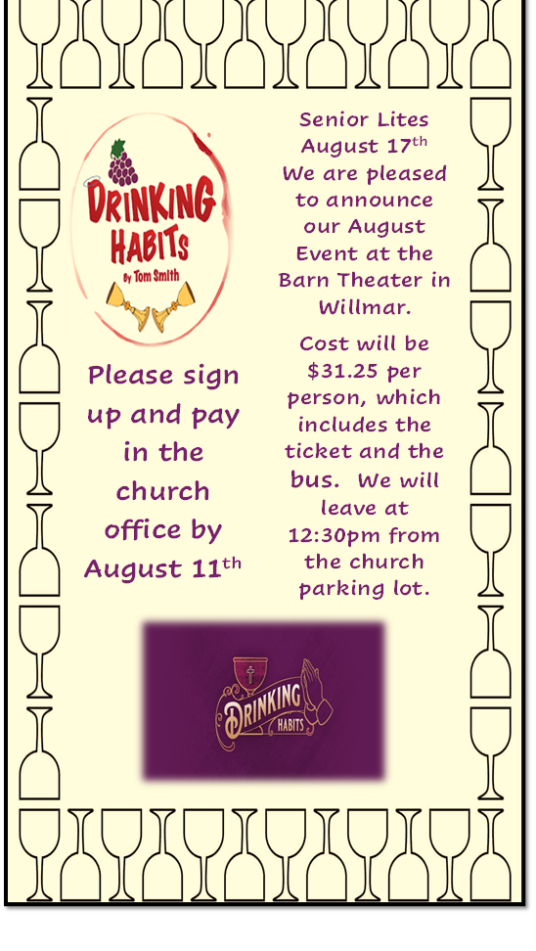

**August 2025**

**Worship**

**9:00am**

Newsletter of Our Savior’s Lutheran Church

Montevideo, MN · 320-269-8824

**Email:** [**oursaviors@oslcmonte.net**](mailto:oursaviors@oslcmonte.net) **Webpage: oslcmonte.com**

**Summer Vacation**

When I was a child, every summer we had some kind of vacation, where we’d go either some place like a national park, or to visit relatives that lived far away.  We didn’t often do these things in the winter, because my parents both worked at the school, and we didn’t have the option of taking vacations during school days.

Some of my farming friends rarely went anywhere that far away, because there was extra work for livestock, and they had to hire someone to take care of them while they were gone.  Sometimes, those families would divide their activities, and some went one direction at one time, and others went somewhere else a few weeks later.

Now I have a sister who’s retired, and she gets to be on vacation most of the time, when she is not busy with her participation in various music ensembles!

Shortly before the writing of this piece, I took an afternoon to watch her in one of those ensembles, the Twin Cities Bronze.  They ring handbells and chimes, and they were celebrating 25 years of ringing with an anniversary tour.  The event I saw was their homecoming concert at Mount Calvary Lutheran in Eagan.

The event was quite different than I’d expected, as they used both chimes and bells in the same piece—and they’d added different ways of creating the sounds!  One piece even added a flute part (which she played this time).

I share this with you today as a reminder that the beauty of God’s creation is not limited to natural formations of lakes, seas, and mountains.  It is not limited to music or other arts.  It is not limited to the speeds some of us reach on the tracks or in the skies—or the resolute motion of the turtle.  The beauty of God’s creation is as limitless as those who enjoy any of its many aspects.  Let us each take in some of those moments, to notice God’s gifts in creation, and in one another.

In Jesus’ name,

**Pastor Michelle**

**Baptism:**

Waylen Noel Augeson May 25, 2025

Freya Marie Ayyagari June 18, 2025

Brielle Lois Dennis July 12, 2025

Persephone Ruth Ann Enger Woltjer July 19, 2025

**Funerals**:

Darrold Wallace Boettcher May 7, 2025

Helen Joanna Hendrickson May 9, 2025

James Melvin Wik May 10, 2025

Kevin Lee Tadd May 22, 2025

Jacob Richard Refsland June 4, 2025

Bernice Evangeline Mae Lofthus July 10, 2025

**In memory of:**

Jim Wik Undesignated $50.00

Pastor James Sjolie Undesignated $20.00

**Financial Information:**

June Income: $45,350.11

Expense: - $56,575.23

**- $18,770.76**

**Go For The Gold**

Many times in life we watch sports teams going for the gold, to be #1.  We want this as well for our congregation.  We want to be #1 in giving, in our generosity.

Will you help us with a ‘Go For The Gold’ extra gift?

**Thank you in Advance for your gifts keeping us out of the red….**

**THANK YOU FOR YOUR GIFTS!**

We have many ways you can give. We offer auto-giving through your bank. Please contact Sue in the office to arrange for this to happen.

We have a drop-box outside the front door of Mason Hall. You may put your offering in an envelope and slip it in the slot.

**We have online giving through Tithe.ly. Just scan the QR code here and it will take you to our page.**

We have our regular offering envelopes that are sent to you

bi-monthly for you to fill and bring to worship.

Finally, we have Pew Envelopes at the end of each pew for you to use during church. You can specify on that envelope where you want your special gift to go.

**AS THE SUMMER GOES, SO GOES OUR**

**SKIMPY OFFERINGS… WE CAN USE YOUR**

**HELP…..THANKS FOR THINKING OF US….**

**GIFTS TO HERITAGE HAVEN**

Windows are in and framing is done as I write this.

Molde’s Electric is working on the wiring.

We are waiting for the state to approve the plumbing and heating plan and then we will move forward again.

We will also have to do some landscaping… the rain revealed some issues for us.

We are working with as many local people as possible. Donations are coming in and we hope that you might help us with our project.

Contact Pastor Don if interested in funding a piece of our renovation work.

You can give through our Go Fund Me Page – Heritage Haven Montevideo or you can give locally at the CO-OP Credit Union directly to Heritage Haven.



**Our Mission Statement:**

**Reflect on the ways that you can put this mission into action….**

Mission Statement:

In Jesus' name God is sending us into the community to find and express the joy of God's love. God is challenging us to overcome fear and take risks; to welcome, help, and give to others.

We are promised all the energy we need by gathering around God's word and sacrament for worship and study.

God reminds and encourages us to trust, listen, love, and rejoice together,

***Wake up! God is calling you to joyful living.***

