Rite of Celebration and Remembrance
Blessed be the God and Father of our Lord Jesus Christ who is the source of all mercy and the God of all consolation. Blessed be God who did not let his Son stay in the grave but rather raised him to greater Glory. We pray for your presence among us as we remember those who have gone before us.

P: God of Creation
C: We remember all the saints who have known your truth.
P: We remember Adam and Eve, Abraham, Isaac and Jacob.
C: We thank you for the gift of faith to each of them.
P: We thank you for judges, kings, queens and prophets. People like Samson, Deborah, David, Esther and Elijah.
C: We remember the strength you gave them to lead.
P: We thank you for the 12 disciples who met you face-to-face and learned from you.
C: We remember those saints who walked with you.
P: We thank you for those who spent their living spreading the good news.
C: We remember with gratitude that the good news is for all people.
P: We thank you for those whose lives are still in danger today as they tell of your love.
C: We remember the saints living today throughout the world.
P: We thank you for our newest saints and our seasoned saints.
C: Help us all to serve our living God.
P: We remember all the saints who have known your love and lived it.
All: I thank you for listing me as a saint, redeemed by your gracious hand.
Loving Father, we thank you for each child baptized this year in our congregation. Bless them with your grace and love. Help each of them to grow into active saints for the Kingdom, through Jesus Christ, our Savior and Lord, who lives and reigns with you and the Holy Spirit, one God now and forever. Amen.
(A candle will be lit for each saint baptized)

O God, our help in ages past, our hope for years to come. Hear our prayer in the name of the good and gracious shepherd, Jesus Christ, our Savior and Lord. Amen.
(A candle will be lit in remembrance for each departed saint.)

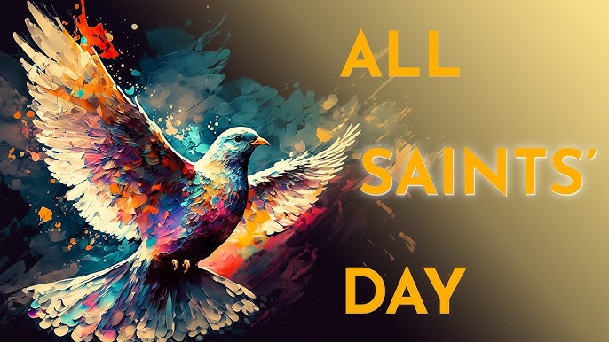

All Saints is a festival for remembering, honoring, and giving thanks for all who are in Christ Jesus - the saints. We celebrate God’s people who, through the centuries, have witnessed to Christ by their lives. We remember those saints of our own families and community who have died in Christ and those who were reborn into the family of God through Holy Baptism in the past year.

Our Saints - Baptisms 2025
Hattison Maray Hansen 03/23/2025
Waylen Noel Augeson 05/25/2025
Brielle Lois Dennis 07/12/2025
Persephone Enger 07/19/2025
Isley Quinzel Zawacki 08/07/2025
Roxy Michelle Dahl 08/09/2025
Parker John Stevens 09/28/2025

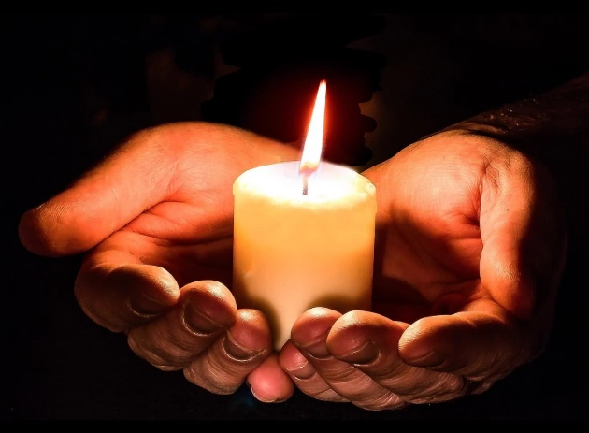

Almighty God, thank you for working in the lives of all your saints. Give us faith to engage the world according to your ways, living in hope and confidence of your gift of salvation. Amen.

Our Saints - Funerals 2025
David Offerman | 11/12/2024
Gerald Melvin Lund | 11/16/2024
Debra Marie Blom | 11/27/2024
Wesley Schrapp | 12/27/2024
Mae Elizabeth Ericksen | 12/28/2024
Debbie Louise Hedin | 01/25/2025
Robert Kurtzbein | 02/13/2025
Lois Carolyn Dyshaw | 03/08/2025
Jonathan Kenneth Dahl | 03/29/2025
Catherine Ann Groothuis | 04/04/2025
Gene Leroy Larson | 04/24/2025
Elaine Carole Vik | 04/29/2025
Lois Christine Nordby | 05/07/2025
Darrold Wallace Boettcher | 05/08/2025
Helen Joanna Hendrickson | 05/09/2025
James Melvin Wik | 05/10/2025
Kevin Lee Tadd | 05/22/2025
Jacob Richard Refsland | 06/04/2025
Bernice E.M. Lofthus | 07/10/2025
Ardyce Jean Johnson | 10/16/2025

